ADVENT MIDWEEK SERVICES

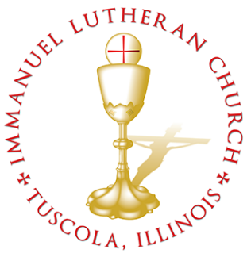
ADVENT II MIDWEEK SERVICE
Welcome to Immanuel Lutheran Church! Here, you will find a community thriving on God’s mercy and forgiveness, anchored in the Holy Scriptures and the Lutheran Confessions, rejoicing in the historic liturgy of the Church, and learning to live as the family of God. As God’s family here in Tuscola, we invite you to join us for worship to grow in God’s rich mercies in Christ, and we welcome you to the life of Christ and His Church with open arms!

WELCOME VISITORS

Evening Prayer, LSB 243
Stand
The SERVICE OF LIGHT LSB 243

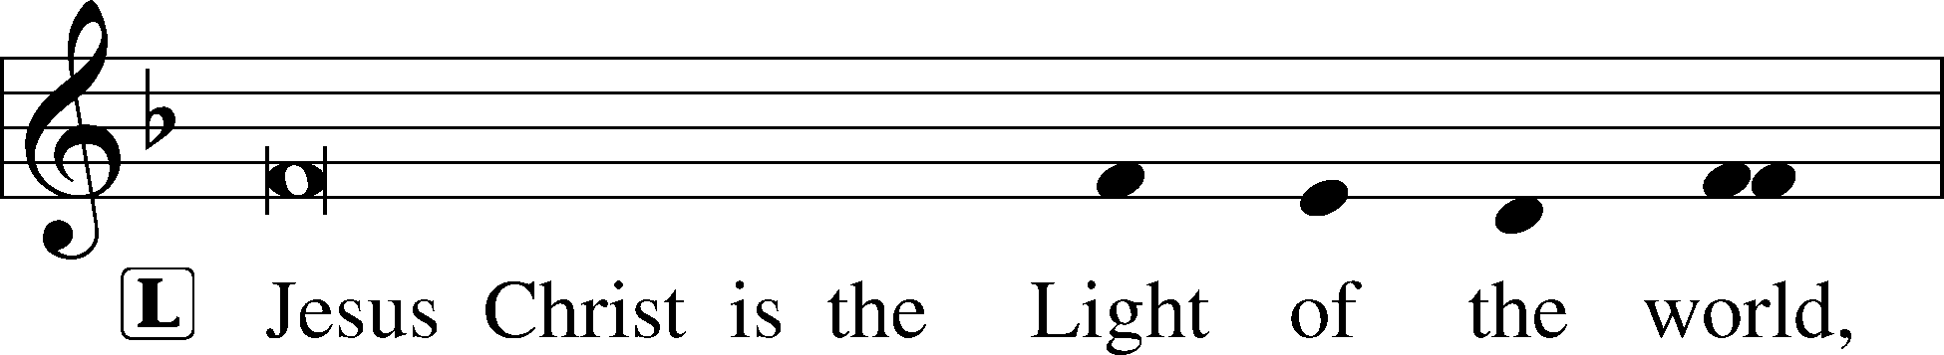
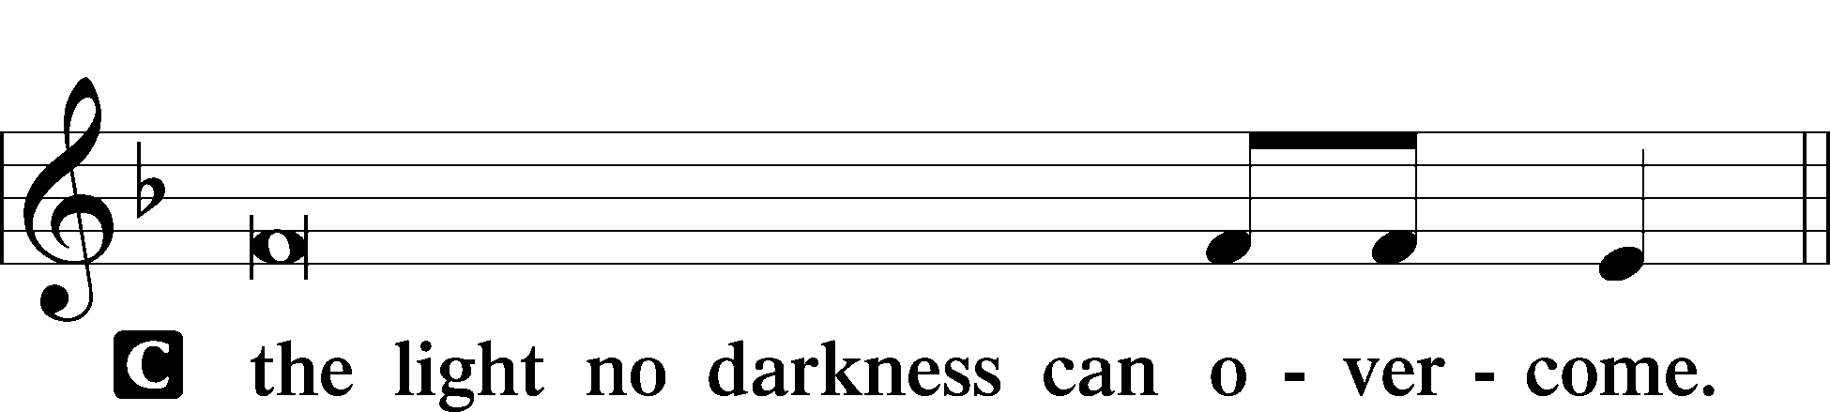
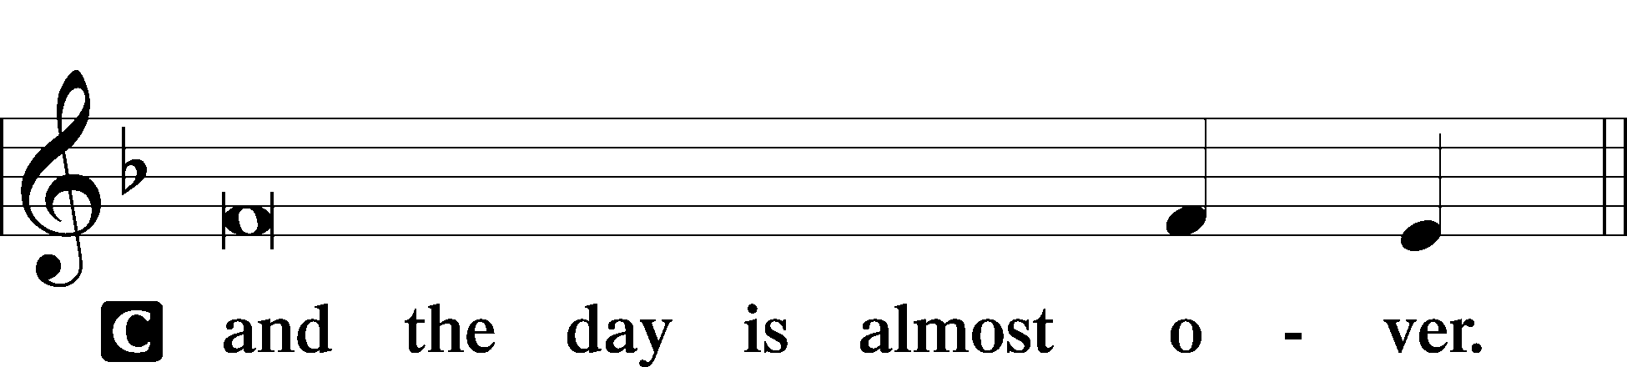
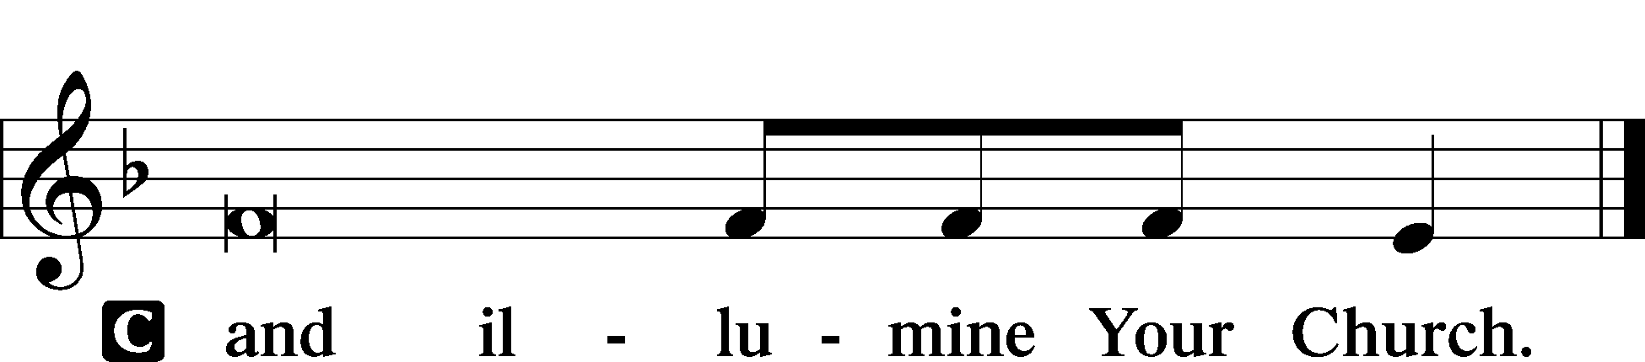

The PHOS HILARON LSB 244
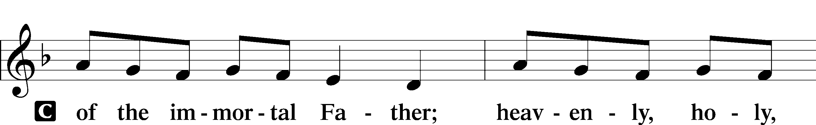
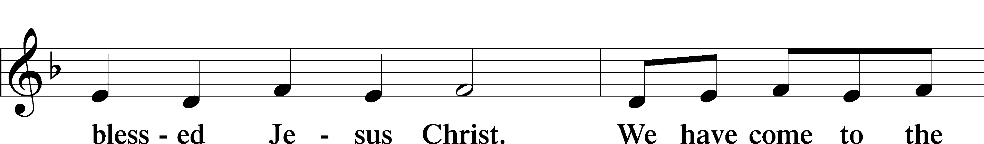
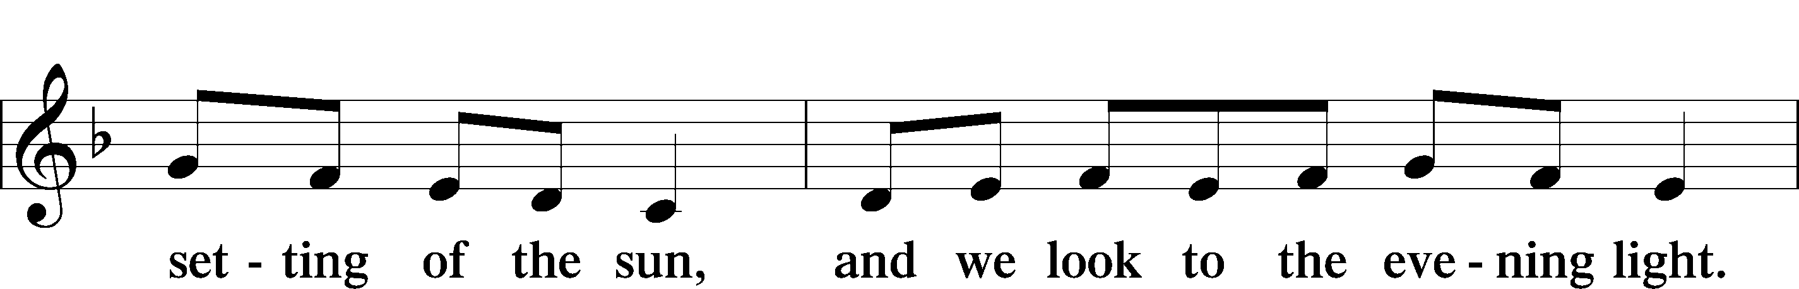
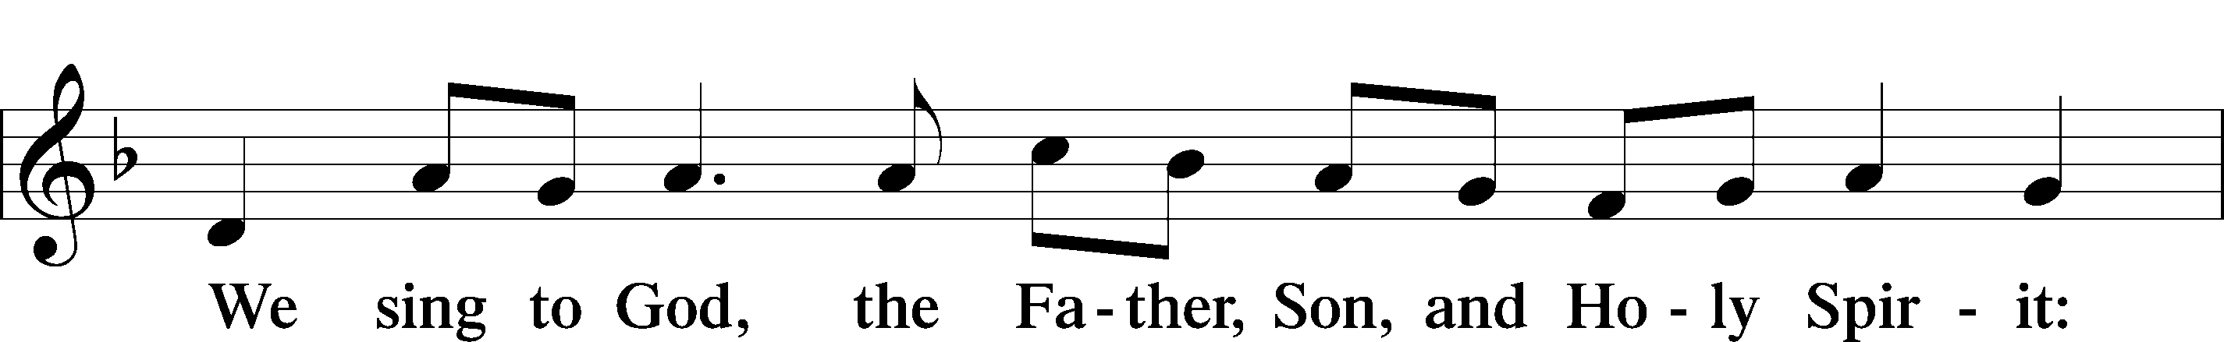
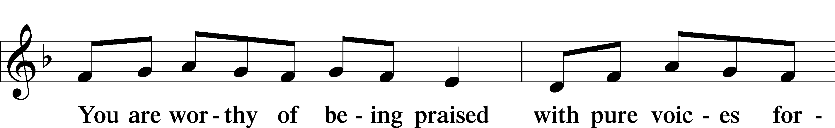
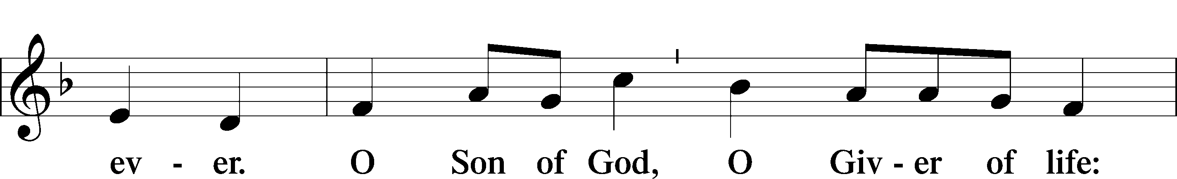
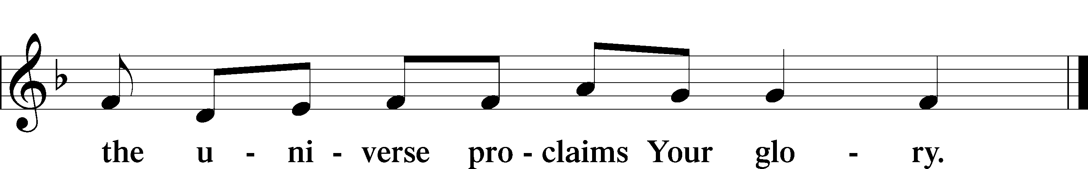

The THANKSGIVING FOR LIGHT LSB 245
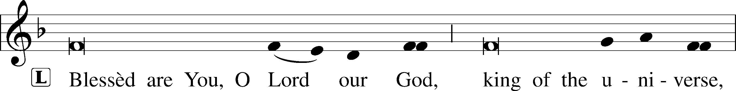
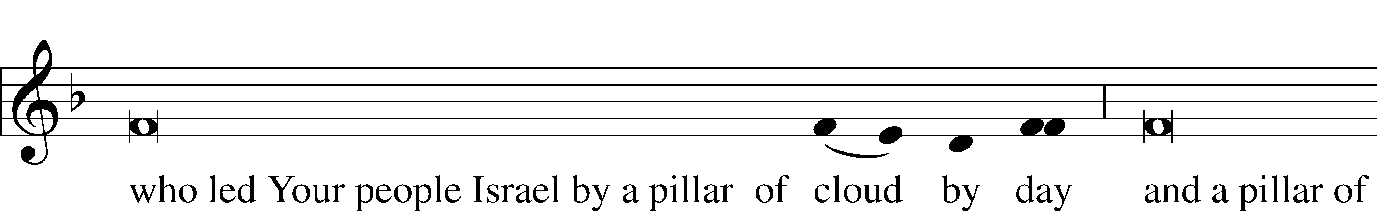
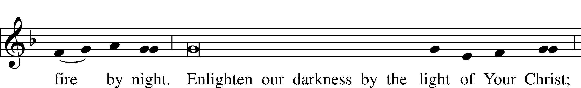
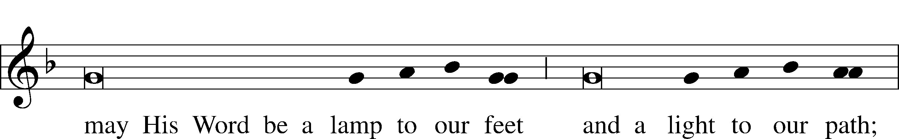
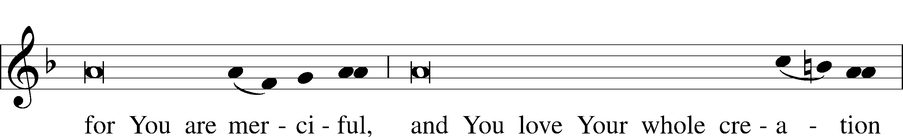
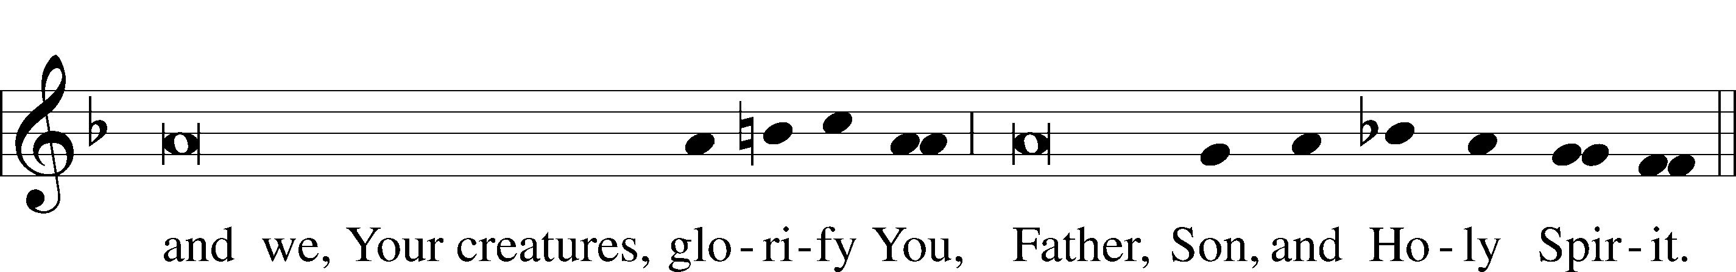

Sit

The OFFICE HYMN LSB 508 The Day is Surely Drawing Near
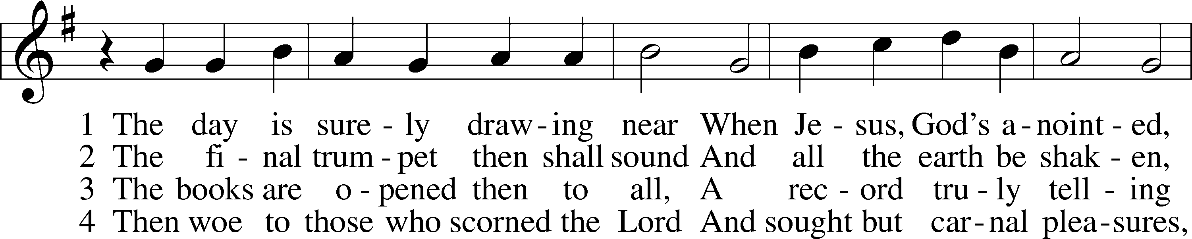
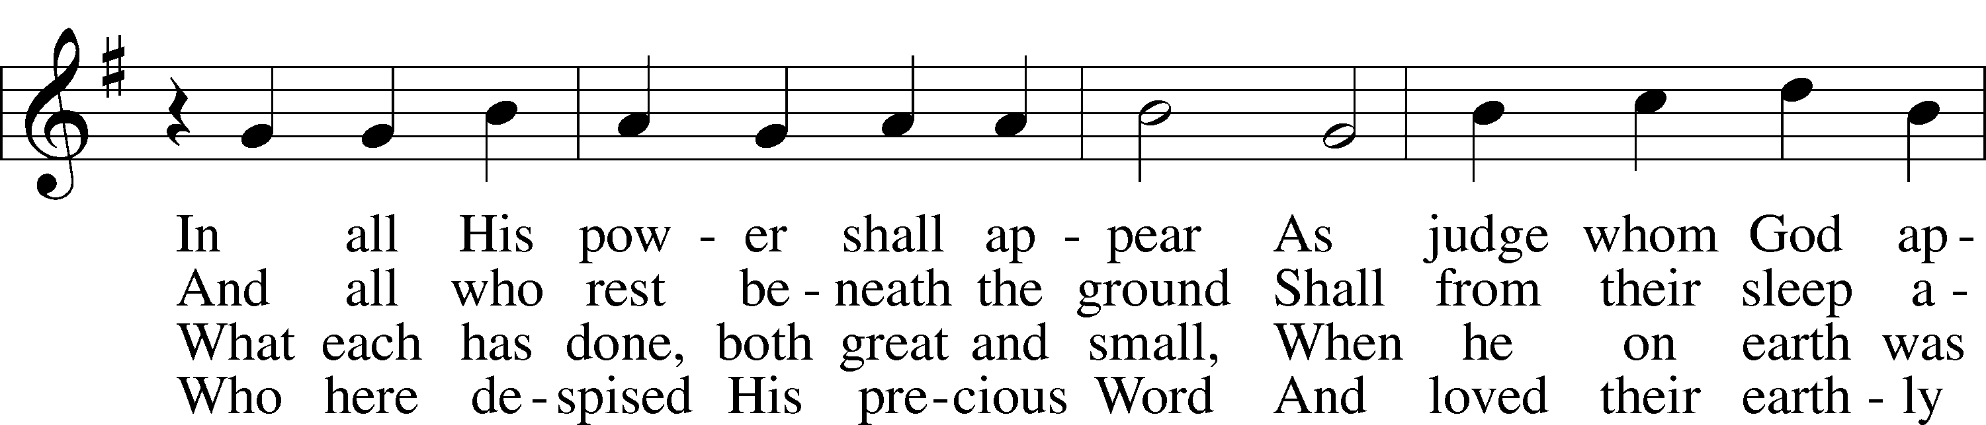
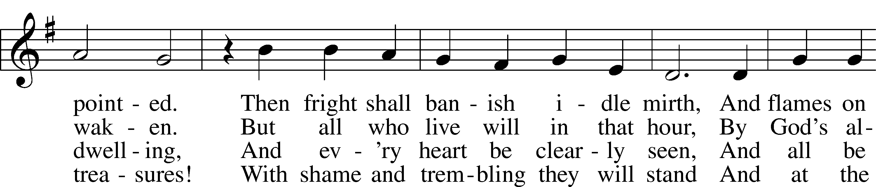
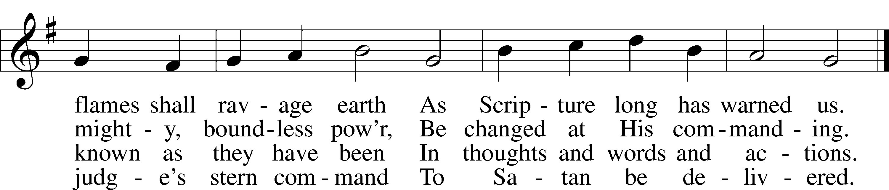

5 My Savior paid the debt I owe
And for my sin was smitten;
Within the Book of Life I know
My name has now been written.
I will not doubt, for I am free,
And Satan cannot threaten me;
There is no condemnation!

6 May Christ our intercessor be
And through His blood and merit
Read from His book that we are free
With all who life inherit.
Then we shall see Him face to face,
With all His saints in that blest place
Which He has purchased for us

7 O Jesus Christ, do not delay,
But hasten our salvation;
We often tremble on our way
In fear and tribulation.
O hear and grant our fervent plea:
Come, mighty judge, and set us free
From death and ev’ry evil.
The READINGS 2 Peter 3:1–18, Matthew 25:31–46
P O Lord, have mercy on us.
C Thanks be to God.
After all the readings are completed the liturgist shall speak.
P In many and various ways, God spoke to His people of old by the prophets.
C But now in these last days, He has spoken to us by His Son.
The SERMON
Stand
The LITANY LSB 288–289
L O Lord,
C have mercy.
L O Christ,
C have mercy.
L O Lord,
C have mercy.
L O Christ,
C hear us.
L God the Father in heaven,
C have mercy.
L God the Son, Redeemer of the world,
C have mercy.
L God the Holy Spirit,
C have mercy.
L Be gracious to us.
C Spare us, good Lord.
L Be gracious to us.
C Help us, good Lord.

L From all sin, from all error, from all evil;
From the crafts and assaults of the devil; from sudden and evil death;
From pestilence and famine; from war and bloodshed; from sedition and from rebellion;
From lightning and tempest; from all calamity by fire and water; and from everlasting death:
C Good Lord, deliver us.
L By the mystery of Your holy incarnation; by Your holy nativity;
By Your baptism, fasting, and temptation; by Your agony and bloody sweat; by Your cross and passion; by Your precious death and burial;
By Your glorious resurrection and ascension; and by the coming of the Holy Spirit, the Comforter:
C Help us, good Lord.
L In all time of our tribulation; in all time of our prosperity; in the hour of death; and in the day of judgment:
C Help us, good Lord.
L We poor sinners implore You
C to hear us, O Lord.
L To rule and govern Your holy Christian Church; to preserve all pastors and ministers of Your Church in the true knowledge and understanding of Your wholesome Word and to sustain them in holy living;
To put an end to all schisms and causes of offense; to bring into the way of truth all who have erred and are deceived;
To beat down Satan under our feet; to send faithful laborers into Your harvest; and to accompany Your Word with Your grace and Spirit:
C We implore You to hear us, good Lord.
L To raise those who fall and to strengthen those who stand; and to comfort and help the weakhearted and the distressed:
C We implore You to hear us, good Lord.
L To give to all peoples concord and peace; to preserve our land from discord and strife; to give our country Your protection in every time of need;
To direct and defend our president and all in authority; to bless and protect our magistrates and all our people;
To watch over and help all who are in danger, necessity, and tribulation; to protect and guide all who travel;
To grant all women with child, and all mothers with infant children, increasing happiness in their blessings; to defend all orphans and widows and provide for them;
To strengthen and keep all sick persons and young children; to free those in bondage; and to have mercy on us all:
C We implore You to hear us, good Lord.
L To forgive our enemies, persecutors, and slanderers and to turn their hearts; to give and preserve for our use the kindly fruits of the earth; and graciously to hear our prayers:
C We implore You to hear us, good Lord.
L Lord Jesus Christ, Son of God,
C we implore You to hear us.
L Christ, the Lamb of God, who takes away the sin of the world,
C have mercy.
L Christ, the Lamb of God, who takes away the sin of the world,
C have mercy.
L Christ, the Lamb of God, who takes away the sin of the world,
C grant us Your peace.
L O Christ,
C hear us.
L O Lord,
C have mercy.
L O Christ,
C have mercy.
L O Lord,
C have mercy. Amen.
The Lord's Prayer LSB 251
C Our Father who art in heaven,
hallowed be Thy name,
Thy kingdom come,
Thy will be done on earth as it is in heaven;
give us this day our daily bread;
and forgive us our trespasses as we forgive those who trespass against us;
and lead us not into temptation,
but deliver us from evil.
For Thine is the kingdom and the power and the glory forever and ever. Amen.
The COLLECT FOR PEACE
P O God, from whom come all holy desires, all good counsels, and all just works, give to us, Your servants, that peace which the world cannot give, that our hearts may be set to obey Your commandments and also that we, being defended from the fear of our enemies, may live in peace and quietness; through Jesus Christ, Your Son, our Lord, who lives and reigns with You and the Holy Spirit, one God, now and forever.
C Amen.
The BENEDICAMUS and BENEDICTION LSB 252
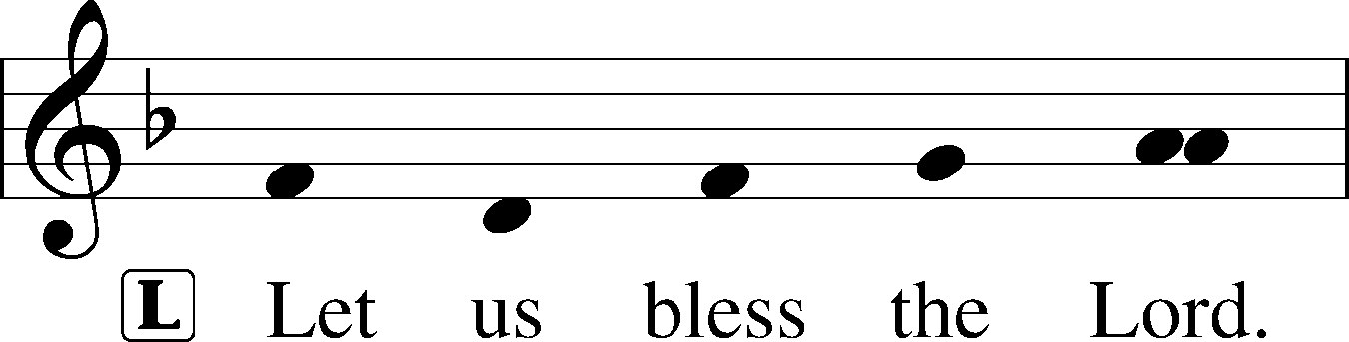
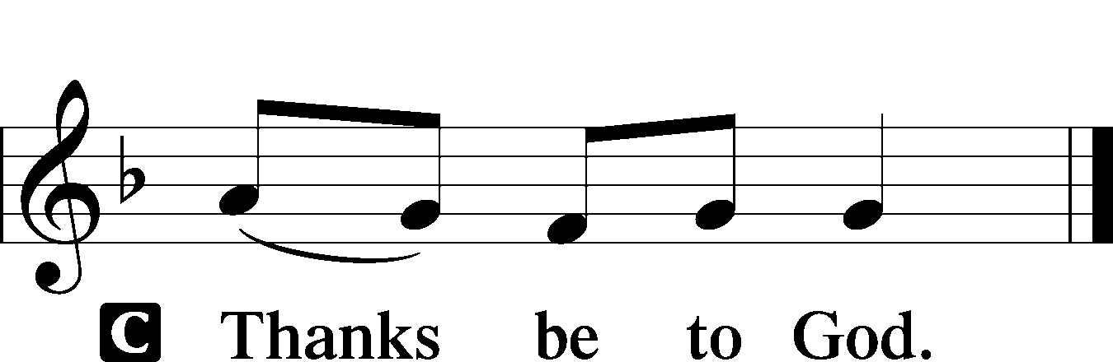

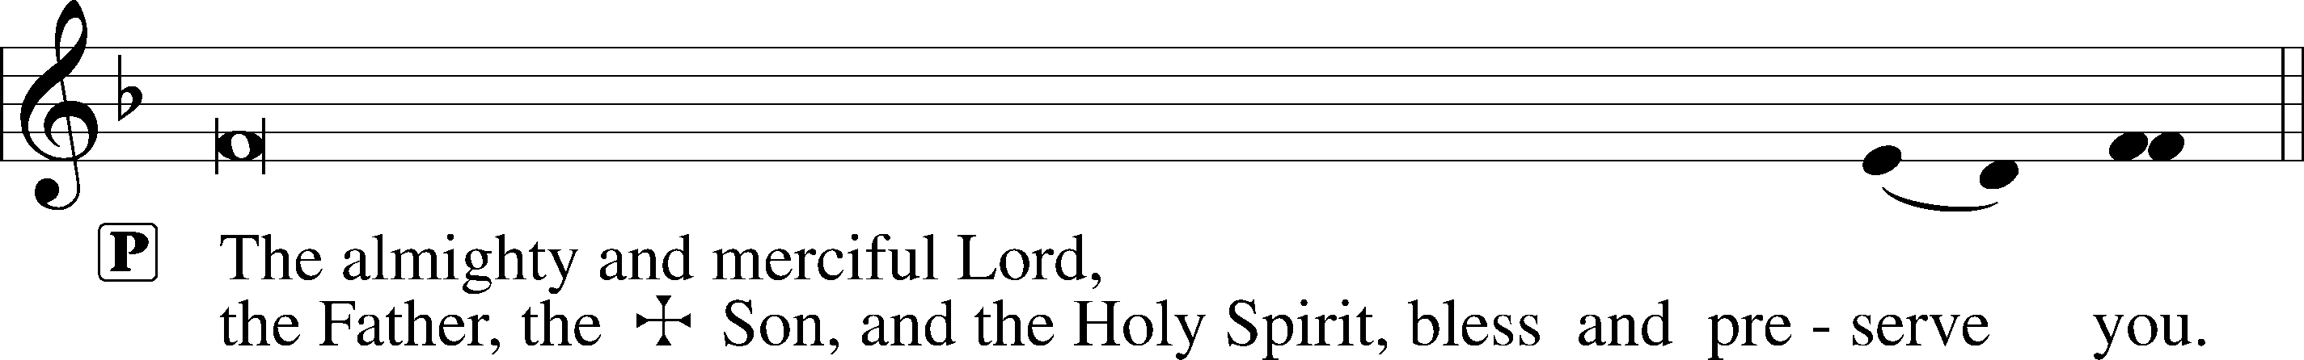

ACKNOWLEDGEMENTS: Evening Prayer from Lutheran Service Book Unless otherwise indicated, all scripture quotations are from The Holy Bible, English Standard Version, copyright © 2001 by Crossway Bibles, a division of Good News Publishers. Used by permission. All rights reserved. Created by Lutheran Service Builder © 2006 Concordia Publishing House.

