THE FIRST SUNDAY AFTER CHRISTMAS

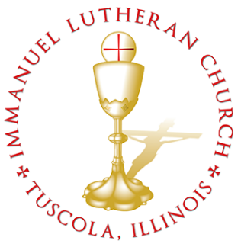
THE FIRST SUNDAY AFTER CHRISTMAS

Today we celebrate the Sacrament of our Lord Jesus Christ’s true body and blood. Since receiving the Lord’s Supper expresses fellowship with the Lord and agreement with the teaching of the pastor and congregation, we follow the Biblical practice of closed communion. All guests are kindly asked to speak with Pastor Braaten before communing at our altar. Normally, members from congregations of The Lutheran Church—Missouri Synod are welcome to partake, as are people from churches in fellowship with the LCMS.
WELCOME VISITORS

Divine Service, Setting Three with Holy Communion
Stand
The PROCESSIONAL HYMN LSB 375 Come, Your Hearts and Voices Raising
(See Page 16)
The INVOCATION, CONFESSION, and ABSOLUTION LSB 184
P In the name of the Father and of the T Son and of the Holy Spirit.
C Amen.
P Beloved in the Lord! Let us draw near with a true heart and confess our sins unto God our Father, beseeching Him in the name of our Lord Jesus Christ to grant us forgiveness.
P Our help is in the name of the Lord,
C who made heaven and earth.
P I said, I will confess my transgressions unto the Lord,
C and You forgave the iniquity of my sin.
P O almighty God, merciful Father,
C I, a poor, miserable sinner, confess unto You all my sins and iniquities with which I have ever offended You and justly deserved Your temporal and eternal punishment. But I am heartily sorry for them and sincerely repent of them, and I pray You of Your boundless mercy and for the sake of the holy, innocent, bitter sufferings and death of Your beloved Son, Jesus Christ, to be gracious and merciful to me, a poor, sinful being.

P Upon this your confession, I, by virtue of my office, as a called and ordained servant of the Word, announce the grace of God unto all of you, and in the stead and by the command of my Lord Jesus Christ I forgive you all your sins in the name of the Father and of the T Son and of the Holy Spirit.
C Amen.
The INTROIT Ps. 93:1, 3– 4; antiphon: Ps. 93:5, 2
Your decrees are very | trustworthy;*
holiness befits your house, O Lord, for- | evermore.
Your throne is established | from of old;*
you are from ever- | lasting.
The Lord reigns; he is robed in | majesty;*
the Lord is robed; he has put on strength | as his belt.
Yes, the world is es- | tablished;*
it shall nev- | er be moved.
The floods have lifted up, O Lord, the floods have lifted | up their voice;*
the floods lift up their | roaring.
Mightier than the thunders of many waters, mightier than the waves | of the sea,*
the Lord on high is | mighty!
Glory be to the Father and | to the Son*
and to the Holy | Spirit;
as it was in the be- | ginning,*
is now, and will be forever. | Amen.
Your decrees are very | trustworthy;*
holiness befits your house, O Lord, for- | evermore.
Your throne is established | from of old;*
you are from ever- | lasting.
The KYRIE LSB 186
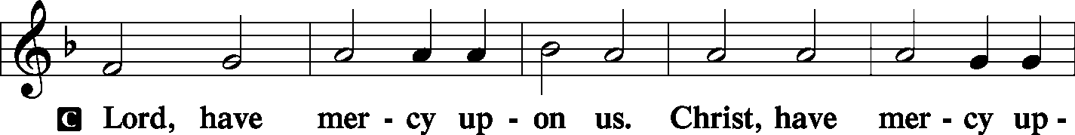
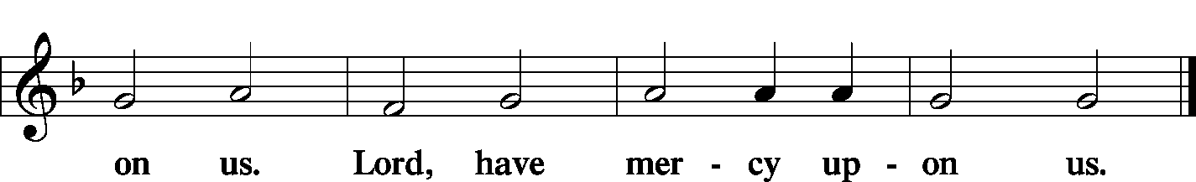
GLORIA IN EXCELSIS LSB 187–189
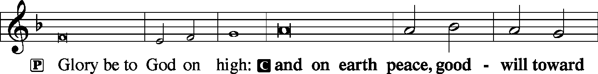
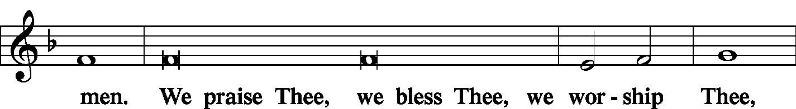
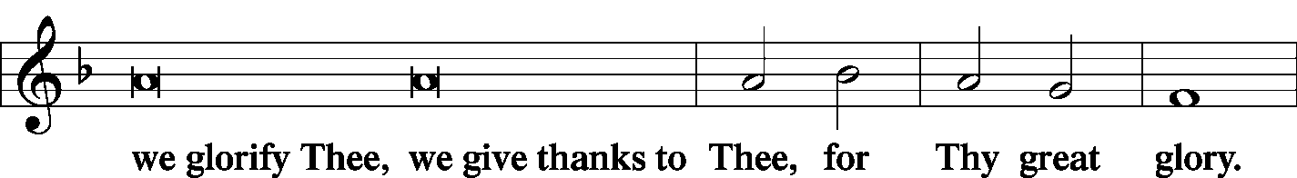
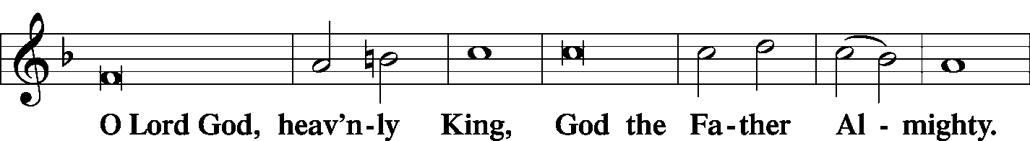
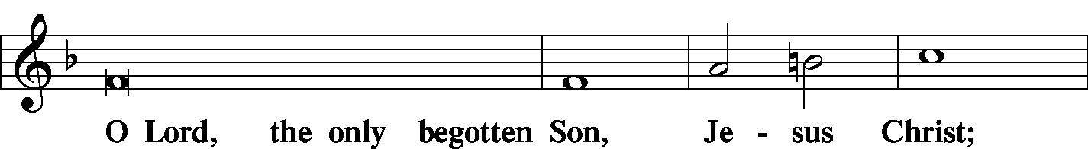
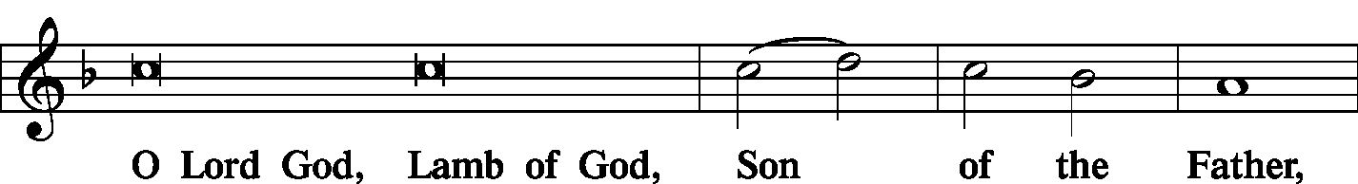
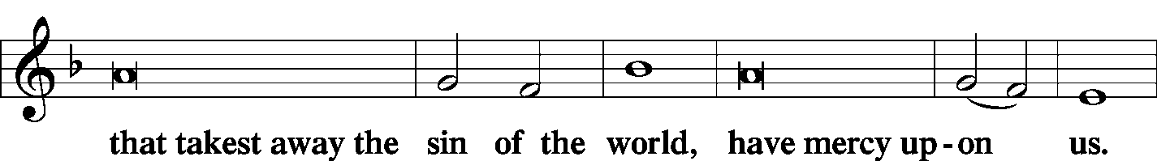
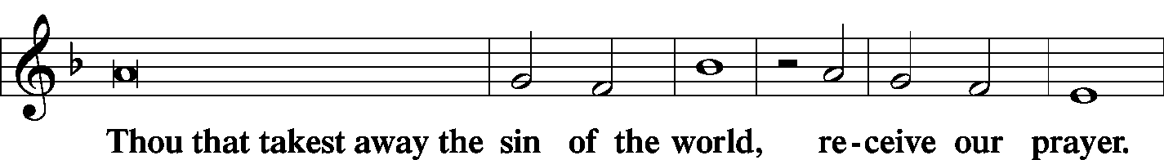
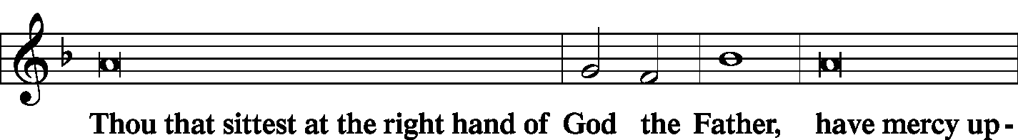
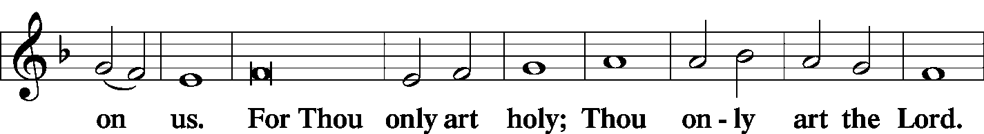
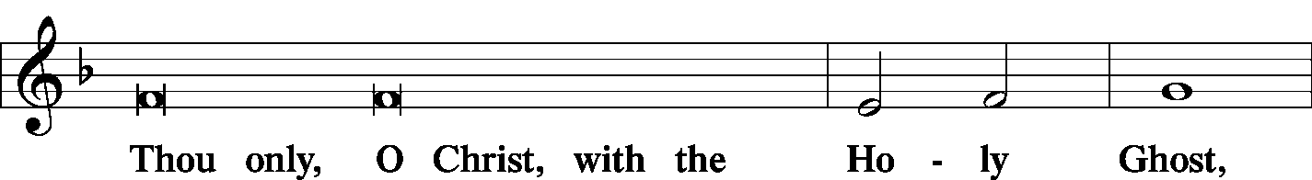
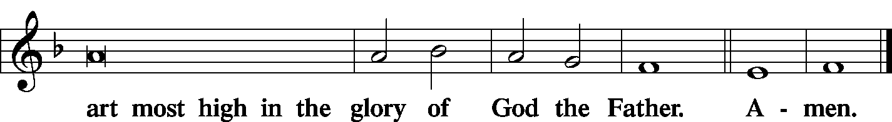

The SALUTATION and COLLECT OF THE DAY LSB 189
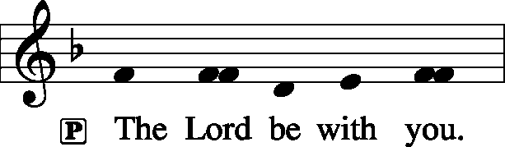
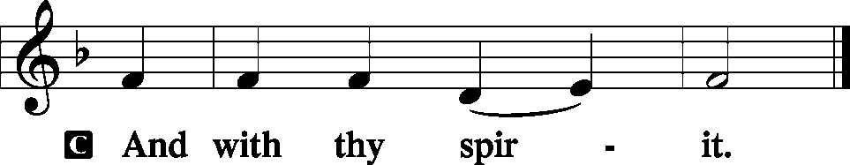
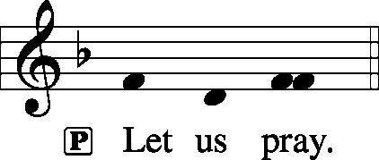
C O God, our Maker and Redeemer, You wonderfully created us and in the incarnation of Your Son yet more wondrously restored our human nature. Grant that we may ever be alive in Him who made Himself to be like us; through Jesus Christ, our Lord, who lives and reigns with You and the Holy Spirit, one God, now and forever.
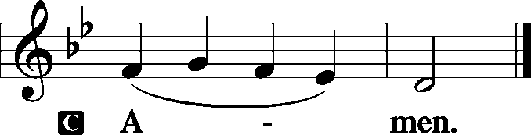
Sit

The FIRST READING Isaiah 11:1–5
There shall come forth a shoot from the stump of Jesse, and a branch from his roots shall bear fruit. And the Spirit of the Lord shall rest upon him, the Spirit of wisdom and understanding, the Spirit of counsel and might, the Spirit of knowledge and the fear of the Lord. And his delight shall be in the fear of the Lord. He shall not judge by what his eyes see, or decide disputes by what his ears hear, but with righteousness he shall judge the poor, and decide with equity for the meek of the earth; and he shall strike the earth with the rod of his mouth, and with the breath of his lips he shall kill the wicked. Righteousness shall be the belt of his waist, and faithfulness the belt of his loins.
P This is the Word of the Lord.

C Thanks be to God.
The GRADUAL Ps. 45:2a, 1b
You are the most handsome of the | sons of men;*
grace is poured up- | on your lips.
I address my verses | to the king;*
my tongue is like the pen of a | ready scribe.
The SECOND READING Galatians 4:1–7
I mean that the heir, as long as he is a child, is no different from a slave, though he is the owner of everything, but he is under guardians and managers until the date set by his father. In the same way we also, when we were children, were enslaved to the elementary principles of the world. But when the fullness of time had come, God sent forth his Son, born of woman, born under the law, to redeem those who were under the law, so that we might receive adoption as sons. And because you are sons, God has sent the Spirit of his Son into our hearts, crying, “Abba! Father!” So you are no longer a slave, but a son, and if a son, then an heir through God.
P This is the Word of the Lord.

C Thanks be to God.

Stand

The ALLELUIA LSB 190
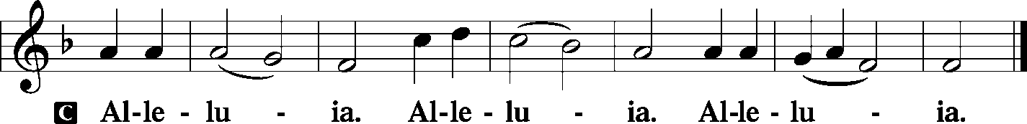
The HOLY GOSPEL St. Luke 2:33–40
P The Holy Gospel according to St. Luke, the second chapter.
C Glory be to Thee, O Lord. (Sung)
And his father and his mother marveled at what was said about him. And Simeon blessed them and said to Mary his mother, “Behold, this child is appointed for the fall and rising of many in Israel, and for a sign that is opposed (and a sword will pierce through your own soul also), so that thoughts from many hearts may be revealed.”
And there was a prophetess, Anna, the daughter of Phanuel, of the tribe of Asher. She was advanced in years, having lived with her husband seven years from when she was a virgin, and then as a widow until she was eighty-four. She did not depart from the temple, worshiping with fasting and prayer night and day. And coming up at that very hour she began to give thanks to God and to speak of him to all who were waiting for the redemption of Jerusalem.
And when they had performed everything according to the Law of the Lord, they returned into Galilee, to their own town of Nazareth. And the child grew and became strong, filled with wisdom. And the favor of God was upon him.
P This is the Gospel of the Lord.

C Praise be to Thee, O Christ. (Sung)

The NICENE CREED LSB 191
C I believe in one God,
the Father Almighty,
maker of heaven and earth
and of all things visible and invisible.

And in one Lord Jesus Christ,
the only-begotten Son of God,
begotten of His Father before all worlds,
God of God, Light of Light,
very God of very God,
begotten, not made,
being of one substance with the Father,
by whom all things were made;
who for us men and for our salvation came down from heaven
and was incarnate by the Holy Spirit of the virgin Mary
and was made man;
and was crucified also for us under Pontius Pilate.
He suffered and was buried.
And the third day He rose again according to the Scriptures
and ascended into heaven
and sits at the right hand of the Father.
And He will come again with glory to judge both the living and the dead,
whose kingdom will have no end.

And I believe in the Holy Spirit,
the Lord and giver of life,
who proceeds from the Father and the Son,
who with the Father and the Son together is worshiped and glorified,
who spoke by the prophets.
And I believe in one holy Christian and apostolic Church,
I acknowledge one Baptism for the remission of sins,
and I look for the resurrection of the dead
and the life T of the world to come. Amen.

Sit

The HYMN OF THE DAY LSB 389 Let All Together Praise Our God
(See Page 17)
The SERMON
Stand
The OFFERTORY LSB 192
Sit
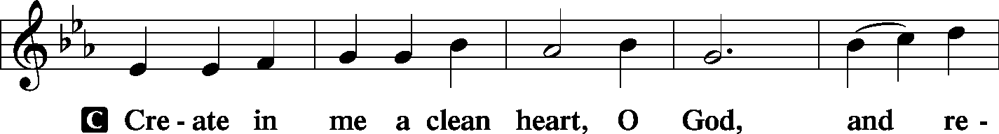
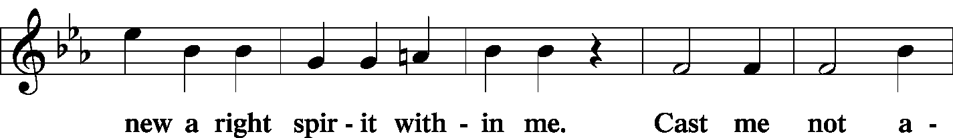
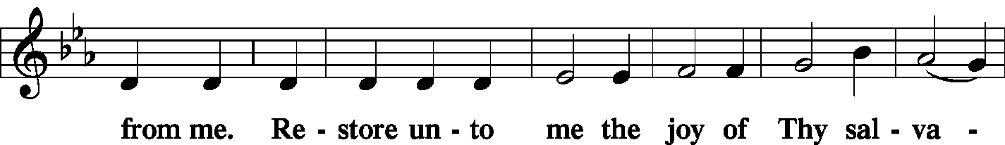
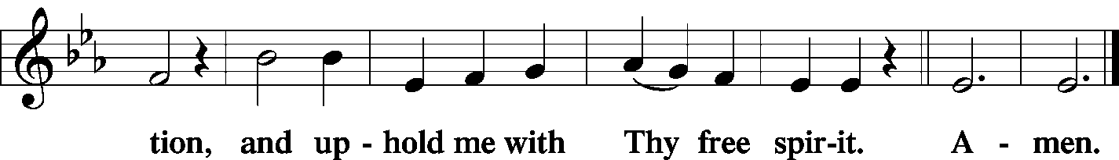
Stand

The PRAYER OF THE CHURCH
P Lord, in Your mercy.

C Hear our prayer.
The Preface and PROPER PREFACE LSB 194
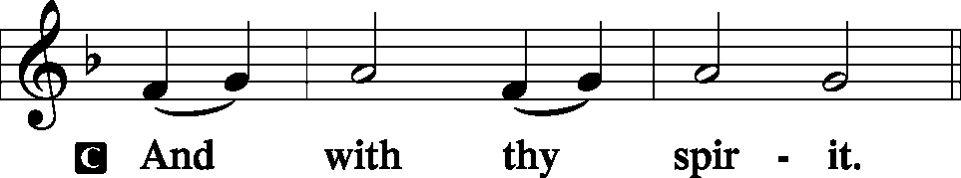
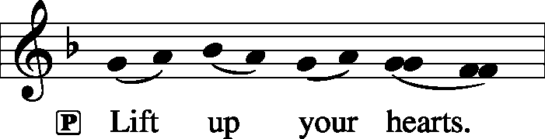
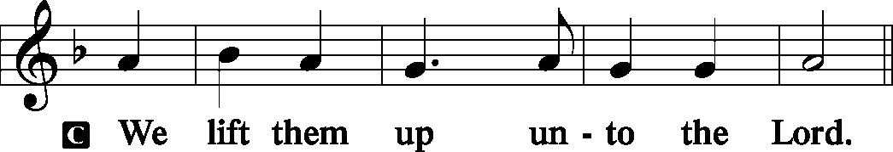
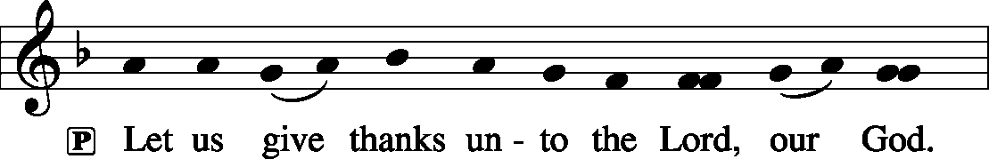
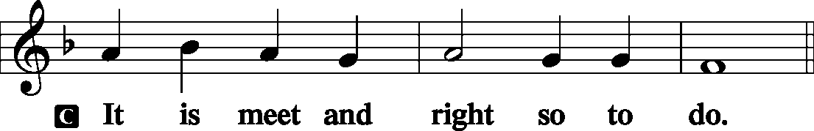
P It is truly meet, right, and salutary . . . evermore praising You and saying:
The SANCTUS LSB 195
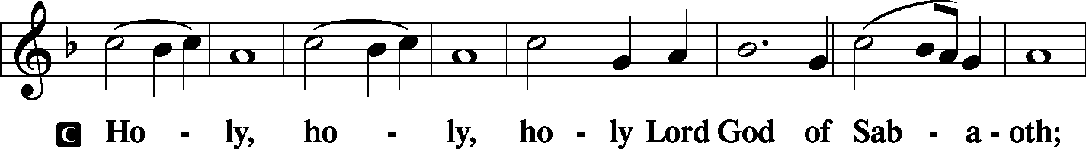
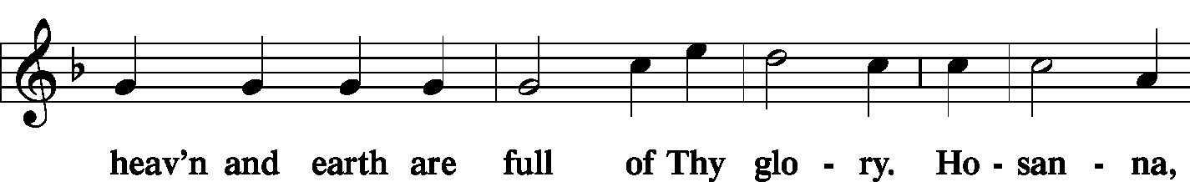
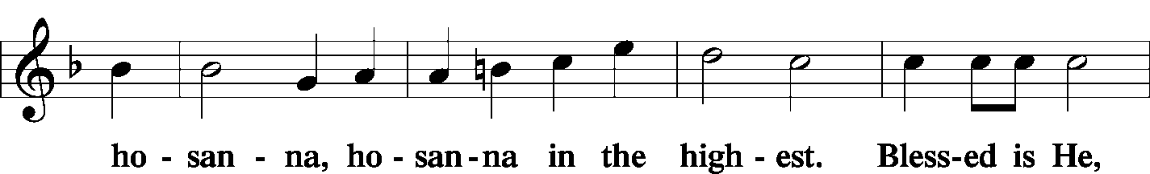
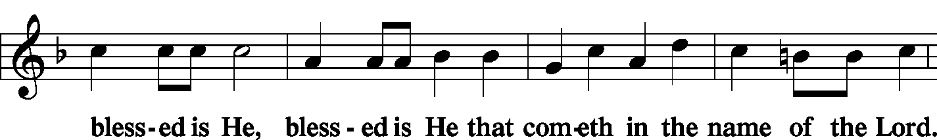
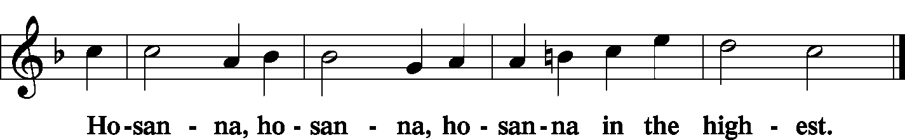
The Lord's Prayer LSB 196
C Our Father who art in heaven,
hallowed be Thy name,
Thy kingdom come,
Thy will be done on earth as it is in heaven;
give us this day our daily bread;
and forgive us our trespasses as we forgive those who trespass against us;
and lead us not into temptation,
but deliver us from evil.
For Thine is the kingdom and the power and the glory forever and ever. Amen.
The Words of Institution LSB 197
The Pax Domini LSB 197
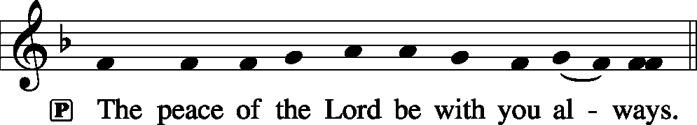
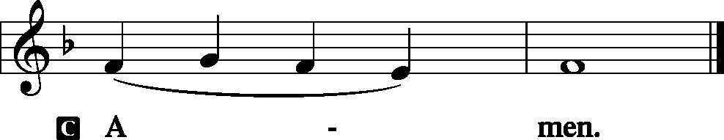
The Agnus Dei LSB 198
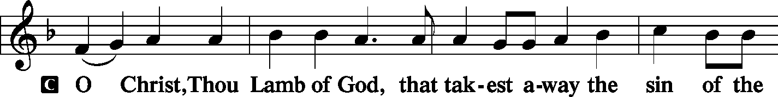
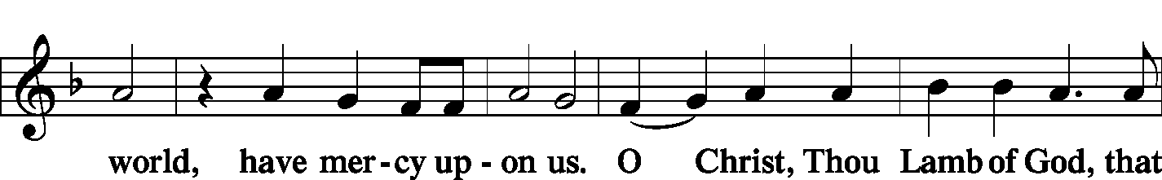
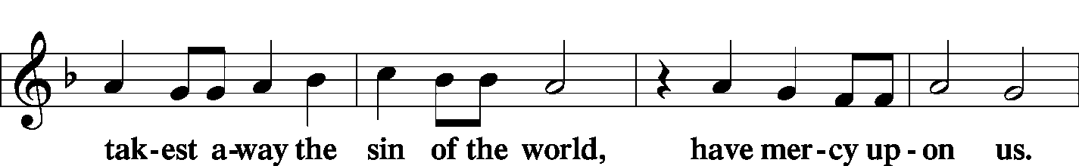
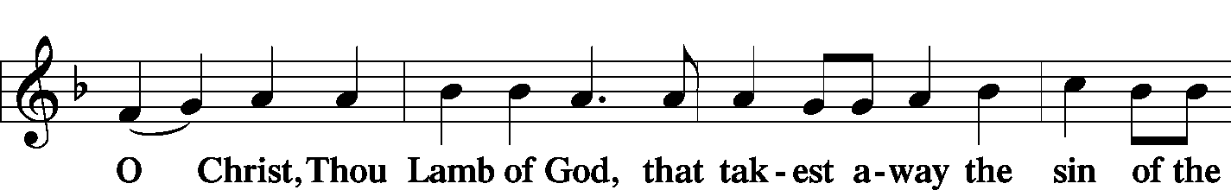
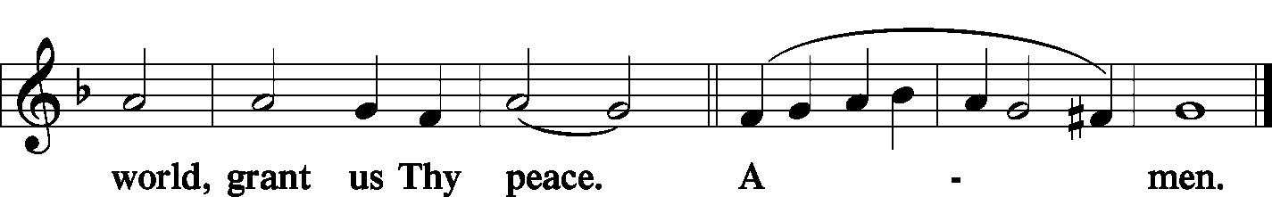
Sit
The HYMN LSB 367 Angels from the Realms of Glory
LSB 398 Hail to the Lord’s Anointed
(See PageS 18 &19)
Stand

The NUNC DIMITTIS LSB 199–200
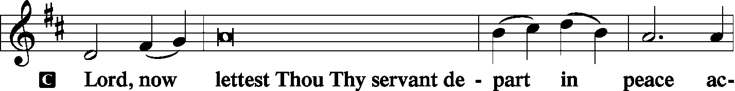
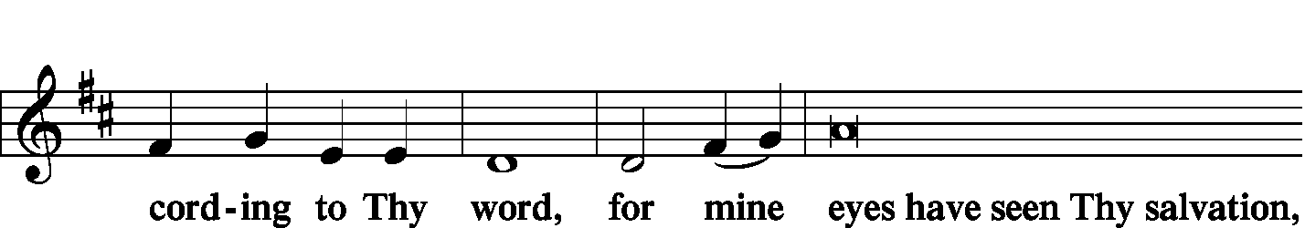
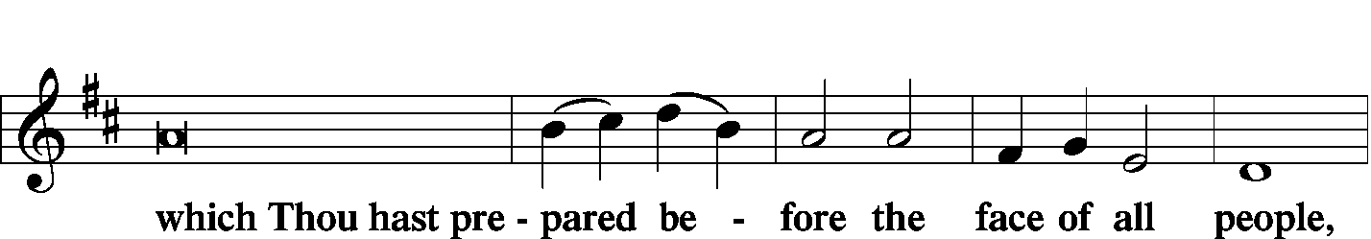
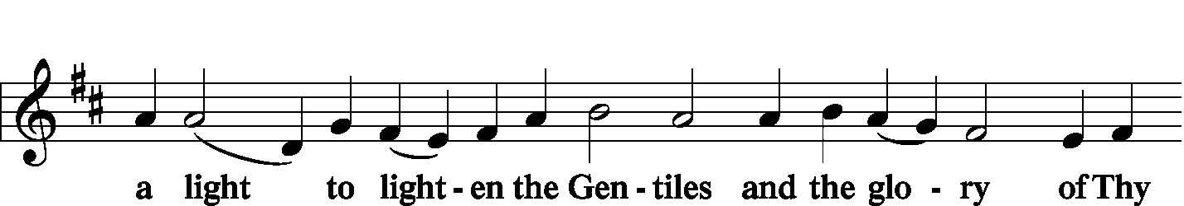
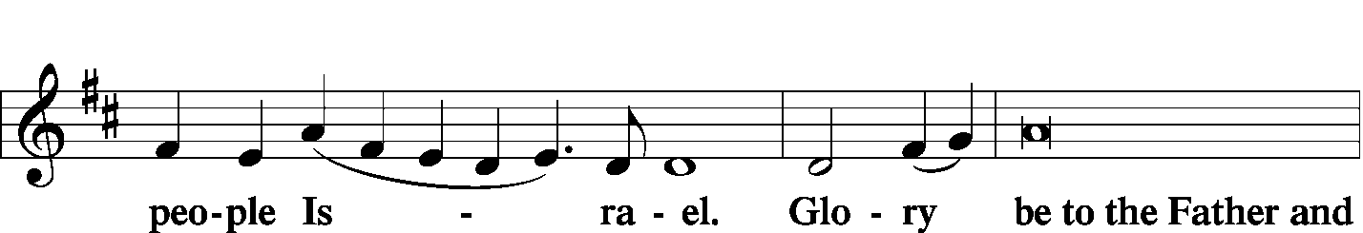
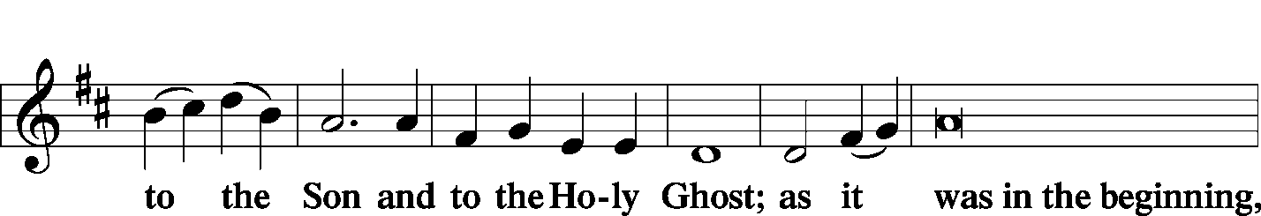
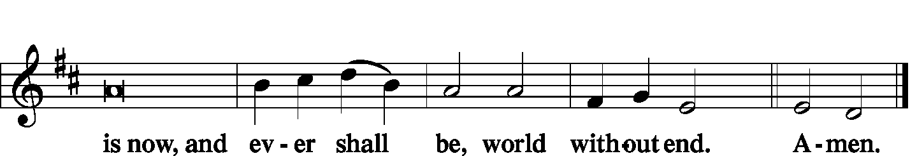

The Thanksgiving LSB 200
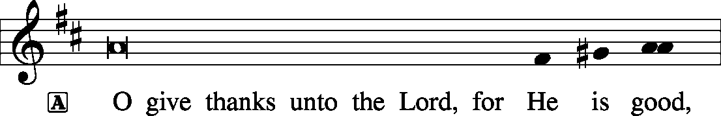
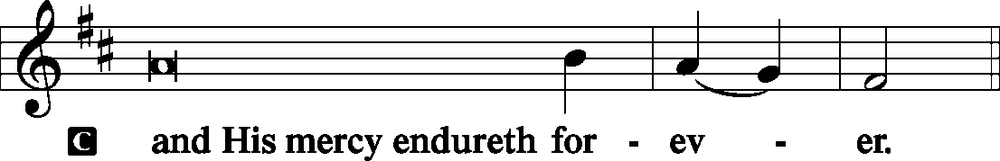
P We give thanks to You, almighty God, that You have refreshed us through this salutary gift, and we implore You that of Your mercy You would strengthen us through the same in faith toward You and fervent love toward one another; through Jesus Christ, Your Son, our Lord, who lives and reigns with You and the Holy Spirit, one God, now and forever.
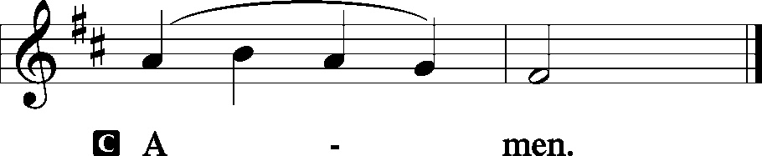
The SALUTATION, BENEDICAMUS and BENEDICTION LSB 201–202
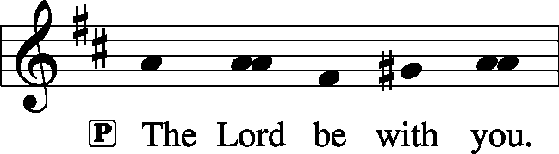
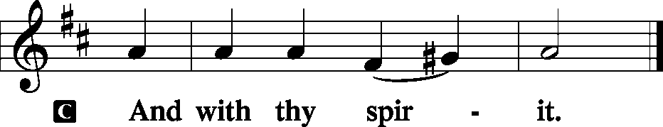
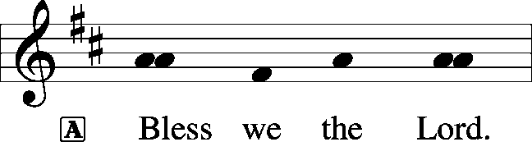
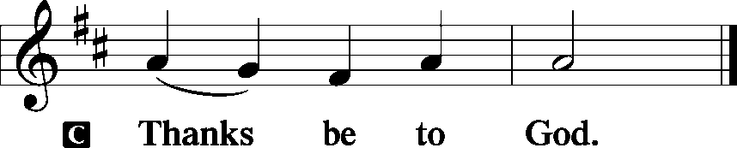
The Benediction LSB 202
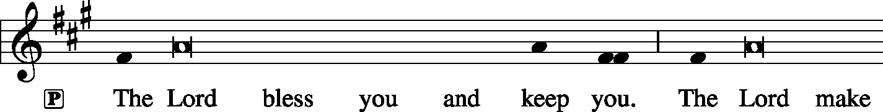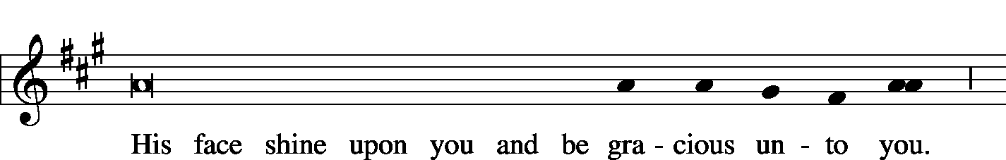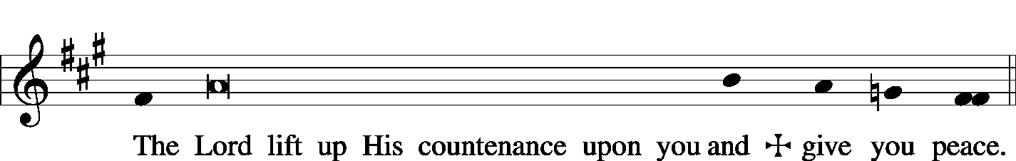
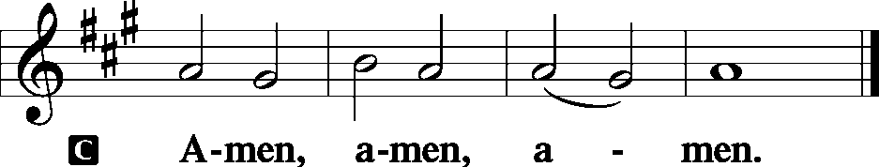

The RECESSIONAL HYMN LSB 805 Praise God, from Whom All Blessings Flow
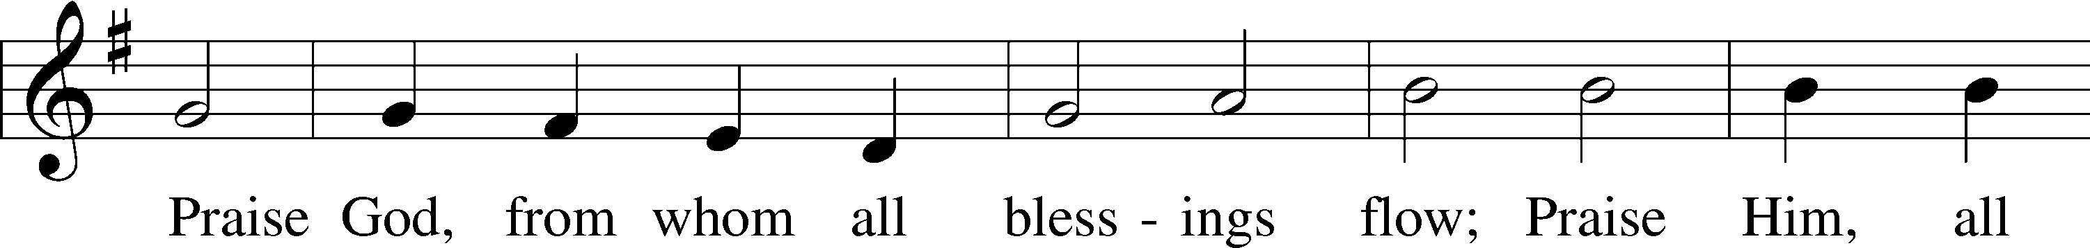
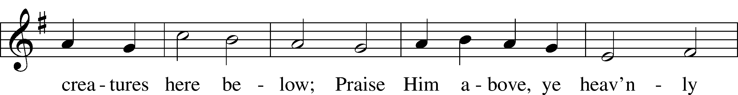
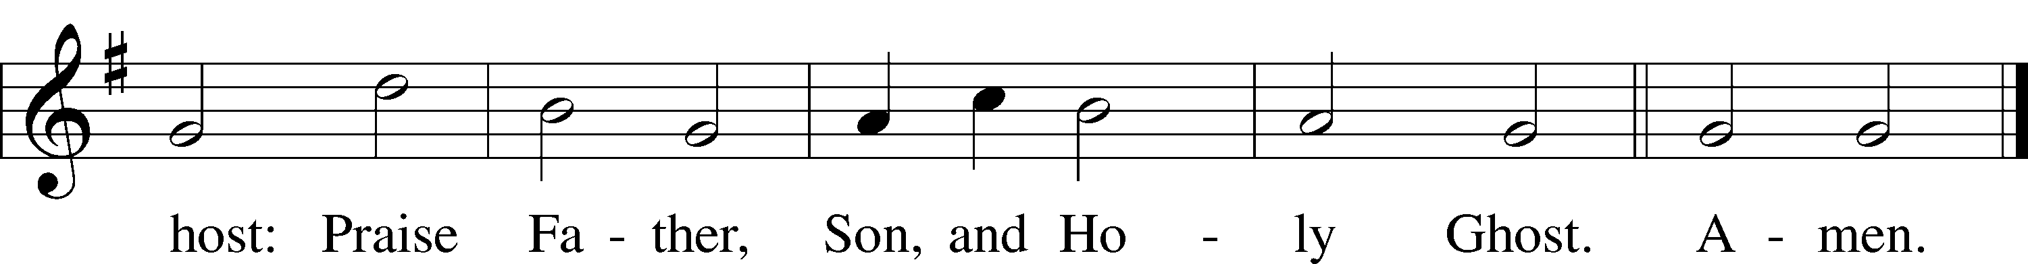
Public domain

SERVING TODAY
CELEBRANT Rev. Jason Braaten
ORGANIST Mr. Glenn Linstead
Mrs. Leigh Ann Whitson

ACKNOWLEDGEMENTS: Divine Service, Setting Three from Lutheran Service Book Unless otherwise indicated, all scripture quotations are from The Holy Bible, English Standard Version, copyright © 2001 by Crossway Bibles, a division of Good News Publishers. Used by permission. All rights reserved. Created by Lutheran Service Builder © 2006 Concordia Publishing House.

LSB 375 Come, Your Hearts and Voices Raising
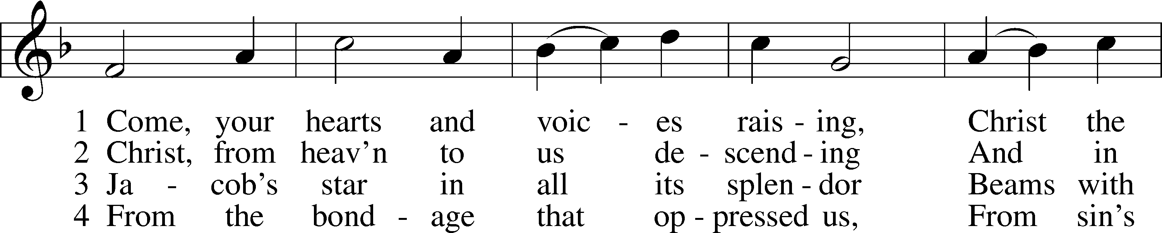
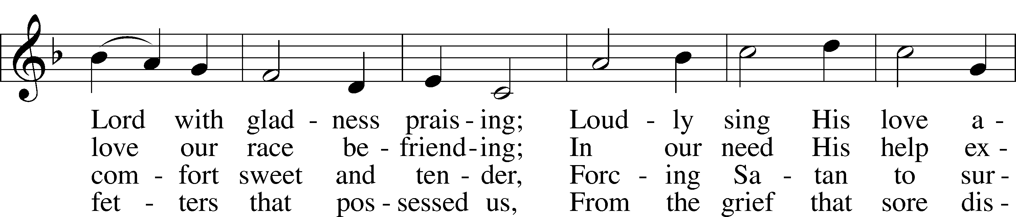
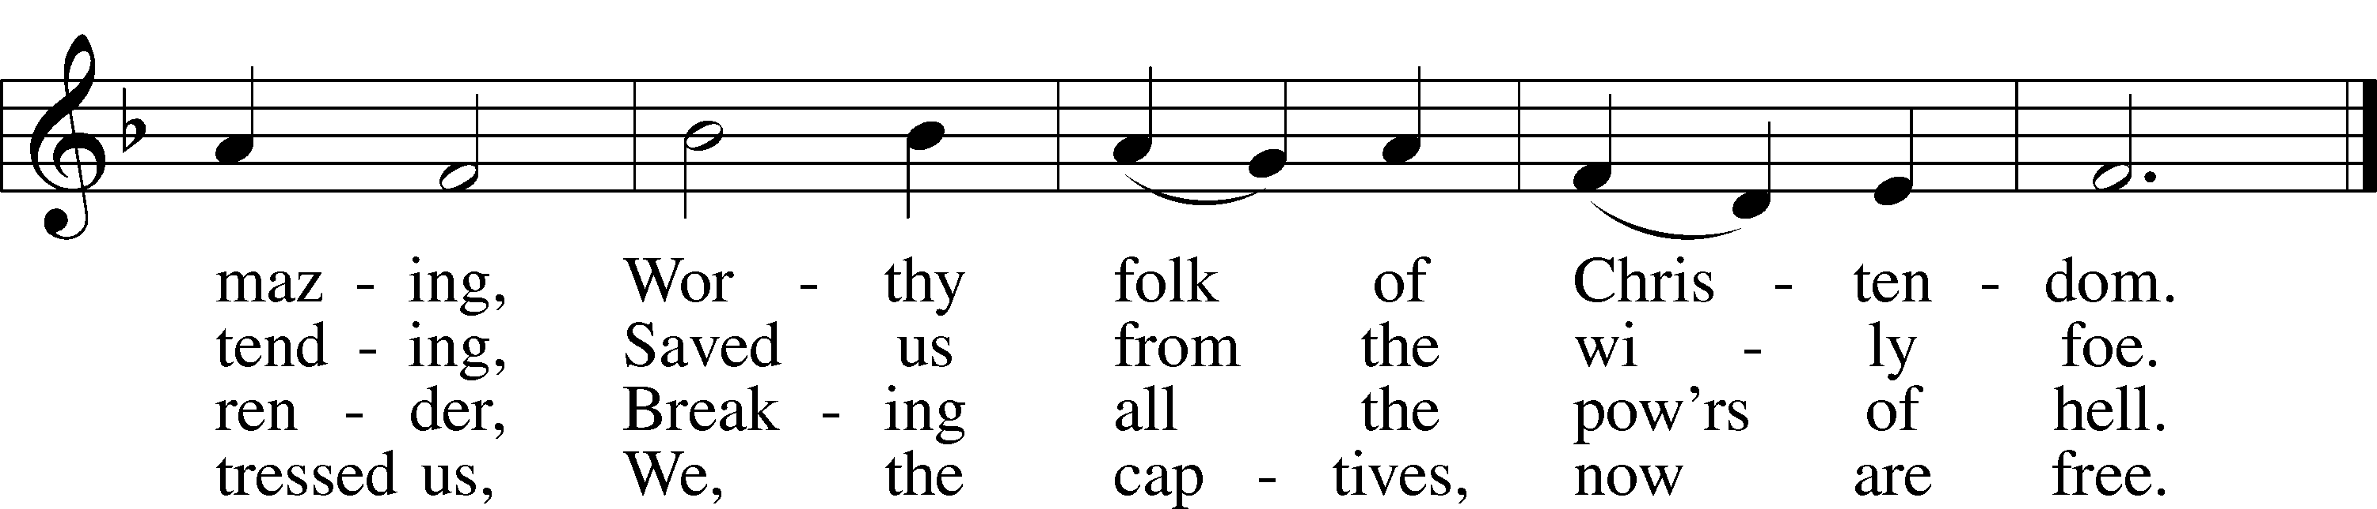

5 Oh, the joy beyond expressing
When by faith we grasp this blessing,
And to You we come confessing
That Your love has set us free.

6 Gracious Child, we pray, O hear us,
From Your lowly manger cheer us,
Gently lead us and be near us
Till we join Your choir above.
Public domain
LSB 389 Let All Together Praise Our God
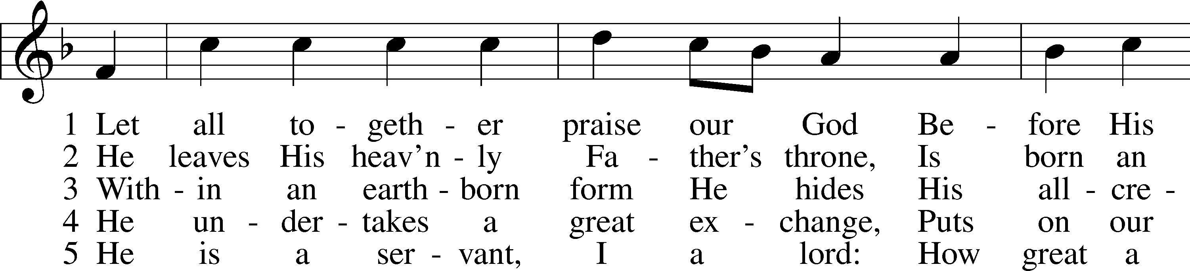
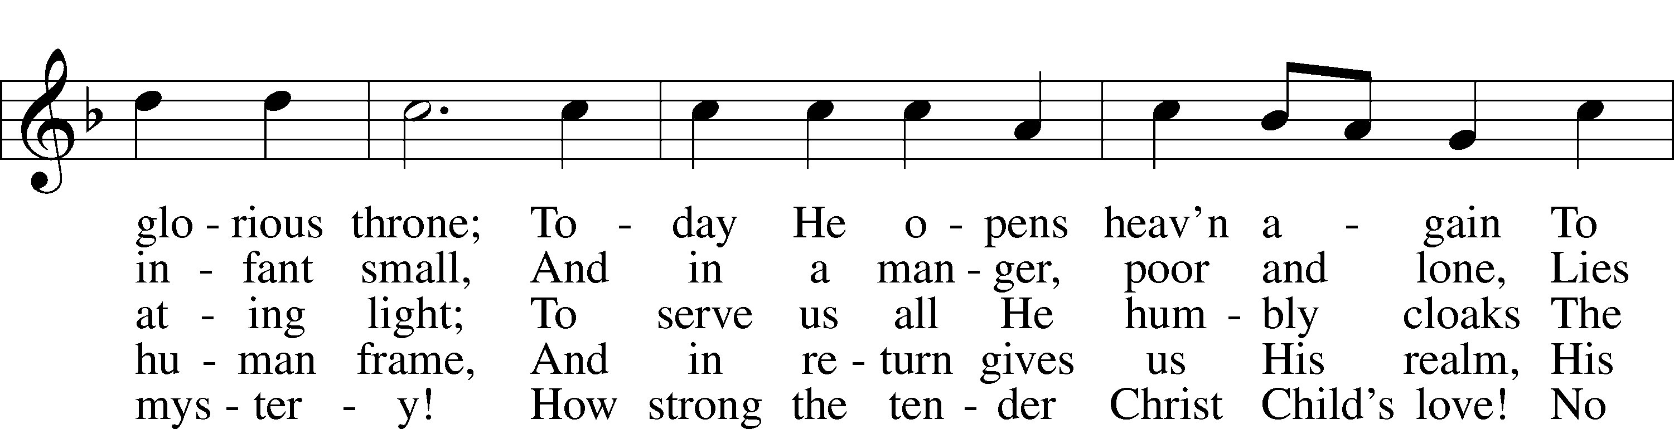
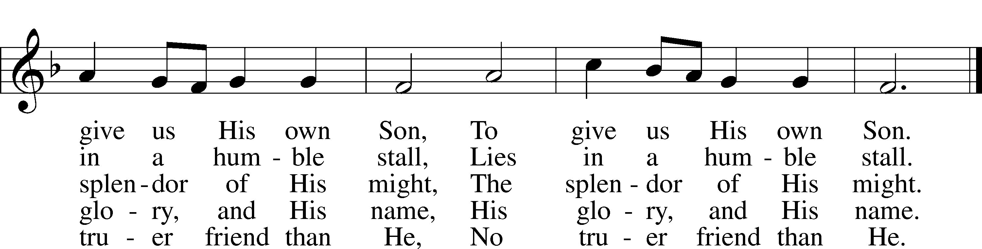

6 He is the key and He the door
To blessèd paradise;
The angel bars the way no more.
To God our praises rise,
To God our praises rise.

7 Your grace in lowliness revealed,
Lord Jesus, we adore
And praise to God the Father yield
And Spirit evermore;
We praise You evermore.
© 1969 Concordia Publishing House. Used by permission: LSB Hymn License .NET, no. 100012632.
Public domain
LSB 367 Angels from the Realms of Glory
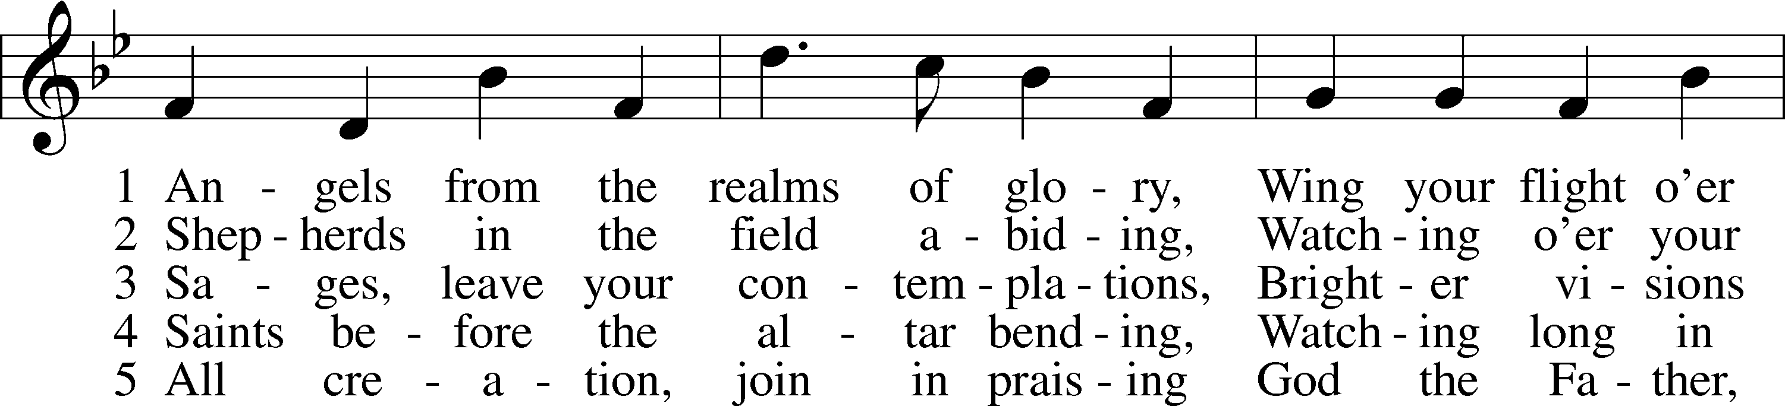
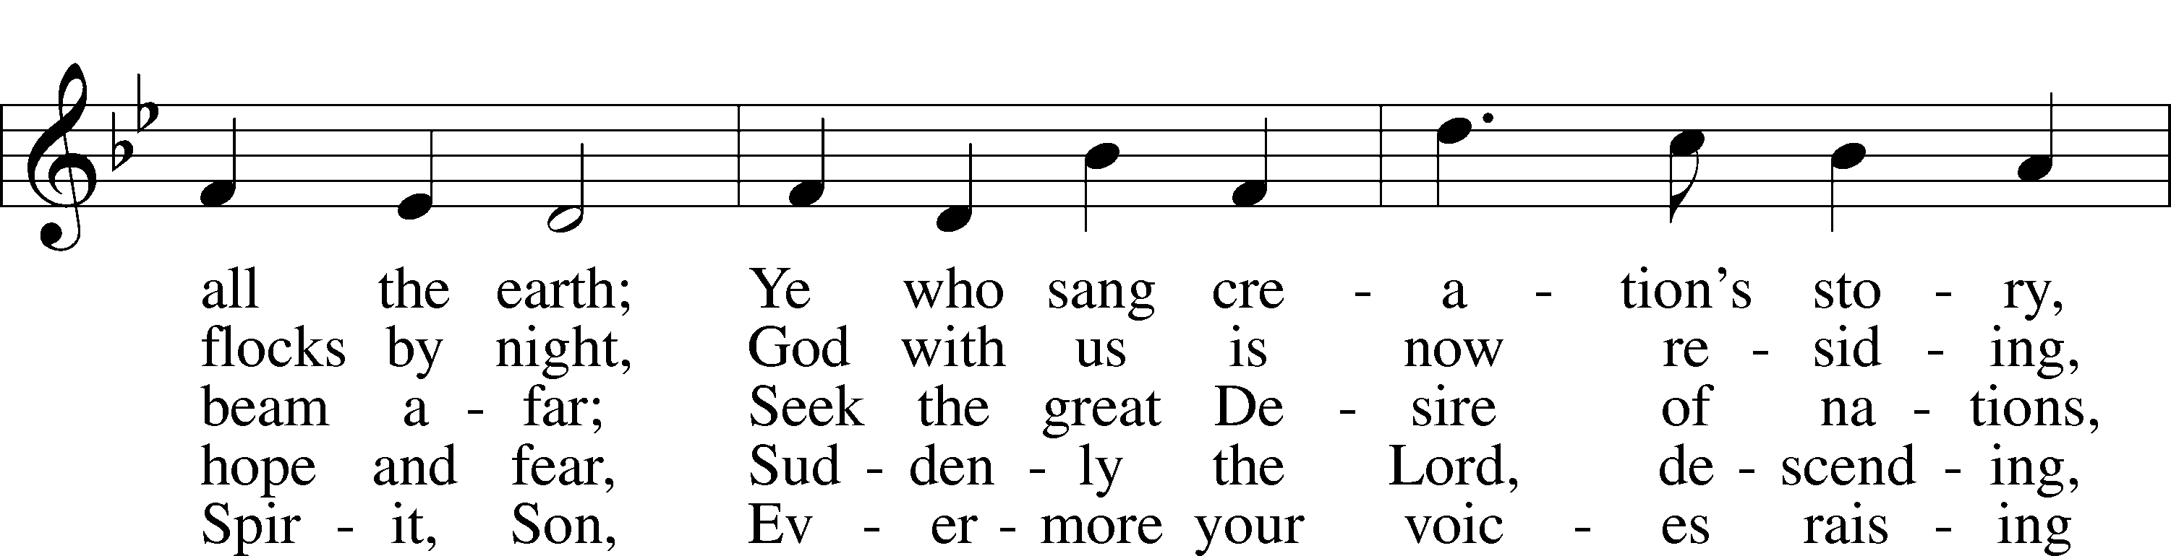
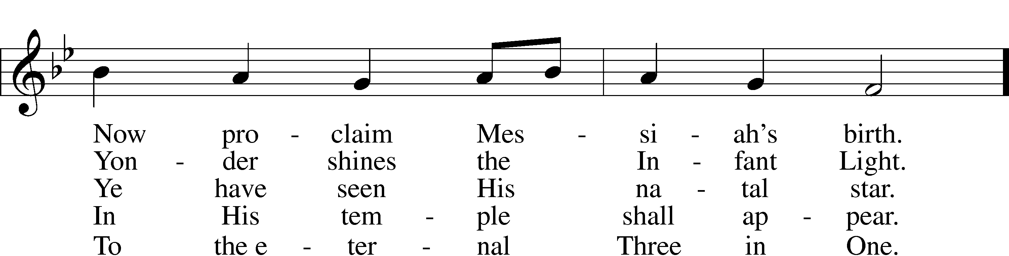
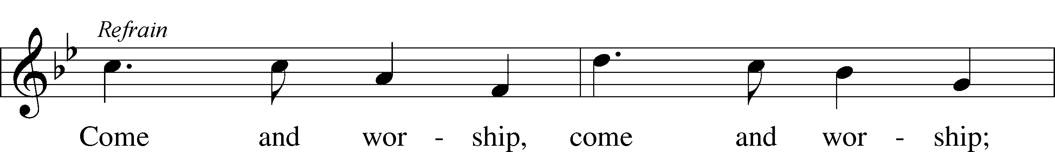
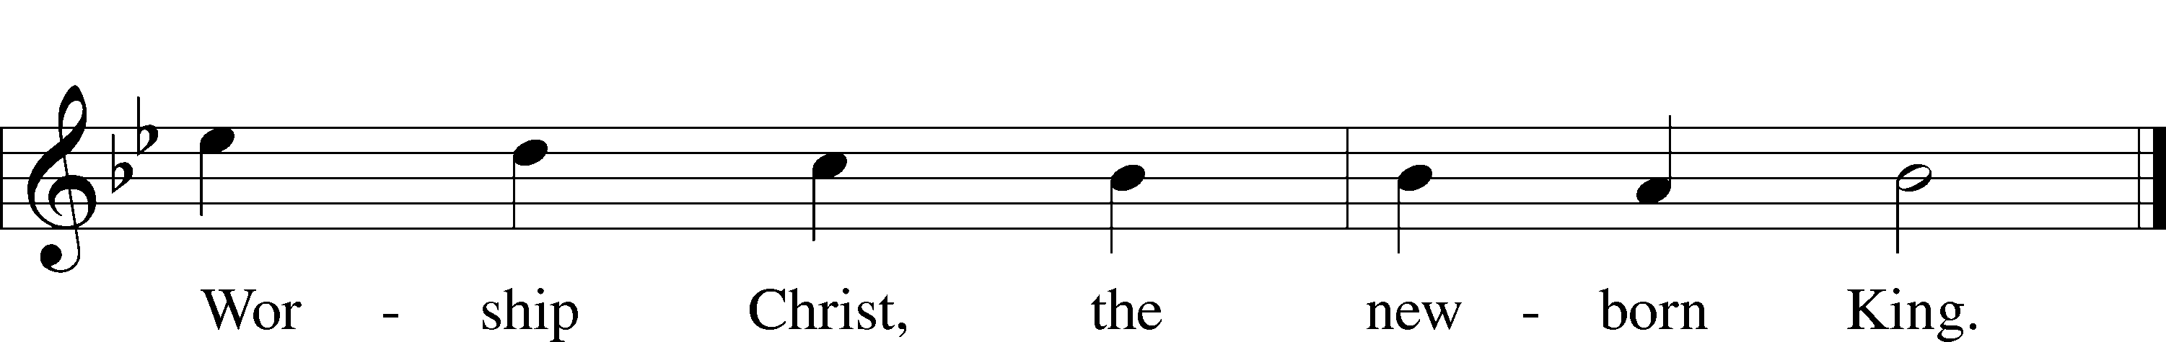
Public domain
LSB 398 Hail to the Lord's Anointed
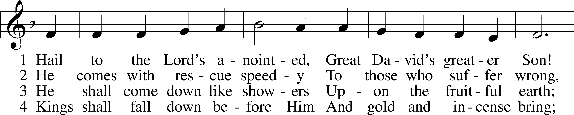
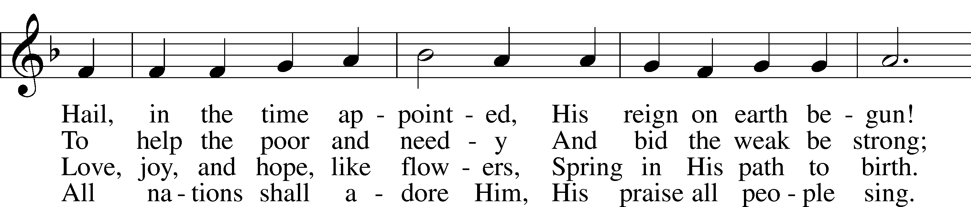
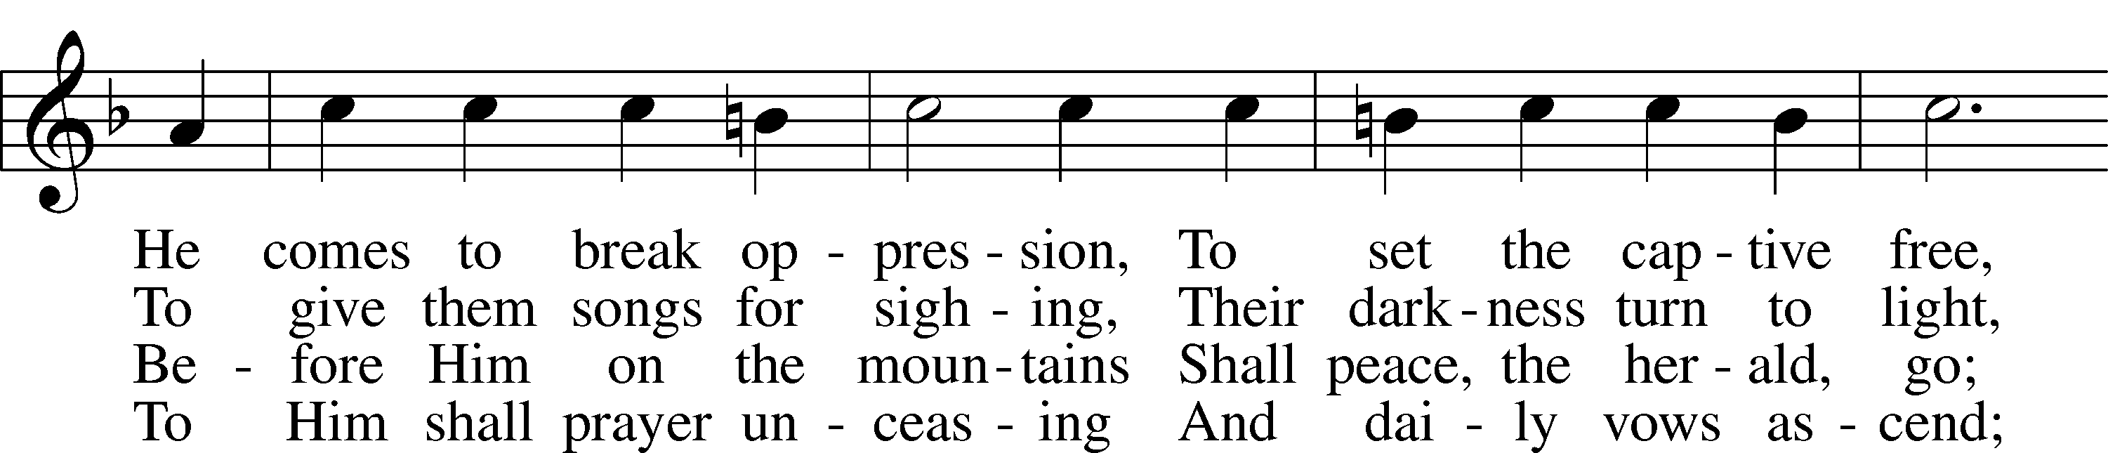
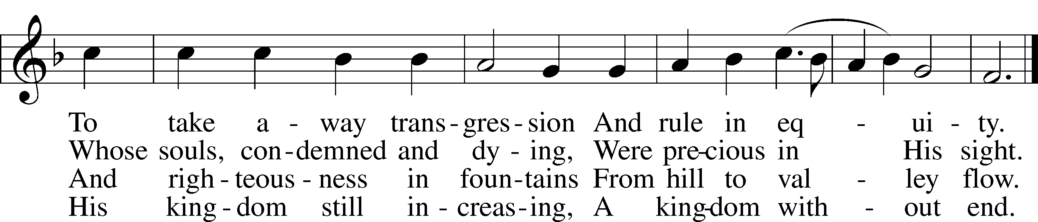

5 O’er ev’ry foe victorious,
He on His throne shall rest,
From age to age more glorious,
All blessing and all-blest.
The tide of time shall never
His covenant remove;
His name shall stand forever—
That name to us is Love.
Public domain
THIS WEEK AT IMMANUEL

Sunday (12/27) 9:00 am Divine Service with Holy Communion
10:30 am Bible Class & Sunday School
Wednesday (12/30) 12:30 PM Catechism Class
Thursday (12/31) 7:00 pm New Year’s Eve Evening Prayer Service
Saturday 3:30 pm Individual Confession & Absolution
5:30 pm Divine Service with Holy Communion
Sunday (1/3) 9:00 am Divine Service with Holy Communion
10:15 am Immanuel Officer Reception
10:30 am Bible Class & Sunday School

IN OUR PRAYERS
HEALTH CONCERNS: Bernita Ashwill; Connie Bruns (cousin of Mary Appleby); Lynn Corrie (friend of Arleigh Jones); Ellie Crawford (daughter of Laran Crawford); Whitney Czerwonka; Lynn Davis (cousin of Mark Whitson); Cindy Ekstrom; Theresa Fields; Darrell Ford; Lisa Hall (sister of Holly Wikoff); Rick Hardesty (family of the Hoels); Forrest Harvey (son of John Harvey); Kim Hausman (friend of Ann Carroll); Deanna Henningsen (sister-in-law of Jerry & Joyce Alexander); Mary Miller (friend of David Holzrichter); Kimberly Mulvany (daughter of Pastor Doug Meyer); Mary Negangard (grandmother of Bryce Reifsteck); Dennis Pickett (friend of Ann Carroll); Tim Pollock; Misti Post (niece of Sue Rothe); Cary & Beth Rahn; Joan Rahn; Aurelia Tuegal (grandmother of Bethany Campbell); Emma Silver; Dave Slaughter; Ocil Slone (grandfather of Josh & Jake Dyer); Joy Stenger; Carolyn Stremming (sister-in-law of Arleigh Jones); Brian Walker (uncle of Bryce Reifsteck); Lynn & Jane Whitson (parents of Mark Whitson).
SEMINARY STUDENT: Gunnar Campbell; Logan Smith.
DEACONESS STUDENT: Emily McLean.
MISSIONARIES: The Naumann Family; The McDermott Family, Julie Lutz
HOMEBOUND: Bernita Ashwill; Leonard Boerngen; Jim Harbaugh; Janet Pollock; Ruth Rentschler; Ruth Sims; Irene Wattjes.
MILITARY: Carl Crawford; Josh Dyer; Jeremy Gordon; Jack Leonard; Jake Lindgren; Raymond Longtin; Joey Pollock; Blake Stokes; Ruben Wilson.
THE ANNOUNCEMENTS
NEXT WEEK’S READINGS . . . Gen 46: 1–7; 1 Peters 4:12–19; Matthew 2:13–23.
ABOUT THIS WEEK’S READINGS . . A Rod has come forth from the stem of Jesse (Is. 11:1–5)—the Seed of David whose kingdom shall be established forever (2 Sam. 7:1–16). In the fullness of time, God sent forth His Son Jesus to redeem us from the judgment of the Law (Gal. 4:1–7). Now He is presented in the temple in fulfillment of the Law and revealed to be “a light for revelation to the Gentiles, and for glory to your people Israel” (Luke 2:22–40). Christ has enlightened us in baptism, giving us to be adopted as sons of God and heirs of eternal life. Receiving the Holy Sacrament of His body and blood, we are prepared to depart this world in peace, for our eyes have seen the salvation of God in Him.
THOUGHTS ABOUT STEWARDSHIP . . . Luke 2:39 “And when they had performed everything according to the Law of the Lord. . .” The Law of God is good. Of course, it always shows us our sins: but that is good, too! We need to be driven back to the forgiveness of Christ. But the Law also shows us the truly blessed way to live – as Mary and Joseph found their joy in a godly life, so should we see the Law as a guide for Christian living, as the roadmap for saying thank you to the Lord for all His grace and mercy to us.
THE FLOWERS ON THE ALTAR . . . are given by Ray & Norma Uthe to the glory of God on the occasion of their wedding anniversary.
NEW OFFICER INSTALLATION . . . will be Sunday, January 3, during the Divine Service immediately following the offering. If you are a newly-elected officer, please plan to attend. A reception will be held in the Fellowship Hall following the Divine Service to say thank you to out-going, current, and in-coming officers. Their hard work and dedication are to be commended!
POINSETTIAS . . . If you did not get your poinsettia after the Christmas Day Divine Service, you will find it in the kitchen on the counter.

PASTOR WILL BE AWAY . . . Monday, January 4, through Wednesday, January 6, to visit family for Christmas. In case of emergency, you may contact Pastor on his mobile phone, or one of the Elders: Jack Appleby, John Harvey, Bryce Reifsteck, Josh Whitson.

WE WILL BE TAKING DOWN . . . the Christmas decorations on Saturday, January 9, 9:00 am.

THE JANUARY CALENDAR . . . with birthdays and anniversaries is available on the table across from members’ mailboxes.

A PRAYER FOR RIGHT RECEPTION OF THE LORD’S SUPPER . . . O Lord, our God, in Holy baptism You have called us to be Christians and granted us the remission of sins. Make us ready to receive the most holy body and blood of Christ for the forgiveness of all our sins, and grant us grateful hearts that we may give thanks to You, O Father, to Your Son, and to the Holy Spirit, one God, now and forever.

A PRAYER FOR THANKSGIVING AFTER RECEIVING THE SACRAMENT . . . Blessed Savior, Jesus Christ, You have given Yourself to us in this holy Sacrament. Keep us in Your faith and favor that we may live in You even as You live in us. May Your body and blood preserve us in the true faith to life everlasting. Hear us for the sake of Your name.

A PRAYER FOR IMMANUEL
Rev. Jason Braaten, Pastor
Home: (217) 253-4539
Mobile: (217) 460-2077
Email: pastor.braaten@gmail.com
Office Hours:
Monday–Thursday 8:00 am–12:00 pm
or by appointment

My dear Lord Jesus, I want to know You as Savior and Friend, Help me to grow into a mature disciple so that I can demonstrate God’s love and forgiveness in all I do. Teach me to share my faith in You and to serve others in my vocation. Make Immanuel Lutheran Church a place where lost and hurting people find friendship, forgiveness, and faith, and where Christians gather to serve You in love for one another, for the community, and for the world. Amen.
Debra Parsley, Office Manager
Office: (217) 253-4341
Email: immanuel.tuscola@gmail.com

Office Hours:
Monday–Tuesday 8:00 am–4:30 pm
Wednesday 8:00 am–12:30 pm

