THE FEAST OF THE
NATIVITY OF OUR LORD

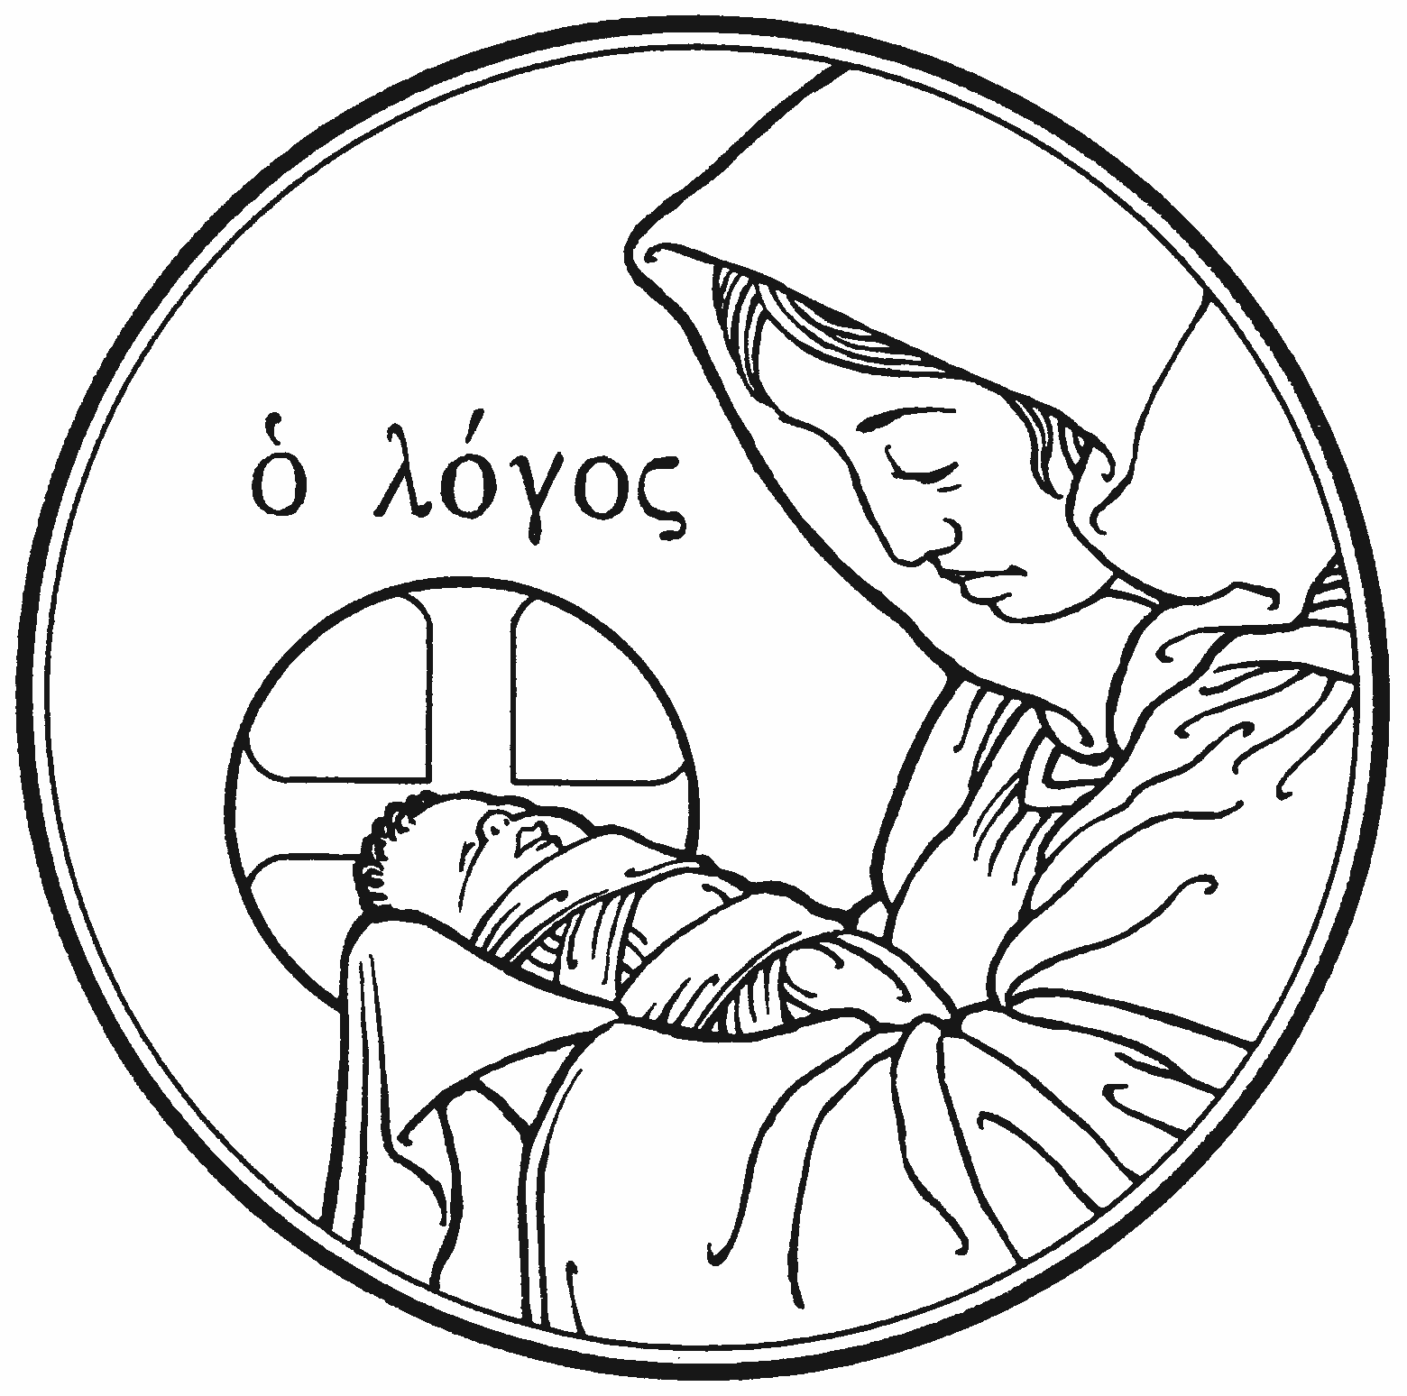

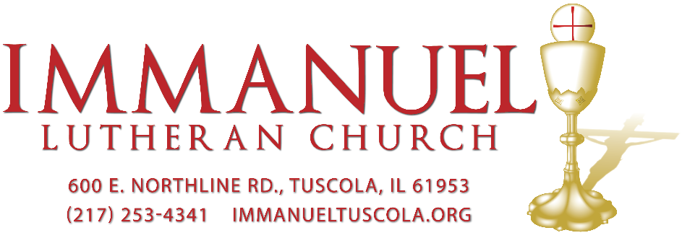
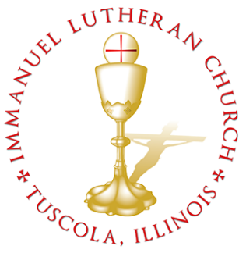
THE FEAST OF THE NATIVITY OF OUR LORD

Today we celebrate the Sacrament of our Lord Jesus Christ’s true body and blood. Since receiving the Lord’s Supper expresses fellowship with the Lord and agreement with the teaching of the pastor and congregation, we follow the Biblical practice of closed communion. All guests are kindly asked to speak with Pastor Braaten before communing at our altar. Normally, members from congregations of The Lutheran Church—Missouri Synod are welcome to partake, as are people from churches in fellowship with the LCMS.
WELCOME VISITORS

Divine Service, Setting Three with Holy Communion
Stand
The PROCESSIONAL HYMN LSB 379 O Come, All Ye Faithful
(See Page 16)
The INVOCATION, CONFESSION, and ABSOLUTION LSB 184
P In the name of the Father and of the T Son and of the Holy Spirit.
C Amen.
P Beloved in the Lord! Let us draw near with a true heart and confess our sins unto God our Father, beseeching Him in the name of our Lord Jesus Christ to grant us forgiveness.
P Our help is in the name of the Lord,
C who made heaven and earth.
P I said, I will confess my transgressions unto the Lord,
C and You forgave the iniquity of my sin.
P O almighty God, merciful Father,
C I, a poor, miserable sinner, confess unto You all my sins and iniquities with which I have ever offended You and justly deserved Your temporal and eternal punishment. But I am heartily sorry for them and sincerely repent of them, and I pray You of Your boundless mercy and for the sake of the holy, innocent, bitter sufferings and death of Your beloved Son, Jesus Christ, to be gracious and merciful to me, a poor, sinful being.
P Upon this your confession, I, by virtue of my office, as a called and ordained servant of the Word, announce the grace of God unto all of you, and in the stead and by the command of my Lord Jesus Christ I forgive you all your sins in the name of the Father and of the T Son and of the Holy Spirit.
C Amen.
The INTROIT Ps. 98:1– 4; antiphon: Is. 9:6
For to us a child is born, to us a son is | given;*
and the government shall be upon his | shoulder,
and his name shall be called Wonderful | Counselor,*
Mighty God, Everlasting Father, | Prince of Peace.
Oh sing to the Lord a new song, for he has done | marvelous things!*
His right hand and his holy arm have worked salva- | tion for him.
The Lord has made known his sal- | vation;*
he has revealed his righteousness in the sight of the | nations.
He has remembered his steadfast love and faithfulness to the
house of | Israel.*
All the ends of the earth have seen the salvation | of our God.
Make a joyful noise to the Lord, | all the earth;*
break forth into joyous song and sing | praises!
Glory be to the Father and | to the Son*
and to the Holy | Spirit;
as it was in the be- | ginning,*
is now, and will be forever. | Amen.
For to us a child is born, to us a son is | given;*
and the government shall be upon his | shoulder,
and his name shall be called Wonderful | Counselor,*
Mighty God, Everlasting Father, | Prince of Peace.

The KYRIE LSB 186
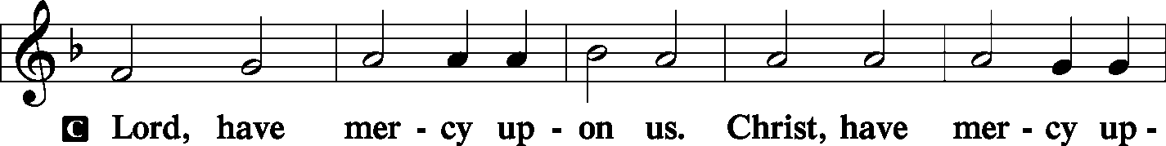
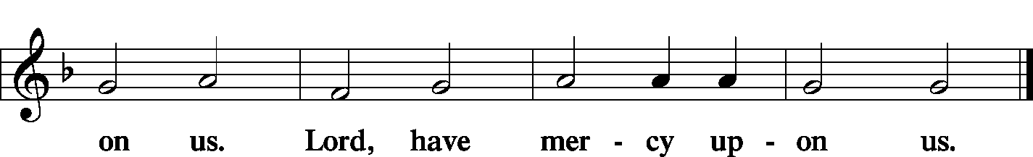
The GLORIA IN EXCELSIS LSB 187–189
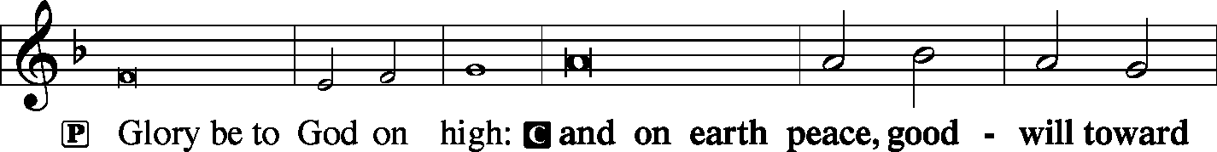
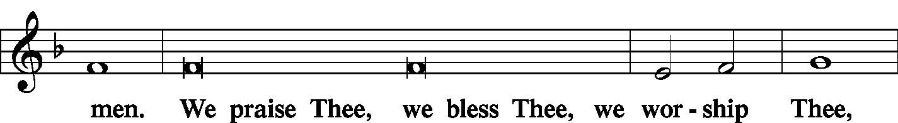
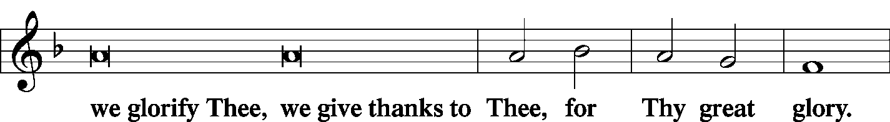
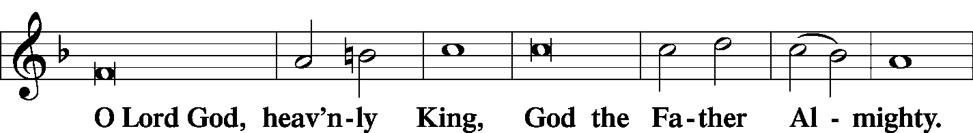
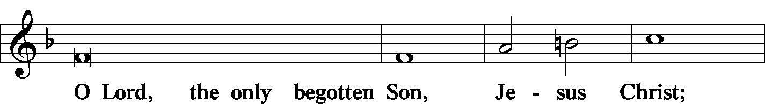
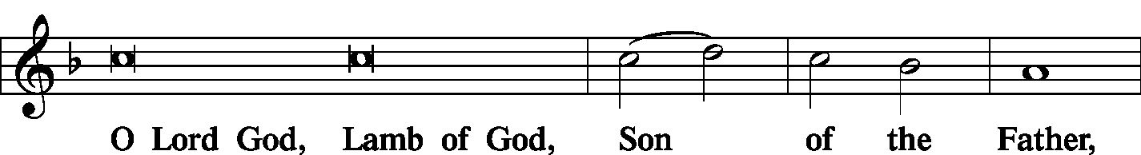
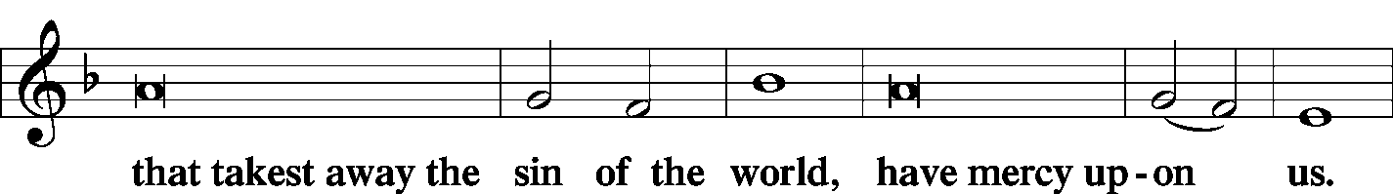
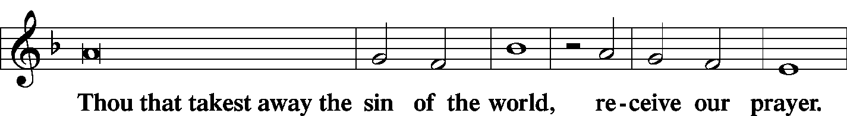
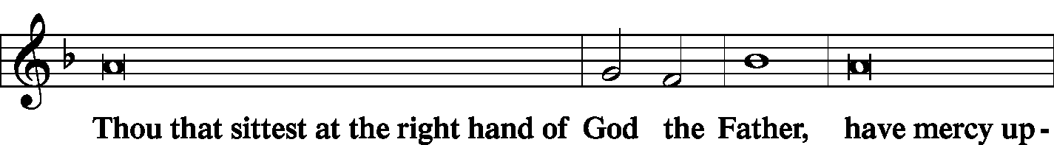
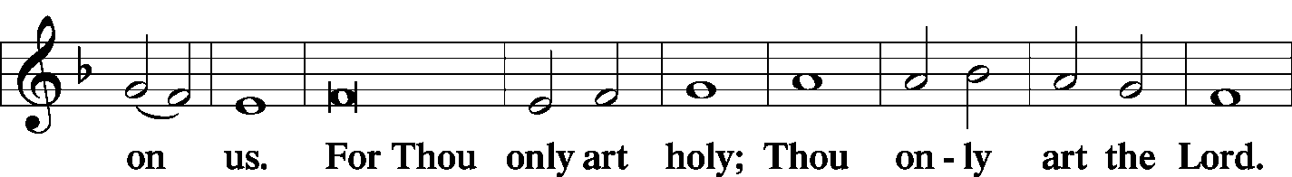
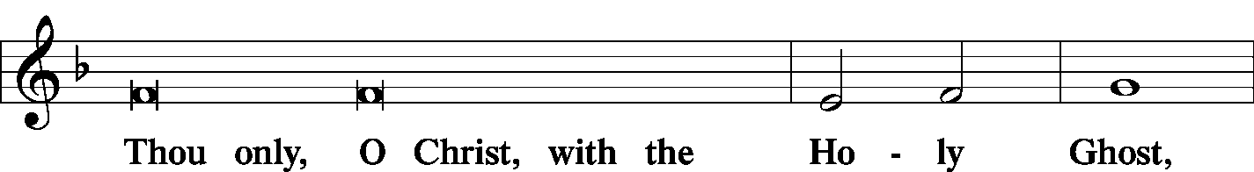
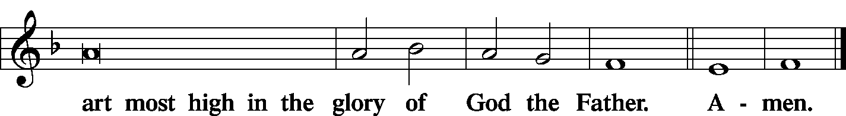

The SALUTATION and COLLECT OF THE DAY LSB 189
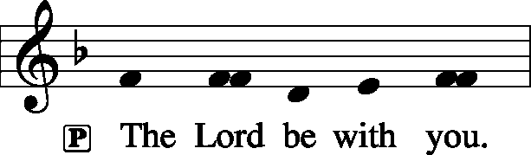
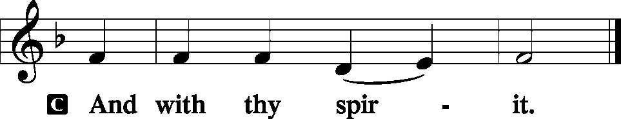
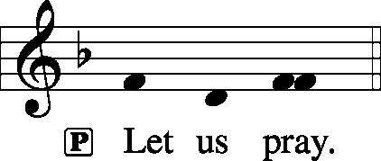
C Almighty God, grant that the birth of Your only-begotten Son in the flesh may set us free from the bondage of sin; through Jesus Christ, Your Son, our Lord, who lives and reigns with You and the Holy Spirit, one God, now and forever.
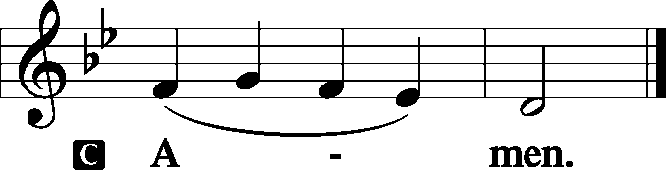
Sit
The FIRST READING Exodus 40:17–21, 34–38
In the first month in the second year, on the first day of the month, the tabernacle was erected. Moses erected the tabernacle. He laid its bases, and set up its frames, and put in its poles, and raised up its pillars. And he spread the tent over the tabernacle and put the covering of the tent over it, as the Lord had commanded Moses. He took the testimony and put it into the ark, and put the poles on the ark and set the mercy seat above on the ark. And he brought the ark into the tabernacle and set up the veil of the screen, and screened the ark of the testimony, as the Lord had commanded Moses.
Then the cloud covered the tent of meeting, and the glory of the Lord filled the tabernacle. And Moses was not able to enter the tent of meeting because the cloud settled on it, and the glory of the Lord filled the tabernacle. Throughout all their journeys, whenever the cloud was taken up from over the tabernacle, the people of Israel would set out. But if the cloud was not taken up, then they did not set out till the day that it was taken up. For the cloud of the Lord was on the tabernacle by day, and fire was in it by night, in the sight of all the house of Israel throughout all their journeys.
P This is the Word of the Lord.

C Thanks be to God.
The GRADUAL Psalm 118:26a, 27a, 23
Blessèd is he who comes in the name | of the Lord!*
The Lord is God, and he has made his light to shine up- | on us.
This is the Lord’s | doing;*
it is marvelous | in our eyes.
The SECOND READING Titus 3:4–7
But when the goodness and loving kindness of God our Savior appeared, he saved us, not because of works done by us in righteousness, but according to his own mercy, by the washing of regeneration and renewal of the Holy Spirit, whom he poured out on us richly through Jesus Christ our Savior, so that being justified by his grace we might become heirs according to the hope of eternal life.
P This is the Word of the Lord.

C Thanks be to God.

Stand
The ALLELUIA LSB 190
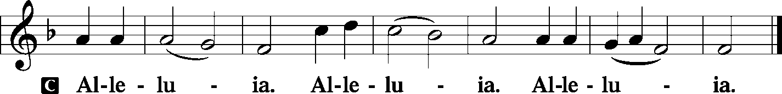
The HOLY GOSPEL St. John 1:1–14
P The Holy Gospel according to St. John, the first chapter.
C Glory be to Thee, O Lord. (Sung)
In the beginning was the Word, and the Word was with God, and the Word was God. He was in the beginning with God. All things were made through him, and without him was not anything made that was made. In him was life, and the life was the light of men. The light shines in the darkness, and the darkness has not overcome it.
There was a man sent from God, whose name was John. He came as a witness, to bear witness about the light, that all might believe through him. He was not the light, but came to bear witness about the light.
The true light, which enlightens everyone, was coming into the world. He was in the world, and the world was made through him, yet the world did not know him. He came to his own, and his own people did not receive him. But to all who did receive him, who believed in his name, he gave the right to become children of God, who were born, not of blood nor of the will of the flesh nor of the will of man, but of God.
And the Word became flesh and dwelt among us, and we have seen his glory, glory as of the only Son from the Father, full of grace and truth.
P This is the Gospel of the Lord.

C Praise be to Thee, O Christ. (Sung)

The NICENE CREED LSB 191
C I believe in one God,
the Father Almighty,
maker of heaven and earth
and of all things visible and invisible.

And in one Lord Jesus Christ,
the only-begotten Son of God,
begotten of His Father before all worlds,
God of God, Light of Light,
very God of very God,
begotten, not made,
being of one substance with the Father,
by whom all things were made;
who for us men and for our salvation came down from heaven
and was incarnate by the Holy Spirit of the virgin Mary
and was made man;
and was crucified also for us under Pontius Pilate.
He suffered and was buried.
And the third day He rose again according to the Scriptures
and ascended into heaven
and sits at the right hand of the Father.
And He will come again with glory to judge both the living and the dead,
whose kingdom will have no end.

And I believe in the Holy Spirit,
the Lord and giver of life,
who proceeds from the Father and the Son,
who with the Father and the Son together is worshiped and glorified,
who spoke by the prophets.
And I believe in one holy Christian and apostolic Church,
I acknowledge one Baptism for the remission of sins,
and I look for the resurrection of the dead
and the life T of the world to come. Amen.

Sit

The HYMN OF THE DAY LSB 387 Joy to the World
(See Page 17)
The SERMON
Stand
The OFFERTORY LSB 192
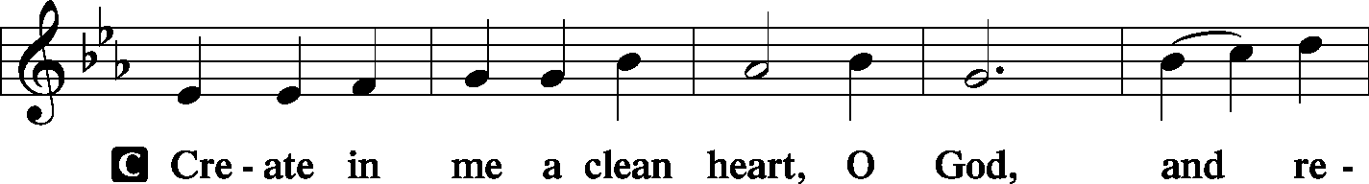
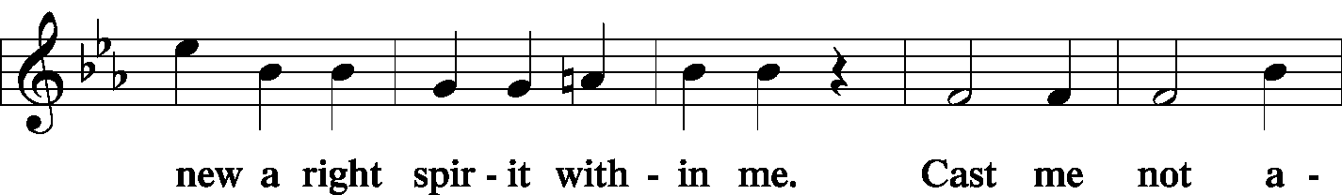
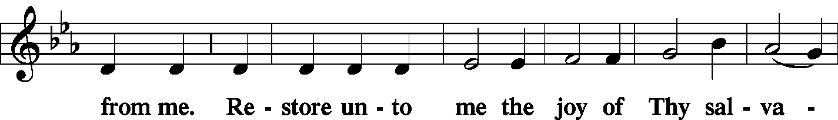
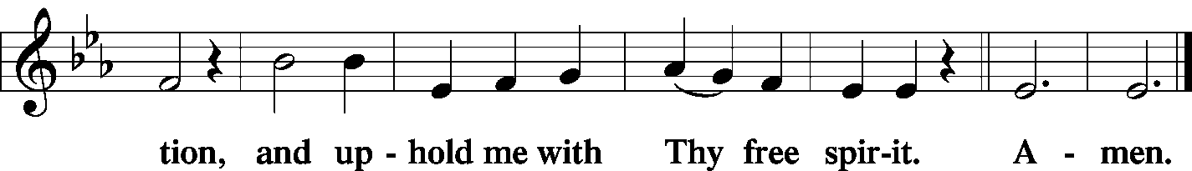
The OFFERING
Stand

The PRAYER OF THE CHURCH
P Lord, in Your mercy.

C Hear our prayer.
The Preface and PROPER PREFACE LSB 194
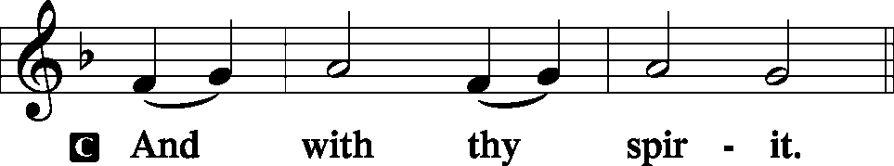
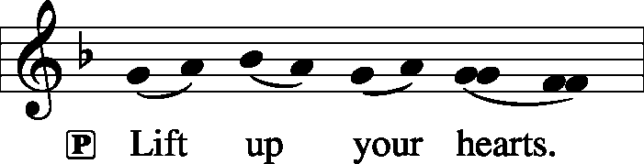
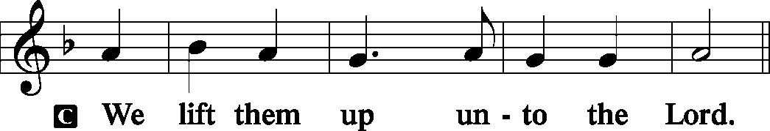
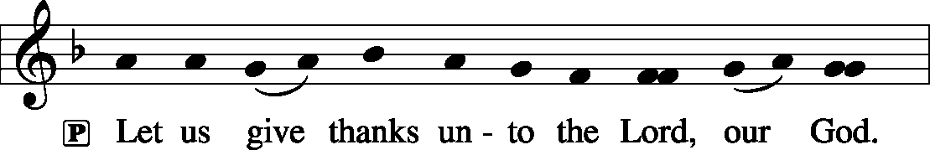
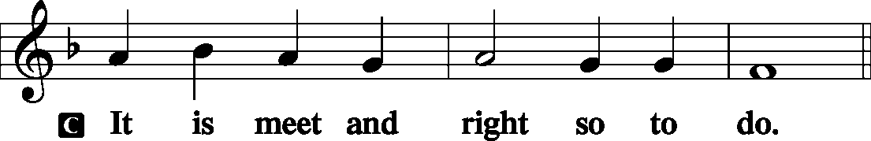
P It is truly meet, right, and salutary . . . evermore praising You and saying:

The SANCTUS LSB 195
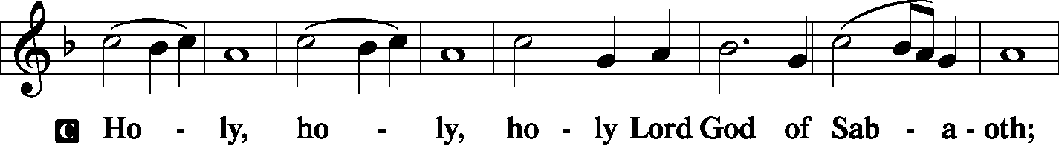
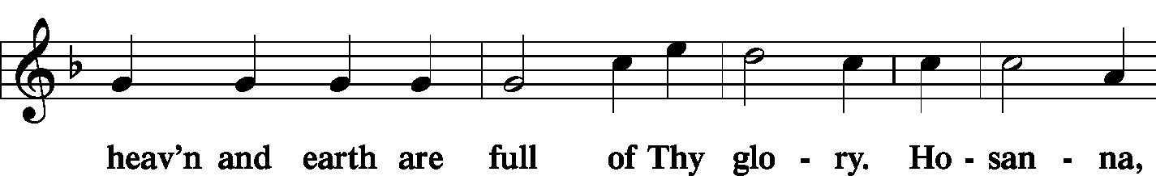
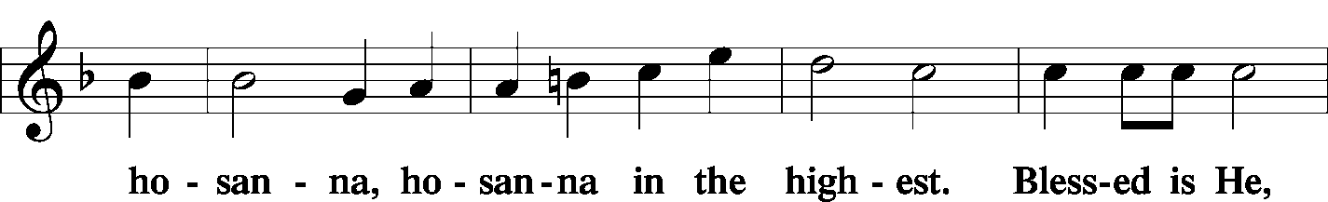
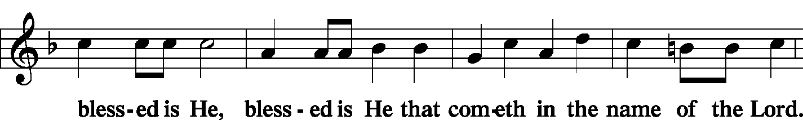
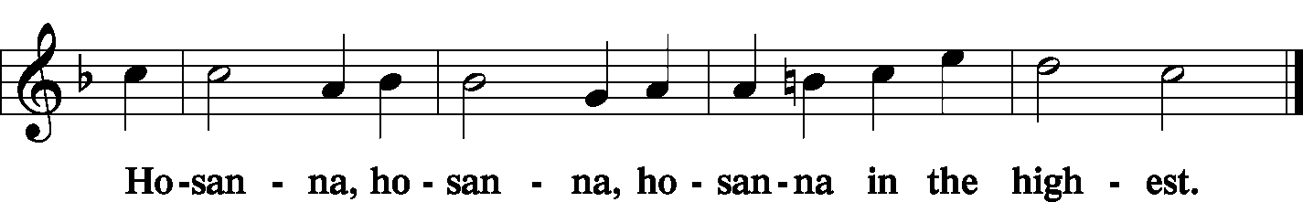
The Lord's Prayer LSB 196
C Our Father who art in heaven,
hallowed be Thy name,
Thy kingdom come,
Thy will be done on earth as it is in heaven;
give us this day our daily bread;
and forgive us our trespasses as we forgive those who trespass against us;
and lead us not into temptation,
but deliver us from evil.
For Thine is the kingdom and the power and the glory forever and ever. Amen.
The Words of Institution LSB 197
The Pax Domini LSB 197
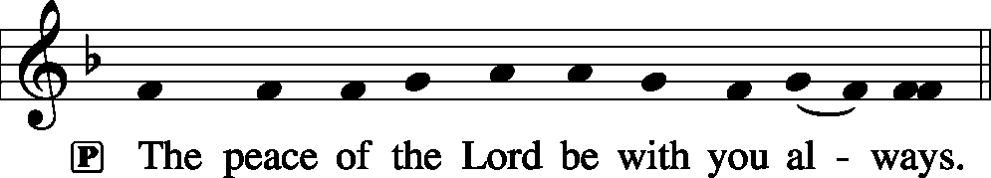
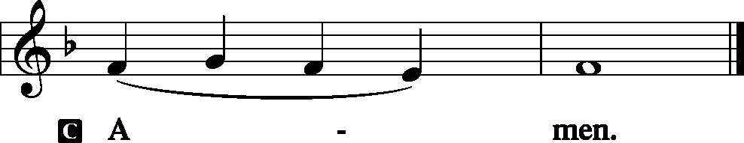
The Agnus Dei LSB 198
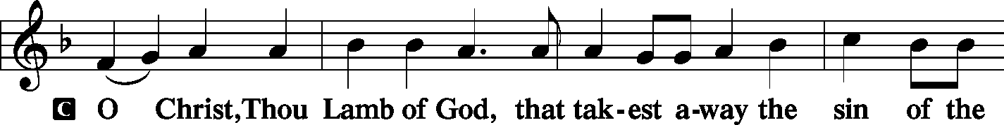
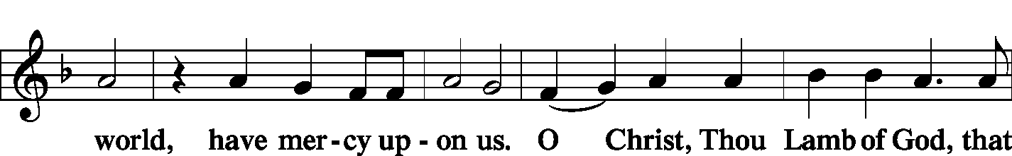
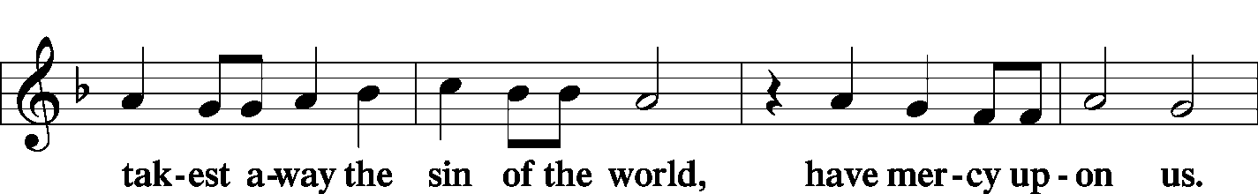
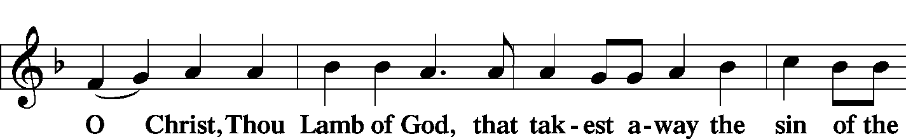
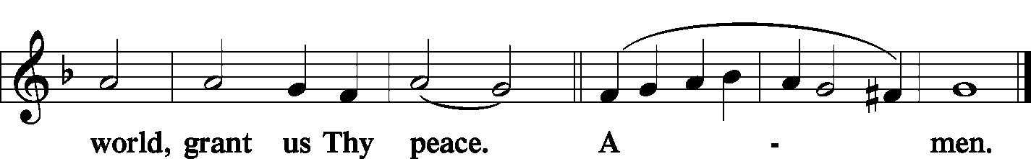

The HYMN LSB 368 Angels We Have Heard on High
LSB 370 What Child Is This
(See Pages 18–19)
Stand
The NUNC DIMITTIS LSB 199–200
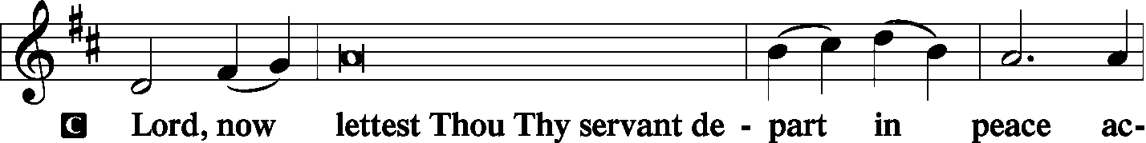
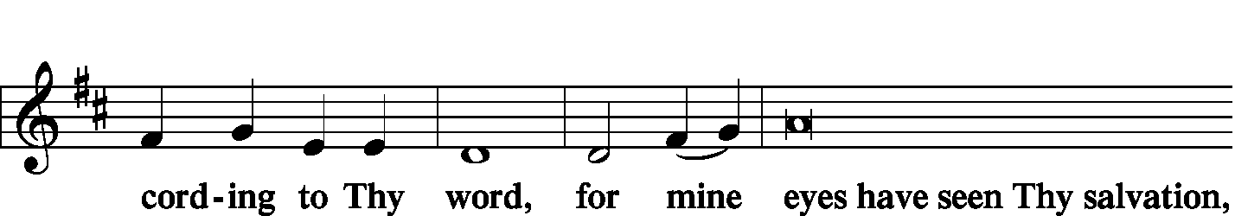
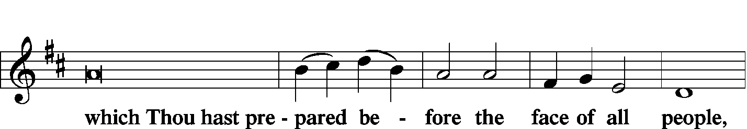
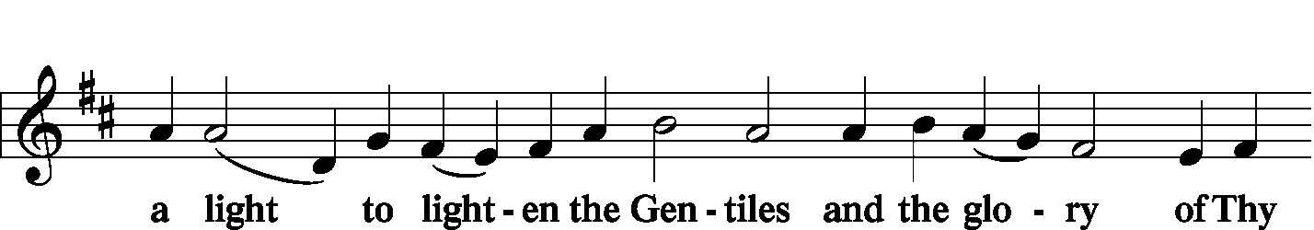
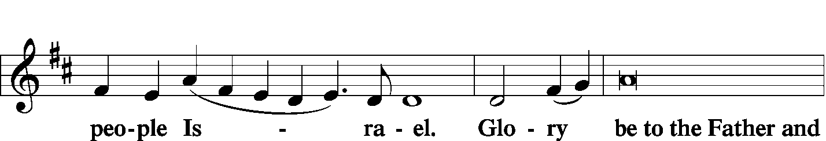
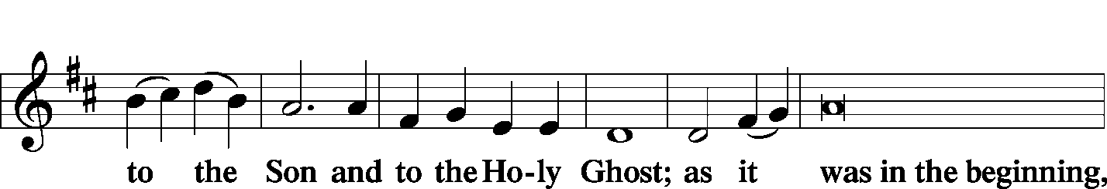
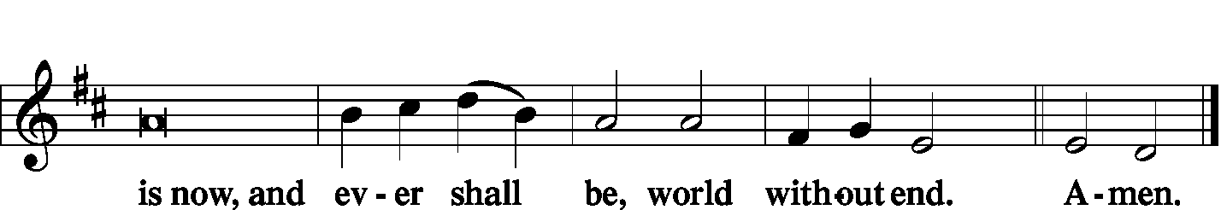
The SALUTATION, BENEDICAMUS and BENEDICTION LSB 201–202
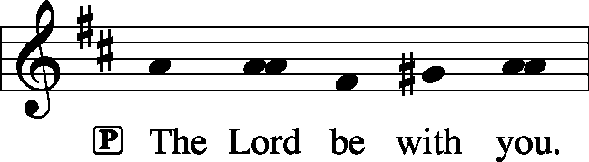
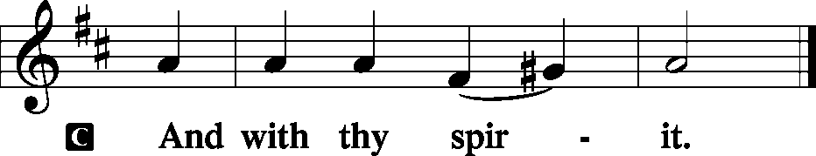
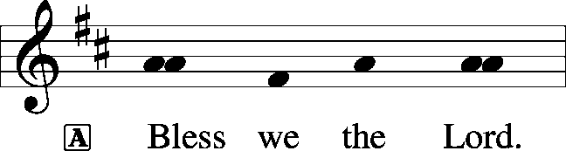
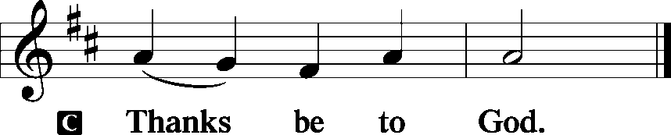

The Benediction LSB 202
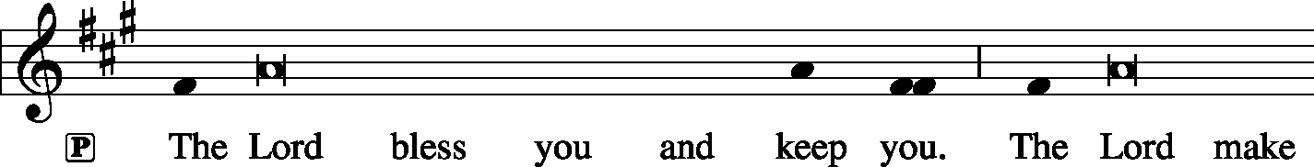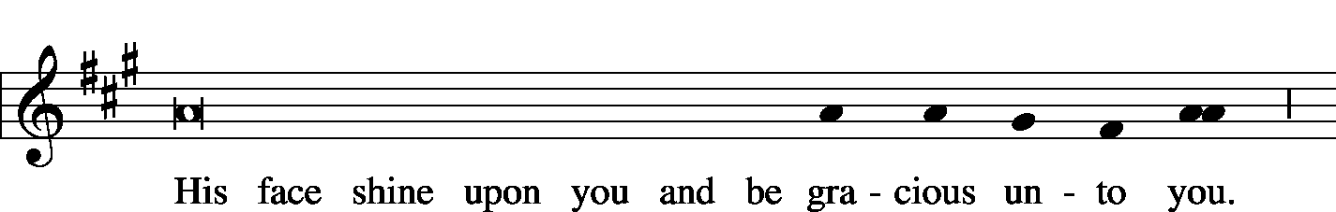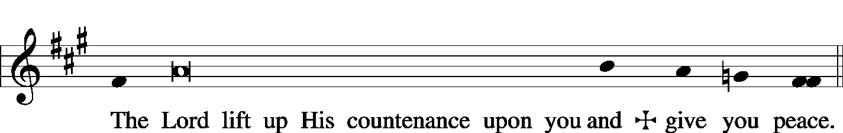
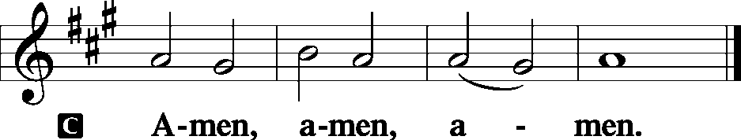
The RECESSIONAL HYMN LSB 380 Hark! The Herald Angels Sing
(See Page 20)

SERVING TODAY
CELEBRANT Rev. Jason Braaten
ORGANIST Mrs. Leigh Ann Whitson
TRUMPET Mr. Tom Wold

ACKNOWLEDGEMENTS: Divine Service, Setting Three from Lutheran Service Book Unless otherwise indicated, all scripture quotations are from The Holy Bible, English Standard Version, copyright © 2001 by Crossway Bibles, a division of Good News Publishers. Used by permission. All rights reserved. Created by Lutheran Service Builder © 2006 Concordia Publishing House.
LSB 379 O Come, All Ye Faithful
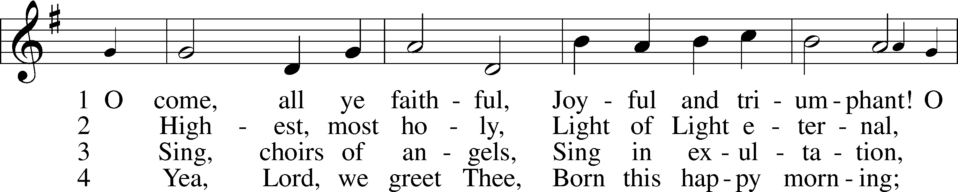
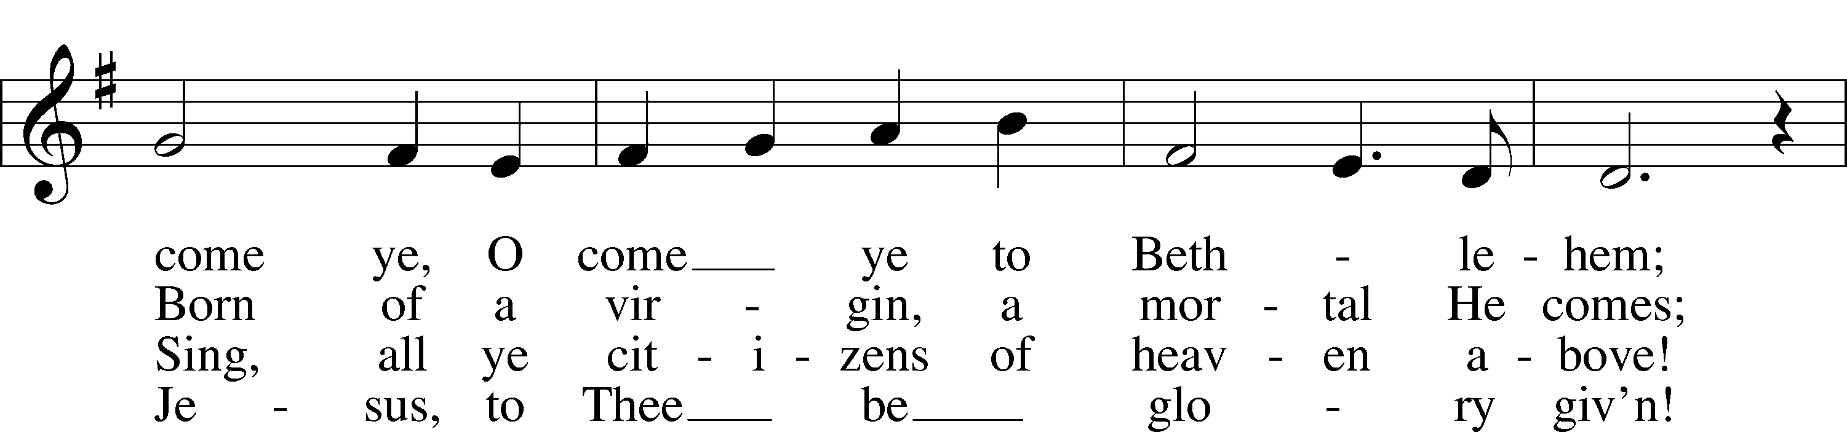
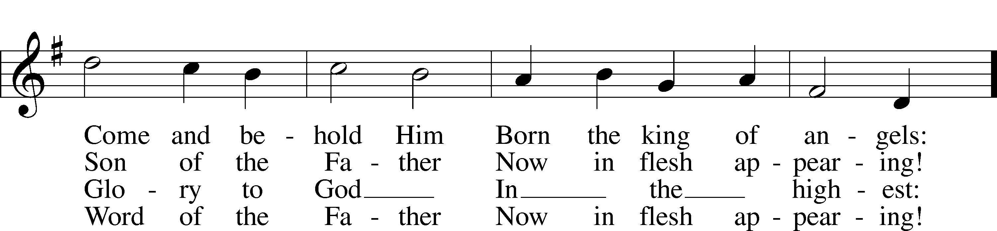
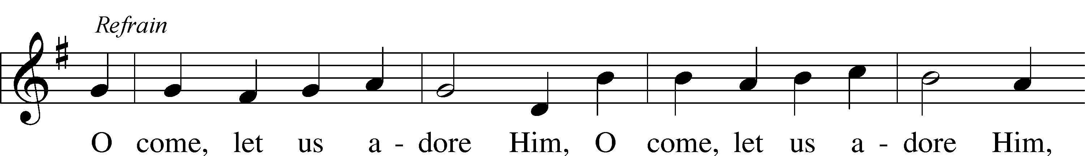
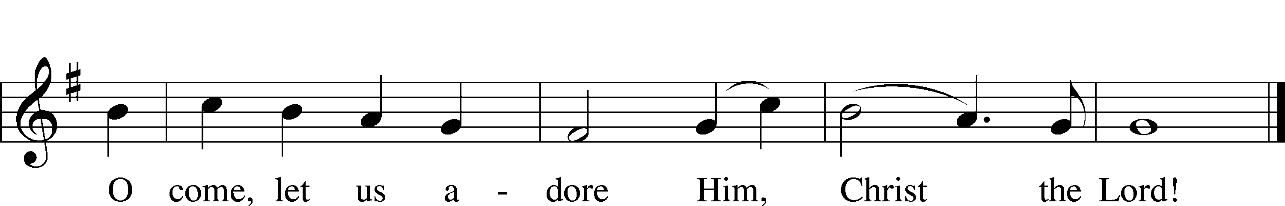
Public domain
LSB 387 Joy to the World
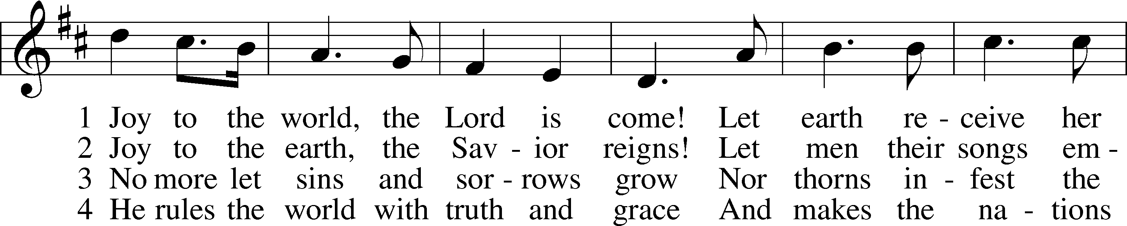
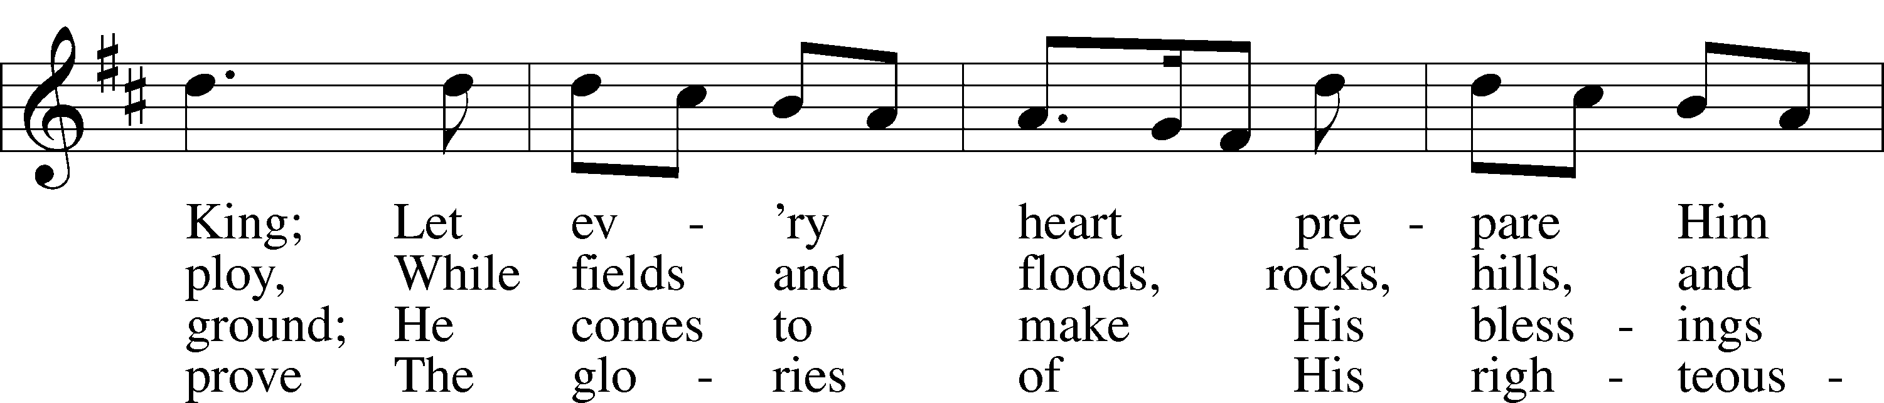
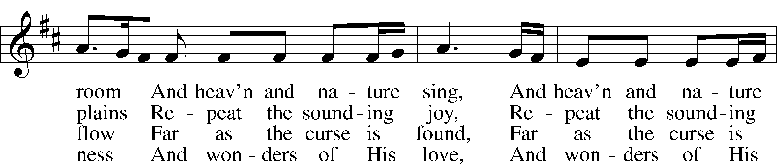
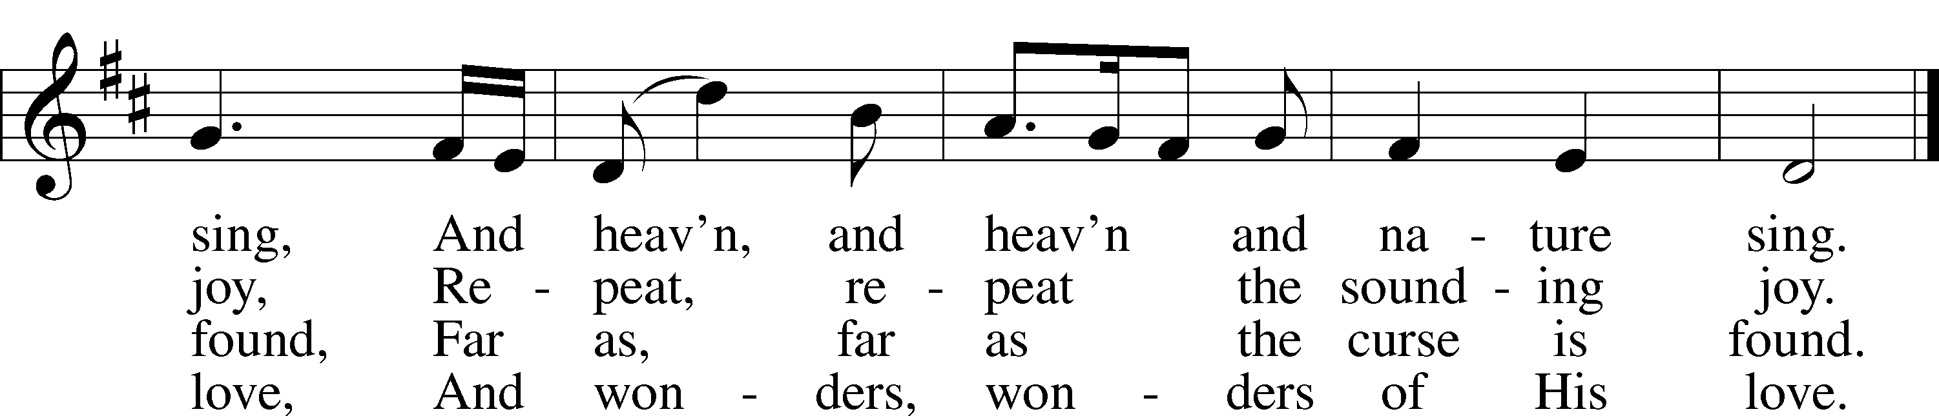
Public domain
LSB 368 Angels We Have Heard on High
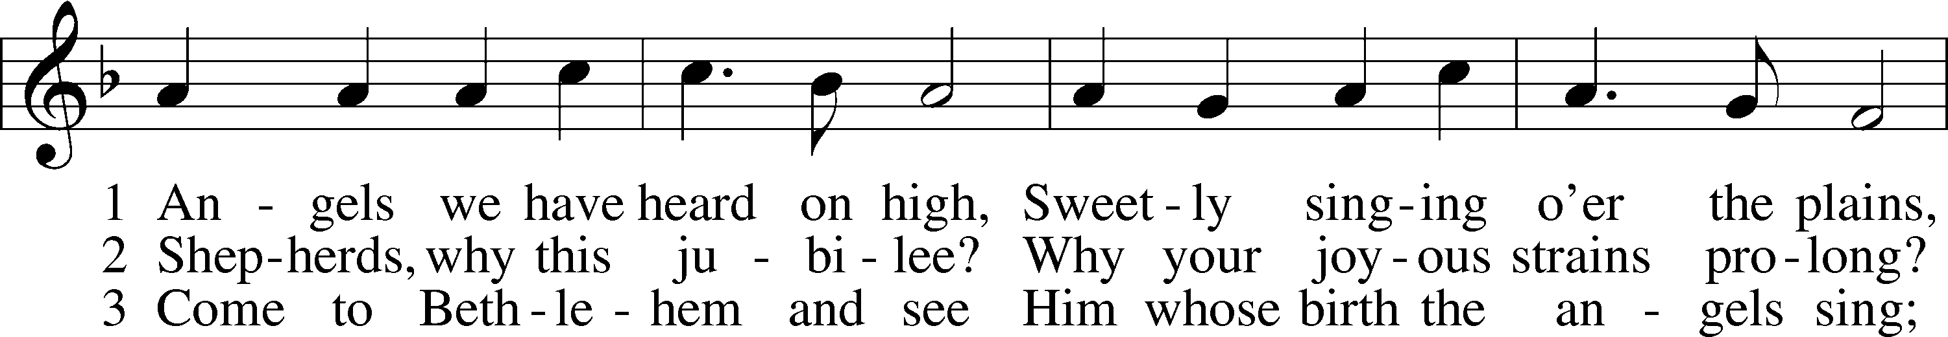
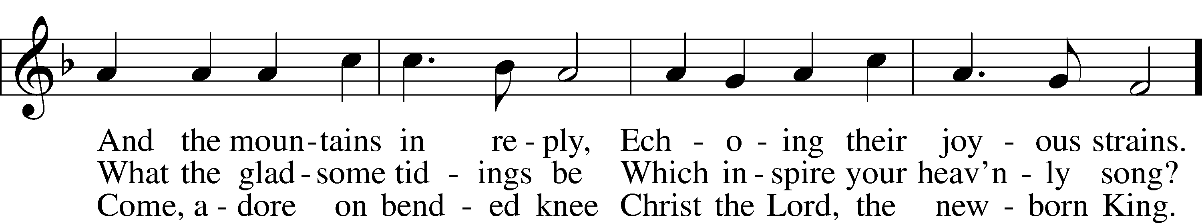
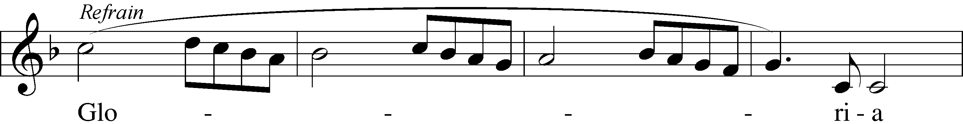
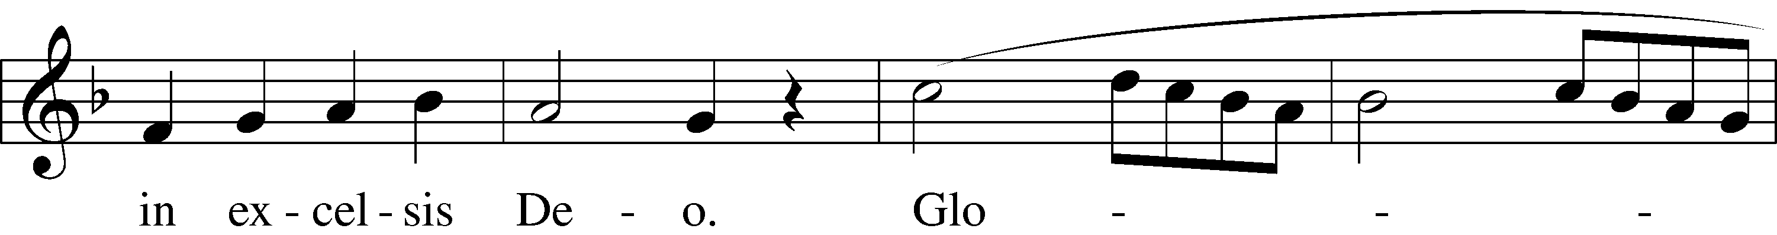
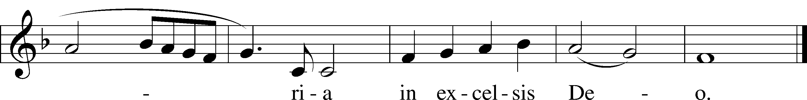
Public domain
LSB 370 What Child Is This
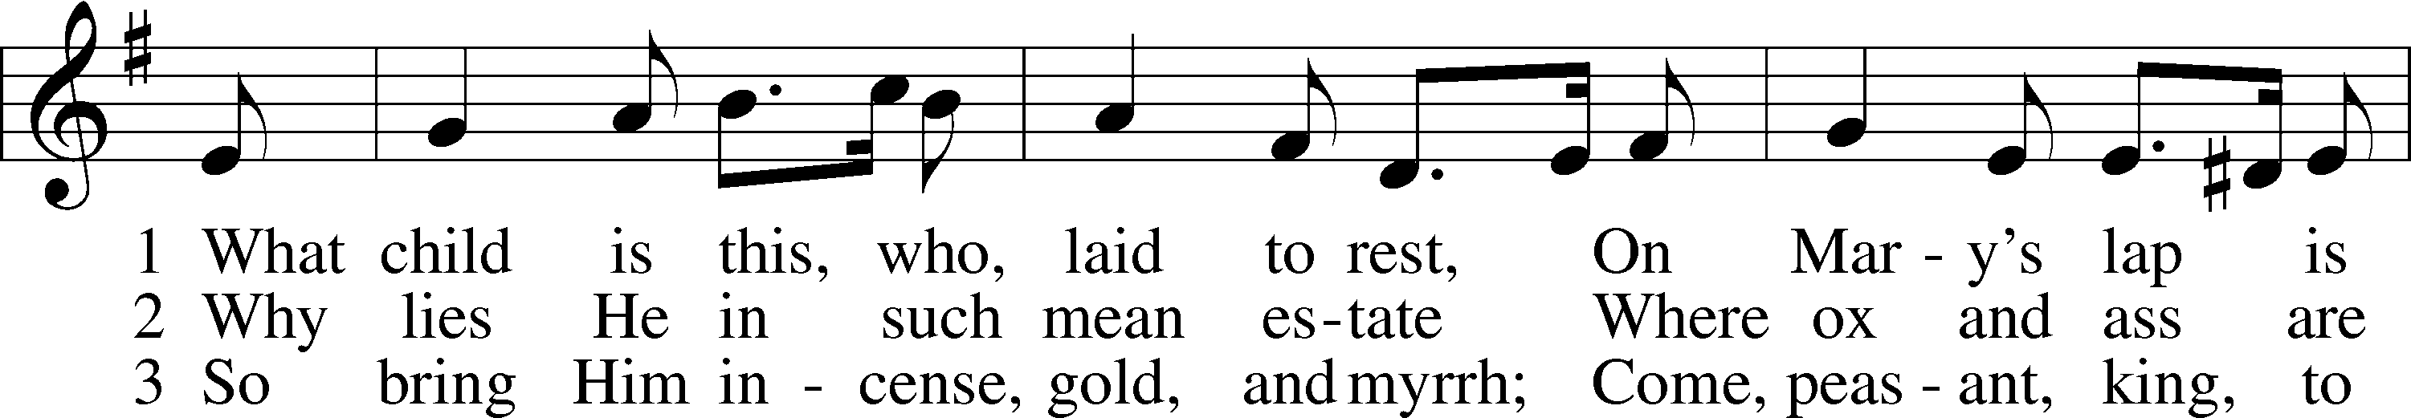
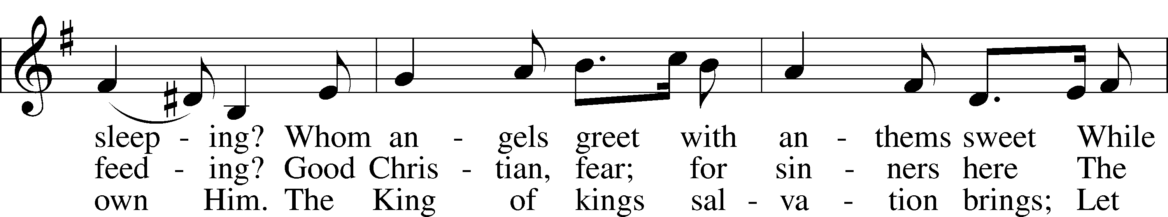
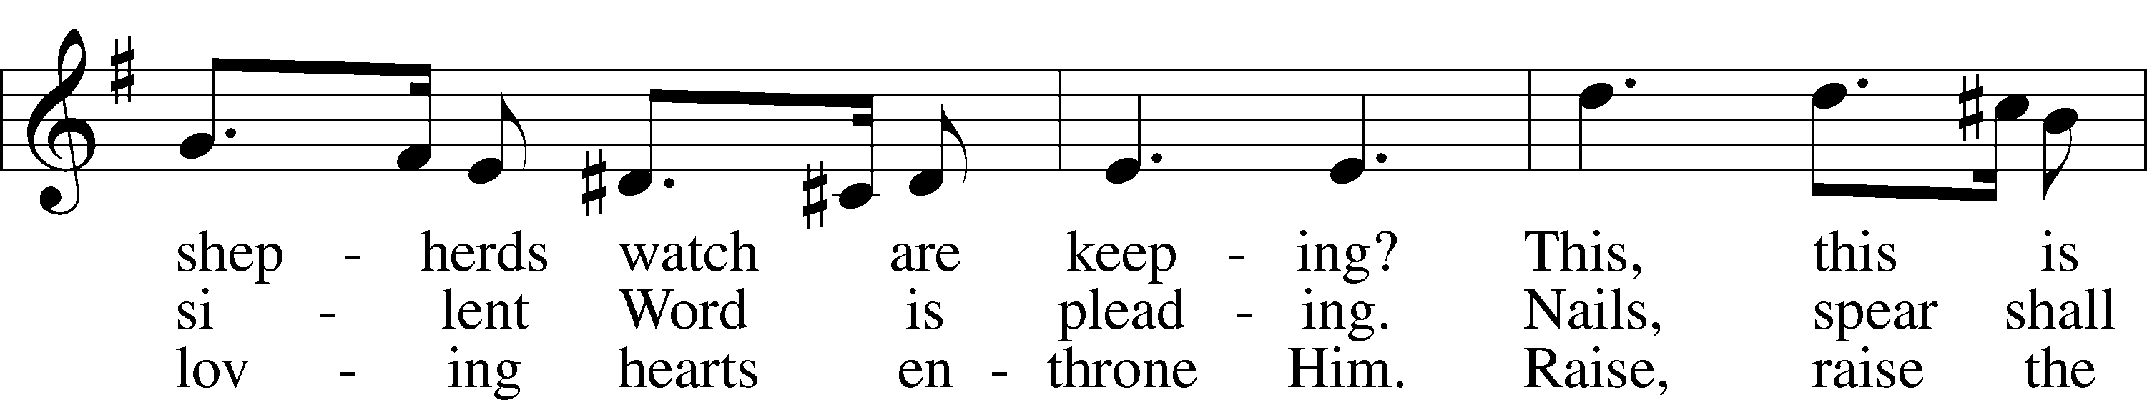
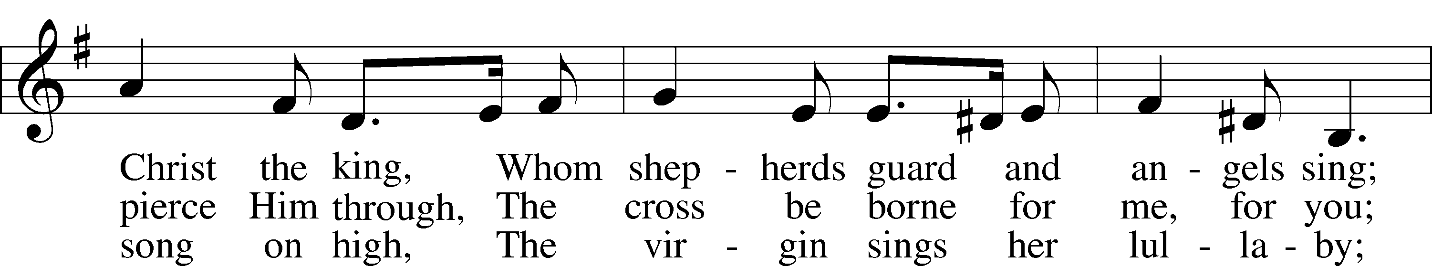
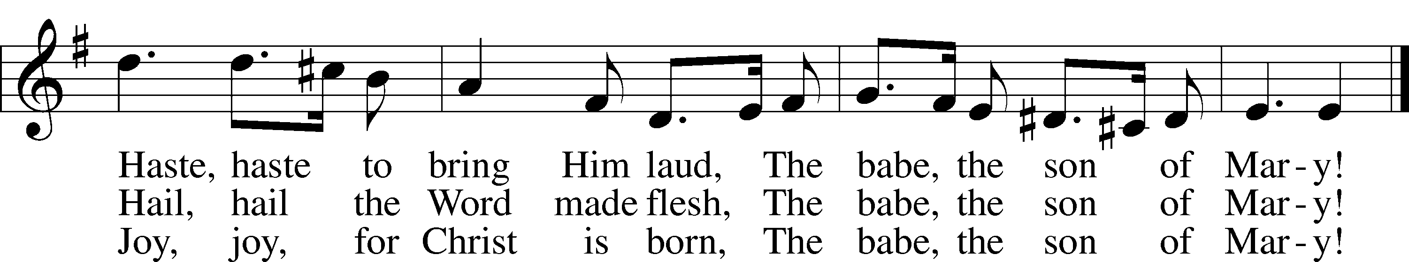
Public domain
LSB 380 Hark! The Herald Angels Sing
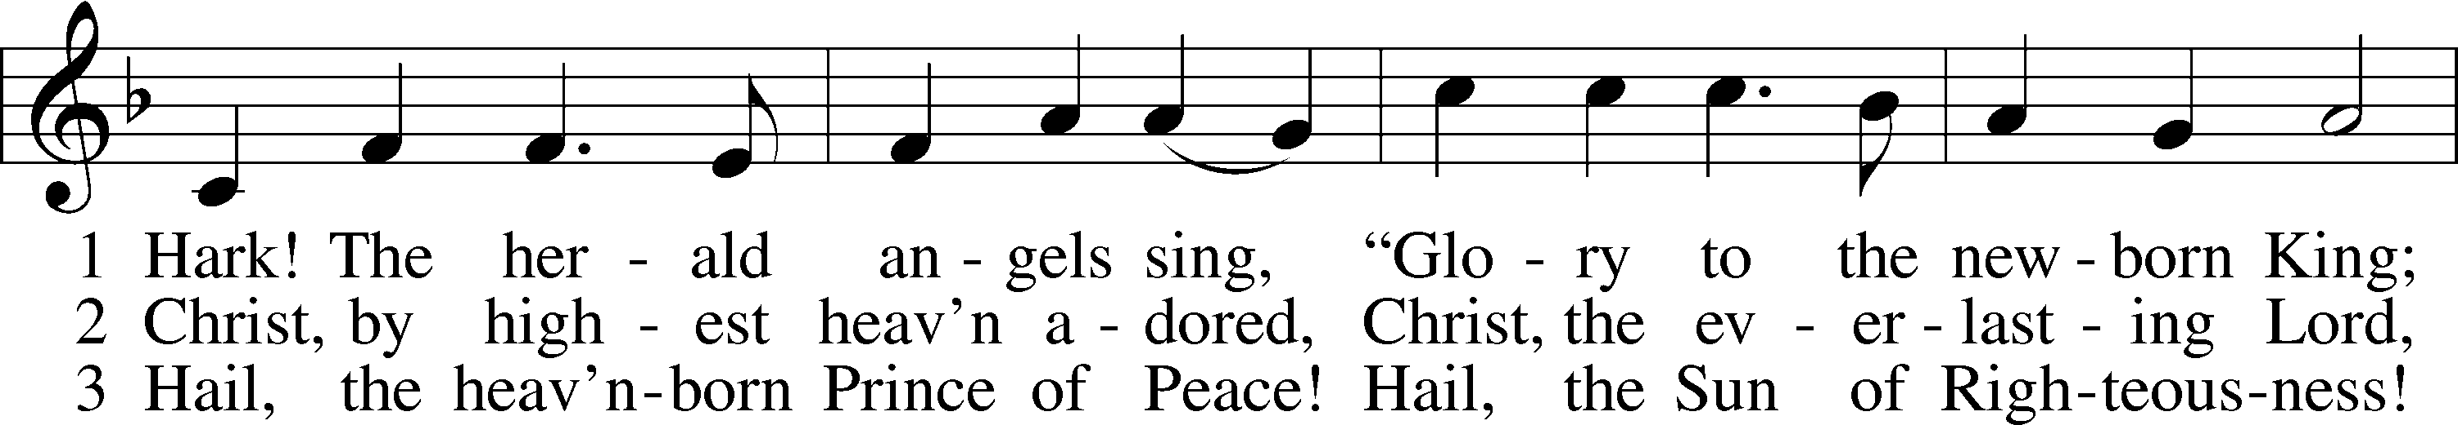
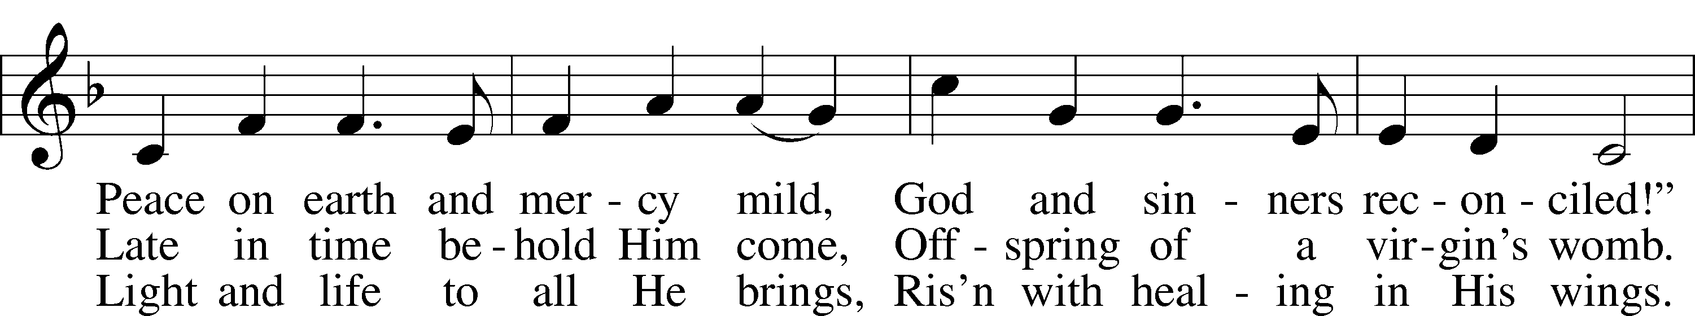
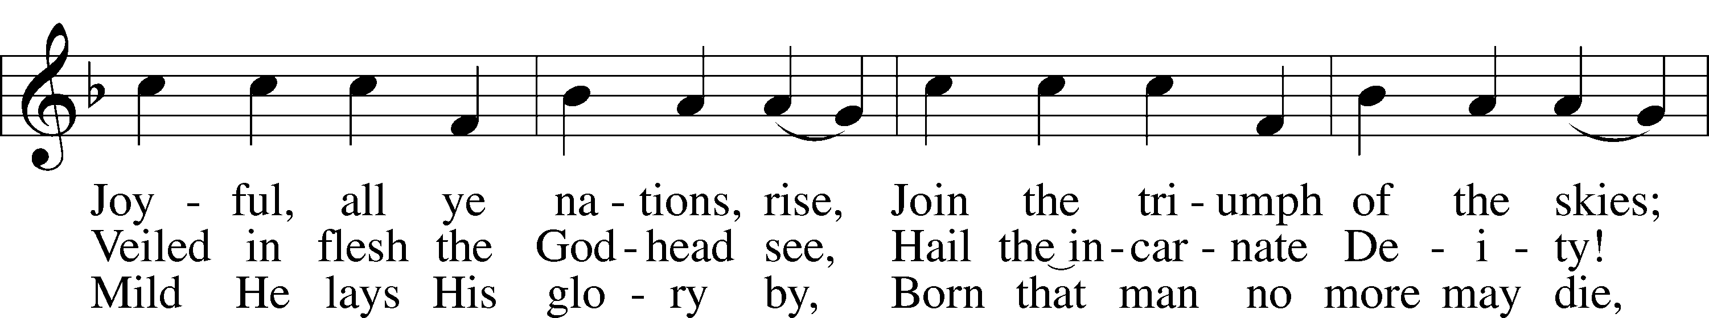
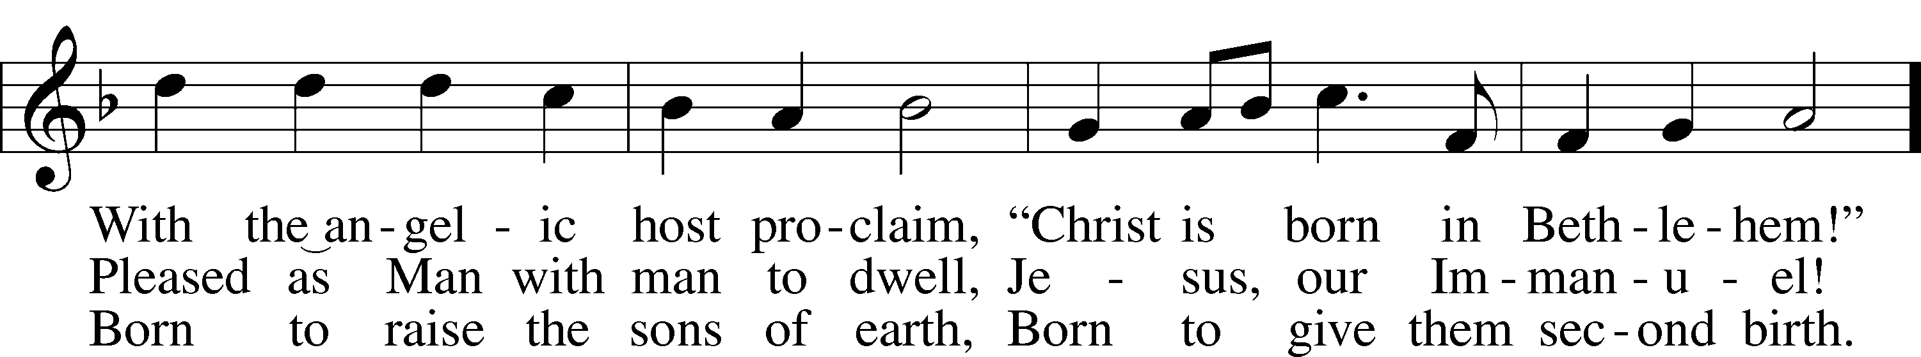
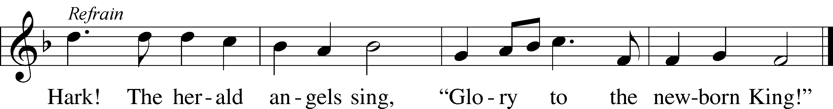
Public domain
IN OUR PRAYERS
HEALTH CONCERNS: Bernita Ashwill; Connie Bruns (cousin of Mary Appleby); Lynn Corrie (friend of Arleigh Jones); Ellie Crawford (daughter of Laran Crawford); Whitney Czerwonka; Lynn Davis (cousin of Mark Whitson); Cindy Ekstrom; Theresa Fields; Darrell Ford; Lisa Hall (sister of Holly Wikoff); Rick Hardesty (family of the Hoels); Forrest Harvey (son of John Harvey); Kim Hausman (friend of Ann Carroll); Deanna Henningsen (sister-in-law of Jerry & Joyce Alexander); Mary Miller (friend of David Holzrichter); Kimberly Mulvany (daughter of Pastor Doug Meyer); Mary Negangard (grandmother of Bryce Reifsteck); Dennis Pickett (friend of Ann Carroll); Tim Pollock; Misti Post (niece of Sue Rothe); Cary & Beth Rahn; Joan Rahn; Aurelia Tuegal (grandmother of Bethany Campbell); Emma Silver; Dave Slaughter; Ocil Slone (grandfather of Josh & Jake Dyer); Joy Stenger; Carolyn Stremming (sister-in-law of Arleigh Jones); Brian Walker (uncle of Bryce Reifsteck); Lynn & Jane Whitson (parents of Mark Whitson).
SEMINARY STUDENT: Gunnar Campbell; Logan Smith.
DEACONESS STUDENT: Emily McLean.
MISSIONARIES: The Naumann Family; The McDermott Family, Julie Lutz
HOMEBOUND: Bernita Ashwill; Leonard Boerngen; Jim Harbaugh; Janet Pollock; Ruth Rentschler; Ruth Sims; Irene Wattjes.
MILITARY: Carl Crawford; Josh Dyer; Jeremy Gordon; Jack Leonard; Jake Lindgren; Raymond Longtin; Joey Pollock; Blake Stokes; Ruben Wilson.

THE ANNOUNCEMENTS
ABOUT THE READINGS . . . In the beginning God created all things through His Word, His Son. But man fell into sin, and with man all creation was cursed. Therefore, God spoke His Word again, this time into the womb of the blessed Virgin Mary. The glory of the Lord filled the tabernacle of our human nature (Ex. 40:17–21, 34–38). “The Word became flesh and dwelt among us” (John 1:1–14). The Son of God took on our flesh and blood and died on the cross in order that we might receive the right to become the children of God through faith. Baptized into Christ’s body, we are made partakers of a new Genesis, “the washing of regeneration and renewal of the Holy Spirit” (Titus 3:4–7). In Christ, the kindness and love of God our Savior toward man has truly appeared.
THOUGHTS ABOUT STEWARDSHIP . . . John 1:12 “But to all who did receive him, who believed in his name, he gave the right to become children of God.” What a joy to be called the children of God! We have a Father who cares for us and loves us. Therefore we have no need to fear. For perfect love casts out fear. And with our fear set aside, we are free to serve the Christ who has become flesh.
NEW OFFICER INSTALLATION . . . will be Sunday, January 3, during the Divine Service immediately following the offering. If you are a newly-elected officer, please plan to attend. A reception will be held in the Fellowship Hall following the Divine Service to say thank you to out-going, current, and in-coming officers. Their hard work and dedication are to be commended!
A PRAYER FOR NEWNESS OF LIFE IN CHRIST . . . Almighty God, give us grace that we may cast away the works of darkness and put upon ourselves the armor of light now in the time of this mortal life in which Your Son, Jesus Christ, came to visit us in great humility, that in the Last Day, when He shall come again in glorious majesty to judge both the living and the dead, we may rise to life immortal; through Jesus Christ, our Lord.

POINSETTIAS GIVEN BY
Jerry & Joyce Alexander in thanksgiving for blessings received
Ann Carroll in memory of Carl & Marie Charnetzki and Troy, Michael, & Steve Allison
Steve, Ann, Jacob & Meagan Hilgendorf in memory of Rev Dr MD & Adeline Hilgendorf
Robert & Irene Wright
Joel Hilgendorf
Reuben & Dorothy Hostetler in memory of Mary Kauffman
Arleigh Jones in memory of Mary Jane
Roger & Wanda Long in thanksgiving for blessings, our health, Family and Friends, etc.
The Munson Family in thanksgiving of God’s blessings
Glen & Janet Stumeier in thanksgiving for God’s many blessings
Irene Wattjes in thanksgiving for God’s many blessings
The Whitson Family in memory of loved ones passed
Poinsettias can be taken home immediately following the Christmas Day service

The bells of waiting Advent ring,
The Tortoise stove is lit again
And lamp-oil light across the night
Has caught the streaks of winter rain
In many a stained-glass window sheen
From Crimson Lake to Hookers Green.

CHRISTMAS

By Sir John Betjeman

The holly in the windy hedge
And round the Manor House the yew
Will soon be stripped to deck the ledge,
The altar, font and arch and pew,
So that the villagers can say
‘The church looks nice’ on Christmas Day.

Provincial Public Houses blaze,
Corporation tramcars clang,
On lighted tenements I gaze,
Where paper decorations hang,
And bunting in the red Town Hall
Says ‘Merry Christmas to you all’.

And London shops on Christmas Eve
Are strung with silver bells and flowers
As hurrying clerks the City leave
To pigeon-haunted classic towers,
And marbled clouds go scudding by
The many-steepled London sky.

And girls in slacks remember Dad,
And oafish louts remember Mum,
And sleepless children’s hearts are glad.
And Christmas-morning bells say ‘Come!’
Even to shining ones who dwell
Safe in the Dorchester Hotel.

And is it true,
This most tremendous tale of all,
Seen in a stained-glass window’s hue,
A Baby in an ox’s stall?
The Maker of the stars and sea
Become a Child on earth for me?

And is it true? For if it is,
No loving fingers tying strings
Around those tissued fripperies,
The sweet and silly Christmas things,
Bath salts and inexpensive scent
And hideous tie so kindly meant,

No love that in a family dwells,
No caroling in frosty air,
Nor all the steeple-shaking bells
Can with this single Truth compare -
That God was man in Palestine
And lives today in Bread and Wine.

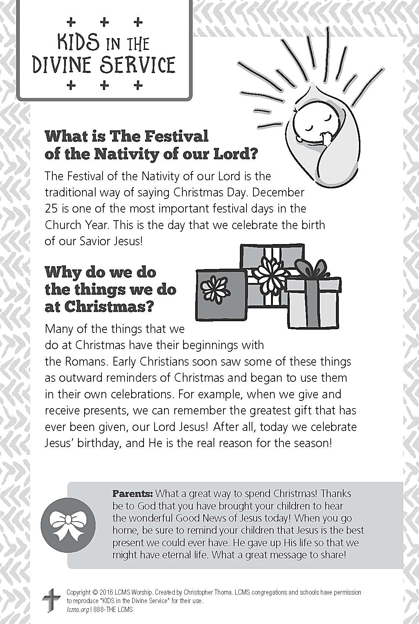

A PRAYER FOR IMMANUEL
Rev. Jason Braaten, Pastor
Home: (217) 253-4539
Mobile: (217) 460-2077
Email: pastor.braaten@gmail.com
Office Hours:
Monday–Thursday 8:00 am–12:00 pm
or by appointment

My dear Lord Jesus, I want to know You as Savior and Friend, Help me to grow into a mature disciple so that I can demonstrate God’s love and forgiveness in all I do. Teach me to share my faith in You and to serve others in my vocation. Make Immanuel Lutheran Church a place where lost and hurting people find friendship, forgiveness, and faith, and where Christians gather to serve You in love for one another, for the community, and for the world. Amen.
Debra Parsley, Office Manager
Office: (217) 253-4341
Email: immanuel.tuscola@gmail.com

Office Hours:
Monday–Tuesday 8:00 am–4:30 pm
Wednesday 8:00 am–12:30 pm

