THE EVE OF THE NATIVITY
OF OUR LORD

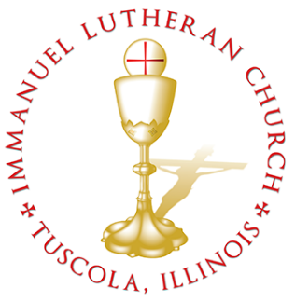
THE EVE OF THE NATIVITY OF OUR LORD

Today we celebrate the Sacrament of our Lord Jesus Christ’s true body and blood. Since receiving the Lord’s Supper expresses fellowship with the Lord and agreement with the teaching of the pastor and congregation, we follow the Biblical practice of closed communion. All guests are kindly asked to speak with Pastor Braaten before communing at our altar. Normally, members from congregations of The Lutheran Church—Missouri Synod are welcome to partake, as are people from churches in fellowship with the LCMS.
WELCOME VISITORS

Divine Service, Setting Three with Holy Communion
Stand
The PROCESSIONAL HYMN LSB 384 Of the Father’s Love Begotten
(See Pages 15)
The INVOCATION, CONFESSION, and ABSOLUTION LSB 184
P In the name of the Father and of the T Son and of the Holy Spirit.
C Amen.
P Beloved in the Lord! Let us draw near with a true heart and confess our sins unto God our Father, beseeching Him in the name of our Lord Jesus Christ to grant us forgiveness.
P Our help is in the name of the Lord,
C who made heaven and earth.
P I said, I will confess my transgressions unto the Lord,
C and You forgave the iniquity of my sin.
P O almighty God, merciful Father,
C I, a poor, miserable sinner, confess unto You all my sins and iniquities with which I have ever offended You and justly deserved Your temporal and eternal punishment. But I am heartily sorry for them and sincerely repent of them, and I pray You of Your boundless mercy and for the sake of the holy, innocent, bitter sufferings and death of Your beloved Son, Jesus Christ, to be gracious and merciful to me, a poor, sinful being.
P Upon this your confession, I, by virtue of my office, as a called and ordained servant of the Word, announce the grace of God unto all of you, and in the stead and by the command of my Lord Jesus Christ I forgive you all your sins in the name of the Father and of the T Son and of the Holy Spirit.
C Amen.
The INTROIT Ps. 2:1–2, 4–6; antiphon: Liturgical Text
When all was still, and it was | midnight,*
your almighty Word, O Lord, descended from the | royal throne.
Why do the | nations rage*
and the peoples | plot in vain?
The kings of the earth set themselves, and the rulers take
counsel to- | gether,*
against the Lord and against his a- | nointed.
He who sits in the | heavens laughs;*
the Lord holds them in de- | rision.
Then he will speak to them | in his wrath,*
and terrify them in his fury, | saying,
“As for me, I have | set my King*
on Zion, my | holy hill.”
Glory be to the Father and | to the Son*
and to the Holy | Spirit;
as it was in the be- | ginning,*
is now, and will be forever. | Amen.
When all was still, and it was | midnight,*
your almighty Word, O Lord, descended from the | royal throne.
The KYRIE LSB 186
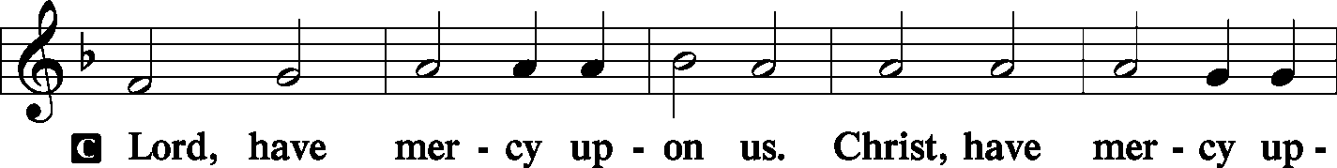
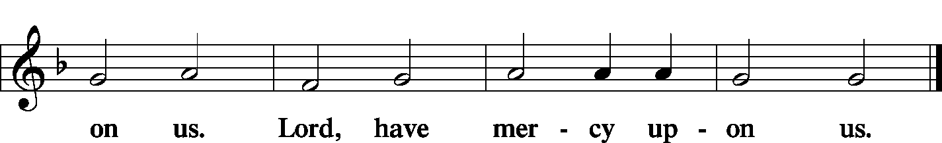

The GLORIA IN EXCELSIS LSB 187–189
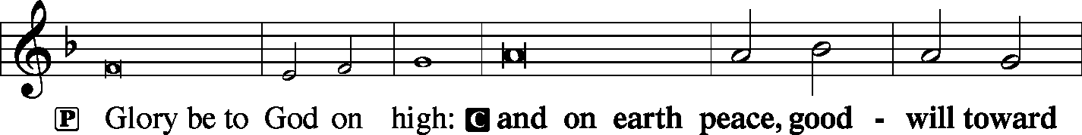
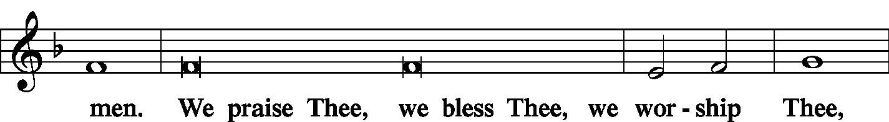
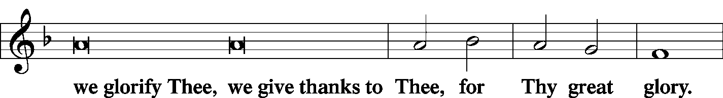
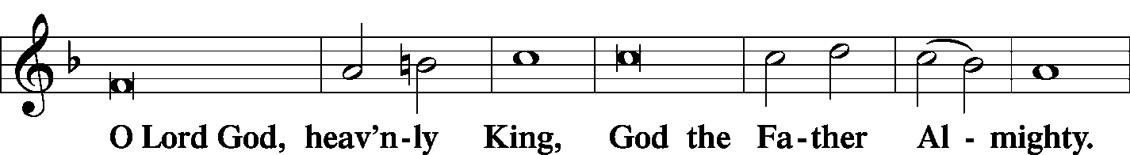
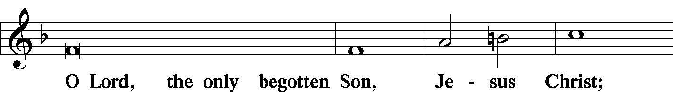
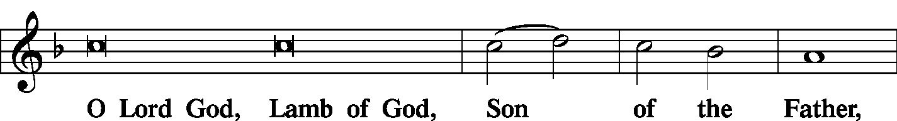
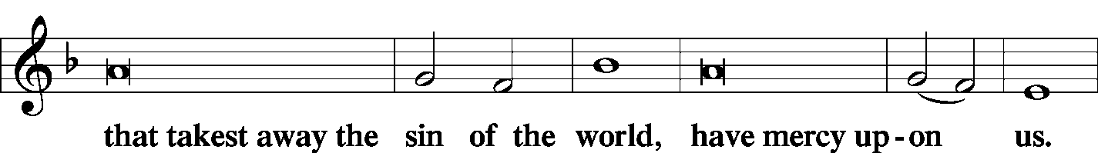
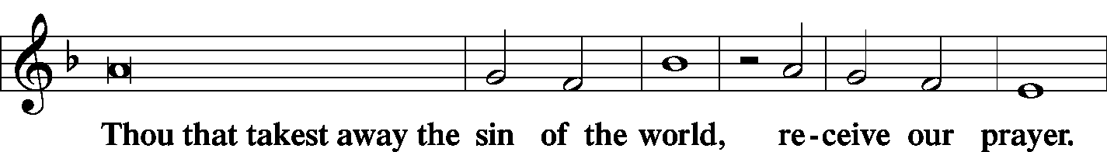
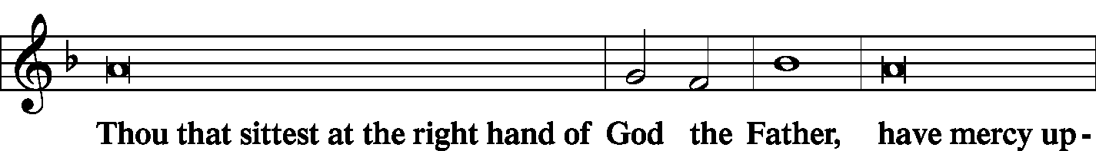
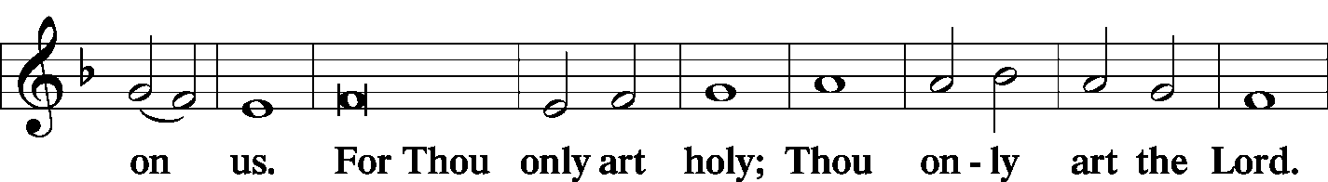
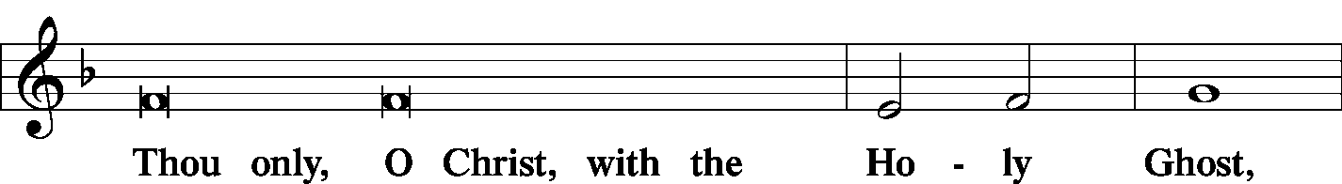
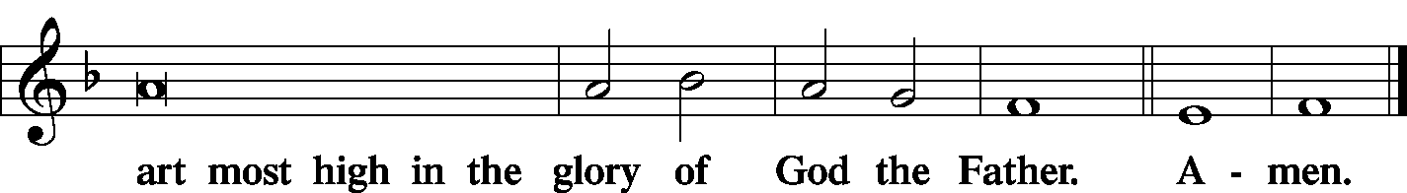

The SALUTATION and COLLECT OF THE DAY LSB 189
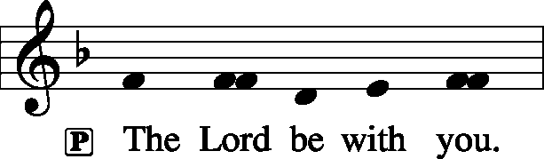
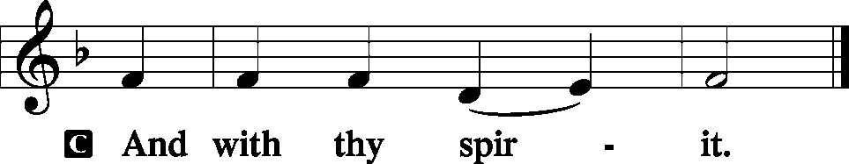
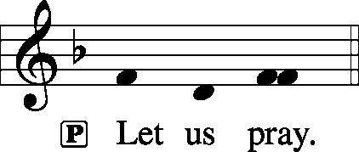
C O God, You make this most holy night to shine with the brightness of the true Light. Grant that as we have known the mysteries of that Light on earth we may also come to the fullness of His joys in heaven; through the same Jesus Christ, Your Son, our Lord, who lives and reigns with You and the Holy Spirit, one God, now and forever.
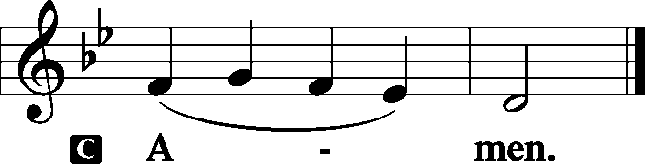
Sit
The FIRST READING Isaiah 9:2–7
The people who walked in darkness have seen a great light; those who dwelt in a land of deep darkness, on them has light shined. You have multiplied the nation; you have increased its joy; they rejoice before you as with joy at the harvest, as they are glad when they divide the spoil. For the yoke of his burden, and the staff for his shoulder, the rod of his oppressor, you have broken as on the day of Midian. For every boot of the tramping warrior in battle tumult and every garment rolled in blood will be burned as fuel for the fire. For to us a child is born, to us a son is given; and the government shall be upon his shoulder, and his name shall be called Wonderful Counselor, Mighty God, Everlasting Father, Prince of Peace. Of the increase of his government and of peace there will be no end, on the throne of David and over his kingdom, to establish it and to uphold it with justice and with righteousness from this time forth and forevermore. The zeal of the Lord of hosts will do this.
P This is the Word of the Lord.

C Thanks be to God.
The GRADUAL Ps. 98:3b–4a, 2
All the ends of the earth have seen the salvation | of our God.*
Make a joyful noise to the Lord, | all the earth.
The Lord has made known his sal- | vation;*
he has revealed his righteousness in the sight of the | nations.
The SECOND READING Titus 2:11–14
For the grace of God has appeared, bringing salvation for all people, training us to renounce ungodliness and worldly passions, and to live self-controlled, upright, and godly lives in the present age, waiting for our blessed hope, the appearing of the glory of our great God and Savior Jesus Christ, who gave himself for us to redeem us from all lawlessness and to purify for himself a people for his own possession who are zealous for good works.
P This is the Word of the Lord.

C Thanks be to God.

Stand

The ALLELUIA LSB 190
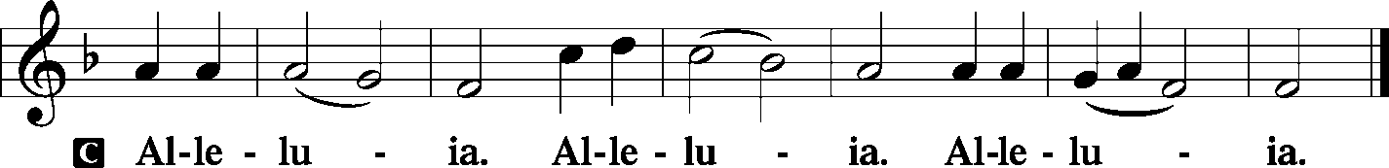
The HOLY GOSPEL St. Luke 2:1–20
P The Holy Gospel according to St. Luke, the second chapter.
C Glory be to Thee, O Lord. (Sung)
And it came to pass in those days, that there went out a decree from Caesar Augustus that all the world should be taxed. (And this taxing was first made when Quirinius was governor of Syria.) And all went to be taxed, every one into his own city. And Joseph also went up from Galilee, out of the city of Nazareth, into Judaea, unto the city of David, which is called Bethlehem; (because he was of the house and lineage of David:). To be taxed with Mary his espoused wife, being great with child. And so it was, that, while they were there, the days were accomplished that she should be delivered. And she brought forth her firstborn son, and wrapped him in swaddling clothes, and laid him in a manger; because there was no room for them in the inn.
And there were in the same country shepherds abiding in the field, keeping watch over their flock by night. And, lo, the angel of the Lord came upon them, and the glory of the Lord shone round about them: and they were sore afraid. And the angel said unto them, Fear not: for, behold, I bring you good tidings of great joy, which shall be to all people. For unto you is born this day in the city of David a Savior, which is Christ the Lord. And this shall be a sign unto you; Ye shall find the babe wrapped in swaddling clothes, lying in a manger. And suddenly there was with the angel a multitude of the heavenly host praising God, and saying, Glory to God in the highest, and on earth peace, good will toward men.
And it came to pass, as the angels were gone away from them into heaven, the shepherds said one to another, “Let us now go even unto Bethlehem, and see this thing which is come to pass, which the Lord hath made known unto us.” And they came with haste, and found Mary, and Joseph, and the babe lying in a manger. And when they had seen it, they made known abroad the saying which was told them concerning this child. And all they that heard it wondered at those things which were told them by the shepherds. But Mary kept all these things, and pondered them in her heart. And the shepherds returned, glorifying and praising God for all the things that they had heard and seen, as it was told unto them.
P This is the Gospel of the Lord.

C Praise be to Thee, O Christ. (Sung)
The NICENE CREED LSB 191
C I believe in one God,
the Father Almighty,
maker of heaven and earth
and of all things visible and invisible.

And in one Lord Jesus Christ,
the only-begotten Son of God,
begotten of His Father before all worlds,
God of God, Light of Light,
very God of very God,
begotten, not made,
being of one substance with the Father,
by whom all things were made;
who for us men and for our salvation came down from heaven
and was incarnate by the Holy Spirit of the virgin Mary
and was made man;
and was crucified also for us under Pontius Pilate.
He suffered and was buried.
And the third day He rose again according to the Scriptures
and ascended into heaven
and sits at the right hand of the Father.
And He will come again with glory to judge both the living and the dead,
whose kingdom will have no end.

And I believe in the Holy Spirit,
the Lord and giver of life,
who proceeds from the Father and the Son,
who with the Father and the Son together is worshiped and glorified,
who spoke by the prophets.
And I believe in one holy Christian and apostolic Church,
I acknowledge one Baptism for the remission of sins,
and I look for the resurrection of the dead
and the life T of the world to come. Amen.

Sit
The HYMN OF THE DAY LSB 387 Joy to the World
(See Pages 16)
The SERMON
Stand
The OFFERTORY LSB 192
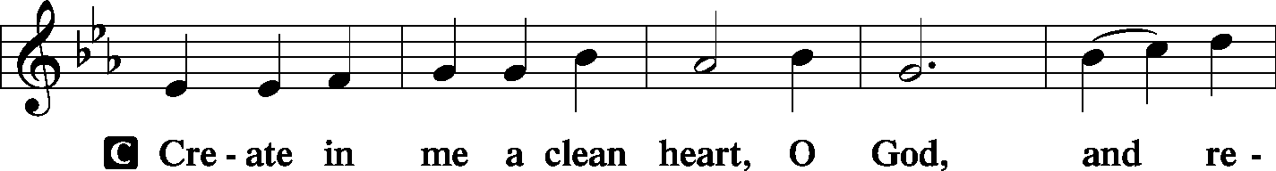
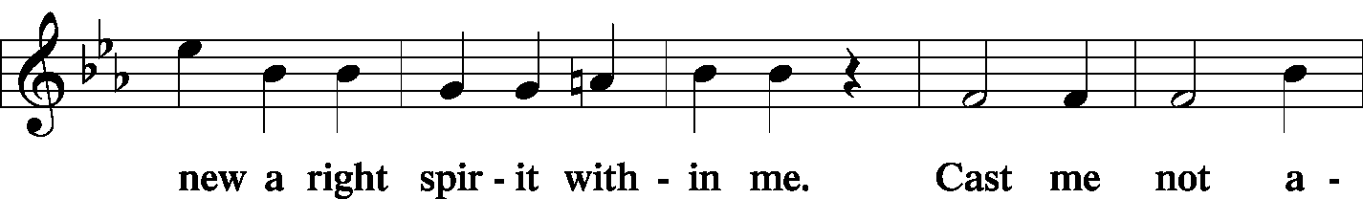
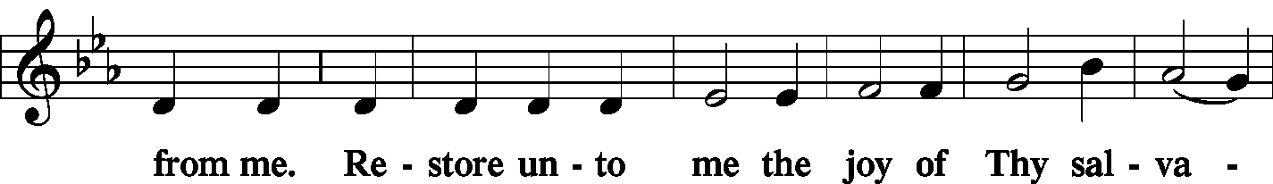
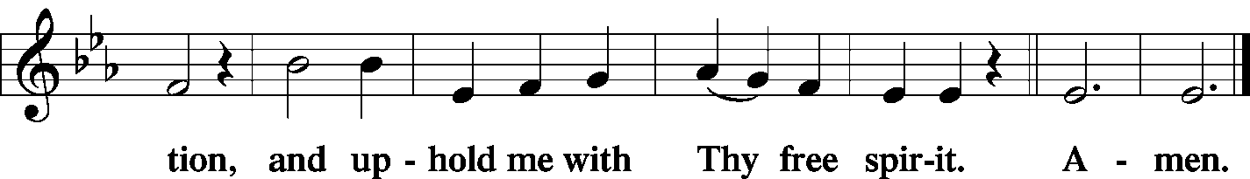
Stand

The PRAYER OF THE CHURCH
P Lord, in Your mercy.

C Hear our prayer.
The Preface and PROPER PREFACE LSB 194
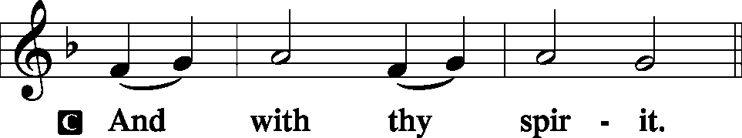
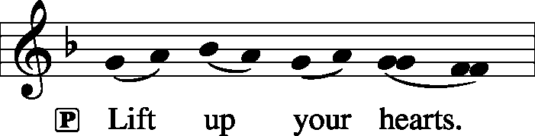
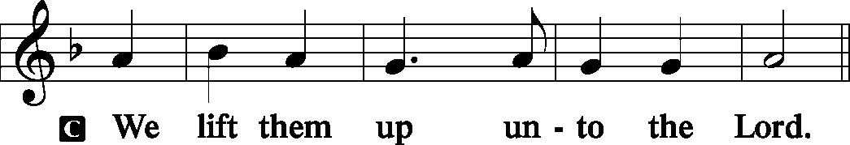
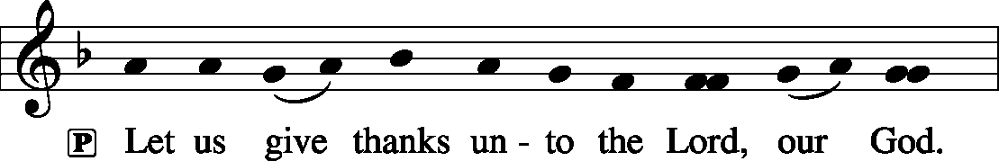
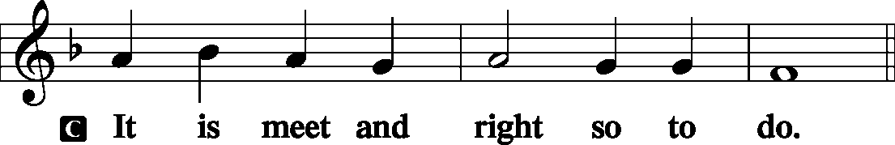
P It is truly meet, right, and salutary . . . evermore praising You and saying:
The SANCTUS LSB 195
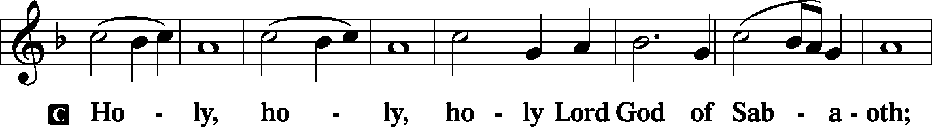
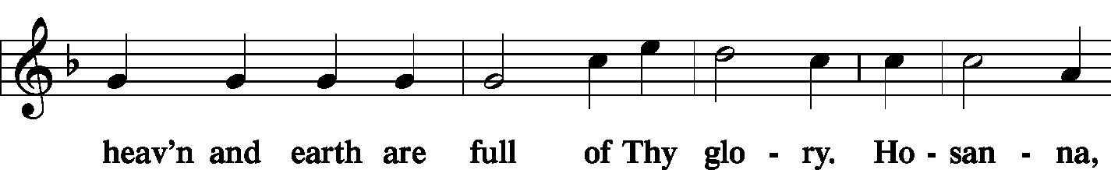
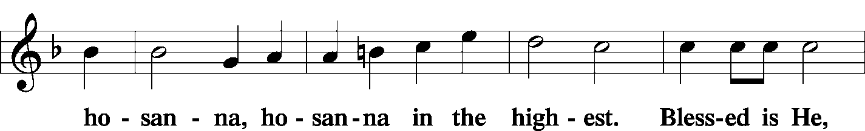
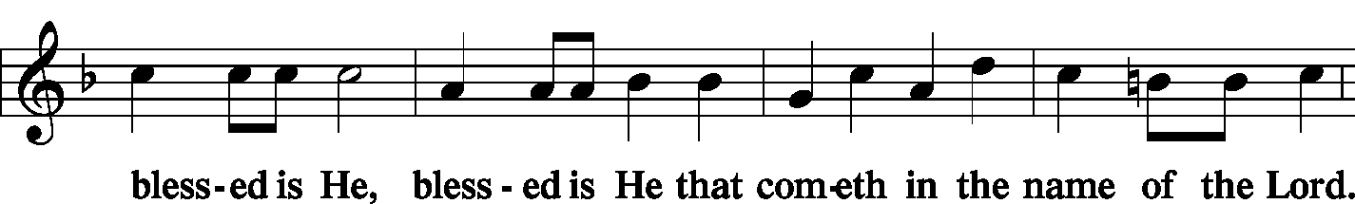
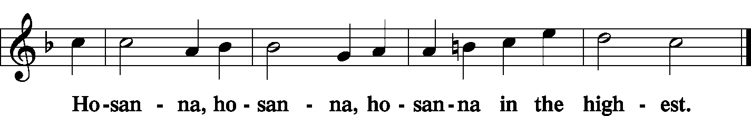
The Lord's Prayer LSB 196
C Our Father who art in heaven,
hallowed be Thy name,
Thy kingdom come,
Thy will be done on earth as it is in heaven;
give us this day our daily bread;
and forgive us our trespasses as we forgive those who trespass against us;
and lead us not into temptation,
but deliver us from evil.
For Thine is the kingdom and the power and the glory forever and ever. Amen.
The Words of Institution LSB 197

The Pax Domini LSB 197
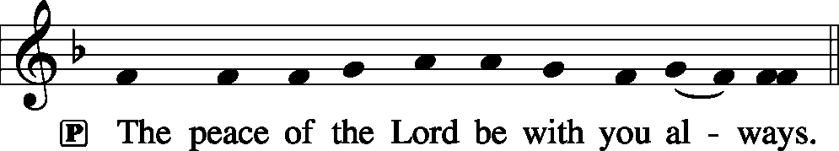
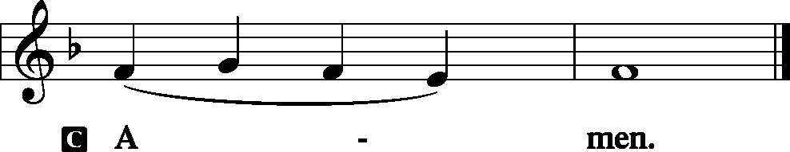
The Agnus Dei LSB 198
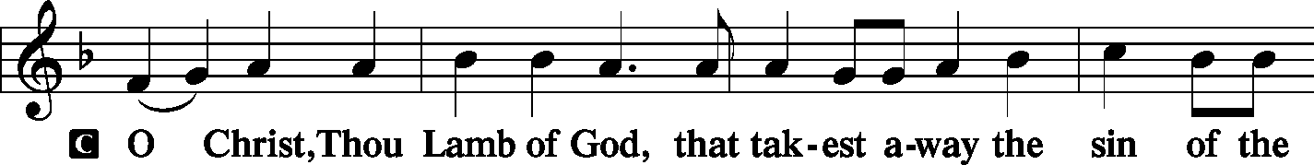
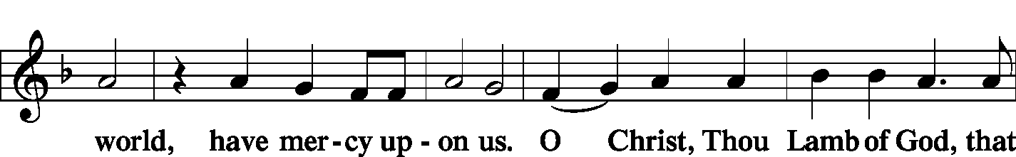
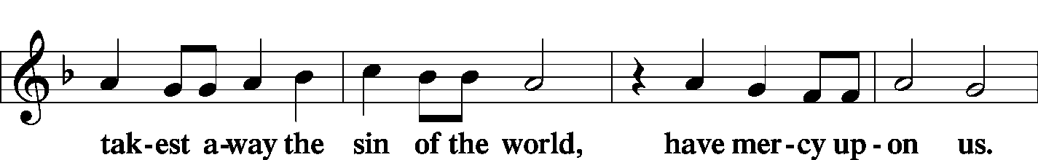
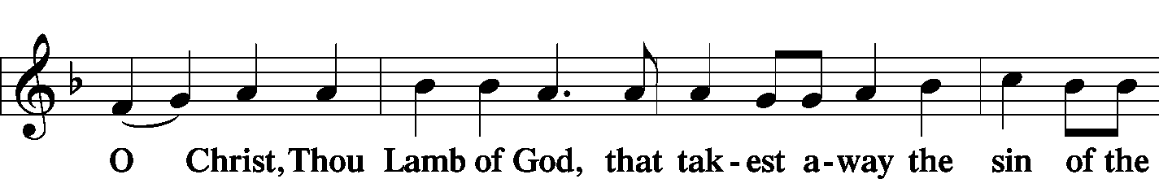
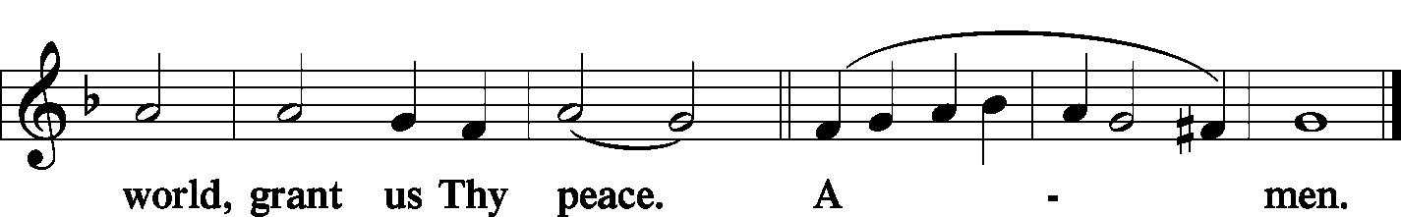
Sit

The HYMN LSB 358 From Heaven Above to Earth I Come
LSB 367 Angels from the Realms of Glory
LSB 376 Once in Royal David’s City
(See Pages 17-20)
Stand
The NUNC DIMITTIS LSB 199–200
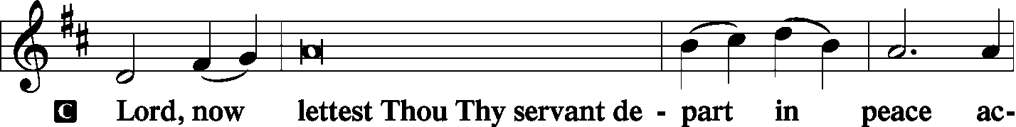
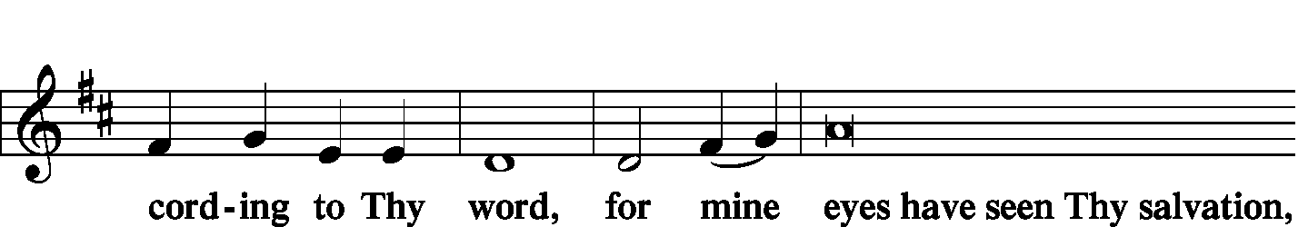
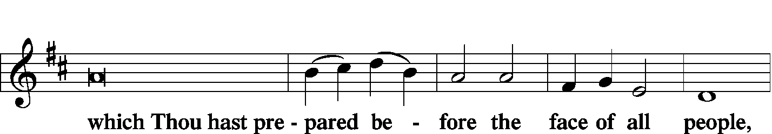
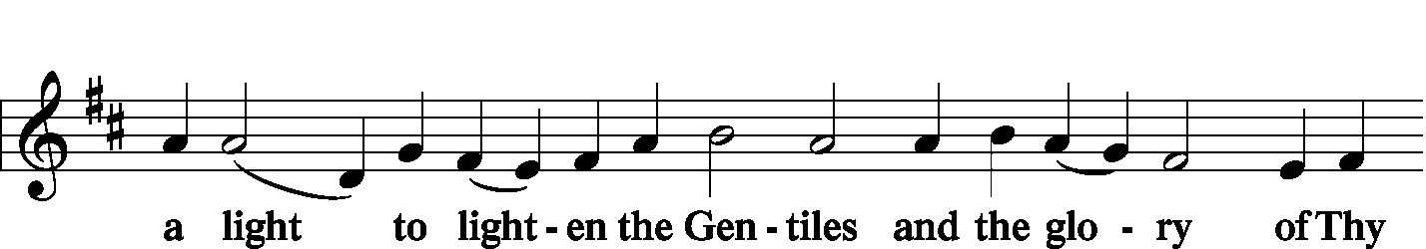
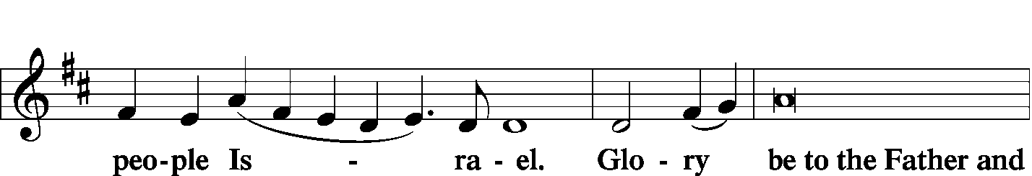
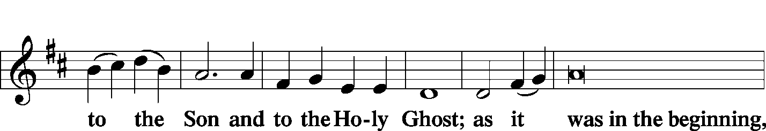
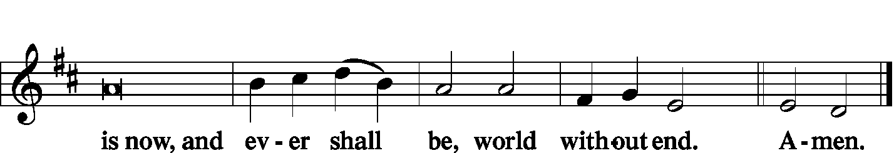
The Thanksgiving LSB 200
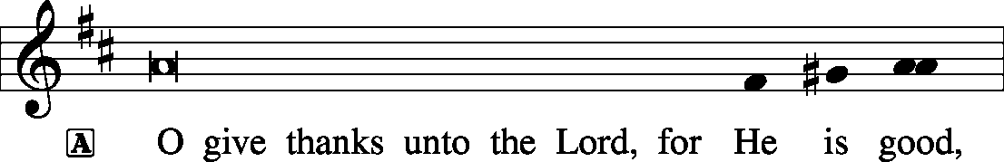
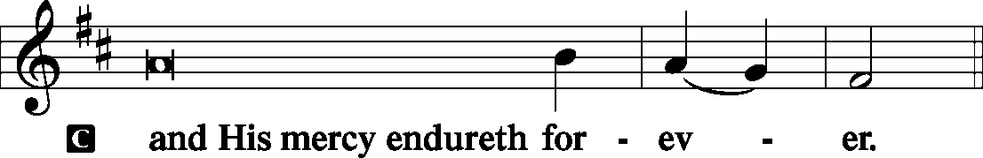
P O God the Father, the fountain and source of all goodness, who in lovingkindness sent Your only-begotten Son into the flesh, we thank You that for His sake You have given us pardon and peace in this Sacrament, and we ask You not to forsake Your children but always to rule our hearts and minds by Your Holy Spirit that we may be enabled constantly to serve You; through Jesus Christ, Your Son, our Lord, who lives and reigns with You and the Holy Spirit, one God, now and forever.

Those who are near the aisle should light their candles from the aisle torches
and then turn to let others light their candles from theirs.
The RECESSIONAL HYMN LSB 363 Silent Night, Holy Night
(See Pages 21)

SERVING TODAY
CELEBRANT Rev. Jason Braaten
ORGANIST Mrs. Leigh Ann Whitson
TRUMPET Mr. Tom Wold

ACKNOWLEDGEMENTS: Divine Service, Setting Three from Lutheran Service Book Unless otherwise indicated, all scripture quotations are from The Holy Bible, English Standard Version, copyright © 2001 by Crossway Bibles, a division of Good News Publishers. Used by permission. All rights reserved. Created by Lutheran Service Builder © 2006 Concordia Publishing House.

LSB 384 Of the Father's Love Begotten
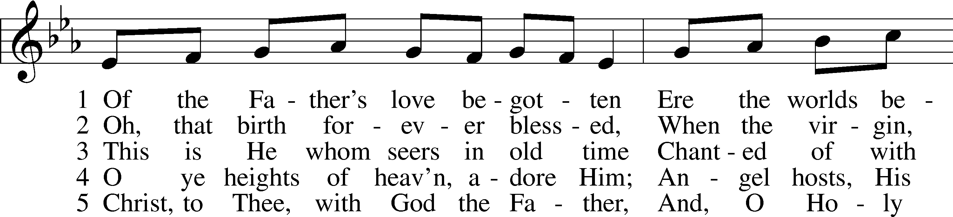
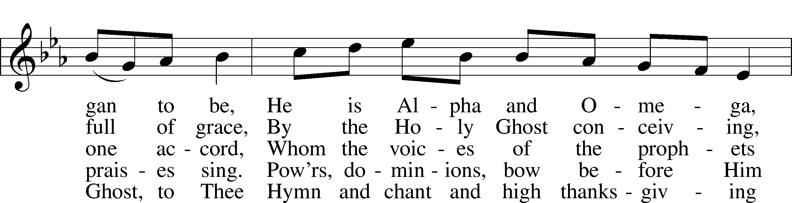
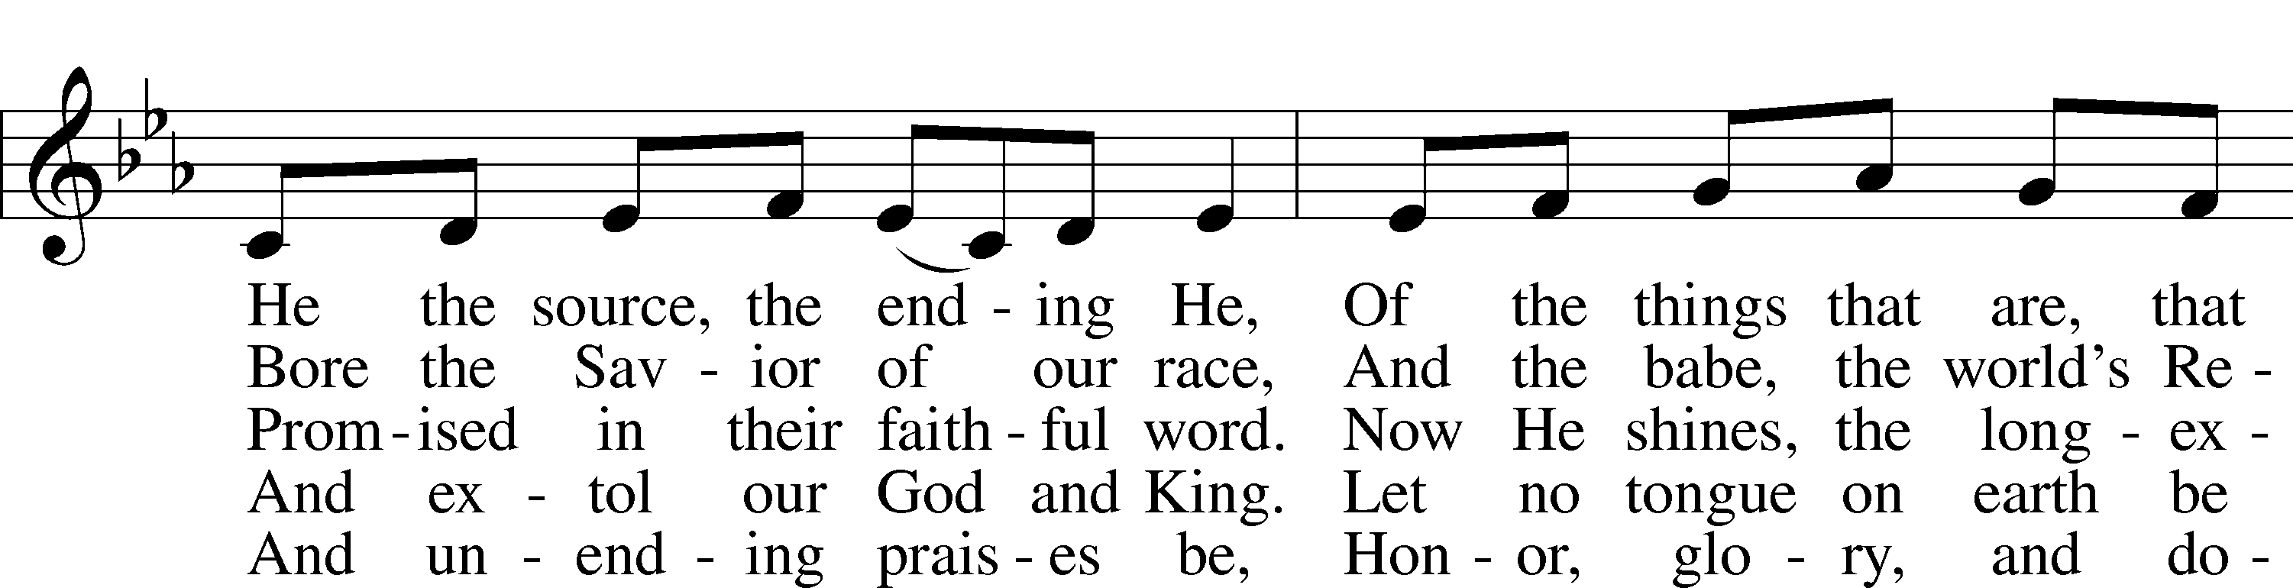
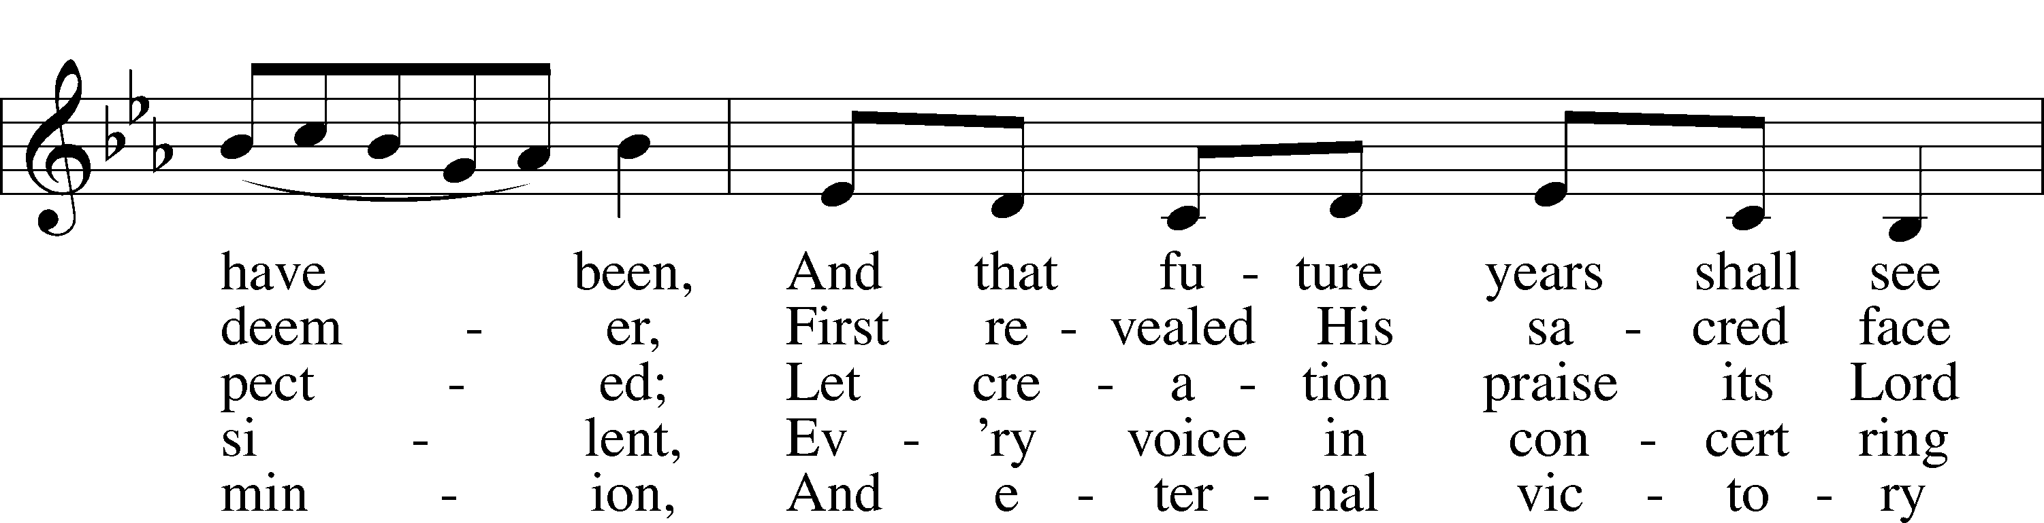
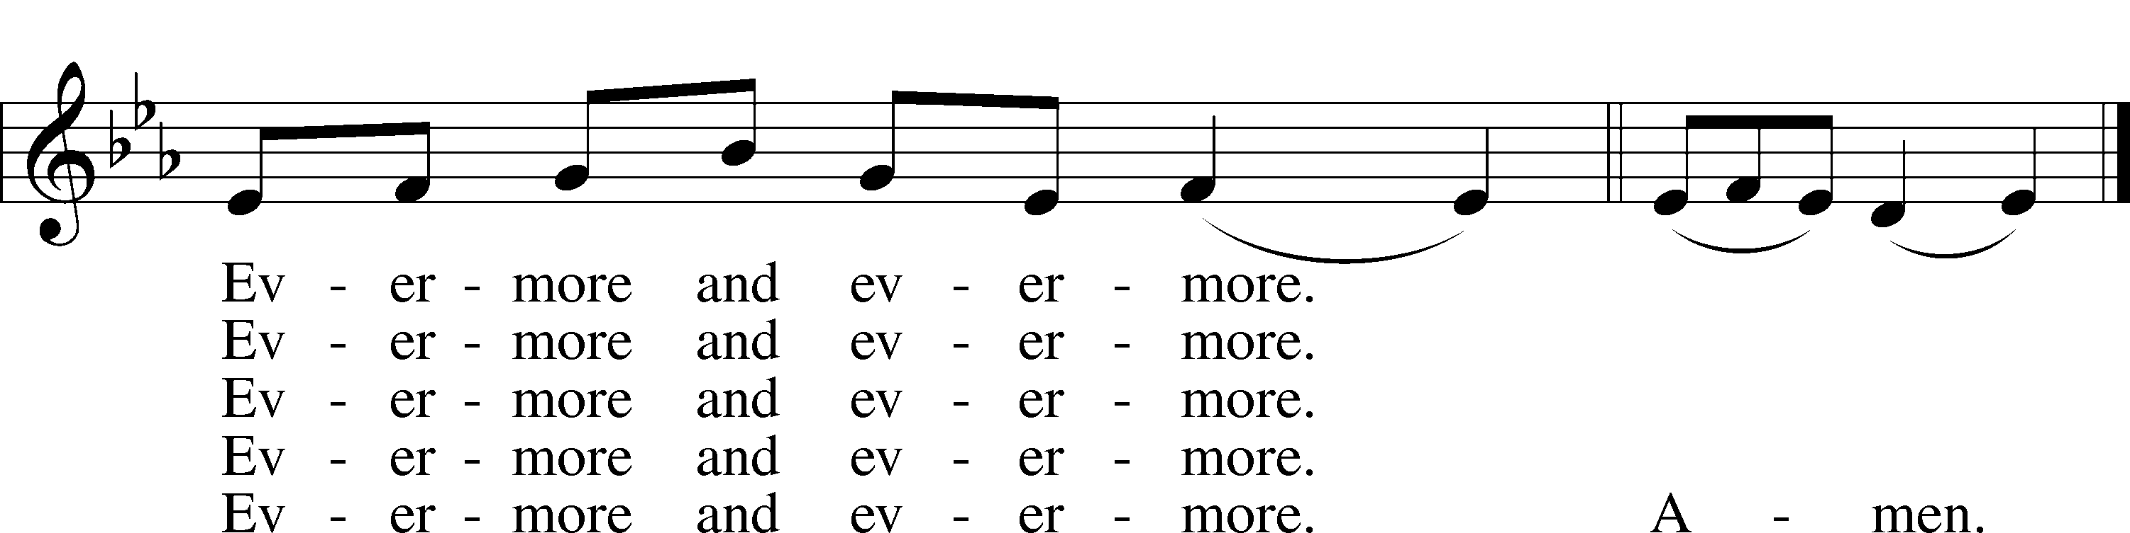
Public domain

LSB 387 Joy to the World
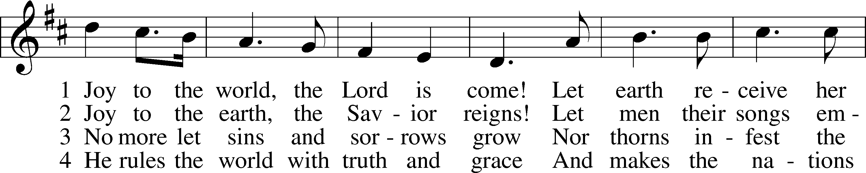
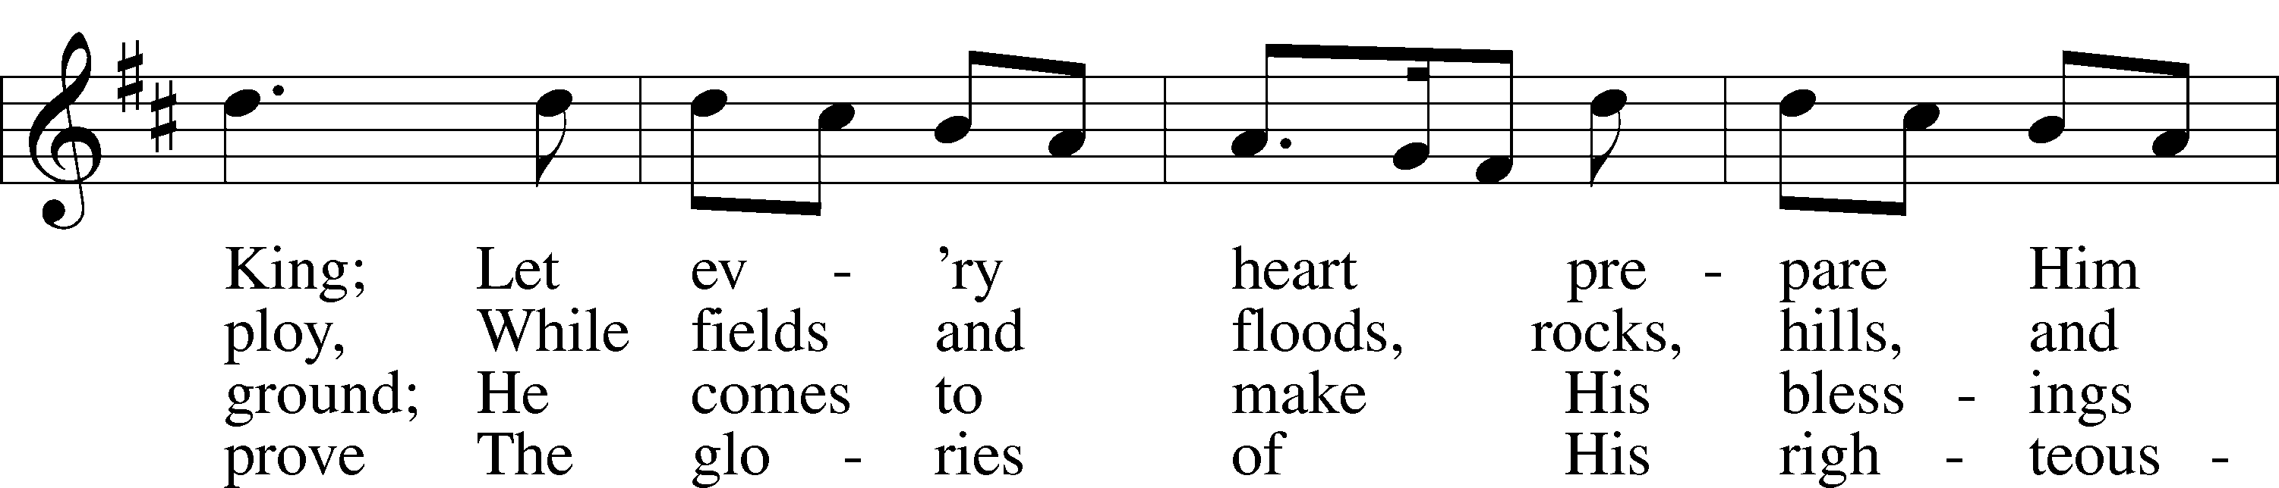
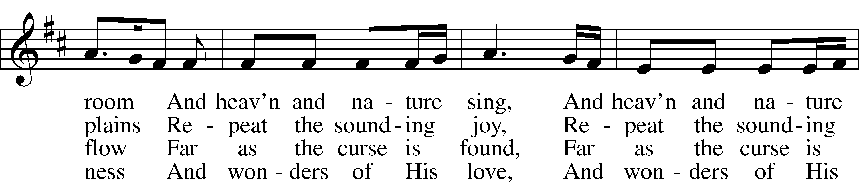
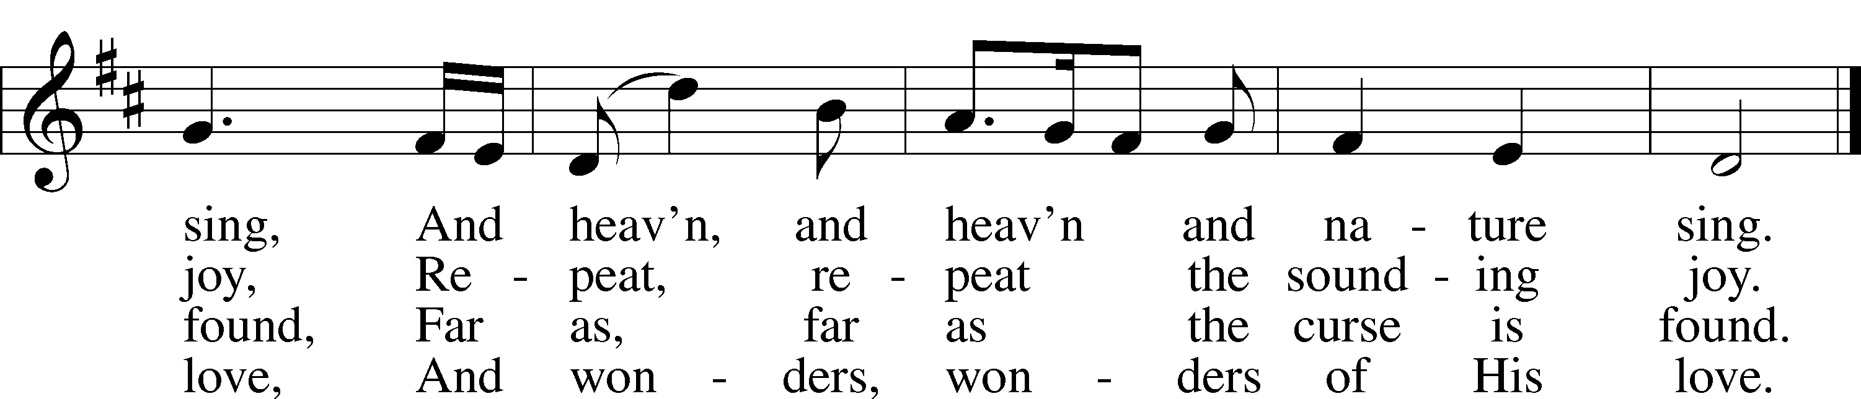
Public domain

LSB 358 From Heaven Above to Earth I Come
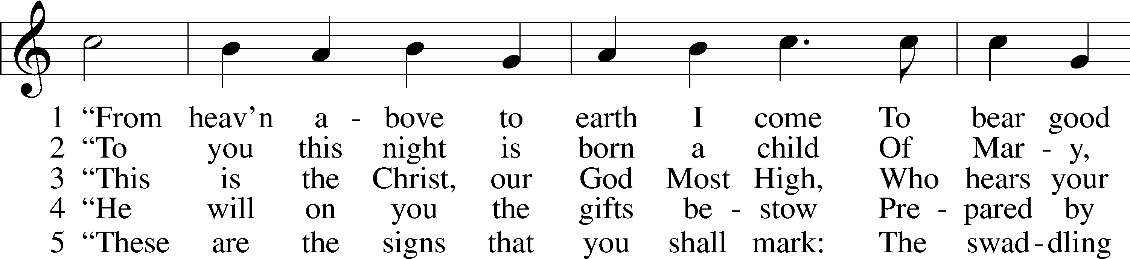
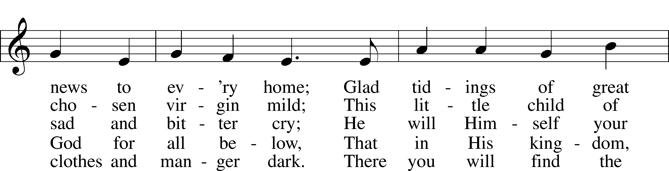
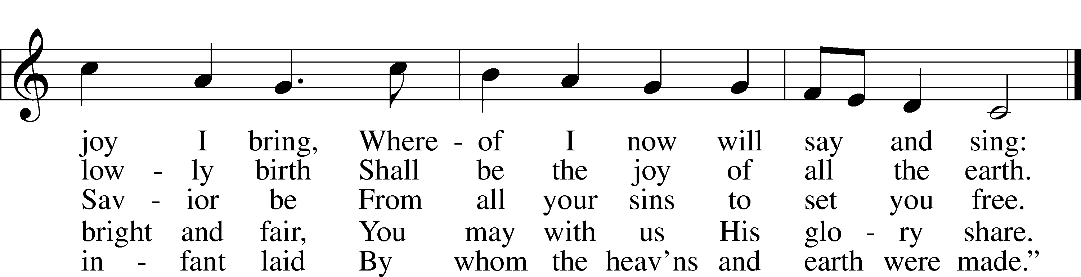

6 How glad we’ll be to find it so!
Then with the shepherds let us go
To see what God for us has done
In sending us His own dear Son.

7 Come here, my friends, lift up your eyes,
And see what in the manger lies.
Who is this child, so young and fair?
It is the Christ Child lying there.

8 Welcome to earth, O noble Guest,
Through whom the sinful world is blest!
You came to share my misery
That You might share Your joy with me.

9 Ah, Lord, though You created all,
How weak You are, so poor and small,
That You should choose to lay Your head
Where lowly cattle lately fed!

10 Were earth a thousand times as fair
And set with gold and jewels rare,
It would be far too poor and small
A cradle for the Lord of all.

11 Instead of soft and silken stuff
You have but hay and straw so rough
On which as King, so rich and great,
To be enthroned in royal state.

12 And so it pleases You to see
This simple truth revealed to me:
That worldly honor, wealth, and might
Are weak and worthless in Your sight.

13 Ah, dearest Jesus, holy Child,
Prepare a bed, soft, undefiled,
A quiet chamber set apart
For You to dwell within my heart.

14 My heart for very joy must leap;
My lips no more can silence keep.
I, too, must sing with joyful tongue
That sweetest ancient cradlesong:

15 Glory to God in highest heav’n,
Who unto us His Son has giv’n!
While angels sing with pious mirth
A glad new year to all the earth.
Public domain

LSB 367 Angels from the Realms of Glory
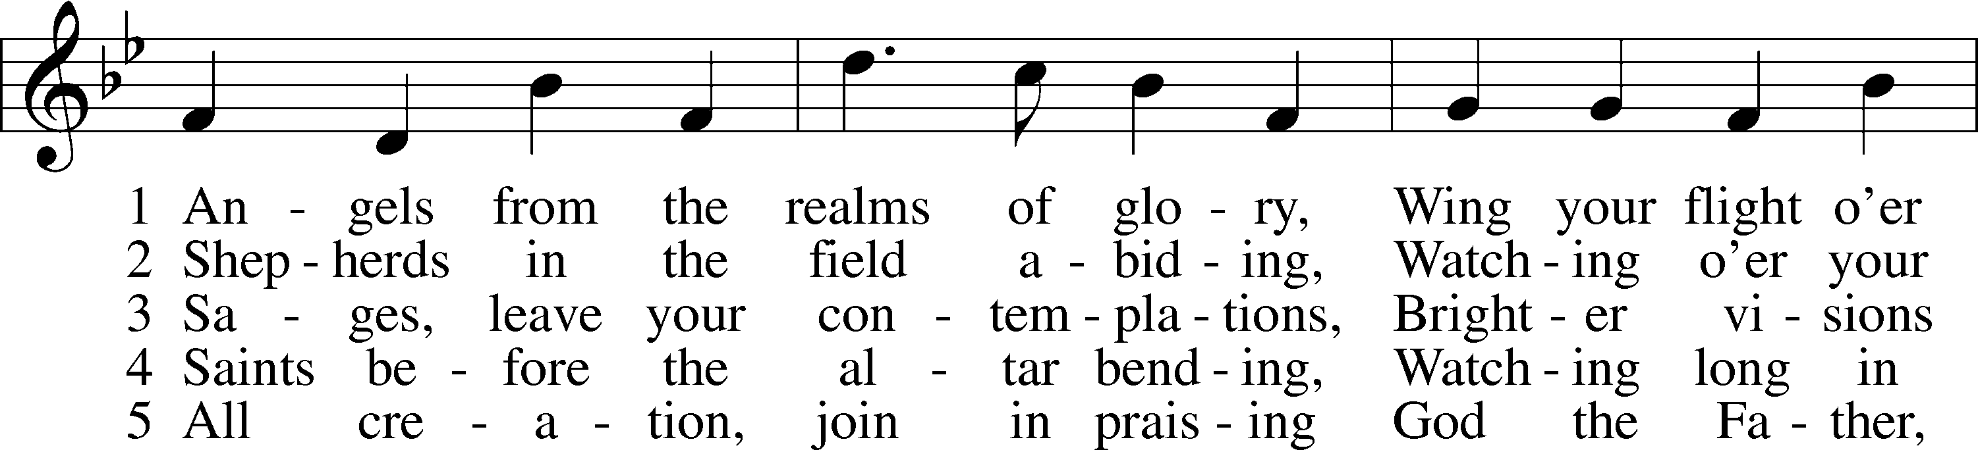
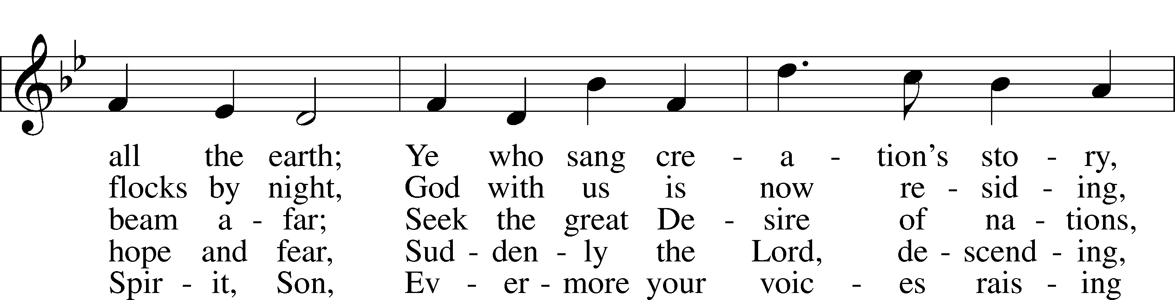
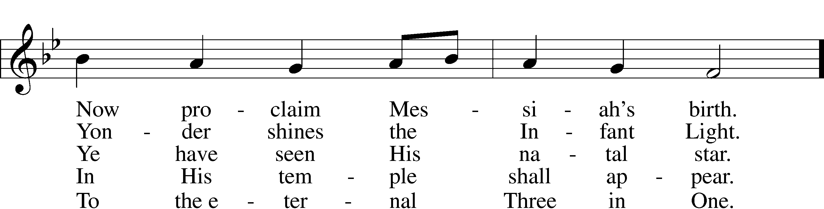
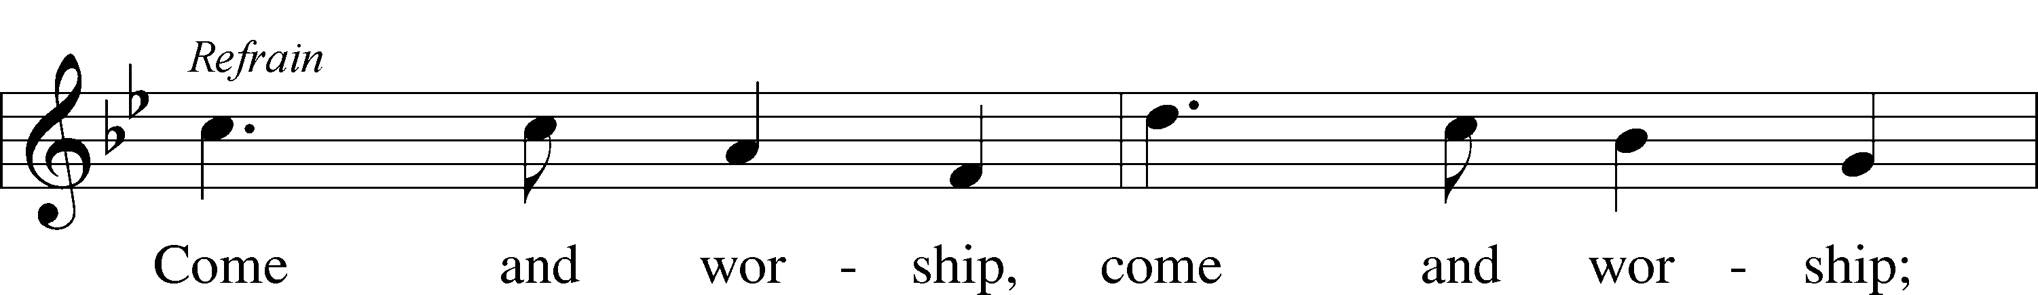
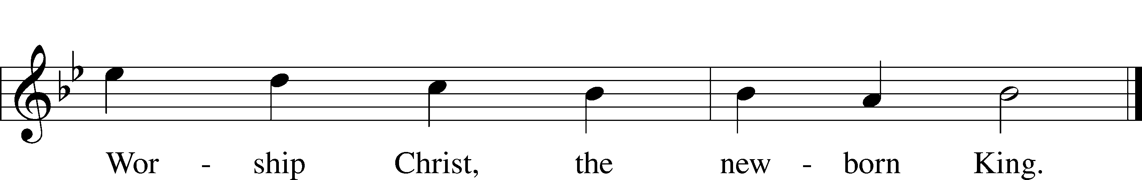
Public domain

LSB 376 Once in Royal David's City
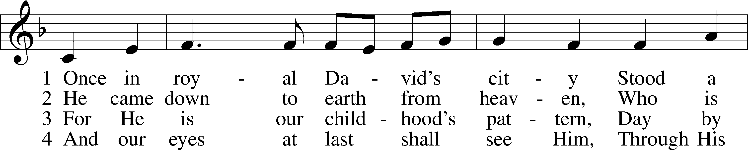
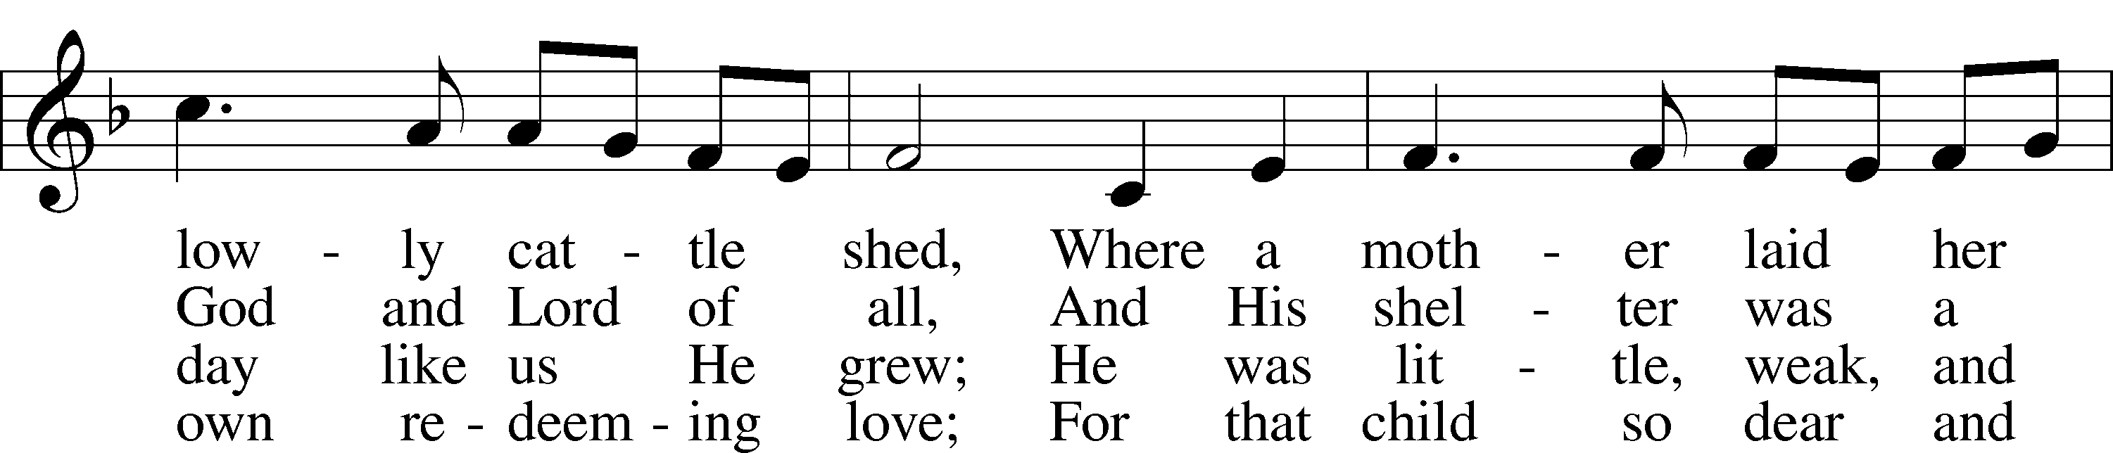
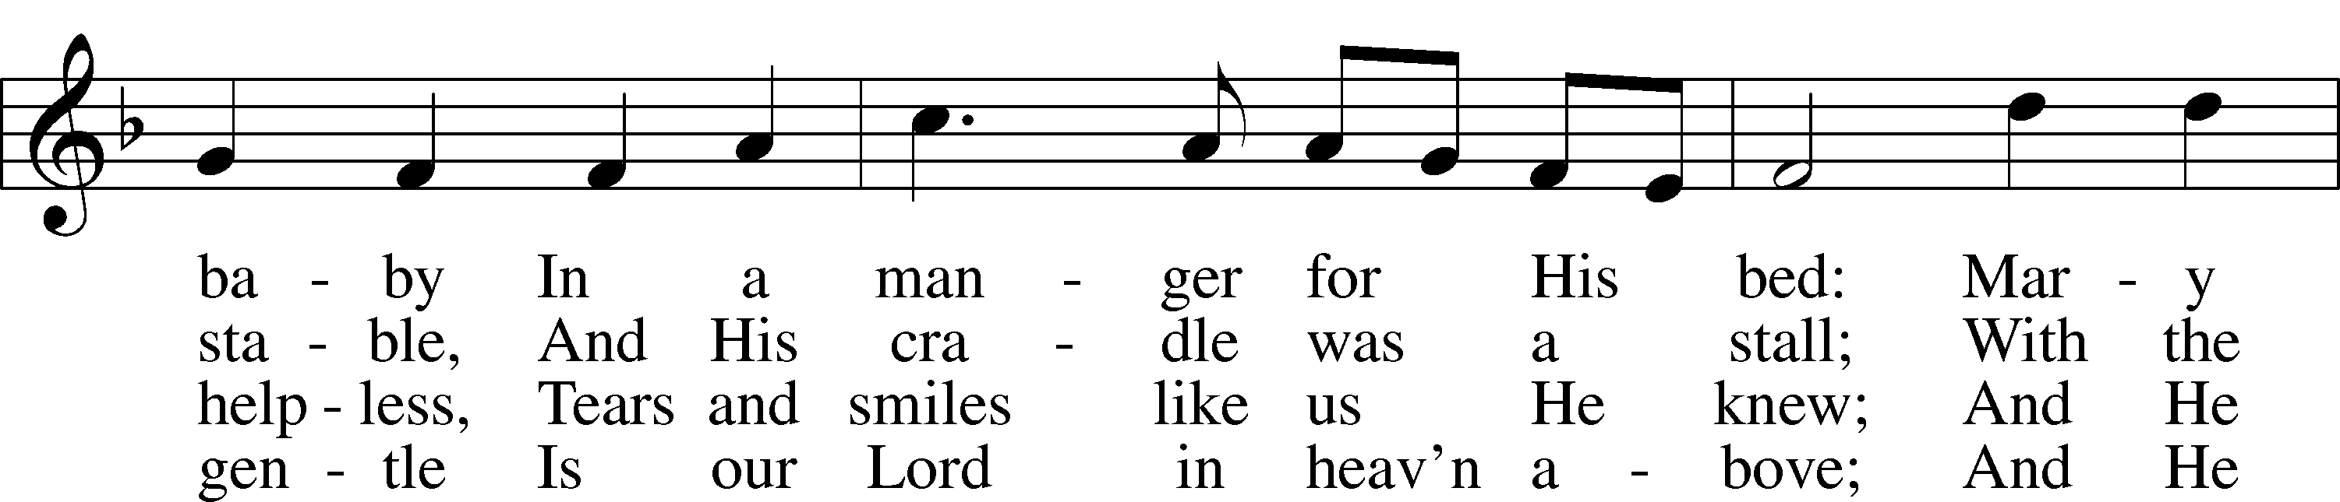
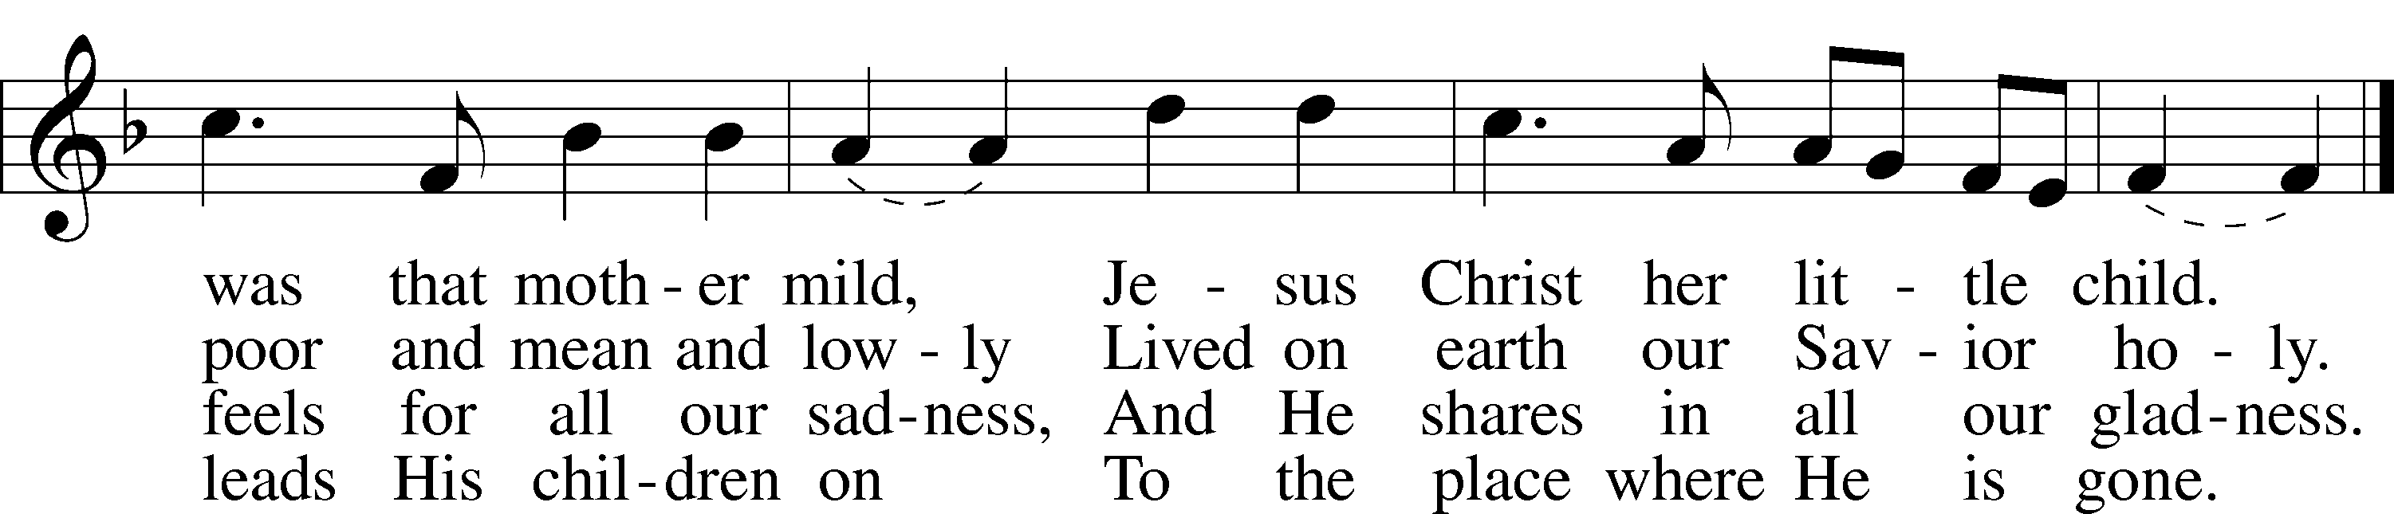

5 Not in that poor, lowly stable
With the oxen standing by
Shall we see Him, but in heaven,
Set at God’s right hand on high.
Then like stars His children, crowned,
All in white, His praise will sound!
Public domain

LSB 363 Silent Night, Holy Night
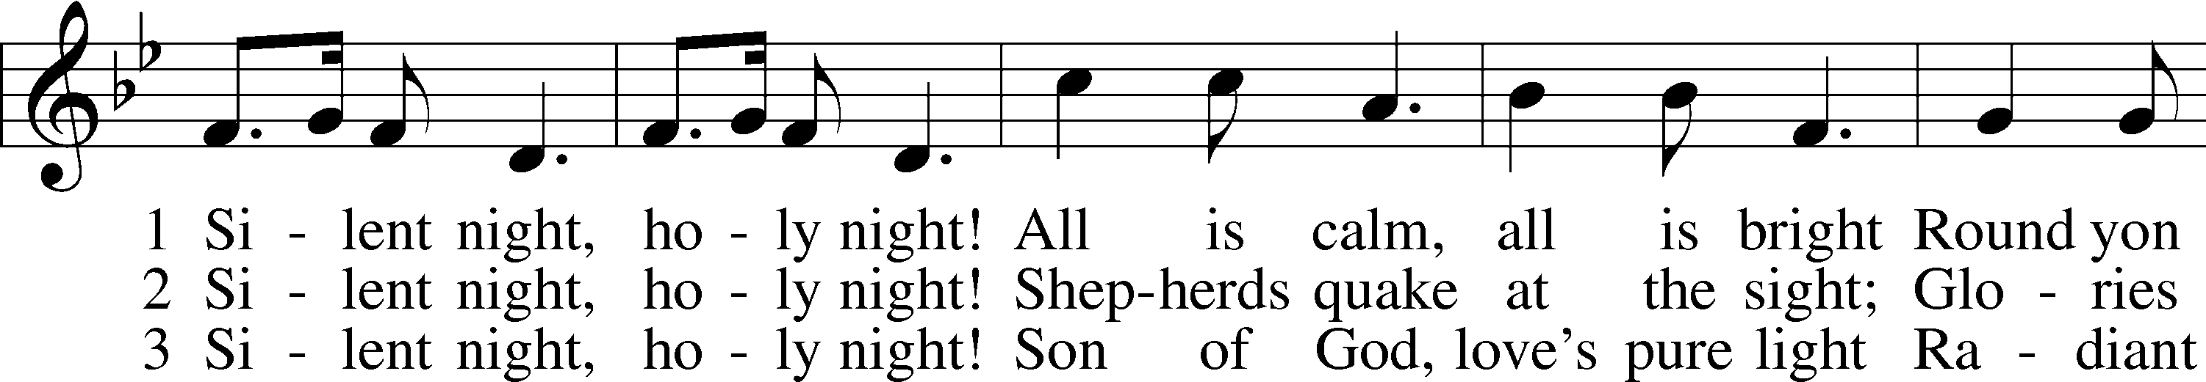
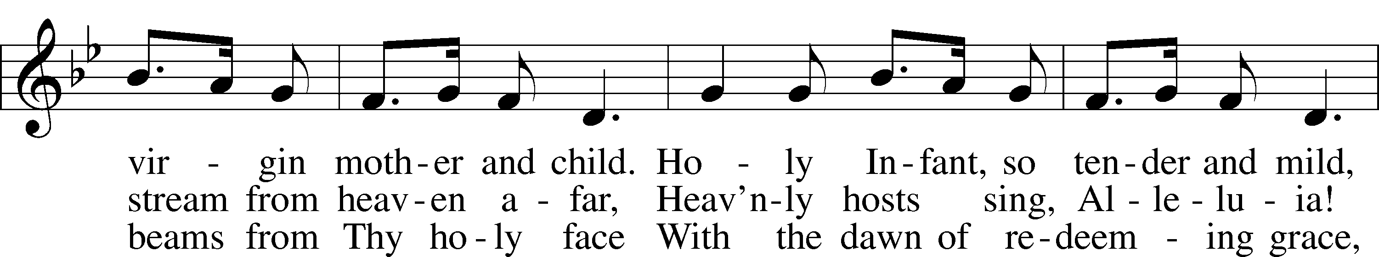
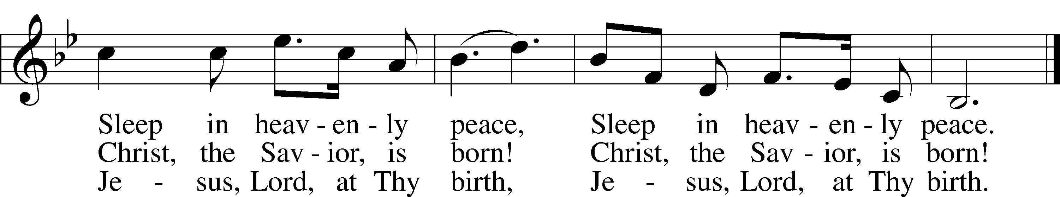
Public domain

IN OUR PRAYERS
HEALTH CONCERNS: Bernita Ashwill; Connie Bruns (cousin of Mary Appleby); Lynn Corrie (friend of Arleigh Jones); Ellie Crawford (daughter of Laran Crawford); Whitney Czerwonka; Lynn Davis (cousin of Mark Whitson); Cindy Ekstrom; Theresa Fields; Darrell Ford; Lisa Hall (sister of Holly Wikoff); Rick Hardesty (family of the Hoels); Forrest Harvey (son of John Harvey); Kim Hausman (friend of Ann Carroll); Deanna Henningsen (sister-in-law of Jerry & Joyce Alexander); Glenn Linstead; Mary Miller (friend of David Holzrichter); Kimberly Mulvany (daughter of Pastor Doug Meyer); Mary Negangard (grandmother of Bryce Reifsteck); Dennis Pickett (friend of Ann Carroll); Tim Pollock; Misti Post (niece of Sue Rothe); Cary & Beth Rahn; Joan Rahn; Aurelia Tuegal (grandmother of Bethany Campbell); Emma Silver; Dave Slaughter; Ocil Slone (grandfather of Josh & Jake Dyer); Joy Stenger; Carolyn Stremming (sister-in-law of Arleigh Jones); Brian Walker (uncle of Bryce Reifsteck); Lynn & Jane Whitson (parents of Mark Whitson).
SEMINARY STUDENT: Gunnar Campbell; Logan Smith.
DEACONESS STUDENT: Emily McLean.
MISSIONARIES: The Naumann Family; The McDermott Family, Julie Lutz
HOMEBOUND: Bernita Ashwill; Leonard Boerngen; Jim Harbaugh; Janet Pollock; Ruth Rentschler; Ruth Sims; Irene Wattjes.
MILITARY: Carl Crawford; Josh Dyer; Jeremy Gordon; Jack Leonard; Jake Lindgren; Raymond Longtin; Joey Pollock; Blake Stokes; Ruben Wilson.
THE ANNOUNCEMENTS
ABOUT THE READINGS . . . Heaven and earth rejoice on this night because the glory of the Triune God is manifested in the human birth of “our great God and Savior Jesus Christ” (Titus 2:13). In Him, the Father’s grace, mercy and peace rest upon the world. The silence of death is broken by this “good news of great joy that will be for all the people” (Luke 2:10). And all we who have gone astray like lost and wandering sheep, who have “walked in the darkness” of doubt and fear and sinful unbelief, behold “a great light” in the nativity of Christ (Is. 9:2). In Him “the grace of God has appeared” (Titus 2:11). For this Child of Mary who is born for us, this dear Son of God who is given to us, will bear the burden of our sin and death in His own body on the cross. He thereby establishes a government of peace, “with justice and with righteousness,” which shall have no end; not by any work of man, but “the zeal of the Lord of hosts will do this” (Is. 9:7).
THOUGHTS ABOUT STEWARDSHIP . . . Luke 2:12 “And this will be a sign for you: you will find a baby wrapped in swaddling cloths and lying in a manger.” Truly, as St. Paul said, He who was rich for our sakes became poor, for behold the King who must be laid in a manger, no crib for His bed! There in the manger is the very picture of self-giving generosity.

POINSETTIAS GIVEN BY
Jerry & Joyce Alexander in thanksgiving for blessings received
Ann Carroll in memory of Carl & Marie Charnetzki and Troy, Michael, & Steve Allison
Steve, Ann, Jacob & Meagan Hilgendorf in memory of Rev Dr MD & Adeline Hilgendorf
Robert & Irene Wright
Joel Hilgendorf
Reuben & Dorothy Hostetler in memory of Mary Kauffman
Arleigh Jones in memory of Mary Jane
Roger & Wanda Long in thanksgiving for blessings, our health, Family and Friends, etc.
The Munson Family in thanksgiving of God’s many blessings
Glen & Janet Stumeier in thanksgiving for God’s many blessings
Irene Wattjes in thanksgiving for God’s many blessings
The Whitson Family in memory of loved ones passed
Poinsettias can be taken home immediately following the Christmas Day service.

CHRISTMAS

By Sir John Betjeman

The bells of waiting Advent ring,
The Tortoise stove is lit again
And lamp-oil light across the night
Has caught the streaks of winter rain
In many a stained-glass window sheen
From Crimson Lake to Hookers Green.

The holly in the windy hedge
And round the Manor House the yew
Will soon be stripped to deck the ledge,
The altar, font and arch and pew,
So that the villagers can say
‘The church looks nice’ on Christmas Day.

Provincial Public Houses blaze,
Corporation tramcars clang,
On lighted tenements I gaze,
Where paper decorations hang,
And bunting in the red Town Hall
Says ‘Merry Christmas to you all’.

And London shops on Christmas Eve
Are strung with silver bells and flowers
As hurrying clerks the City leave
To pigeon-haunted classic towers,
And marbled clouds go scudding by
The many-steepled London sky.

And girls in slacks remember Dad,
And oafish louts remember Mum,
And sleepless children’s hearts are glad.
And Christmas-morning bells say ‘Come!’
Even to shining ones who dwell
Safe in the Dorchester Hotel.

And is it true,
This most tremendous tale of all,
Seen in a stained-glass window’s hue,
A Baby in an ox’s stall?
The Maker of the stars and sea
Become a Child on earth for me?

And is it true ? For if it is,
No loving fingers tying strings
Around those tissued fripperies,
The sweet and silly Christmas things,
Bath salts and inexpensive scent
And hideous tie so kindly meant,

No love that in a family dwells,
No caroling in frosty air,
Nor all the steeple-shaking bells
Can with this single Truth compare -
That God was man in Palestine
And lives today in Bread and Wine.
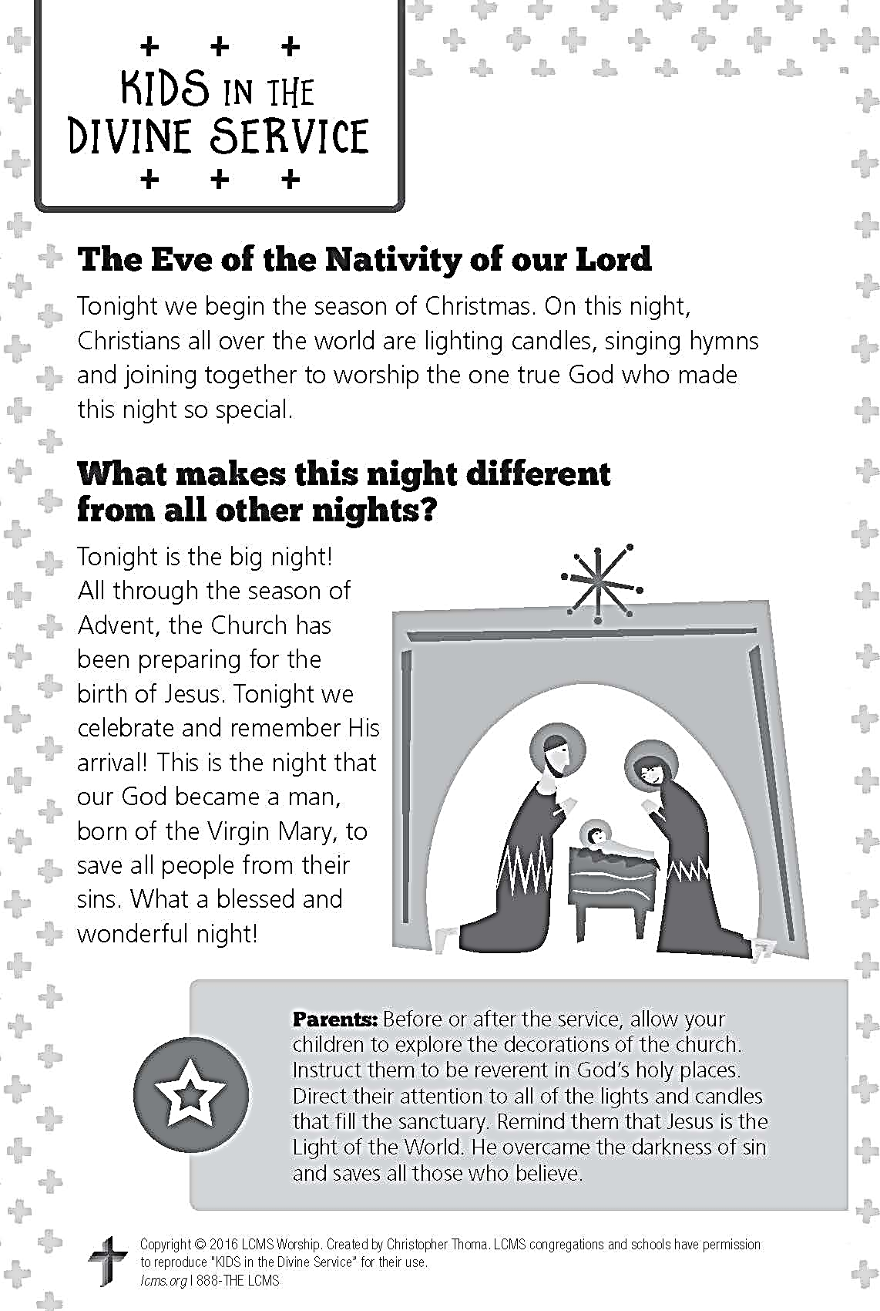

A PRAYER FOR IMMANUEL
Rev. Jason Braaten, Pastor
Home: (217) 253-4539
Mobile: (217) 460-2077
Email: pastor.braaten@gmail.com
Office Hours:
Monday–Thursday 8:00 am–12:00 pm
or by appointment

My dear Lord Jesus, I want to know You as Savior and Friend, Help me to grow into a mature disciple so that I can demonstrate God’s love and forgiveness in all I do. Teach me to share my faith in You and to serve others in my vocation. Make Immanuel Lutheran Church a place where lost and hurting people find friendship, forgiveness, and faith, and where Christians gather to serve You in love for one another, for the community, and for the world. Amen.
Debra Parsley, Office Manager
Office: (217) 253-4341
Email: immanuel.tuscola@gmail.com

Office Hours:
Monday–Tuesday 8:00 am–4:30 pm
Wednesday 8:00 am–12:30 pm

