**THE FOURTH SUNDAY IN ADVENT**





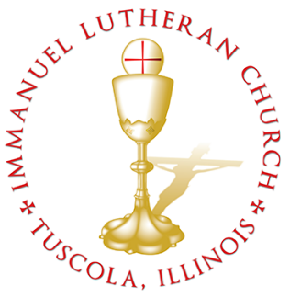 **THE FOURTH SUNDAY IN ADVENT**

*Today we celebrate the Sacrament of our Lord Jesus Christ’s true body and blood. Since receiving the Lord’s Supper expresses fellowship with the Lord and agreement with the teaching of the pastor and congregation, we follow the Biblical practice of closed communion. All guests are kindly asked to speak with Pastor Braaten before communing at our altar. Normally, members from congregations of The Lutheran Church—Missouri Synod are welcome to partake, as are people from churches in fellowship with the LCMS.*

**WELCOME VISITORS**

Divine Service, Setting Three with Holy Communion

*Stand*

The PROCESSIONAL HYMN LSB 350 Come, Thou Precious Ransom, Come

(See Page 14)

**The INVOCATION, CONFESSION, and ABSOLUTION** LSB 184

P In the name of the Father and of the T Son and of the Holy Spirit.

C **Amen.**

P Beloved in the Lord! Let us draw near with a true heart and confess our sins unto God our Father, beseeching Him in the name of our Lord Jesus Christ to grant us forgiveness.

P Our help is in the name of the Lord,

C **who made heaven and earth.**

P I said, I will confess my transgressions unto the Lord,

C **and You forgave the iniquity of my sin.**

P O almighty God, merciful Father,

C **I, a poor, miserable sinner, confess unto You all my sins and iniquities with which I have ever offended You and justly deserved Your temporal and eternal punishment. But I am heartily sorry for them and sincerely repent of them, and I pray You of Your boundless mercy and for the sake of the holy, innocent, bitter sufferings and death of Your beloved Son, Jesus Christ, to be gracious and merciful to me, a poor, sinful being.**

P Upon this your confession, I, by virtue of my office, as a called and ordained servant of the Word, announce the grace of God unto all of you, and in the stead and by the command of my Lord Jesus Christ I forgive you all your sins in the name of the Father and of the T Son and of the Holy Spirit.

C **Amen.**

The INTROIT Ps. 19:1, 4–6; antiphon: Is. 45:8a

*Shower, O heavens,* ***|*** *from above,****\****

*and let the clouds rain down* ***|*** *righteousness;*

*let the earth open, that salvation and righteousness may* ***|*** *bear fruit;****\****

*let the earth cause them* ***|*** *both to sprout.*

**The heavens declare the glo- | ry of God,\***

**and the sky above proclaims his | handiwork.**

*Their measuring line goes out through all the earth, and their words to the*

*end* ***|*** *of the world.****\****

*In them he has set a tent* ***|*** *for the sun,*

**which comes out like a bridegroom leaving his | chamber,\***

**and, like a strong man, runs its | course with joy.**

*Its rising is from the end of the heavens, and its circuit to the* ***|*** *end of them,****\****

*and there is nothing hidden* ***|*** *from its heat.*

**Glory be to the Father and | to the Son\***

**and to the Holy | Spirit;**

**as it was in the be- | ginning,\***

**is now, and will be forever. | Amen.**

*Shower, O heavens,* ***|*** *from above,****\****

*and let the clouds rain down* ***|*** *righteousness;*

**let the earth open, that salvation and righteousness may | bear fruit;\***

**let the earth cause them | both to sprout.**

**The KYRIE** LSB 186

*The GLORIA IN EXCELSIS is omitted during Advent.*

**The SALUTATION and COLLECT OF THE DAY** LSB 189

C **Stir up Your power, O Lord*,* and come and help us by Your might, that the sins which weigh us down may be quickly lifted by Your grace and mercy; for You live and reign with the Father and the Holy Spirit, one God, now and forever.**

*Sit*

The FIRST READING Deuteronomy 18:15–19

The Lord your God will raise up for you a prophet like me from among you, from your brothers—it is to him you shall listen— just as you desired of the Lord your God at Horeb on the day of the assembly, when you said, “Let me not hear again the voice of the Lord my God or see this great fire any more, lest I die.” And the Lord said to me, “They are right in what they have spoken. I will raise up for them a prophet like you from among their brothers. And I will put my words in his mouth, and he shall speak to them all that I command him. And whoever will not listen to my words that he shall speak in my name, I myself will require it of him.”

P This is the Word of the Lord.

C **Thanks be to God.**

**The GRADUAL** Ps. 145:18, 21

*The Lord is near to all who* ***|*** *call on him,****\****

*to all who call on* ***|*** *him in truth.*

**My mouth will speak the praise | of the Lord,\***

**and let all flesh bless his holy name forever and | ever.**

The SECOND READING Philippians 4:4–7

Rejoice in the Lord always; again I will say, Rejoice. Let your reasonableness be known to everyone. The Lord is at hand; do not be anxious about anything, but in everything by prayer and supplication with thanksgiving let your requests be made known to God. And the peace of God, which surpasses all understanding, will guard your hearts and your minds in Christ Jesus.

P This is the Word of the Lord.

C **Thanks be to God.**

*Stand*

The ALLELUIA LSB 190

**The HOLY GOSPEL** St. John 1:19–28

P The Holy Gospel according to St. John, the first chapter.

C **Glory be to Thee, O Lord.** *(Sung)*

And this is the testimony of John, when the Jews sent priests and Levites from Jerusalem to ask him, “Who are you?” He confessed, and did not deny, but confessed, “I am not the Christ.” And they asked him, “What then? Are you Elijah?” He said, “I am not.” “Are you the Prophet?” And he answered, “No.” So they said to him, “Who are you? We need to give an answer to those who sent us. What do you say about yourself?” He said, “I am the voice of one crying out in the wilderness, ‘Make straight the way of the Lord,’ as the prophet Isaiah said.”

(Now they had been sent from the Pharisees.) They asked him, “Then why are you baptizing, if you are neither the Christ, nor Elijah, nor the Prophet?” John answered them, “I baptize with water, but among you stands one you do not know, even he who comes after me, the strap of whose sandal I am not worthy to untie.” These things took place in Bethany across the Jordan, where John was baptizing.

P This is the Gospel of the Lord.

C **Praise be to Thee, O Christ.** *(Sung)*

**The NICENE CREED** LSB 191

C **I believe in one God,**

**the Father Almighty,**

**maker of heaven and earth**

**and of all things visible and invisible.**

**And in one Lord Jesus Christ,**

**the only-begotten Son of God,**

**begotten of His Father before all worlds,**

**God of God, Light of Light,**

**very God of very God,**

**begotten, not made,**

**being of one substance with the Father,**

**by whom all things were made;**

**who for us men and for our salvation came down from heaven**

**and was incarnate by the Holy Spirit of the virgin Mary**

**and was made man;**

**and was crucified also for us under Pontius Pilate.**

**He suffered and was buried.**

**And the third day He rose again according to the Scriptures**

**and ascended into heaven**

**and sits at the right hand of the Father.**

**And He will come again with glory to judge both the living and the dead,**

**whose kingdom will have no end.**

**And I believe in the Holy Spirit,**

**the Lord and giver of life,**

**who proceeds from the Father and the Son,**

**who with the Father and the Son together is worshiped and glorified,**

**who spoke by the prophets.**

**And I believe in one holy Christian and apostolic Church,**

**I acknowledge one Baptism for the remission of sins,**

**and I look for the resurrection of the dead**

**and the life T of the world to come. Amen.**

*Sit*

The HYMN OF THE DAY LSB 357 O Come, O Come, Emmanuel

(See Pages 15 & 16)

**The SERMON**

*Stand*

**The OFFERTORY** LSB 192

*Stand*

**The PRAYER OF THE CHURCH**

P Lord, in Your mercy.

C **Hear our prayer.**

The Preface and PROPER PREFACE LSB 194

P It is truly meet, right, and salutary . . . evermore praising You and saying:

**The SANCTUS** LSB 195

The Lord's Prayer LSB 196

C **Our Father who art in heaven,**

**hallowed be Thy name,**

**Thy kingdom come,**

**Thy will be done on earth as it is in heaven;**

**give us this day our daily bread;**

**and forgive us our trespasses as we forgive those who trespass against us;**

**and lead us not into temptation,**

**but deliver us from evil.**

**For Thine is the kingdom and the power and the glory forever and ever. Amen.**

The Words of Institution LSB 197

The Pax Domini LSB 197

The Agnus Dei LSB 198

*Sit*

The HYMN LSB 379 O Come, All Ye Faithful

LSB 361 O Little Town of Bethlehem

(See Pages 17 & 18)

*Stand*

**The NUNC DIMITTIS** LSB 199–200

The Thanksgiving LSB 200

P O God the Father, the fountain and source of all goodness, who in lovingkindness sent Your only-begotten Son into the flesh, we thank You that for His sake You have given us pardon and peace in this Sacrament, and we ask You not to forsake Your children but always to rule our hearts and minds by Your Holy Spirit that we may be enabled constantly to serve You; through Jesus Christ, Your Son, our Lord, who lives and reigns with You and the Holy Spirit, one God, now and forever.

**The SALUTATION, BENEDICAMUS and BENEDICTION** LSB 201–202

The Benediction LSB 202

The RECESSIONAL HYMNLSB 805 Praise God, from Whom All Blessings Flow

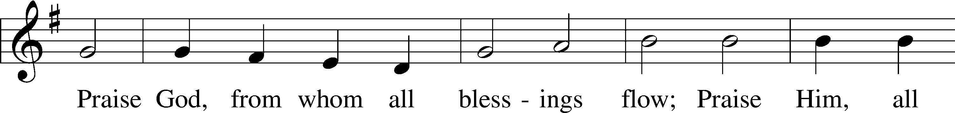

Public domain

**SERVING TODAY**

CELEBRANT *Rev. Jason Braaten*

ORGANIST *Mr. Glenn Linstead*

*Mrs. Leigh Ann Whitson*

ACKNOWLEDGEMENTS: Divine Service, Setting Three from Lutheran Service Book Unless otherwise indicated, all scripture quotations are from *The Holy Bible, English Standard Version*, copyright © 2001 by Crossway Bibles, a division of Good News Publishers. Used by permission. All rights reserved. Created by Lutheran Service Builder © 2006 Concordia Publishing House.

LSB 350 Come, Thou Precious Ransom, Come

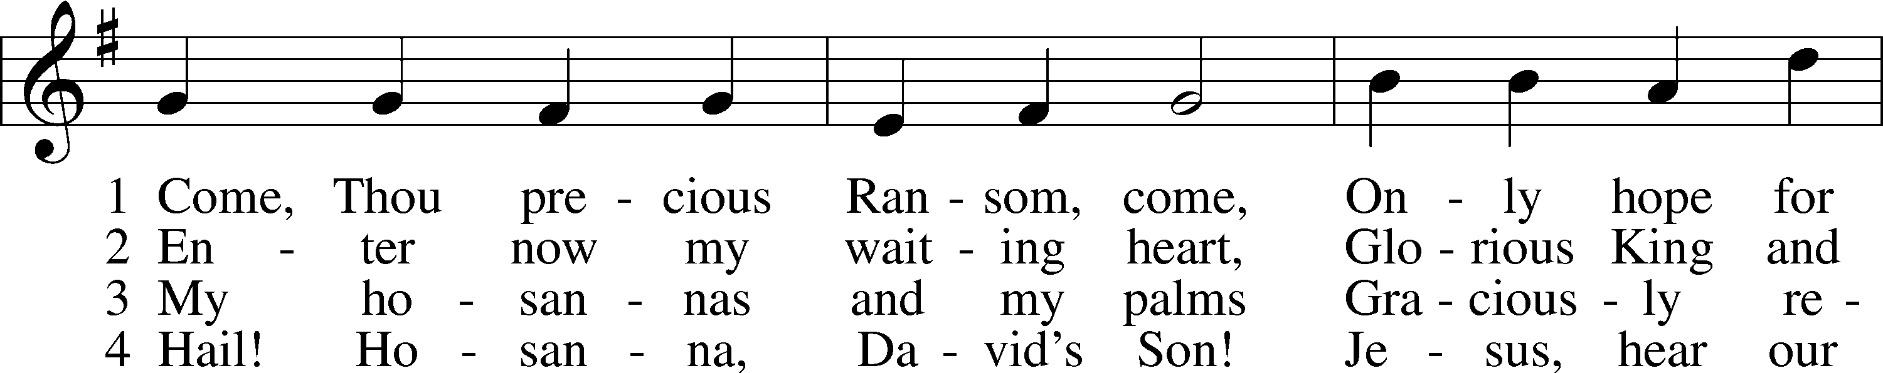

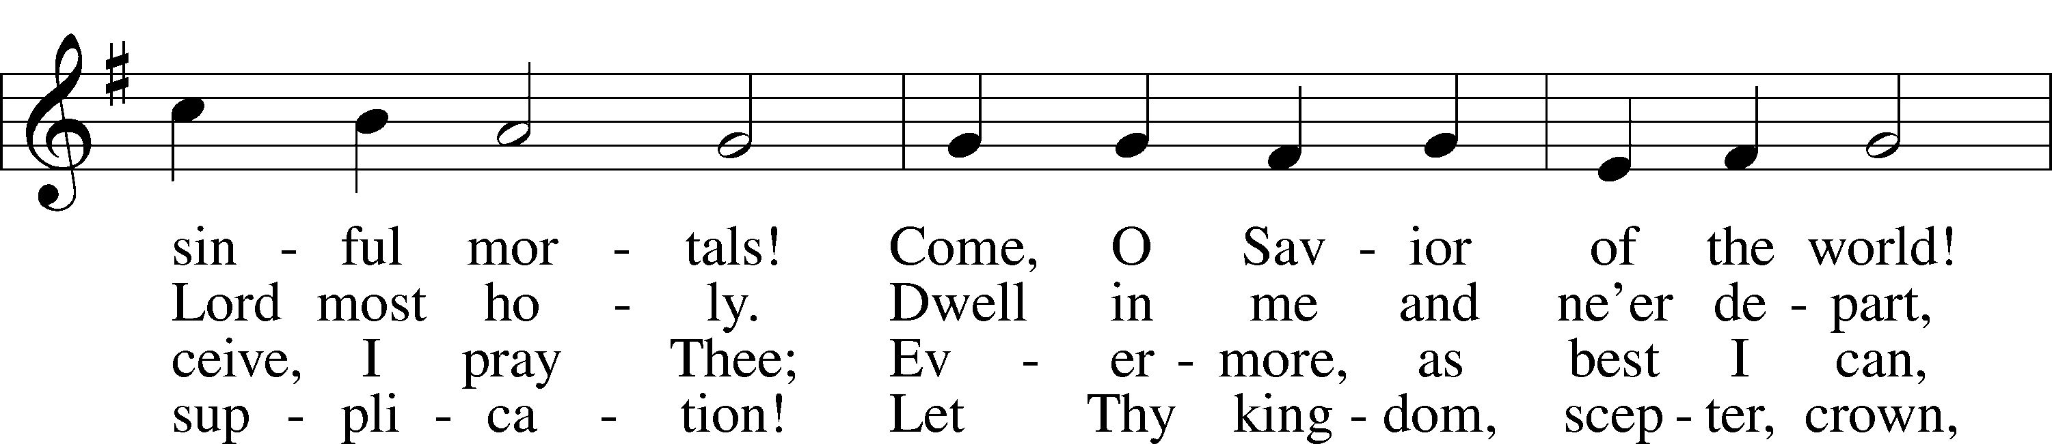

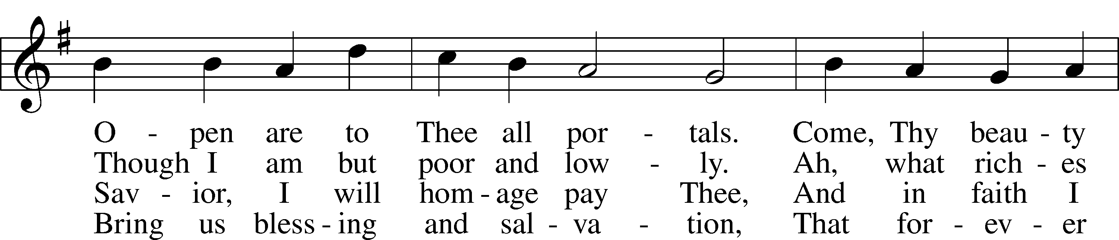

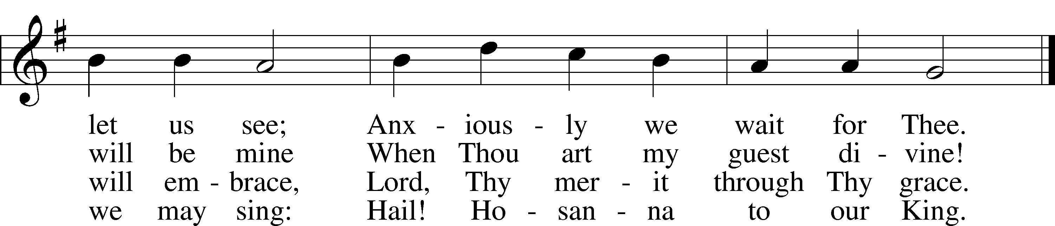

Public domain

LSB 357 O Come, O Come, Emmanuel

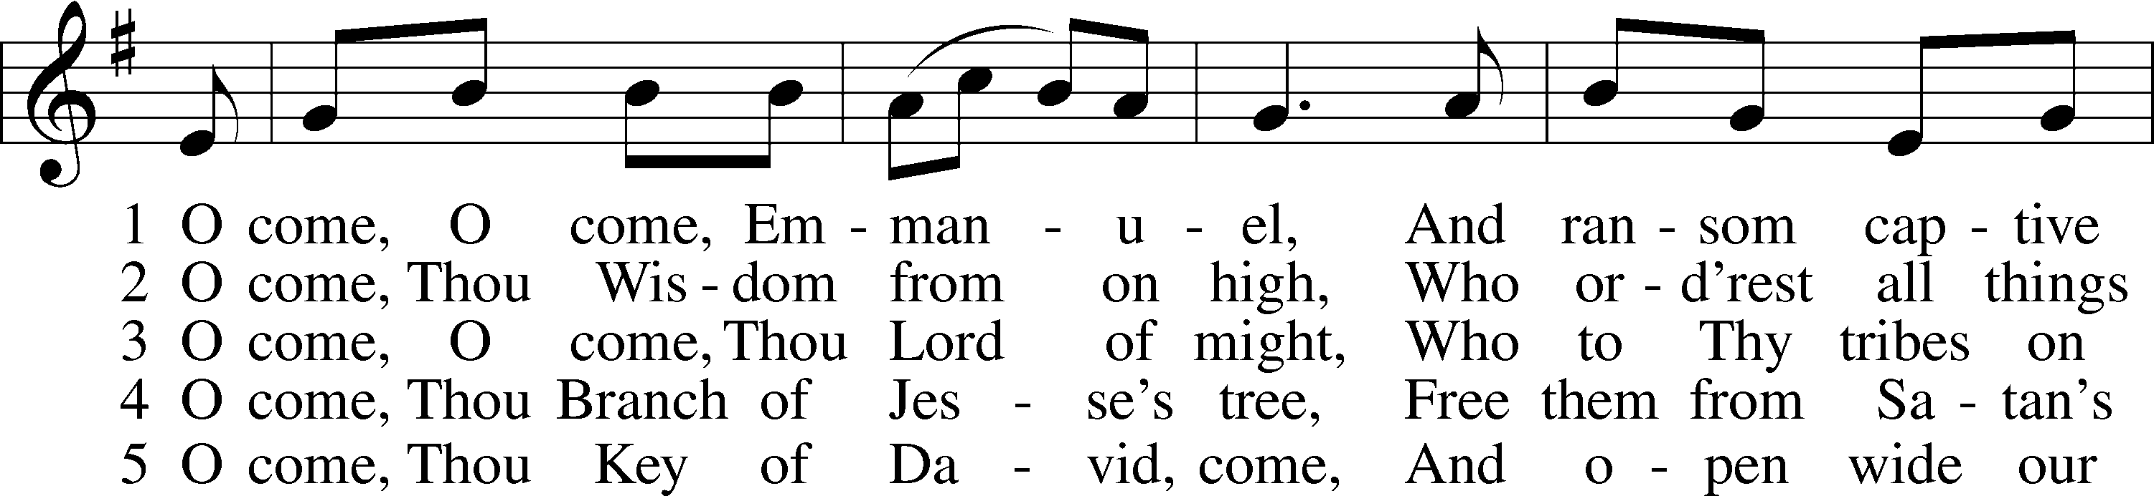

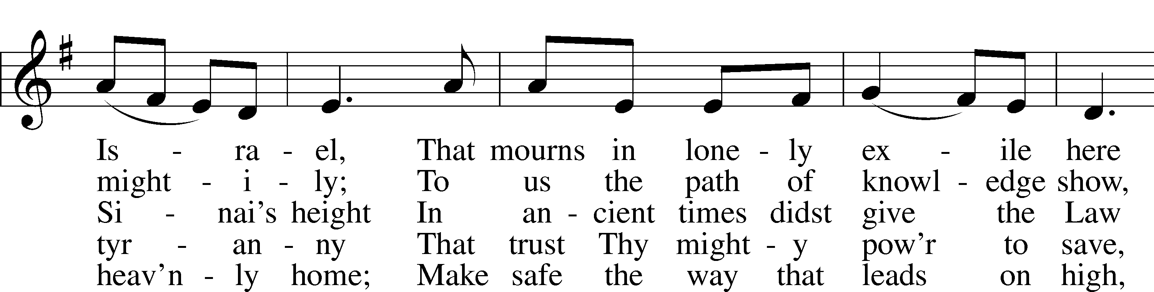

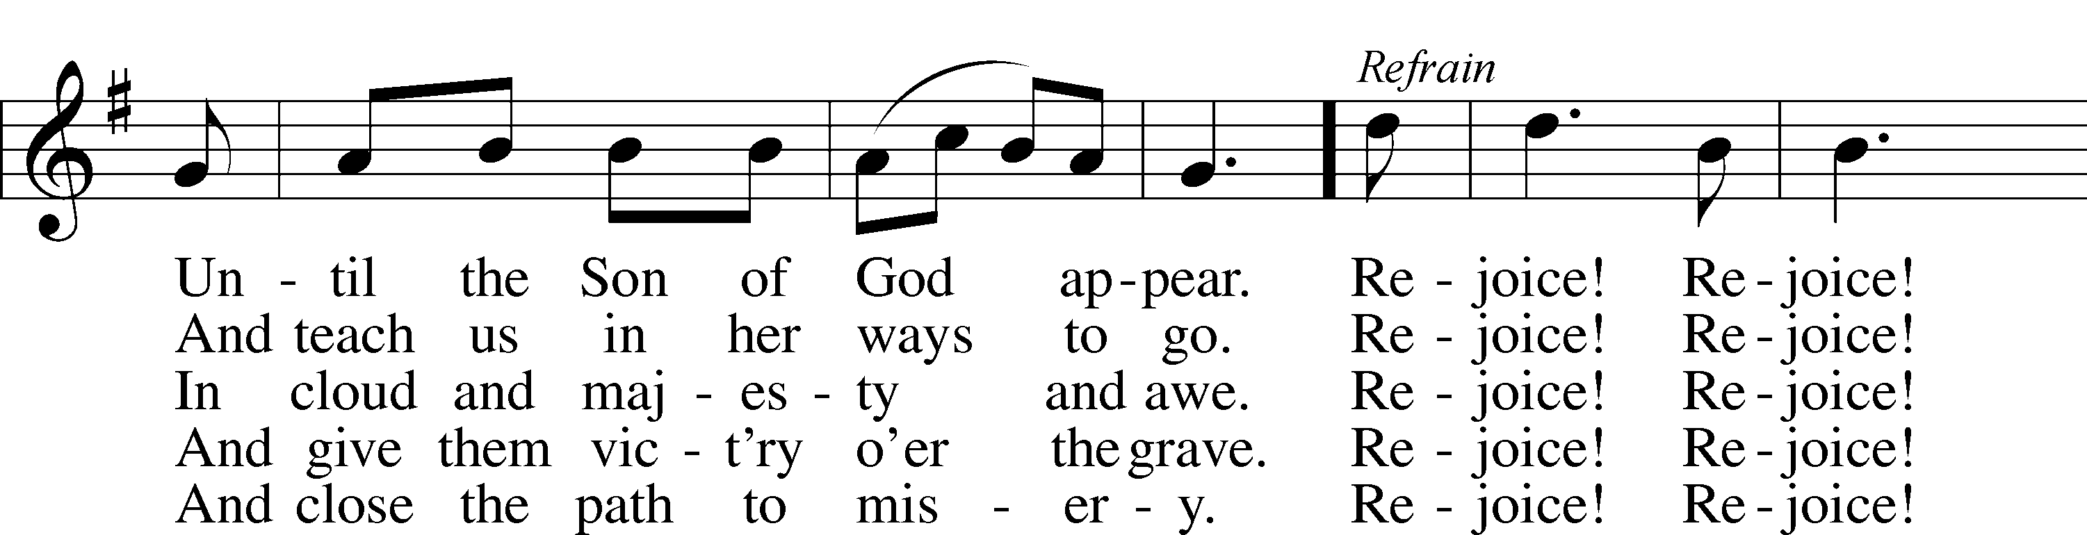

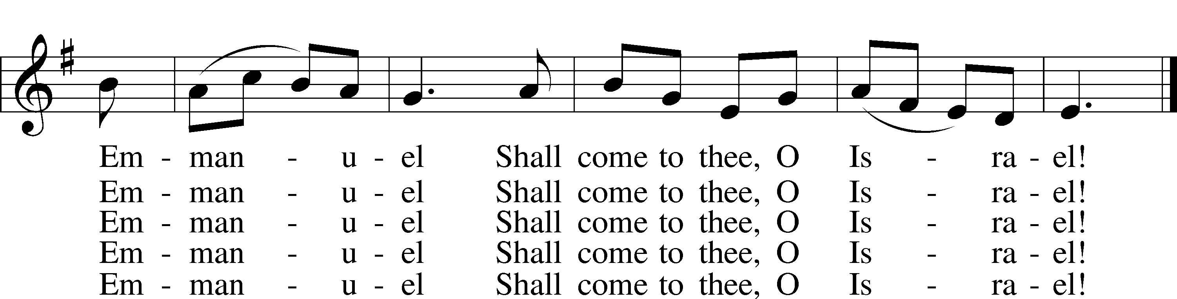

6 O come, Thou Dayspring from on high,  
And cheer us by Thy drawing nigh;  
Disperse the gloomy clouds of night,  
And death’s dark shadows put to flight.

Rejoice! Rejoice! Emmanuel  
Shall come to thee, O Israel!

7 O come, Desire of nations, bind  
In one the hearts of all mankind;  
Bid Thou our sad divisions cease,  
And be Thyself our King of Peace.

Rejoice! Rejoice! Emmanuel  
Shall come to thee, O Israel!

Public domain

LSB 379 O Come, All Ye Faithful

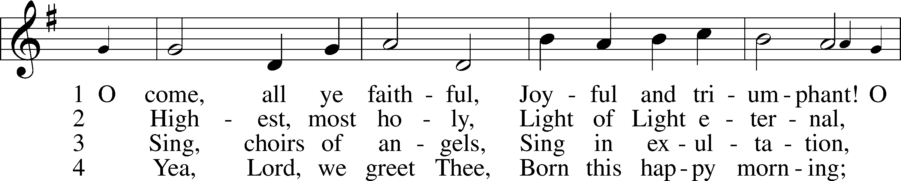

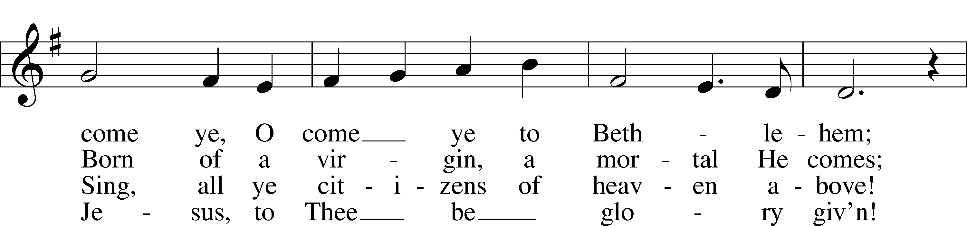

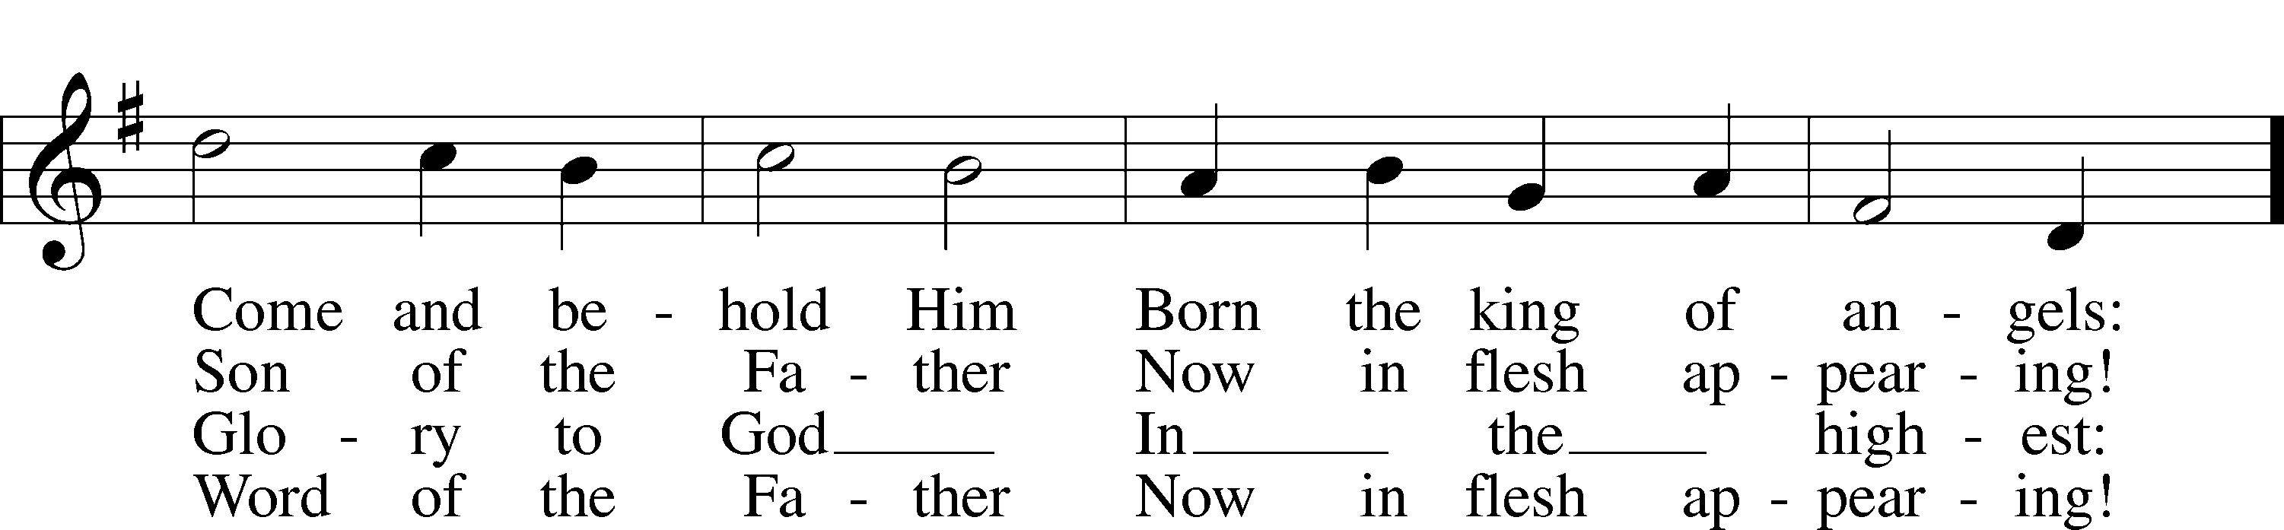

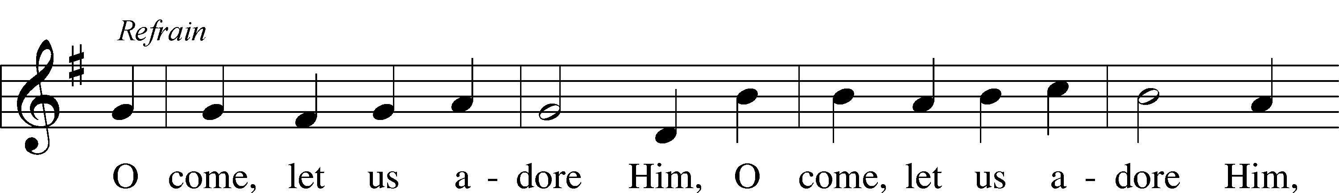

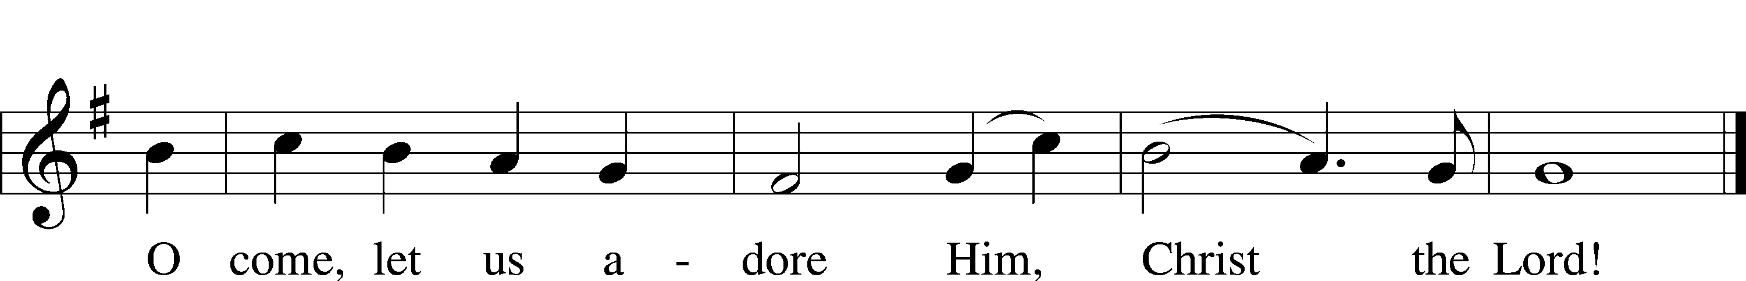

LSB 361 O Little Town of Bethlehem

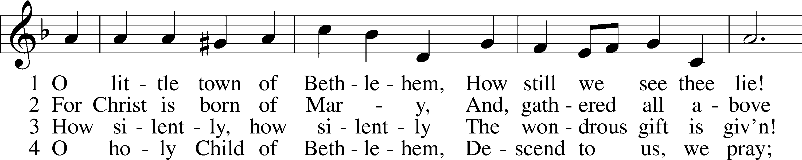

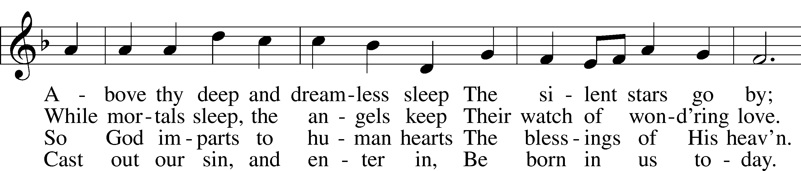

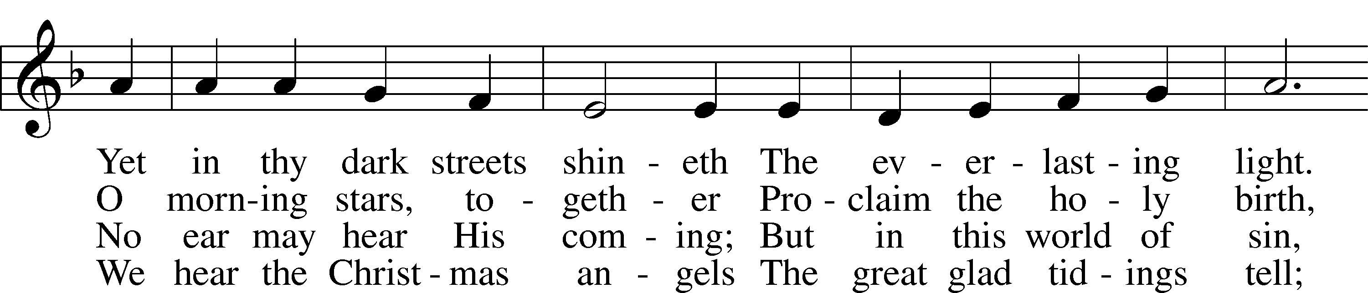

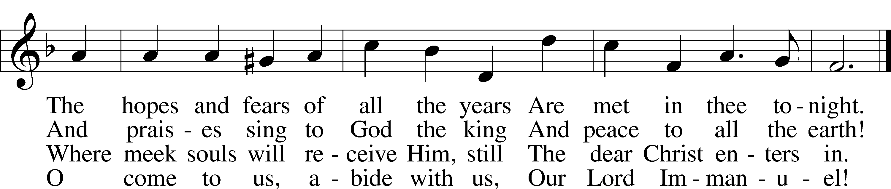

Public domain

THIS WEEK AT IMMANUEL

Sunday (12/20) 9:00 am Divine Service with Holy Communion

Wednesday (12/23) 12:30 pm Catechism Class

Thursday 7:00 pm Christmas Eve Service with Communion

Friday 9:00 am Christmas Day Service with Communion

Saturday 3:30 pm Individual Confession & Absolution

5:30 pm Divine Service with Holy Communion

Sunday (12/27) 9:00 am Divine Service with Holy Communion

10:30 am Bible Class & Sunday School

Thursday (12/31) 7:00 pm New Year’s Eve Evening Prayer Service

**IN OUR PRAYERS**

HEALTH CONCERNS: Bernita Ashwill; Connie Bruns (cousin of Mary Appleby); Lynn Corrie (friend of Arleigh Jones); Ellie Crawford (daughter of Laran Crawford); Whitney Czerwonka; Lynn Davis (cousin of Mark Whitson); Cindy Ekstrom; Theresa Fields; Darrell Ford; Lisa Hall (sister of Holly Wikoff); Rick Hardesty (family of the Hoels); Forrest Harvey (son of John Harvey); Kim Hausman (friend of Ann Carroll); Deanna Henningsen (sister-in-law of Jerry & Joyce Alexander); Glenn Linstead; Mary Miller (friend of David Holzrichter); Kimberly Mulvany (daughter of Pastor Doug Meyer); Mary Negangard (grandmother of Bryce Reifsteck); Dennis Pickett (friend of Ann Carroll); Tim Pollock; Misti Post (niece of Sue Rothe); Cary & Beth Rahn; Joan Rahn; Aurelia Tuegal (grandmother of Bethany Campbell); Emma Silver; Dave Slaughter; Ocil Slone (grandfather of Josh & Jake Dyer); Joy Stenger; Carolyn Stremming (sister-in-law of Arleigh Jones); Brian Walker (uncle of Bryce Reifsteck); Lynn & Jane Whitson (parents of Mark Whitson).

SEMINARY STUDENT: Gunnar Campbell; Logan Smith.

DEACONESS STUDENT: Emily McLean.

MISSIONARIES: The Naumann Family; The McDermott Family, Julie Lutz

HOMEBOUND: Bernita Ashwill; Leonard Boerngen; Jim Harbaugh; Janet Pollock; Ruth Rentschler; Ruth Sims; Irene Wattjes.

MILITARY: Carl Crawford; Josh Dyer; Jeremy Gordon; Jack Leonard; Jake Lindgren; Raymond Longtin; Joey Pollock; Blake Stokes; Ruben Wilson.

**THE ANNOUNCEMENTS**

NEXT WEEK’S READINGS . . . Isaiah 11:1–5; Galatians 4:1–7; St. Luke 2:33–40.

ABOUT THIS WEEK’S READINGS . . . The coming of God in all His unveiled power at Mount Sinai was terrifying to the people of Israel. The thundering voice of the Lord puts sinners in fear of death (Deut. 18:15–19). God, therefore, raised up a prophet like Moses—the Messiah, the Christ. God came to His people veiled in human flesh. The skies poured down the Righteous One from heaven; the earth opened her womb and brought forth Salvation (Introit) through the blessed Virgin Mary, the mother of the Lord (Luke 1:39–56). The fruit of her womb is the very Lamb of God who takes away the sin of the world, the One whose sandal strap John was not worthy to loose (John 1:19–28). In Jesus we are delivered from fear and anxiety. In Him alone we have the peace of God which surpasses all understanding (Phil. 4:4–7).

THOUGHTS ABOUT STEWARDSHIP . . . Philippians 4:6 “Do not be anxious about anything, but in everything by prayer and supplication with thanksgiving let your requests be made known to God.” Paul puts two things in opposition to each other: anxiety and prayer. So trade your worries for prayers! You have a Father who loves you and desires to hear your prayers and bless you.

THANK YOU . . . to the Board of Christian Education, the Sunday School and music teachers, the parents and students for sharing the good news of great joy that is ours because of the Savior, Christ the Lord. Your work and service is a blessing to our congregation and community.

CHRISTMAS CARROLING . . . Help us spread a little cheer by Christmas caroling to some of our members on Sunday, December 20. Meet in the Fellowship Hall after the Divine Service, and we’ll provide music and directions. You’ll brighten their day!

CHRISTMAS CARDS FOR SEMINARY STUDENTS . . . If you’d like to send Christmas greetings to our seminary students, their addresses are: Mr. Gunnar Campbell, Mr. Logan Smith, at: 6600 North Clinton Street, Fort Wayne, IN, 46825-4996. Mrs. Emily McClean’s address is 1104 Marcus Court, Winter Springs, FL, 32708.

NEW OFFICER INSTALLATION . . . will be Sunday, January 3, during the Divine Service immediately following the offering. If you are a newly-elected officer, please plan to attend. A reception will be held in the Fellowship Hall following the Divine Service to say thank you to out‑going, current, and in-coming officers. Their hard work and dedication are to be commended!

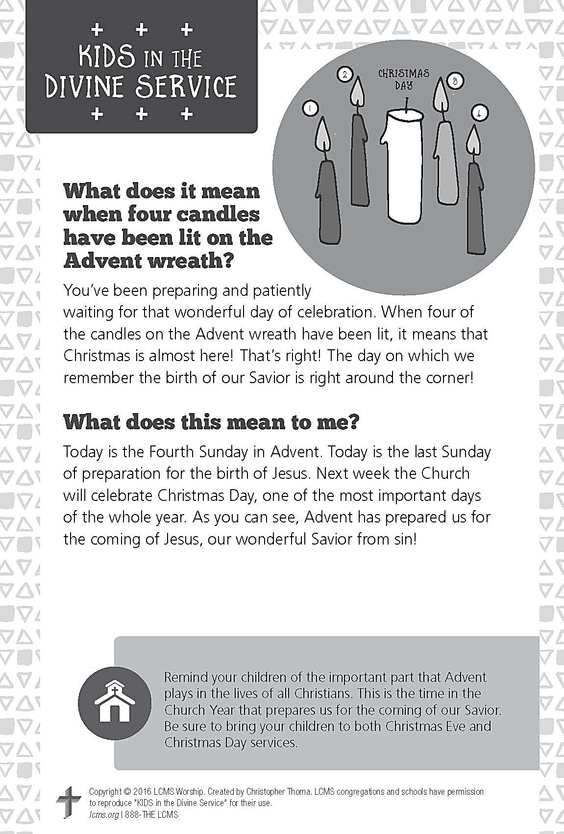

**A PRAYER FOR IMMANUEL**

**Rev. Jason Braaten, Pastor**

Home: *(217) 253‑4539*

Mobile: *(217) 460‑2077*

Email: *pastor.braaten@gmail.com*

Office Hours:

*Monday–Thursday 8:00 am–12:00 pm*

*or by appointment*

*My dear Lord Jesus, I want to know You as Savior and Friend, Help me to grow into a mature disciple so that I can demonstrate God’s love and forgiveness in all I do. Teach me to share my faith in You and to serve others in my vocation. Make Immanuel Lutheran Church a place where lost and hurting people find friendship, forgiveness, and faith, and where Christians gather to serve You in love for one another, for the community, and for the world. Amen.*

**Debra Parsley, Office Manager**

Office: *(217) 253‑4341*

Email: *immanuel.tuscola@gmail.com*

Office Hours:

*Monday–Tuesday* *8:00 am–4:30 pm*

*Wednesday 8:00 am–12:30 pm*