**THE THIRD SUNDAY IN ADVENT**





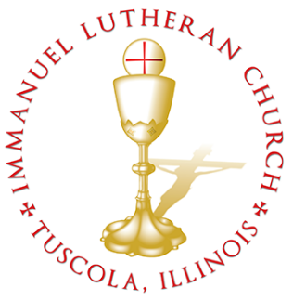 **THE THIRD SUNDAY IN ADVENT**

*Today we celebrate the Sacrament of our Lord Jesus Christ’s true body and blood. Since receiving the Lord’s Supper expresses fellowship with the Lord and agreement with the teaching of the pastor and congregation, we follow the Biblical practice of closed communion. All guests are kindly asked to speak with Pastor Braaten before communing at our altar. Normally, members from congregations of The Lutheran Church—Missouri Synod are welcome to partake, as are people from churches in fellowship with the LCMS.*

**WELCOME VISITORS**

Divine Service, Setting Three with Holy Communion

*Stand*

The PROCESSIONALL HYMN LSB 349 Hark the Glad Sound

(See Page 14)

**The INVOCATION, CONFESSION, and ABSOLUTION** LSB 184

P In the name of the Father and of the T Son and of the Holy Spirit.

C **Amen.**

P Beloved in the Lord! Let us draw near with a true heart and confess our sins unto God our Father, beseeching Him in the name of our Lord Jesus Christ to grant us forgiveness.

P Our help is in the name of the Lord,

C **who made heaven and earth.**

P I said, I will confess my transgressions unto the Lord,

C **and You forgave the iniquity of my sin.**

P O almighty God, merciful Father,

C **I, a poor, miserable sinner, confess unto You all my sins and iniquities with which I have ever offended You and justly deserved Your temporal and eternal punishment. But I am heartily sorry for them and sincerely repent of them, and I pray You of Your boundless mercy and for the sake of the holy, innocent, bitter sufferings and death of Your beloved Son, Jesus Christ, to be gracious and merciful to me, a poor, sinful being.**

P Upon this your confession, I, by virtue of my office, as a called and ordained servant of the Word, announce the grace of God unto all of you, and in the stead and by the command of my Lord Jesus Christ I forgive you all your sins in the name of the Father and of the T Son and of the Holy Spirit.

C **Amen.**

The INTROIT Ps. 85:1–2, 6, 8; antiphon: Phil. 4:4–5

*Rejoice in the Lord* ***|*** *always;****\****

*again I will* ***|*** *say, Rejoice.*

*Let your reasonableness be known to* ***|*** *everyone.****\****

*The Lord* ***|*** *is at hand.*

**Lord, you were favorable | to your land;\***

**you restored the fortunes of | Jacob.**

*You forgave the iniquity of your* ***|*** *people;****\****

*you covered* ***|*** *all their sin.*

**Will you not revive | us again,\***

**that your people may re- | joice in you?**

*Let me hear what God the* ***|*** *Lord will speak,****\****

*for he will speak peace to his people, to his saints; but let them not turn*

*back to* ***|*** *folly.*

**Glory be to the Father and | to the Son\***

**and to the Holy | Spirit;**

**as it was in the be- | ginning,\***

**is now, and will be forever. | Amen.**

*Rejoice in the Lord* ***|*** *always;****\****

*again I will* ***|*** *say, Rejoice.*

**Let your reasonableness be known to | everyone.\***

**The Lord | is at hand.**

**The KYRIE** LSB 186

*The GLORIA IN EXCELSIS is omitted during Advent.*

**The SALUTATION and COLLECT OF THE DAY** LSB 189

C **Lord Jesus Christ, we implore You to hear our prayers and to lighten the darkness of our hearts by Your gracious visitation; for You live and reign with the Father and the Holy Spirit, one God, now and forever.**

*Sit*

The FIRST READING Isaiah 40:1–8

Comfort, comfort my people, says your God. Speak tenderly to Jerusalem, and cry to her that her warfare is ended, that her iniquity is pardoned, that she has received from the Lord’s hand double for all her sins. A voice cries: “In the wilderness prepare the way of the Lord; make straight in the desert a highway for our God. Every valley shall be lifted up, and every mountain and hill be made low; the uneven ground shall become level, and the rough places a plain. And the glory of the Lord shall be revealed, and all flesh shall see it together, for the mouth of the Lord has spoken.”

A voice says, “Cry!” And I said, “What shall I cry?” All flesh is grass, and all its beauty is like the flower of the field. The grass withers, the flower fades when the breath of the Lord blows on it; surely the people are grass. The grass withers, the flower fades, but the word of our God will stand forever.

P This is the Word of the Lord.

C **Thanks be to God.**

**The GRADUAL** Ps. 80:1–2

*You who are enthroned upon the cherubim,* ***|*** *shine forth.****\****

*Stir up your might and come to* ***|*** *save us!*

**Give ear, O Shepherd of | Israel,\***

**you who lead Joseph | like a flock!**

The SECOND READING 1 Corinthians 4:1–5

This is how one should regard us, as servants of Christ and stewards of the mysteries of God. Moreover, it is required of stewards that they be found trustworthy. But with me it is a very small thing that I should be judged by you or by any human court. In fact, I do not even judge myself. I am not aware of anything against myself, but I am not thereby acquitted. It is the Lord who judges me. Therefore do not pronounce judgment before the time, before the Lord comes, who will bring to light the things now hidden in darkness and will disclose the purposes of the heart. Then each one will receive his commendation from God.

P This is the Word of the Lord.

C **Thanks be to God.**

*Stand*

The ALLELUIA LSB 190

**The HOLY GOSPEL** St. Matthew 11:2–10

P The Holy Gospel according to St. Matthew, the eleventh chapter.

C **Glory be to Thee, O Lord.** *(Sung)*

Now when John heard in prison about the deeds of the Christ, he sent word by his disciples and said to him, “Are you the one who is to come, or shall we look for another?” And Jesus answered them, “Go and tell John what you hear and see: the blind receive their sight and the lame walk, lepers are cleansed and the deaf hear, and the dead are raised up, and the poor have good news preached to them. And blessed is the one who is not offended by me.”

As they went away, Jesus began to speak to the crowds concerning John: “What did you go out into the wilderness to see? A reed shaken by the wind? What then did you go out to see? A man dressed in soft clothing? Behold, those who wear soft clothing are in kings’ houses. What then did you go out to see? A prophet? Yes, I tell you, and more than a prophet. This is he of whom it is written, “‘Behold, I send my messenger before your face, who will prepare your way before you.’”

P This is the Gospel of the Lord.

C **Praise be to Thee, O Christ.** *(Sung)*

**The NICENE CREED** LSB 191

C **I believe in one God,**

**the Father Almighty,**

**maker of heaven and earth**

**and of all things visible and invisible.**

**And in one Lord Jesus Christ,**

**the only-begotten Son of God,**

**begotten of His Father before all worlds,**

**God of God, Light of Light,**

**very God of very God,**

**begotten, not made,**

**being of one substance with the Father,**

**by whom all things were made;**

**who for us men and for our salvation came down from heaven**

**and was incarnate by the Holy Spirit of the virgin Mary**

**and was made man;**

**and was crucified also for us under Pontius Pilate.**

**He suffered and was buried.**

**And the third day He rose again according to the Scriptures**

**and ascended into heaven**

**and sits at the right hand of the Father.**

**And He will come again with glory to judge both the living and the dead,**

**whose kingdom will have no end.**

**And I believe in the Holy Spirit,**

**the Lord and giver of life,**

**who proceeds from the Father and the Son,**

**who with the Father and the Son together is worshiped and glorified,**

**who spoke by the prophets.**

**And I believe in one holy Christian and apostolic Church,**

**I acknowledge one Baptism for the remission of sins,**

**and I look for the resurrection of the dead**

**and the life T of the world to come. Amen.**

*Sit*

The HYMN OF THE DAY LSB 345 Hark! A Thrilling Voice Is Sounding

(See Page 15)

**The SERMON**

*Stand*

**The OFFERTORY** LSB 192

*Stand*

**The PRAYER OF THE CHURCH**

P Lord, in Your mercy.

C **Hear our prayer.**

The Preface and PROPER PREFACE LSB 194

P It is truly meet, right, and salutary . . . evermore praising You and saying:

**The SANCTUS** LSB 195

The Lord's Prayer LSB 196

C **Our Father who art in heaven,**

**hallowed be Thy name,**

**Thy kingdom come,**

**Thy will be done on earth as it is in heaven;**

**give us this day our daily bread;**

**and forgive us our trespasses as we forgive those who trespass against us;**

**and lead us not into temptation,**

**but deliver us from evil.**

**For Thine is the kingdom and the power and the glory forever and ever. Amen.**

The Words of Institution LSB 197

The Pax Domini LSB 197

The Agnus Dei LSB 198

*Sit*

The HYMN LSB 347 Comfort, Comfort Ye My People

LSB 344 On Jordan’s Bank the Baptist’s Cry

(See Pages 16 & 17)

*Stand*

The Nunc Dimittis LSB 199

The Thanksgiving LSB 200

P O God the Father, the fountain and source of all goodness, who in lovingkindness sent Your only-begotten Son into the flesh, we thank You that for His sake You have given us pardon and peace in this Sacrament, and we ask You not to forsake Your children but always to rule our hearts and minds by Your Holy Spirit that we may be enabled constantly to serve You; through Jesus Christ, Your Son, our Lord, who lives and reigns with You and the Holy Spirit, one God, now and forever.

**The SALUTATION, BENEDICAMUS and BENEDICTION** LSB 201–202

The Benediction LSB 202

The RECESSIONAL HYMNLSB 805 Praise God, from Whom All Blessings Flow

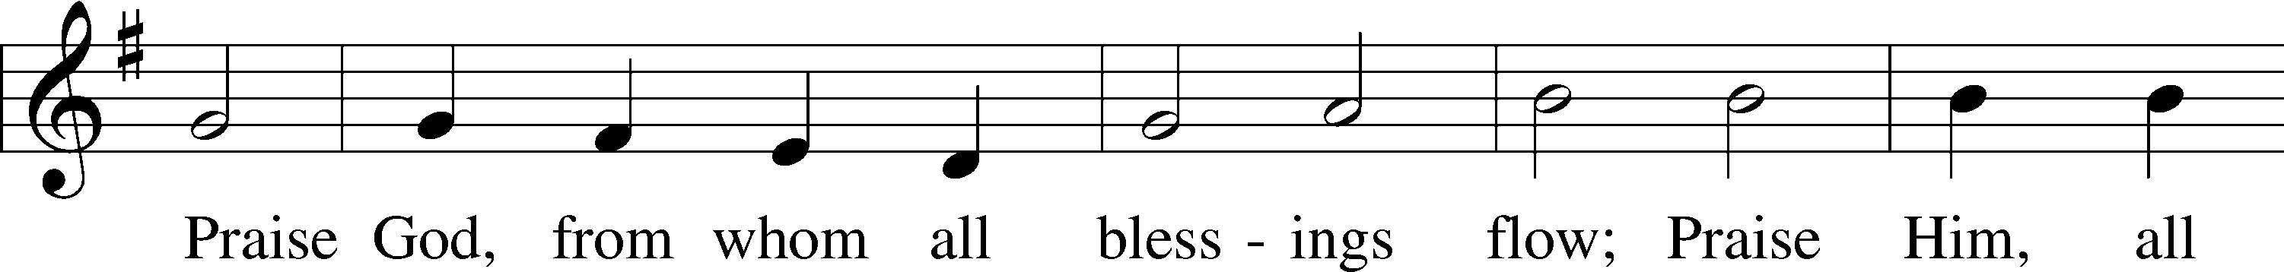

**SERVING TODAY**

CELEBRANT *Rev. Jason Braaten*

ORGANIST *Mr. Glenn Linstead*

*Mrs. Leigh Ann Whitson*

ACKNOWLEDGEMENTS: Divine Service, Setting Three from Lutheran Service Book Unless otherwise indicated, all scripture quotations are from *The Holy Bible, English Standard Version*, copyright © 2001 by Crossway Bibles, a division of Good News Publishers. Used by permission. All rights reserved. Created by Lutheran Service Builder © 2006 Concordia Publishing House.

LSB 349 Hark the Glad Sound

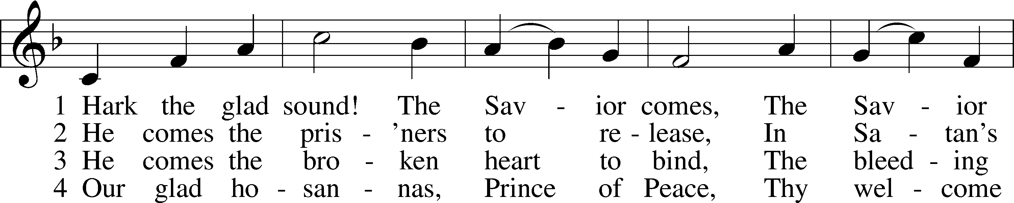

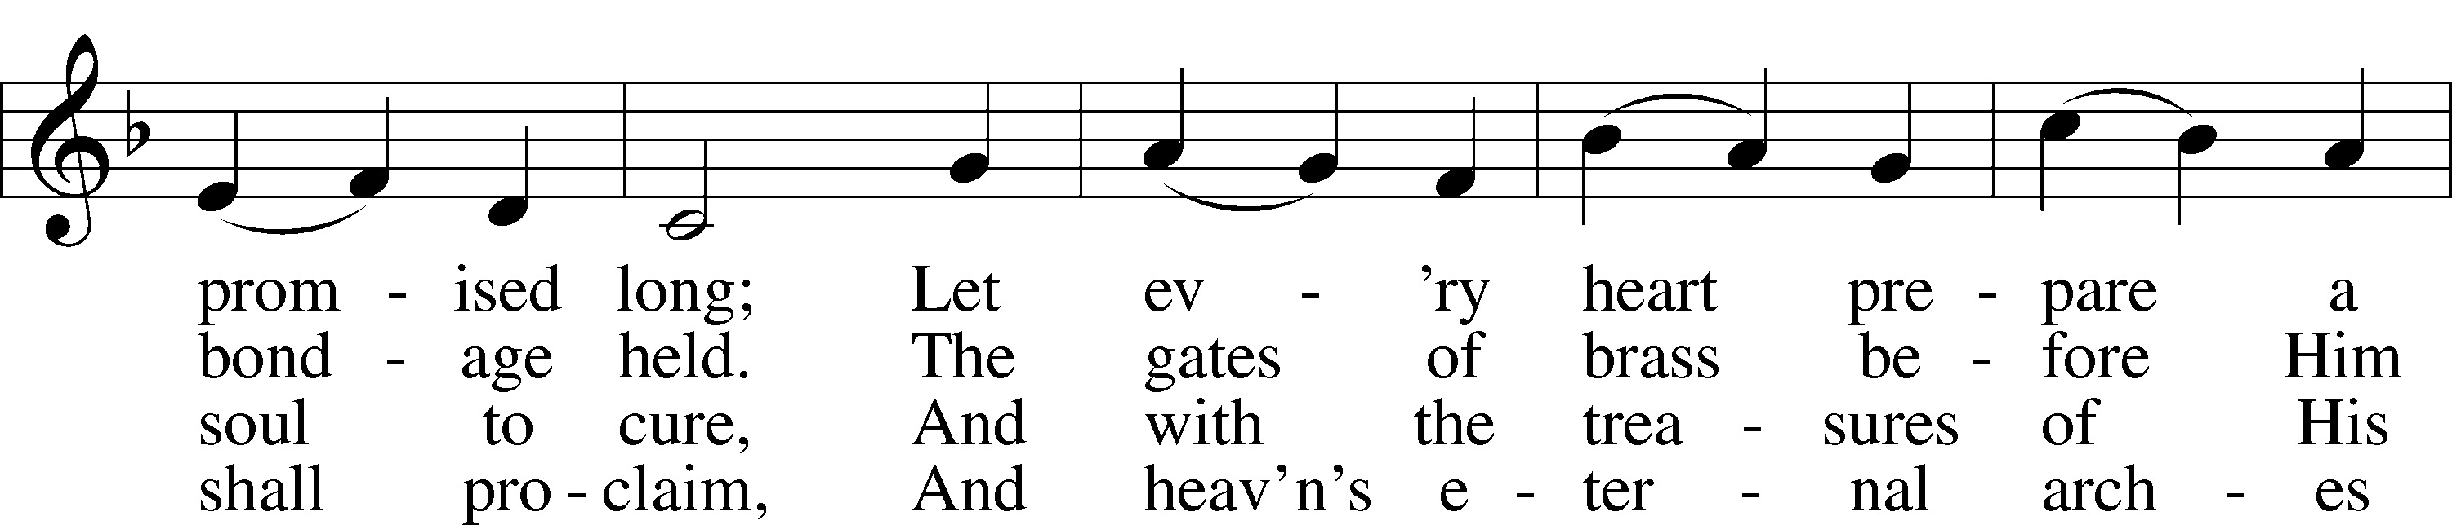

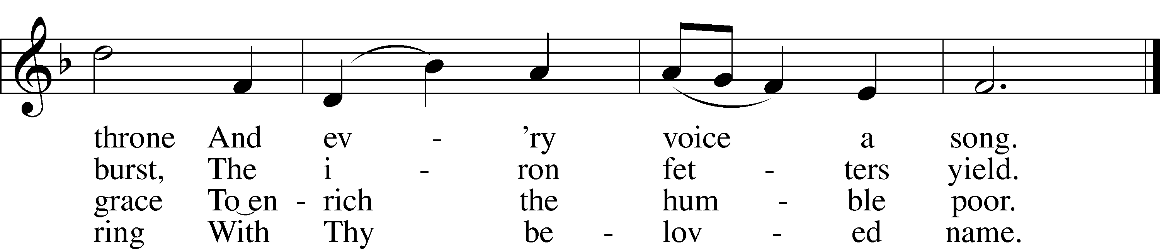

Public domain

LSB 345 Hark! A Thrilling Voice Is Sounding

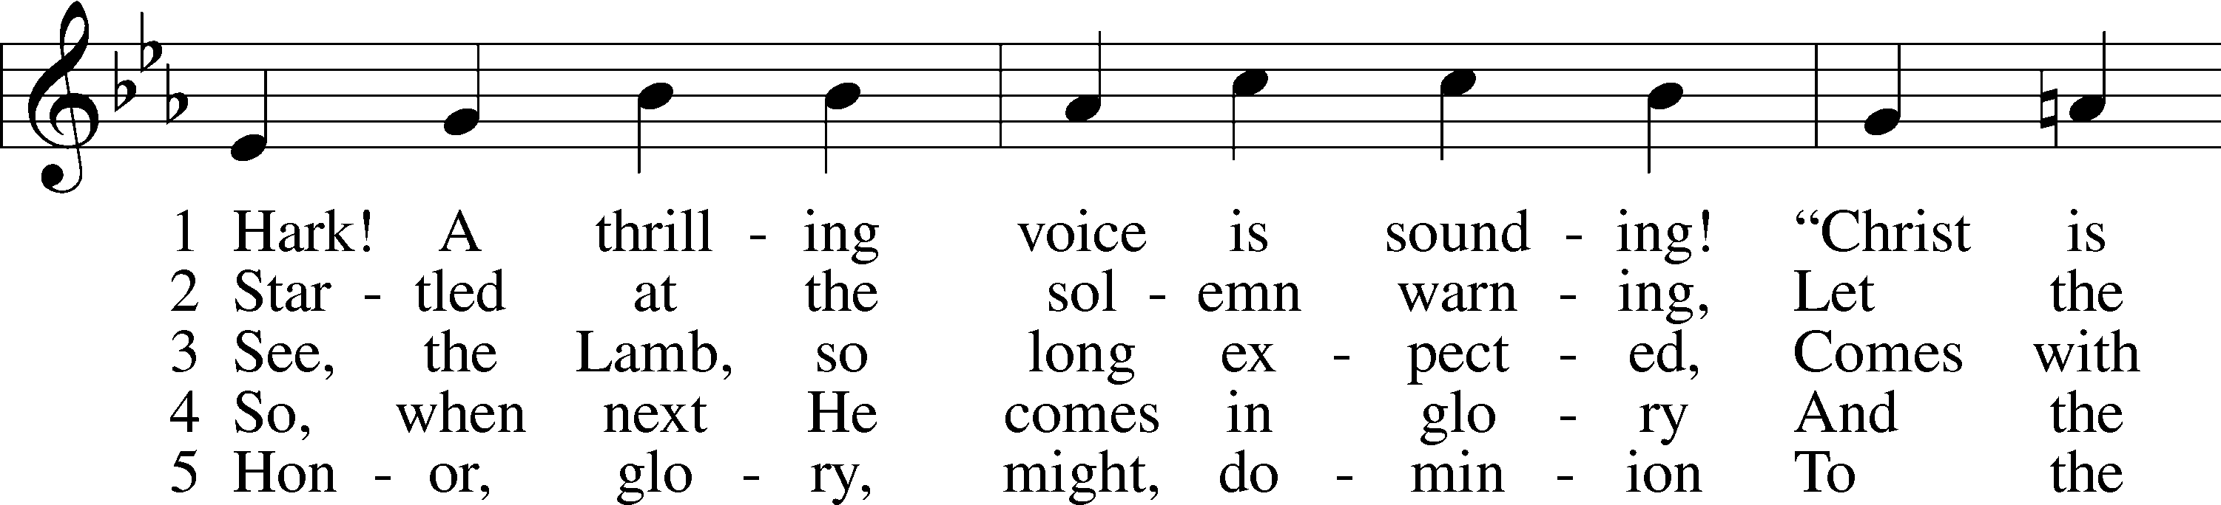

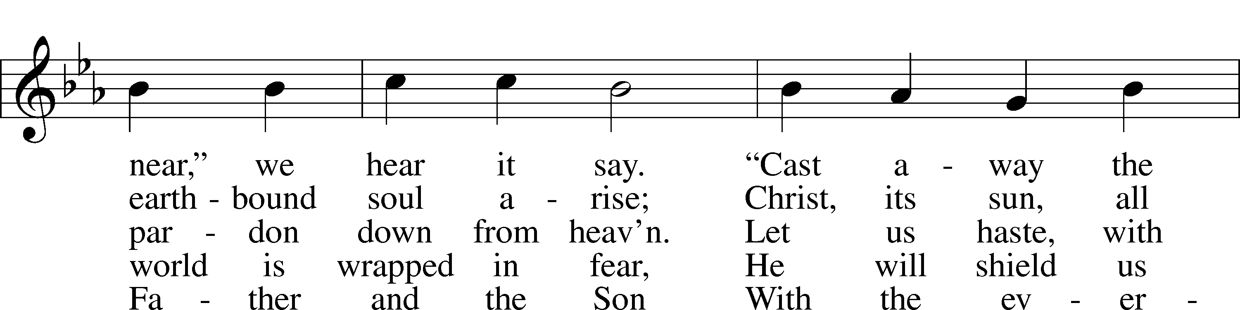

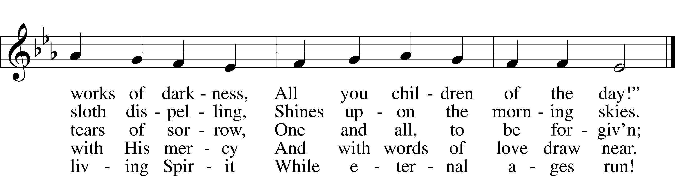

Public domain

LSB 347 Comfort, Comfort Ye My People

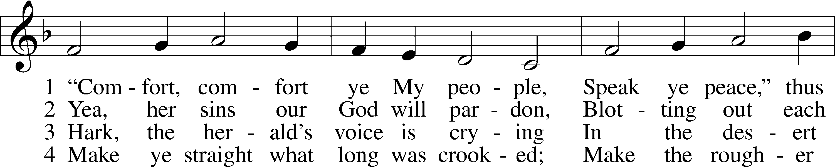

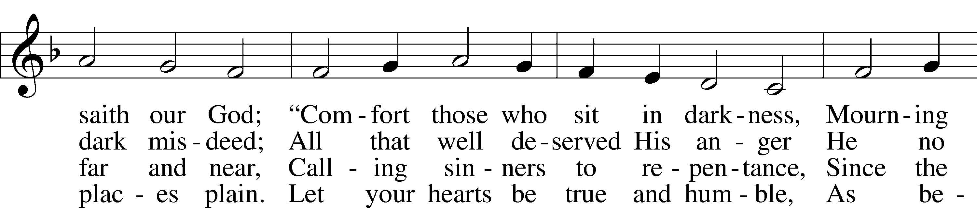

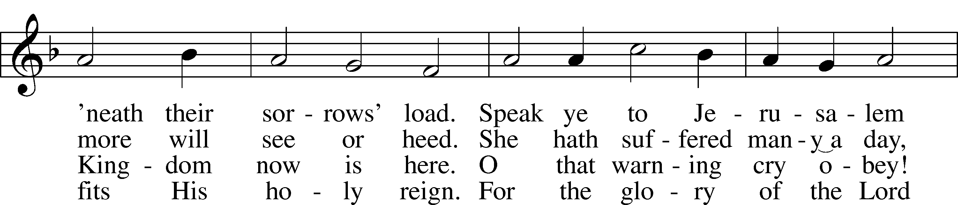

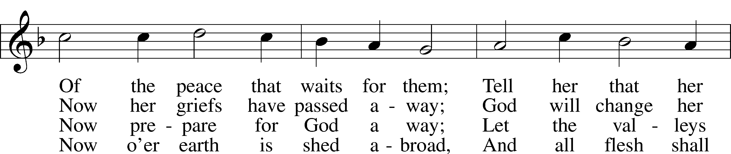

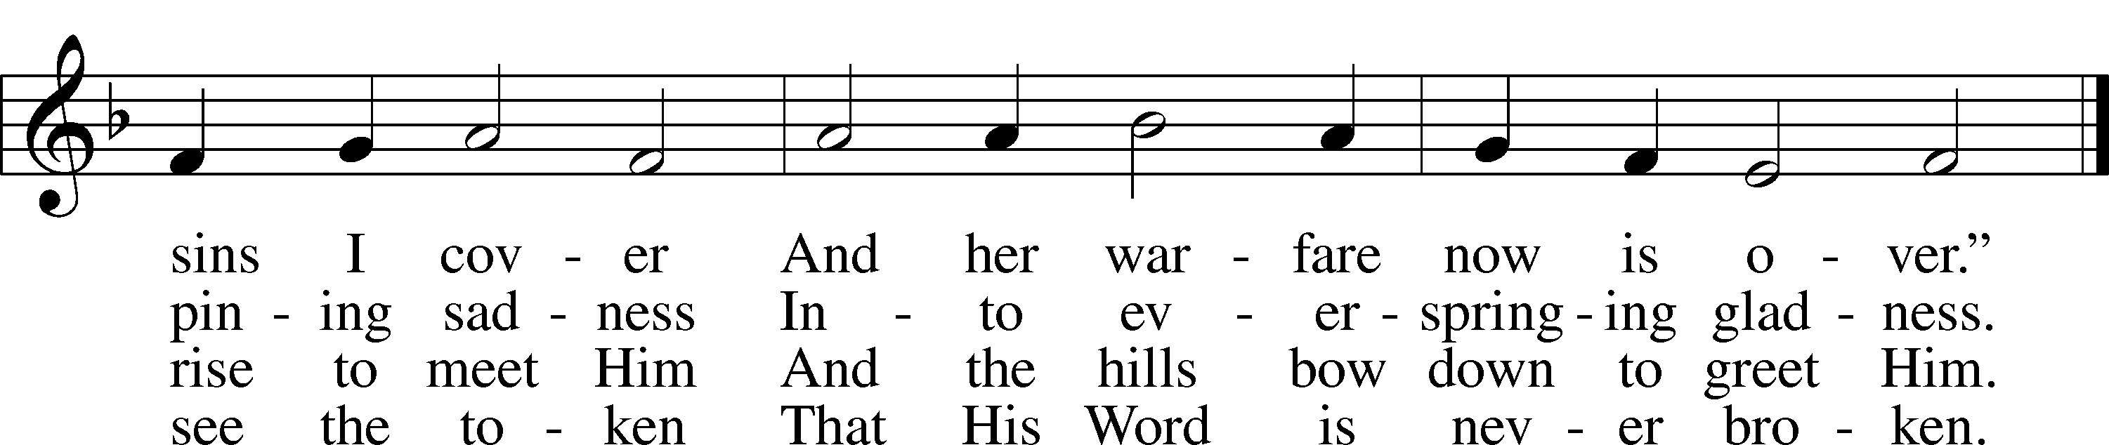

Public domain

LSB 344 On Jordan's Bank the Baptist's Cry

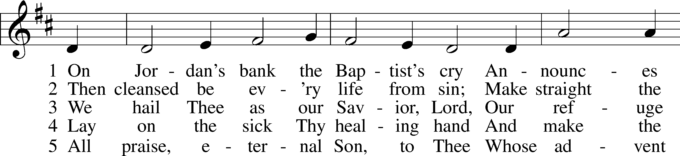

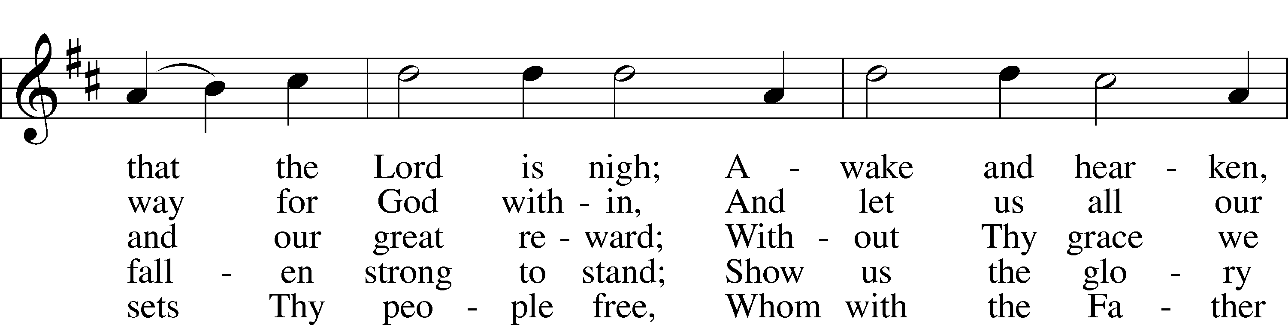

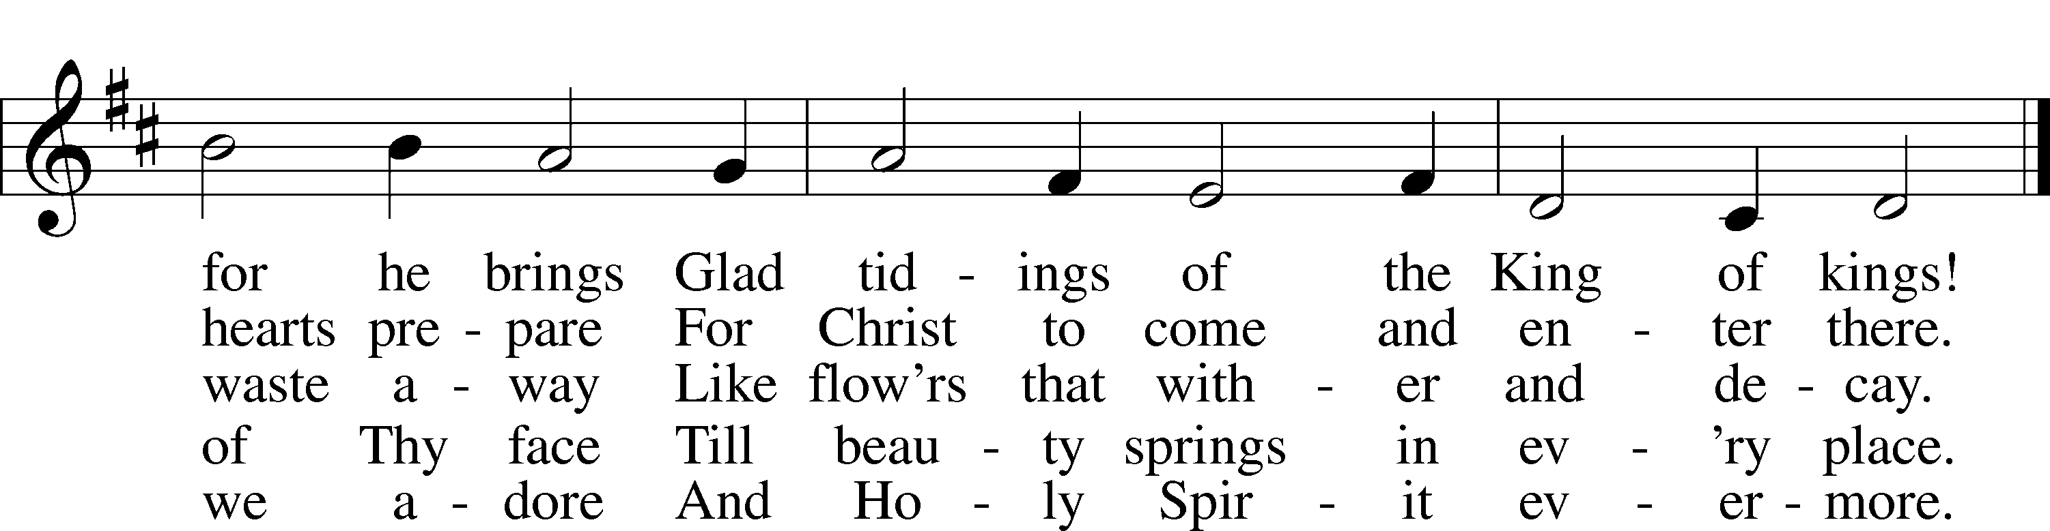

Public domain

**THIS WEEK AT IMMANUEL**

Sunday (12/13) 9:00 am Divine Service with Holy Communion

10:30 am Bible Class & Christmas Program Practice

11:15 am Church Council Meeting

6:00 pm Sunday School Christmas Service

12:30 pm Catechism Class

Monday 5:00 pm Board of Mission & Evangelist

6:00 pm Board of Education

6:30 pm Board of Trustees

7:00 pm Board of Elders

Wednesday 12:30 pm Catechism Class

7:00 pm Midweek Advent Service

Saturday 3:30 pm Individual Confession & Absolution

5:30 pm Divine Service with Holy Communion

Sunday (12/20) 9:00 am Divine Service with Holy Communion

**IN OUR PRAYERS**

HEALTH CONCERNS: Bernita Ashwill; Connie Bruns (cousin of Mary Appleby); Bill Cornwell (friend of Celeste Nau); Lynn Corrie (friend of Arleigh Jones); Ellie Crawford (daughter of Laran Crawford); Whitney Czerwonka; Lynn Davis (cousin of Mark Whitson); Cindy Ekstrom; Theresa Fields; Darrell Ford; Lisa Hall (sister of Holly Wikoff); Rick Hardesty (family of the Hoels); Kim Hausman (friend of Ann Carroll); Deanna Henningsen (sister-in-law of Jerry & Joyce Alexander); Sharon Johnson (friend of Glenda Rahn); Daniel McClean (husband of Emily McClean); Mary Miller (friend of David Holzrichter); Kimberly Mulvany (daughter of Pastor Doug Meyer); Mary Negangard (grandmother of Bryce Reifsteck); Dennis Pickett (friend of Ann Carroll); Misti Post (niece of Sue Rothe); Cary & Beth Rahn; Joan Rahn; Aurelia Tuegal (grandmother of Bethany Campbell); Emma Silver; Dave Slaughter; Ocil Slone (grandfather of Josh & Jake Dyer); Joy Stenger; Carolyn Stremming (sister-in-law of Arleigh Jones); Janet Stumeier; Brian Walker (uncle of Bryce Reifsteck); Lynn & Jane Whitson (parents of Mark Whitson).

SEMINARY STUDENT: Gunnar Campbell; Logan Smith.

DEACONESS STUDENT: Emily McLean.

MISSIONARIES: The Naumann Family; The McDermott Family, Julie Lutz

HOMEBOUND: Bernita Ashwill; Leonard Boerngen; Jim Harbaugh; Janet Pollock; Ruth Rentschler; Ruth Sims; Irene Wattjes.

MILITARY: Carl Crawford; Josh Dyer; Jeremy Gordon; Jack Leonard; Jake Lindgren; Raymond Longtin; Joey Pollock; Blake Stokes; Ruben Wilson.

**THE ANNOUNCEMENTS**

NEXT WEEK’S READINGS . . . Deut. 18:15–19; Philippians 4:4–7; John 1:19–28

ABOUT THIS WEEK’S READINGS . . . The voice of John the Baptist cried out in the wilderness: “*Prepare the way of the Lord . . .*” (Isa. 40:1). John called the people to be made ready for the Messiah’s coming through repentance, for “*all flesh is grass*” (Isa. 40:6). Now He asks from prison, “*Are you the one who is to come?*” (Matt. 11:2). Jesus’ works bear witness that He is. The sick are made well; the dead are raised, and the poor have the Gospel preached to them. Their iniquity is pardoned; they have received from the Lord’s hand double forgiveness for all their sins. The “*stewards of the mysteries of God*” (1 Cor. 4:1) still deliver Christ’s overflowing forgiveness to the poor in spirit, comforting God’s people with the word of the Gospel which stands forever. This Gospel produces rejoicing among all those who believe.

THOUGHTS ABOUT STEWARDSHIP . . . 1 Corinthians 4:2 “Moreover, it is required of stewards that they be found trustworthy.” A steward manages the property of the owner for the owner’s purposes. We are stewards of all that God has given us. So we are called to use all that we are and all that we have for God’s purposes. How do we know what these are? Consider your vocations, your callings from God, in the Home, the Church, and Society: what are the roles God has called you to play? And how should you be using the gifts He’s given you to fulfill those roles?

THE ALTAR FLOWERS . . . given by Kenny and Tammy Kresin to the glory of God for blessings received.

OUR CHILDREN’S CHRISTMAS PROGRAM . . . is tonight, Sunday, December 13, at 6:00 pm, and each and every one of you are invited to come hear the children speak and sing the story of our Savior’s birth. There will be refreshments in the fellowship hall following the service, so please plan to attend. Parents, please have your children at church by 5:40 pm to assemble in the double classroom. Thank you!

POINSETTIA ORDER FORMS . . . are due today, Sunday, December 13. Order forms are still available in the Narthex. Please complete and return them today, to the office or in the secretary’s box. Poinsettias are $12.00 this year and can be taken and enjoyed at home immediately following the Christmas Day service.

CHRISTMAS CARDS FOR SEMINARY STUDENTS . . . If you’d like to send Christmas greetings to our seminary students, their addresses are: Mr. Gunnar Campbell, Mr. Logan Smith, at: 6600 North Clinton Street, Fort Wayne, IN, 46825-4996. Mrs. Emily McClean’s address is 1104 Marcus Court, Winter Springs, FL, 32708.

UPCOMING SPECIAL SERVICES AND EVENTS . . .

Monday, December 21 7:30 pm Voters’ Assembly Meeting

Thursday, December 24 7:00 pm Christmas Eve Service with Communion

Friday, December 25 9:00 am Christmas Day Service with Communion

Thursday, December 31 7:00 pm New Year’s Eve Evening Prayer Service

**A PRAYER FOR IMMANUEL**

**Rev. Jason Braaten, Pastor**

Home: *(217) 253‑4539*

Mobile: *(217) 460‑2077*

Email: *pastor.braaten@gmail.com*

Office Hours:

*Monday–Thursday 8:00 am–12:00 pm*

*or by appointment*

*My dear Lord Jesus, I want to know You as Savior and Friend, Help me to grow into a mature disciple so that I can demonstrate God’s love and forgiveness in all I do. Teach me to share my faith in You and to serve others in my vocation. Make Immanuel Lutheran Church a place where lost and hurting people find friendship, forgiveness, and faith, and where Christians gather to serve You in love for one another, for the community, and for the world. Amen.*

**Debra Parsley, Office Manager**

Office: *(217) 253‑4341*

Email: *immanuel.tuscola@gmail.com*

Office Hours:

*Monday & Tuesday* *8:00 am–4:30 pm*

*Wednesday 8:00 am–12:30 pm*