THE FIRST SUNDAY IN ADVENT

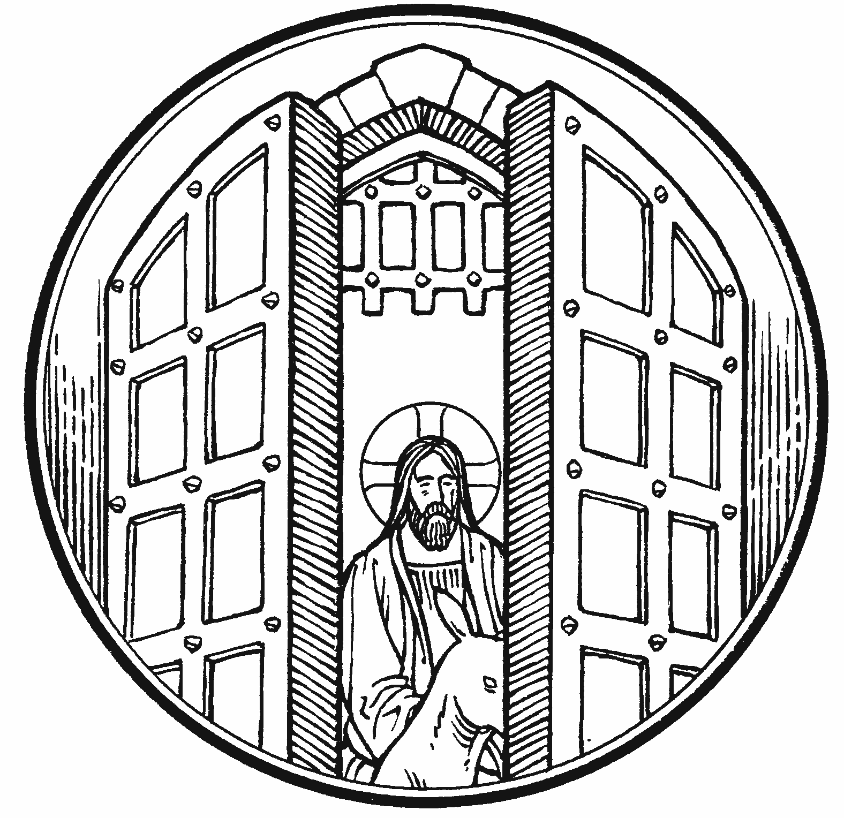

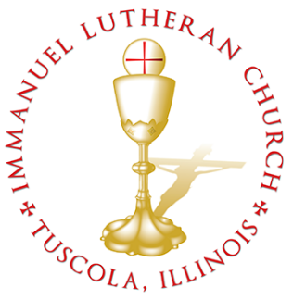
THE FIRST SUNDAY IN ADVENT

Today we celebrate the Sacrament of our Lord Jesus Christ’s true body and blood. Since receiving the Lord’s Supper expresses fellowship with the Lord and agreement with the teaching of the pastor and congregation, we follow the Biblical practice of closed communion. All guests are kindly asked to speak with Pastor Braaten before communing at our altar. Normally, members from congregations of The Lutheran Church—Missouri Synod are welcome to partake, as are people from churches in fellowship with the LCMS.
WELCOME VISITORS

Divine Service, Setting Three with Holy Communion
Stand
The PROCESSIONAL HYMN LSB 331 The Advent of Our King
(See Page 10)
The INVOCATION, CONFESSION, and ABSOLUTION LSB 184–185
P In the name of the Father and of the T Son and of the Holy Spirit.
C Amen.
P Beloved in the Lord! Let us draw near with a true heart and confess our sins unto God our Father, beseeching Him in the name of our Lord Jesus Christ to grant us forgiveness.
P Our help is in the name of the Lord,
C who made heaven and earth.
P I said, I will confess my transgressions unto the Lord,
C and You forgave the iniquity of my sin.
P Almighty God, our maker and redeemer, we poor sinners confess unto You that we are by nature sinful and unclean and that we have sinned against You by thought, word, and deed. Wherefore we flee for refuge to Your infinite mercy, seeking and imploring Your grace for the sake of our Lord Jesus Christ.
C O most merciful God, who has given Your only-begotten Son to die for us, have mercy upon us and for His sake grant us remission of all our sins; and by Your Holy Spirit increase in us true knowledge of You and of Your will and true obedience to Your Word, to the end that by Your grace we may come to everlasting life; through Jesus Christ, our Lord. Amen.
P Almighty God, our heavenly Father, has had mercy upon us and has given His only Son to die for us and for His sake forgives us all our sins. To those who believe on His name He gives the power to become the children of God and has promised them His Holy Spirit. He that believes and is baptized shall be saved. Grant this, Lord, unto us all.
C Amen.
The INTROIT Ps. 25:4–5, 21–22; antiphon: Ps. 25:1–3a
To you, O Lord, I lift | up my soul.*
O my God, in you I trust; let me not be | put to shame.
Let not my enemies exult | over me.*
Indeed, none who wait for you shall be | put to shame.
Make me to know your ways, | O Lord;*
teach me | your paths.
Lead me in your truth and teach me, for you are the God of my sal- | vation;*
for you I wait all the | day long.
May integrity and uprightness pre- | serve me,*
for I | wait for you.
Redeem Israel, | O God,*
out of all his | troubles.
Glory be to the Father and | to the Son*
and to the Holy | Spirit;
as it was in the be- | ginning,*
is now, and will be forever. | Amen.
To you, O Lord, I lift | up my soul.*
O my God, in you I trust; let me not be | put to shame.
Let not my enemies exult | over me.*
Indeed, none who wait for you shall be | put to shame.
The KYRIE LSB 186
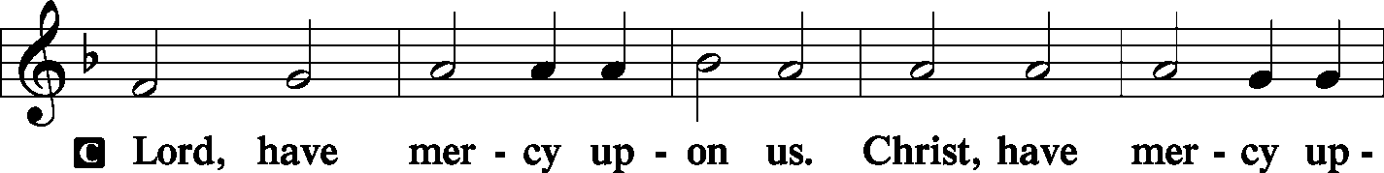
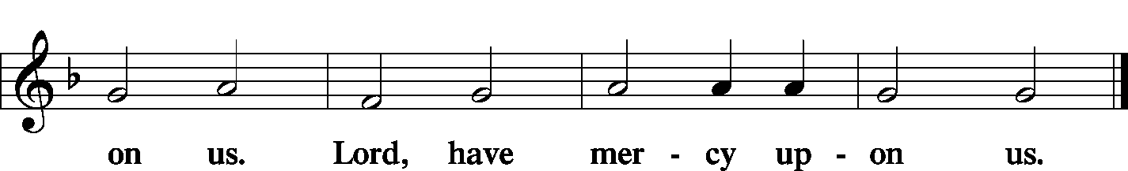
The GLORIA IN EXCELSIS is omitted during Advent.

The SALUTATION and COLLECT OF THE DAY LSB 189
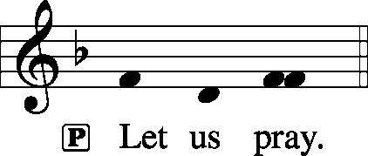
C Lord God, heavenly Father, send forth Your Son, we pray, to lead home His bride, the Church, that with all the company of the redeemed we may finally enter into His eternal wedding feast; through Jesus Christ, our Lord, who lives and reigns with You and the Holy Spirit, one God, now and forever.
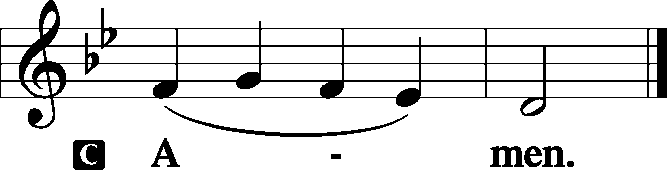
Sit
The FIRST READING Jeremiah 23:5–8
“Behold, the days are coming,” declares the Lord, “when I will raise up for David a righteous Branch, and he shall reign as king and deal wisely, and shall execute justice and righteousness in the land. In his days Judah will be saved, and Israel will dwell securely. And this is the name by which he will be called: ‘The Lord is our righteousness.’
“Therefore, behold, the days are coming,” declares the Lord, “when they shall no longer say, ‘As the Lord lives who brought up the people of Israel out of the land of Egypt,’ but ‘As the Lord lives who brought up and led the offspring of the house of Israel out of the north country and out of all the countries where he had driven them.’ Then they shall dwell in their own land.”
P This is the Word of the Lord.

C Thanks be to God.
The GRADUAL Ps. 25:3–4
None who wait for you shall be | put to shame;*
they shall be ashamed who are wantonly | treacherous.
Make me to know your ways, | O Lord;*
teach me | your paths.
The SECOND READING Romans 13:11–14
Besides this you know the time, that the hour has come for you to wake from sleep. For salvation is nearer to us now than when we first believed. The night is far gone; the day is at hand. So then let us cast off the works of darkness and put on the armor of light. Let us walk properly as in the daytime, not in orgies and drunkenness, not in sexual immorality and sensuality, not in quarreling and jealousy. But put on the Lord Jesus Christ, and make no provision for the flesh, to gratify its desires.
P This is the Word of the Lord.

C Thanks be to God.

Stand
The ALLELUIA LSB 190
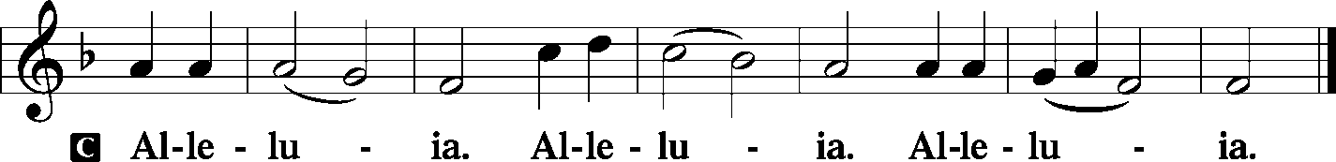
The HOLY GOSPEL St. Matthew 21:1–9
P The Holy Gospel according to St. Matthew, the twenty-first chapter.
C Glory be to Thee, O Lord. (Sung)
Now when they drew near to Jerusalem and came to Bethphage, to the Mount of Olives, then Jesus sent two disciples, saying to them, “Go into the village in front of you, and immediately you will find a donkey tied, and a colt with her. Untie them and bring them to me. If anyone says anything to you, you shall say, ‘The Lord needs them,’ and he will send them at once.” This took place to fulfill what was spoken by the prophet, saying, “Say to the daughter of Zion, ‘Behold, your king is coming to you, humble, and mounted on a donkey, and on a colt, the foal of a beast of burden.’”
The disciples went and did as Jesus had directed them. They brought the donkey and the colt and put on them their cloaks, and he sat on them. Most of the crowd spread their cloaks on the road, and others cut branches from the trees and spread them on the road. And the crowds that went before him and that followed him were shouting, “Hosanna to the Son of David! Blessed is he who comes in the name of the Lord! Hosanna in the highest!”
P This is the Gospel of the Lord.

C Praise be to Thee, O Christ. (Sung)
The NICENE CREED LSB 191
C I believe in one God,
the Father Almighty,
maker of heaven and earth
and of all things visible and invisible.

And in one Lord Jesus Christ,
the only-begotten Son of God,
begotten of His Father before all worlds,
God of God, Light of Light,
very God of very God,
begotten, not made,
being of one substance with the Father,
by whom all things were made;
who for us men and for our salvation came down from heaven
and was incarnate by the Holy Spirit of the virgin Mary
and was made man;
and was crucified also for us under Pontius Pilate.
He suffered and was buried.
And the third day He rose again according to the Scriptures
and ascended into heaven
and sits at the right hand of the Father.
And He will come again with glory to judge both the living and the dead,
whose kingdom will have no end.

And I believe in the Holy Spirit,
the Lord and giver of life,
who proceeds from the Father and the Son,
who with the Father and the Son together is worshiped and glorified,
who spoke by the prophets.
And I believe in one holy Christian and apostolic Church,
I acknowledge one Baptism for the remission of sins,
and I look for the resurrection of the dead
and the life T of the world to come. Amen.

Sit
The HYMN OF THE DAY LSB 332 Savior of the Nations, Come
(See Page 11)
The SERMON
Stand
The OFFERTORY LSB 192
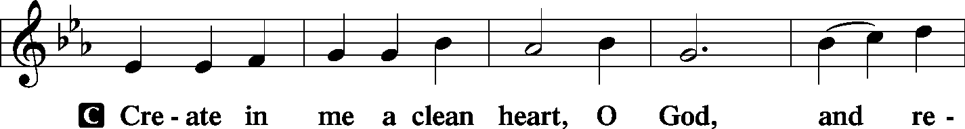
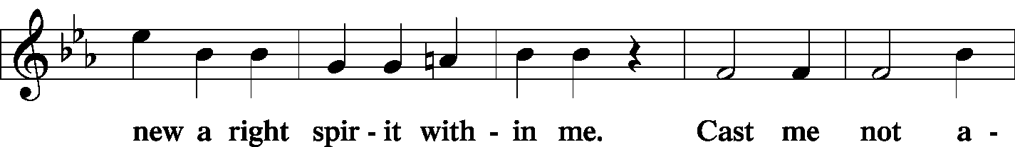
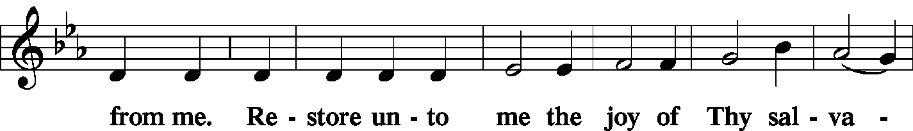
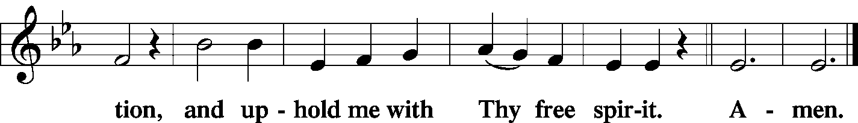

The PRAYER OF THE CHURCH
P Lord, in Your mercy.

C Hear our prayer.
The Lord's Prayer LSB 196
C Our Father who art in heaven,
hallowed be Thy name,
Thy kingdom come,
Thy will be done on earth as it is in heaven;
give us this day our daily bread;
and forgive us our trespasses as we forgive those who trespass against us;
and lead us not into temptation,
but deliver us from evil.
For Thine is the kingdom and the power and the glory forever and ever. Amen.
The COLLECT FOR THE WORD
P Let us pray, Blessed Lord, You have caused all Holy Scriptures to be written for our learning. Grant that we may so hear them, read, mark, learn, and inwardly digest them that, by patience and comfort of Your holy Word, we may embrace and ever hold fast the blessed hope of everlasting life; through Jesus Christ, our Lord, who lives and reigns with You and the Holy Spirit, one God, now and forever.
C Amen.
The COLLECT FOR THE CHURCH
P Almighty God, grant to Your Church Your Holy Spirit and the wisdom that comes down from above, the Your Word may not be bound but have free course and be preached to the joy and edifying of Christ’s holy people, that in steadfast faith we may serve You and, in the confession of Your name, abide unto the end; through Jesus Christ, our Lord.
C Amen.

The COLLECT FOR PEACE IN THE WORLD
P Heavenly Father, God of all concord, it is Your gracious will that Your children on earth live together in harmony and peace. Defeat the plans of all those who would stir up violence and strife, destroy the weapons of those who delight in war and bloodshed, and, according to Your will, end all conflicts in the world. Teach us to examine our hearts that we may recognize our own inclination toward envy, malice, hatred, and enmity. Help us, by Your Word and Spirit, to search our hearts and to root out the evil that would lead to strife and discord, so that in our lives we may be at peace with all people. Fill us with zeal for the work of Your church and the proclamation of the Gospel of Jesus Christ, which alone can bring that peace which is beyond all understanding; through Jesus Christ, our Lord, who lives and reigns with You and the Holy Spirit, one God, now and forever.
C Amen.
The BENEDICAMUS and BENEDICTION LSB 252
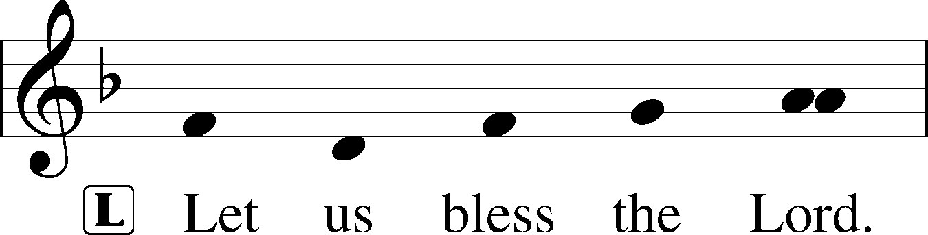
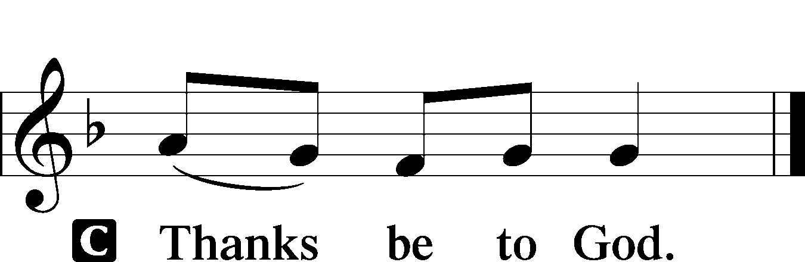
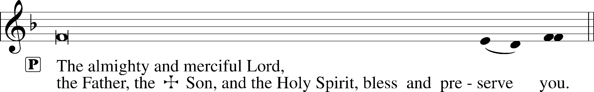

The RECESSIONAL HYMN LSB 805 Praise God, from Whom All Blessings Flow
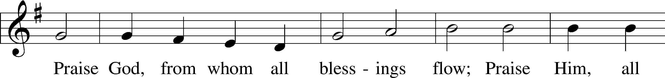
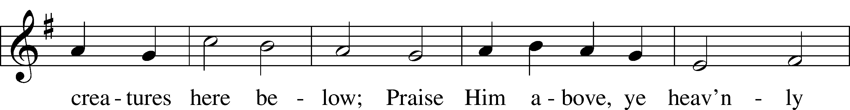
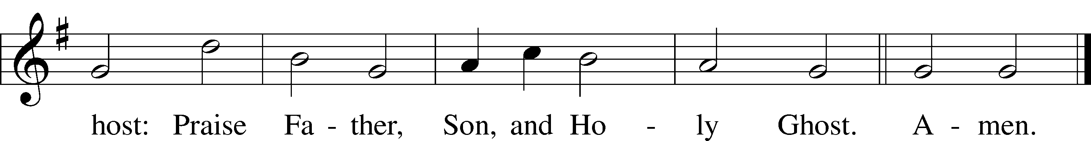

SERVING TODAY
CELEBRANT Sem. Gunnar Campbell
ORGANIST Mr. Glenn Linstead
Mrs. Leigh Ann Whitson

ACKNOWLEDGEMENTS: Divine Service, Setting Three from Lutheran Service Book Unless otherwise indicated, all scripture quotations are from The Holy Bible, English Standard Version, copyright © 2001 by Crossway Bibles, a division of Good News Publishers. Used by permission. All rights reserved. Created by Lutheran Service Builder © 2006 Concordia Publishing House.
LSB 331 The Advent of Our King
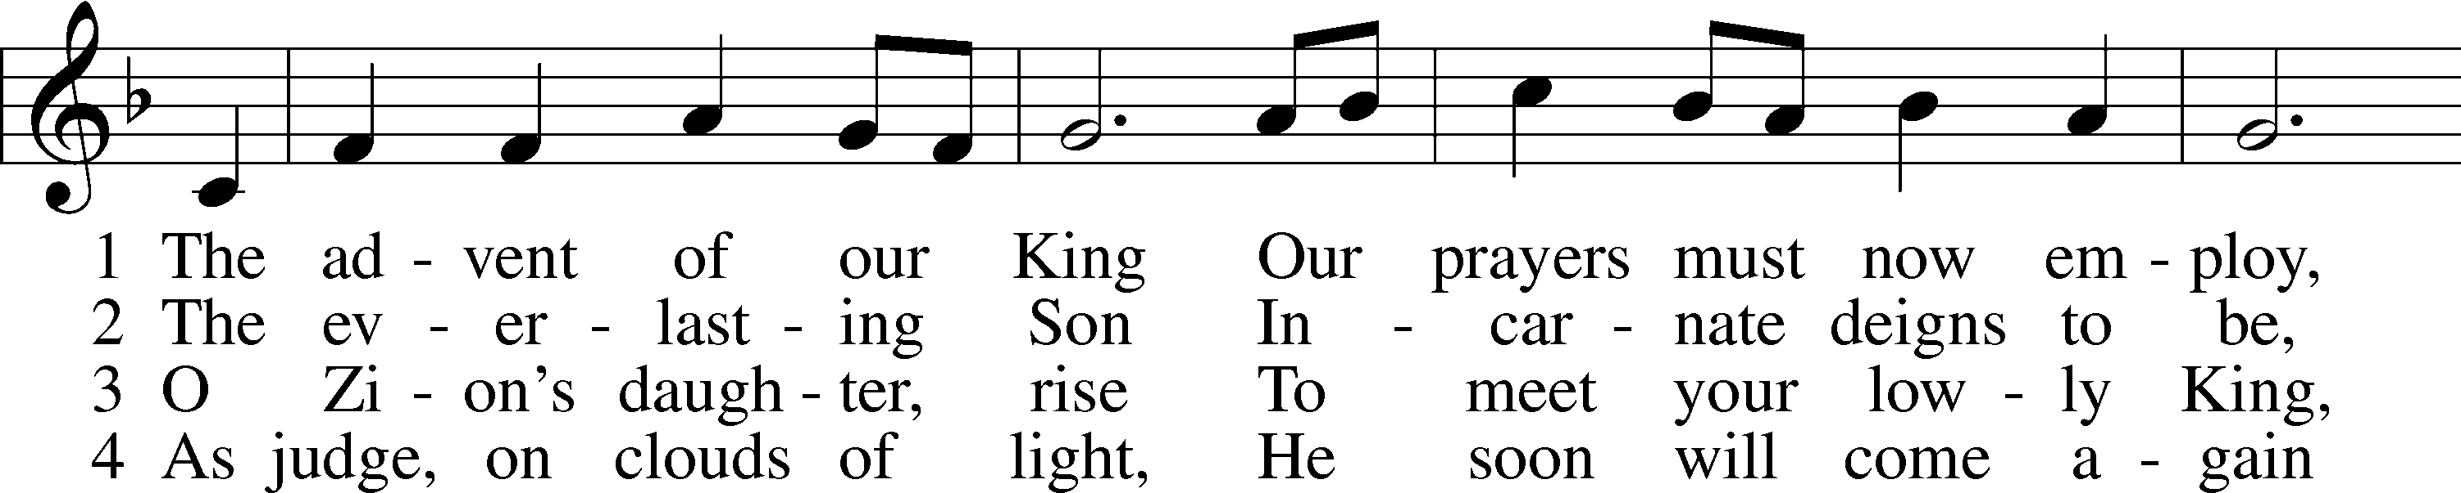
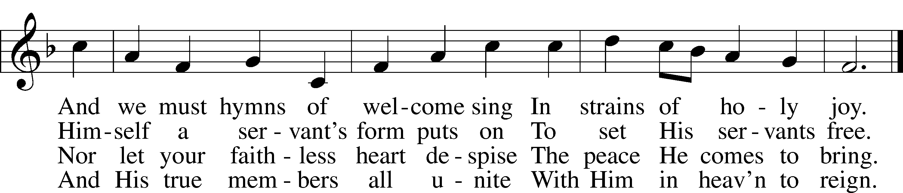

5 Before the dawning day
Let sin’s dark deeds be gone,
The sinful self be put away,
The new self now put on.

6 All glory to the Son,
Who comes to set us free,
With Father, Spirit, ever one
Through all eternity.
Public domain

LSB 332 Savior of the Nations, Come
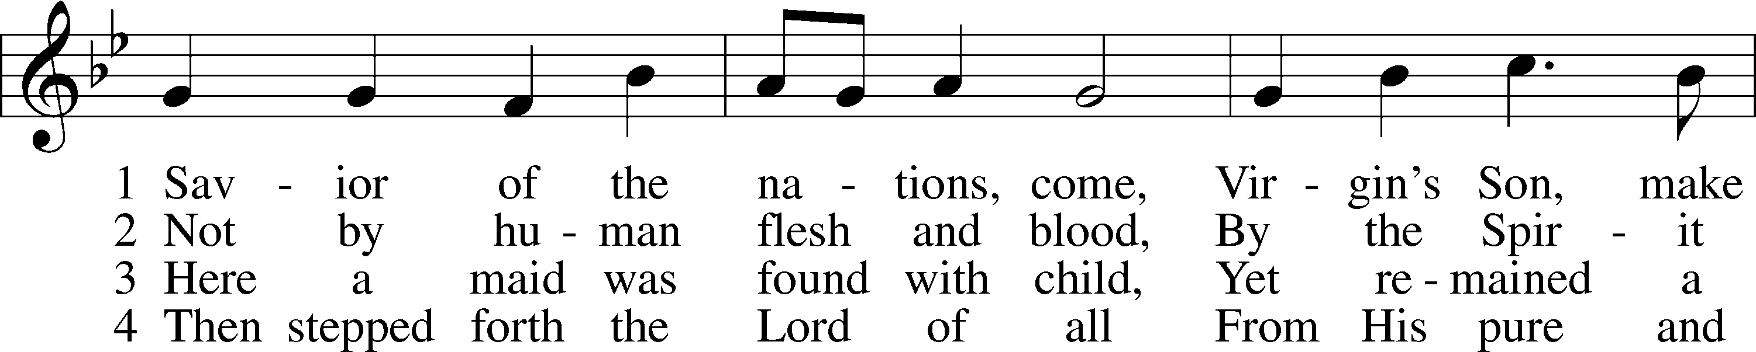
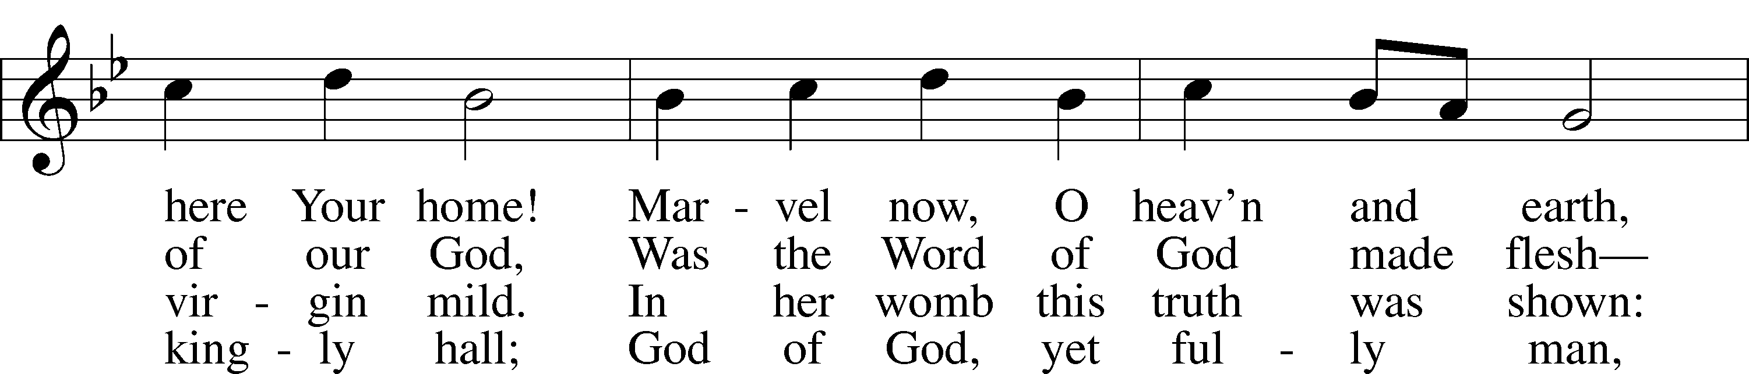
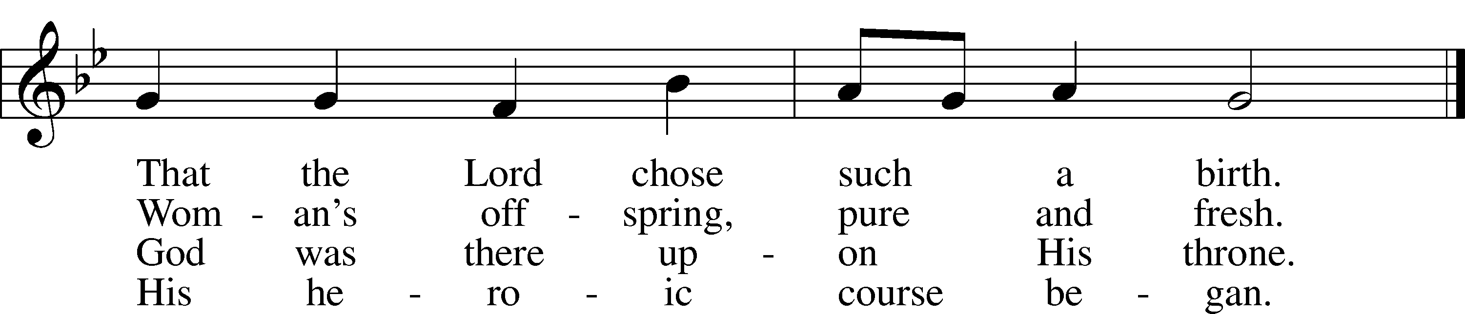

5 God the Father was His source,
Back to God He ran His course.
Into hell His road went down,
Back then to His throne and crown.

6 For You are the Father’s Son
Who in flesh the vict’ry won.
By Your mighty pow’r make whole
All our ills of flesh and soul.

7 From the manger newborn light
Shines in glory through the night.
Darkness there no more resides;
In this light faith now abides.

8 Glory to the Father sing,
Glory to the Son, our king,
Glory to the Spirit be
Now and through eternity.

THIS WEEK AT IMMANUEL
Sunday (11/29) 9:00 am Divine Service without Holy Communion
10:30 am Bible Class & Christmas Program Practice
Wednesday 9:30 am TAMA Meeting
12:30 pm Catechism Class
7:00 pm Midweek Advent Service
Saturday 9:00 am Christmas Decorating
3:30 pm Individual Confession & Absolution
5:30 pm Divine Service with Holy Communion
Sunday (12/6) 9:00 am Divine Service with Holy Communion
10:30 am Bible Class & Christmas Program Practice
5:00 pm Church-wide Live Nativity (Ervin Park)
IN OUR PRAYERS
HEALTH CONCERNS: Bernita Ashwill; Connie Bruns (cousin of Mary Appleby); Lynn Corrie (friend of Arleigh Jones); Ellie Crawford (daughter of Laran Crawford); Whitney Czerwonka; Lynn Davis (cousin of Mark Whitson); Cindy Ekstrom; Theresa Fields; Darrell Ford; Lisa Hall (sister of Holly Wikoff); Rick Hardesty (family of the Hoels); Kim Hausman (friend of Ann Carroll); Deanna Henningsen (sister-in-law of Jerry & Joyce Alexander); Mary Miller (friend of David Holzrichter); Kimberly Mulvany (daughter of Pastor Doug Meyer); Mary Negangard (grandmother of Bryce Reifsteck); Dennis Pickett (friend of Ann Carroll); Misti Post (niece of Sue Rothe); Cary & Beth Rahn; Joan Rahn; Aurelia Tuegal (grandmother of Bethany Campbell); Emma Silver; Ocil Slone (grandfather of Josh & Jake Dyer); Joy Stenger; Carolyn Stremming (sister-in-law of Arleigh Jones); Brian Walker (uncle of Bryce Reifsteck); Lynn & Jane Whitson (parents of Mark Whitson).
SEMINARY STUDENT: Gunnar Campbell; Logan Smith.
DEACONESS STUDENT: Emily McLean.
MISSIONARIES: The Naumann Family; The McDermott Family, Julie Lutz
HOMEBOUND: Bernita Ashwill; Leonard Boerngen; Jim Harbaugh; Janet Pollock; Ruth Rentschler; Ruth Sims; Irene Wattjes.
MILITARY: Carl Crawford; Josh Dyer; Jeremy Gordon; Jack Leonard; Jake Lindgren; Raymond Longtin; Joey Pollock; Blake Stokes; Ruben Wilson.
THE ANNOUNCEMENTS
NEXT WEEK’S READINGS . . . Malachi 4:1–6; Romans 15:4–13; Luke 21:25–36.
ABOUT THIS WEEK’S READINGS . . . The new Church Year begins by focusing on the humble coming of our Lord. “Behold, your king is coming to you, humble, and mounted on a donkey” (Matt. 21:5). Even as He was born in a lowly manger, so Jesus rides into Jerusalem on a beast of burden. For He bears the sin of the world. He is the Son of David riding to His enthronement on the cross, where He shows Himself to be “The LORD is our Righteousness” (Jer. 23:5–6). Our Lord still comes in great humility to deliver His righteousness to us in the Word and Sacraments. Before receiving Christ’s body and blood, we also sing, “Blessed is he who comes in the name of the Lord! Hosanna in the highest!” (Matt. 21:9) And as we receive the Sacrament, we set our hearts on His return in glory, for “our salvation is nearer to us now than when we first believed” (Rom. 13:11).
THOUGHTS ABOUT STEWARDSHIP . . . Jeremiah 23:6 “And this is the name by which he will be called: ‘The LORD is our righteousness.’” Jesus is our righteousness, our justification, our all. In Jesus we are forgiven and free. This knowledge sets us free to live as children of the Heavenly Father without fear. Freed from the supposed need to justify ourselves, good works can be done by us for the right reason: to thank God and to serve our neighbor.
REMINDER: ANGEL TREE . . . offering envelopes are due Sunday, December 6. An envelope designated for Angel Tree has been placed in your mailbox. You can give cash or a check, payable to Immanuel. Use the envelope to return your gift in the offering on December 6. Or you may return it to the church office. Thank you for your generosity in helping area children receive a few gifts under the Christmas Tree.
REMINDER: IMMANUEL BOARDS MEET . . . on Monday, December 14. If you have not done so already, please submit your 2020 budget request to the church office as soon as possible following your board meeting.

THE SUNDAY SCHOOL CHRISTMAS SERVICE . . . will be Sunday, December 13. The service is at 6:00 pm, followed by refreshments hosted by the Board of Education. Join us for a Christmas Service where our children will remind us of the real reason for the season with all your favorite Christmas hymns and then food and fellowship.

POINSETTIA ORDER FORMS . . . are included in this weekend’s bulletins. Please complete and return them by Sunday, December 13. Poinsettias are $14.00 this year and can be taken and enjoyed at home immediately following the Christmas Day service.
ADVENT BIBLE CHALLENGE . . . This Advent the Board of Christian Education is sponsoring a challenge to get through the Book of John by Christmas Eve. There are twenty-one chapters in the Book of John, so if you read one chapter a day, you will have read all the recorded events of our Lord’s birth, life, ministry, death, and resurrection. Take home a schedule and put your name on the sign-up sheet in the Narthex. Those who finish will receive a prize. For more information, contact Pastor or a member of the Board of Christian Education. Let’s delve into God’s Word during the season we anticipate that Word becoming flesh to dwell among us.
UPCOMING SPECIAL SERVICES AND EVENTS . . .
Sunday, November 29 10:20 am Sunday School Christmas Service practice
Wednesday, December 2 7:00 pm Advent Midweek Service
Saturday, December 5 9:00 am Immanuel Christmas Decorating
Sunday, December 6 5:00 pm Church-wide Live Nativity (Ervin Park)
Wednesday, December 9 7:00 pm Advent Midweek Service
Sunday, December 13 10:20 am Sunday School Christmas Service practice
6:00 pm Sunday School Christmas Service
Wednesday, December 16 7:00 pm Advent Midweek Service
Monday, December 21 7:30 pm Voter’s Budget Meeting
Thursday, December 24 7:00 pm Christmas Eve Service with Communion
Friday, December 25 9:00 am Christmas Day Service with Communion
Thursday, December 31 7:00 pm New Year’s Eve Evening Prayer

A PRAYER FOR IMMANUEL
Rev. Jason Braaten, Pastor
Home: (217) 253-4539
Mobile: (217) 460-2077
Email: pastor.braaten@gmail.com
Office Hours:
Monday–Thursday 8:00 am–12:00 pm
or by appointment

My dear Lord Jesus, I want to know You as Savior and Friend, Help me to grow into a mature disciple so that I can demonstrate God’s love and forgiveness in all I do. Teach me to share my faith in You and to serve others in my vocation. Make Immanuel Lutheran Church a place where lost and hurting people find friendship, forgiveness, and faith, and where Christians gather to serve You in love for one another, for the community, and for the world. Amen.
Debra Parsley, Office Manager
Office: (217) 253-4341
Email: immanuel.tuscola@gmail.com

Office Hours:
Monday &Wednesday 8:00 am–4:00 pm
Tuesday 8:00 am–12:00 pm

