THE LAST SUNDAY OF THE
CHURCH YEAR

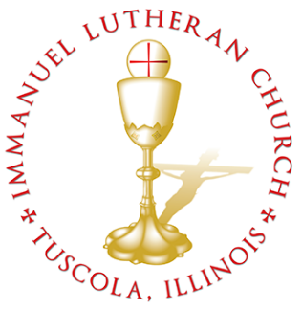
THE LAST SUNDAY OF THE CHURCH YEAR

Today we celebrate the Sacrament of our Lord Jesus Christ’s true body and blood. Since receiving the Lord’s Supper expresses fellowship with the Lord and agreement with the teaching of the pastor and congregation, we follow the Biblical practice of closed communion. All guests are kindly asked to speak with Pastor Braaten before communing at our altar. Normally, members from congregations of The Lutheran Church—Missouri Synod are welcome to partake, as are people from churches in fellowship with the LCMS.
WELCOME VISITORS

Divine Service, Setting Three with Holy Communion
Stand
The PROCESSIONAL HYMN LSB 514 The Bridegroom Soon Will Call Us
(See Page 16)
The INVOCATION, CONFESSION, and ABSOLUTION LSB 184
P In the name of the Father and of the T Son and of the Holy Spirit.
C Amen.
P Beloved in the Lord! Let us draw near with a true heart and confess our sins unto God our Father, beseeching Him in the name of our Lord Jesus Christ to grant us forgiveness.
P Our help is in the name of the Lord,
C who made heaven and earth.
P I said, I will confess my transgressions unto the Lord,
C and You forgave the iniquity of my sin.
P O almighty God, merciful Father,
C I, a poor, miserable sinner, confess unto You all my sins and iniquities with which I have ever offended You and justly deserved Your temporal and eternal punishment. But I am heartily sorry for them and sincerely repent of them, and I pray You of Your boundless mercy and for the sake of the holy, innocent, bitter sufferings and death of Your beloved Son, Jesus Christ, to be gracious and merciful to me, a poor, sinful being.
P Upon this your confession, I, by virtue of my office, as a called and ordained servant of the Word, announce the grace of God unto all of you, and in the stead and by the command of my Lord Jesus Christ I forgive you all your sins in the name of the Father and of the T Son and of the Holy Spirit.
C Amen.
The INTROIT Ps. 39:4–5, 7– 8; antiphon: Is. 35:10
The ransomed of the Lord shall return and come to Zion with | singing;*
everlasting joy shall be up- | on their heads.
They shall obtain glad- | ness and joy,*
and sorrow and sighing shall | flee away.
O Lord, make me know my end and what is the measure | of my days;*
let me know how fleeting | I am!
Behold, you have made my days a few handbreadths, and my lifetime is as
nothing be- | fore you.*
Surely all mankind stands as a | mere breath!
And now, O Lord, for what | do I wait?*
My hope | is in you.
Deliver me from all my trans- | gressions.*
Do not make me the scorn | of the fool!
Glory be to the Father and | to the Son*
and to the Holy | Spirit;
as it was in the be- | ginning,*
is now, and will be forever. | Amen.
The ransomed of the Lord shall return and come to Zion with | singing;*
everlasting joy shall be up- | on their heads.
They shall obtain glad- | ness and joy,*
and sorrow and sighing shall | flee away.
The KYRIE LSB 186
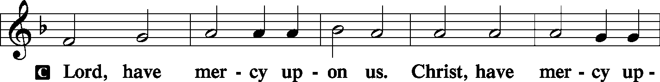
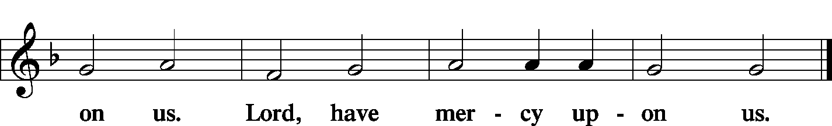
The GLORIA IN EXCELSIS LSB 187–189
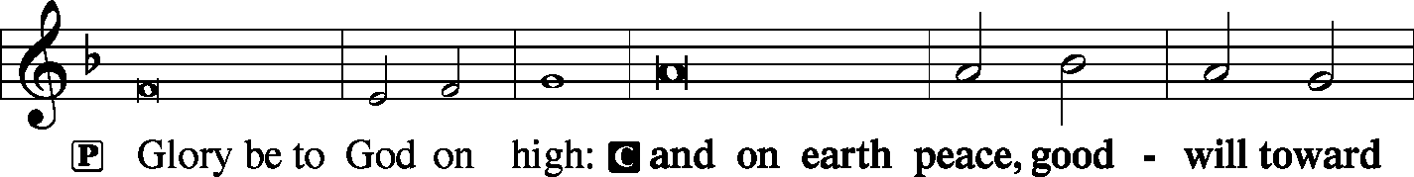
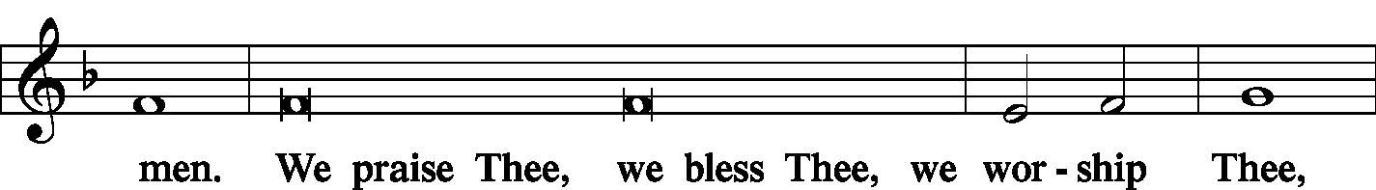
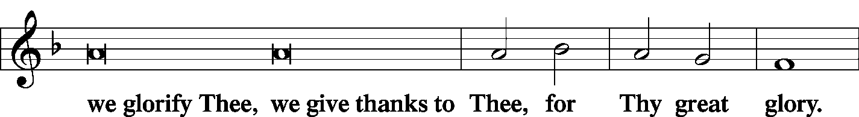
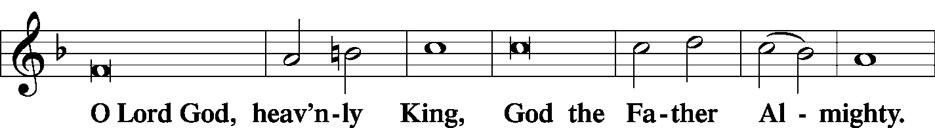
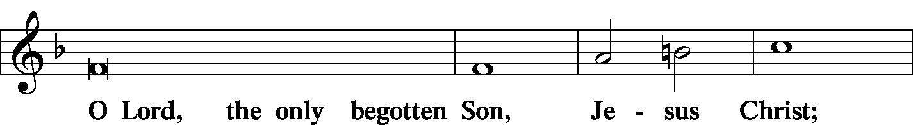
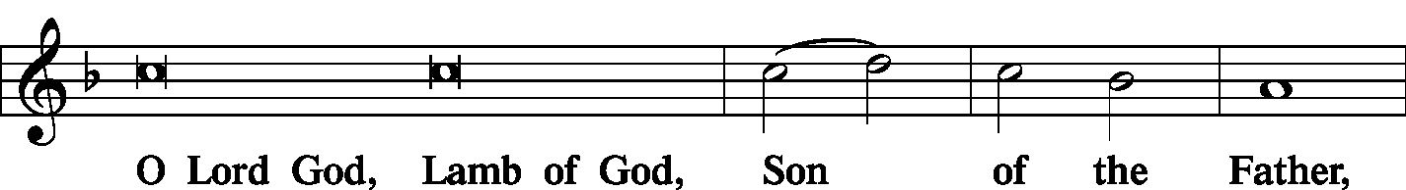
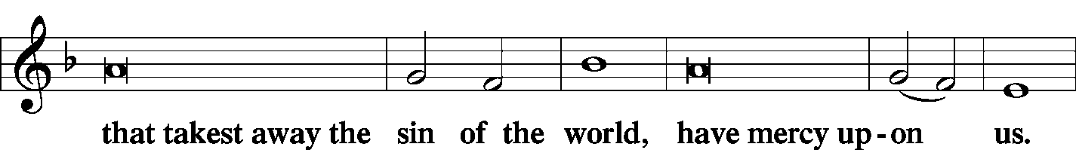
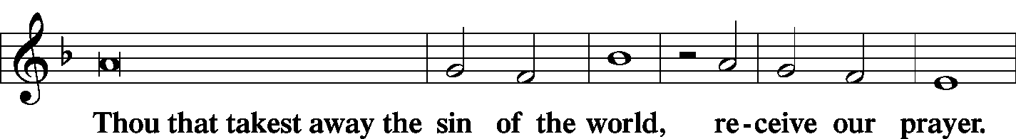
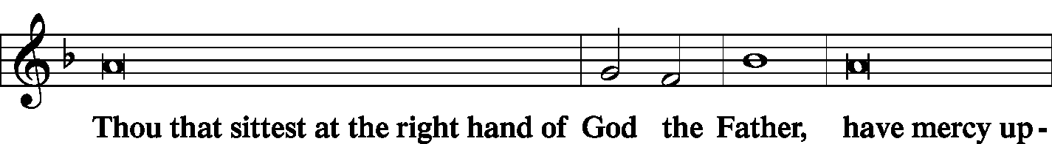
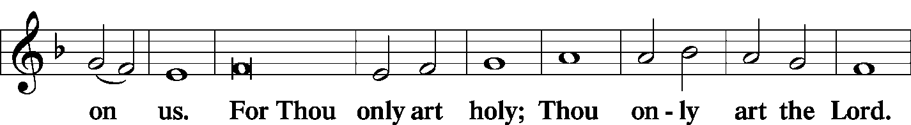
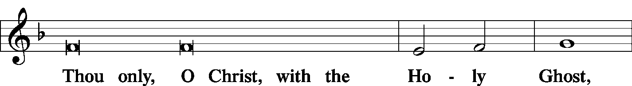
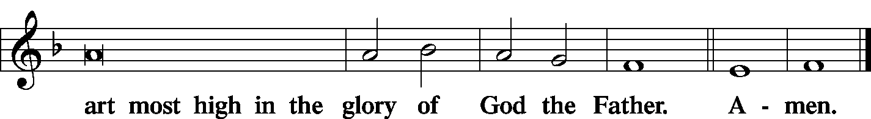

The SALUTATION and COLLECT OF THE DAY LSB 189
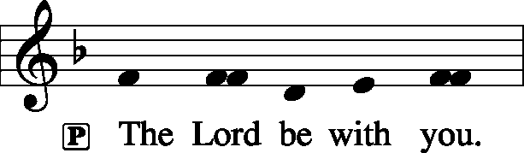
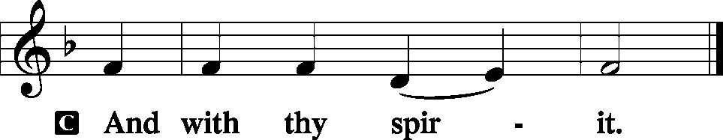
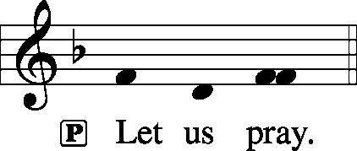
C Lord God, heavenly Father, send forth Your Son, we pray, to lead home His bride, the Church, that with all the company of the redeemed we may finally enter into His eternal wedding feast; through Jesus Christ, our Lord, who lives and reigns with You and the Holy Spirit, one God, now and forever.
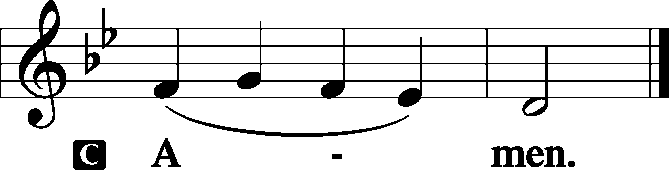
Sit
The FIRST READING Isaiah 65:17–25
“For behold, I create new heavens and a new earth, and the former things shall not be remembered or come into mind. But be glad and rejoice forever in that which I create; for behold, I create Jerusalem to be a joy, and her people to be a gladness. I will rejoice in Jerusalem and be glad in my people; no more shall be heard in it the sound of weeping and the cry of distress. No more shall there be in it an infant who lives but a few days, or an old man who does not fill out his days, for the young man shall die a hundred years old, and the sinner a hundred years old shall be accursed. They shall build houses and inhabit them; they shall plant vineyards and eat their fruit. They shall not build and another inhabit; they shall not plant and another eat; for like the days of a tree shall the days of my people be, and my chosen shall long enjoy the work of their hands. They shall not labor in vain or bear children for calamity, for they shall be the offspring of the blessed of the Lord, and their descendants with them. Before they call I will answer; while they are yet speaking I will hear. The wolf and the lamb shall graze together; the lion shall eat straw like the ox, and dust shall be the serpent’s food. They shall not hurt or destroy in all my holy mountain,” says the Lord.
P This is the Word of the Lord.

C Thanks be to God.
The JUNIOR CHOIR Ps. 141
(Sunday only)
The GRADUAL Ps. 45:14–15
(Saturday only)
In many-colored robes [the king’s daughter] is led | to the king,*
with her virgin companions following be- | hind her.
With joy and gladness they are | led along*
as they enter the palace | of the king.
The SECOND READING 1 Thessalonians 5:1–11
Now concerning the times and the seasons, brothers, you have no need to have anything written to you. For you yourselves are fully aware that the day of the Lord will come like a thief in the night. While people are saying, “There is peace and security,” then sudden destruction will come upon them as labor pains come upon a pregnant woman, and they will not escape. But you are not in darkness, brothers, for that day to surprise you like a thief. For you are all children of light, children of the day. We are not of the night or of the darkness. So then let us not sleep, as others do, but let us keep awake and be sober. For those who sleep, sleep at night, and those who get drunk, are drunk at night. But since we belong to the day, let us be sober, having put on the breastplate of faith and love, and for a helmet the hope of salvation. For God has not destined us for wrath, but to obtain salvation through our Lord Jesus Christ, who died for us so that whether we are awake or asleep we might live with him. Therefore encourage one another and build one another up, just as you are doing.
P This is the Word of the Lord.

C Thanks be to God.

Stand
The ALLELUIA LSB 190
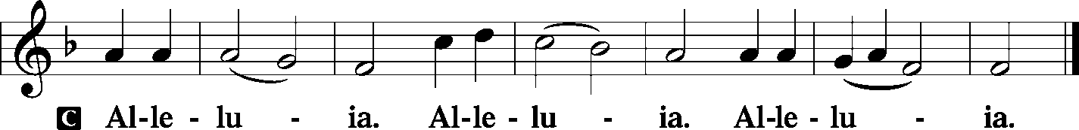
The HOLY GOSPEL St. Matthew 25:1–13
P The Holy Gospel according to St. Matthew, the twenty-fifth chapter.
C Glory be to Thee, O Lord. (Sung)
“Then the kingdom of heaven will be like ten virgins who took their lamps and went to meet the bridegroom. Five of them were foolish, and five were wise. For when the foolish took their lamps, they took no oil with them, but the wise took flasks of oil with their lamps. As the bridegroom was delayed, they all became drowsy and slept. But at midnight there was a cry, ‘Here is the bridegroom! Come out to meet him.’ Then all those virgins rose and trimmed their lamps. And the foolish said to the wise, ‘Give us some of your oil, for our lamps are going out.’ But the wise answered, saying, ‘Since there will not be enough for us and for you, go rather to the dealers and buy for yourselves.’ And while they were going to buy, the bridegroom came, and those who were ready went in with him to the marriage feast, and the door was shut. Afterward the other virgins came also, saying, ‘Lord, lord, open to us.’ But he answered, ‘Truly, I say to you, I do not know you.’ Watch therefore, for you know neither the day nor the hour.”
P This is the Gospel of the Lord.

C Praise be to Thee, O Christ. (Sung)
The NICENE CREED LSB 191
C I believe in one God,
the Father Almighty,
maker of heaven and earth
and of all things visible and invisible.

And in one Lord Jesus Christ,
the only-begotten Son of God,
begotten of His Father before all worlds,
God of God, Light of Light,
very God of very God,
begotten, not made,
being of one substance with the Father,
by whom all things were made;
who for us men and for our salvation came down from heaven
and was incarnate by the Holy Spirit of the virgin Mary
and was made man;
and was crucified also for us under Pontius Pilate.
He suffered and was buried.
And the third day He rose again according to the Scriptures
and ascended into heaven
and sits at the right hand of the Father.
And He will come again with glory to judge both the living and the dead,
whose kingdom will have no end.

And I believe in the Holy Spirit,
the Lord and giver of life,
who proceeds from the Father and the Son,
who with the Father and the Son together is worshiped and glorified,
who spoke by the prophets.
And I believe in one holy Christian and apostolic Church,
I acknowledge one Baptism for the remission of sins,
and I look for the resurrection of the dead
and the life T of the world to come. Amen.

Sit
The HYMN OF THE DAY LSB 516 Wake, Awake, for Night Is Flying (see page 17)
The SERMON
Stand
The OFFERTORY LSB 192
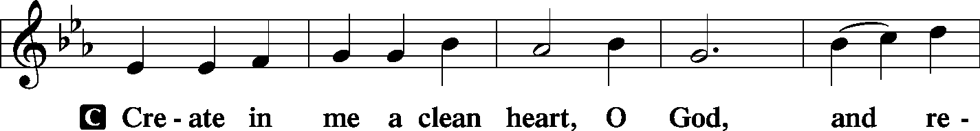
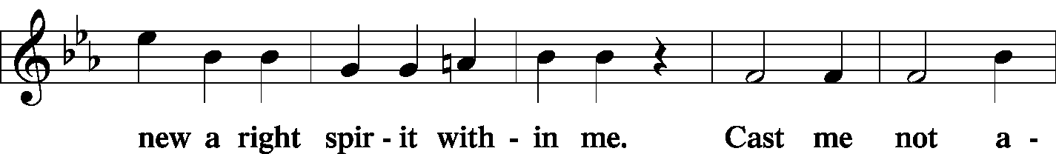
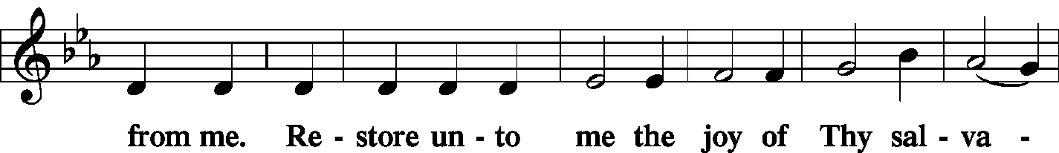
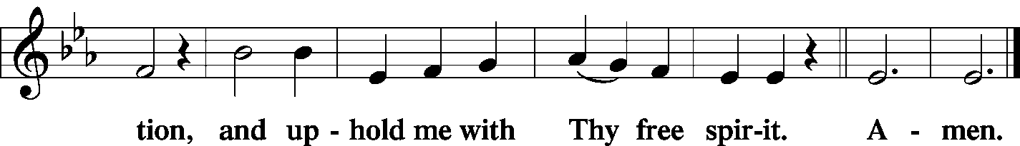
Stand

The PRAYER OF THE CHURCH
P Lord, in Your mercy.

C Hear our prayer.
The Preface and PROPER PREFACE LSB 194
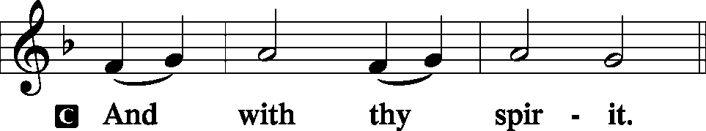
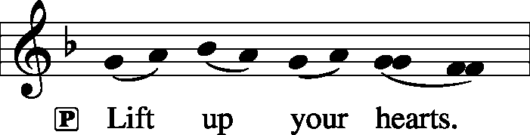
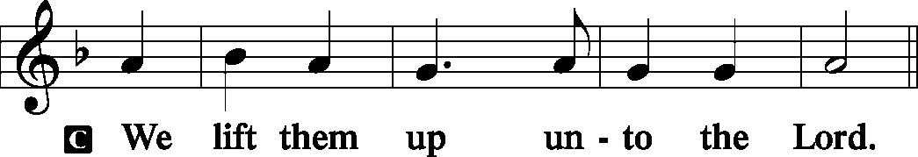
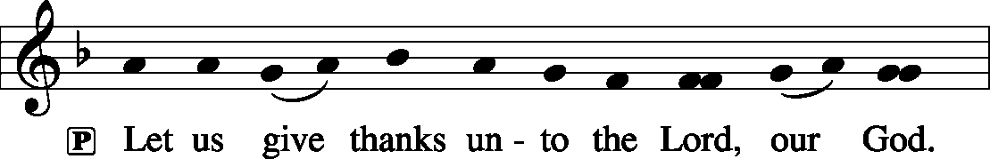
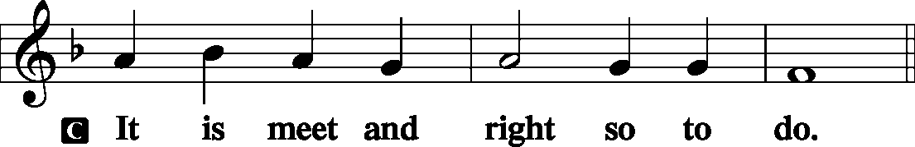
P It is truly meet, right, and salutary . . . evermore praising You and saying:
The SANCTUS LSB 195
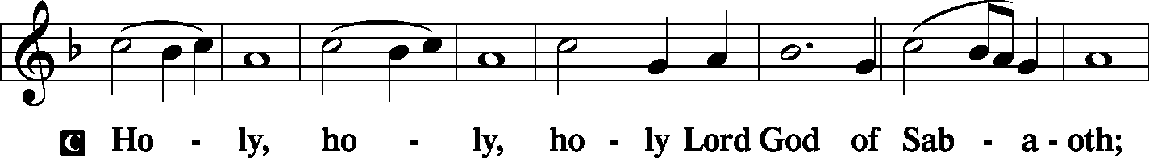
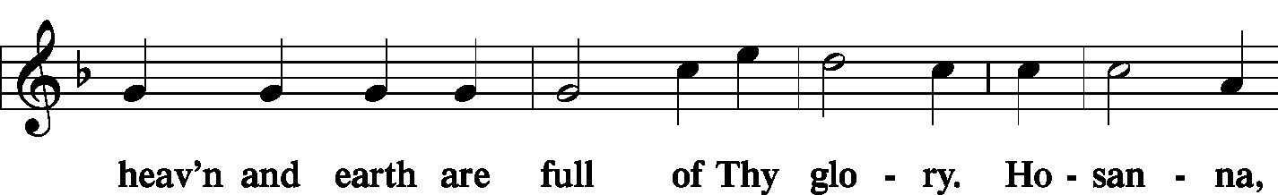
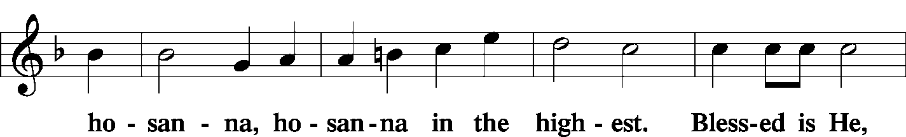
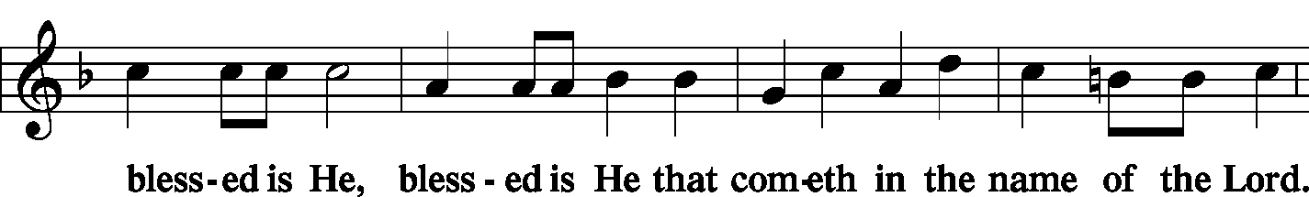
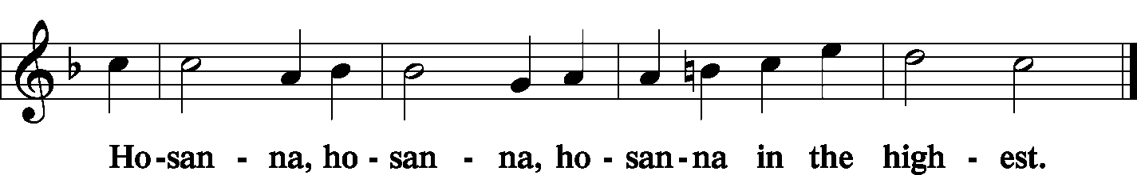
The Lord's Prayer LSB 196
C Our Father who art in heaven,
hallowed be Thy name,
Thy kingdom come,
Thy will be done on earth as it is in heaven;
give us this day our daily bread;
and forgive us our trespasses as we forgive those who trespass against us;
and lead us not into temptation,
but deliver us from evil.
For Thine is the kingdom and the power and the glory forever and ever. Amen.
The Words of Institution LSB 197
The Pax Domini LSB 197
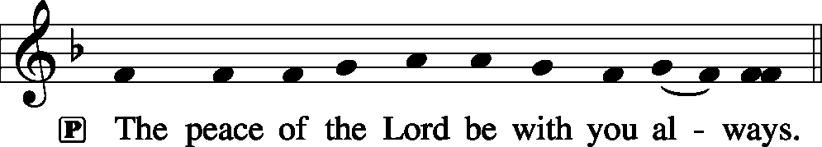
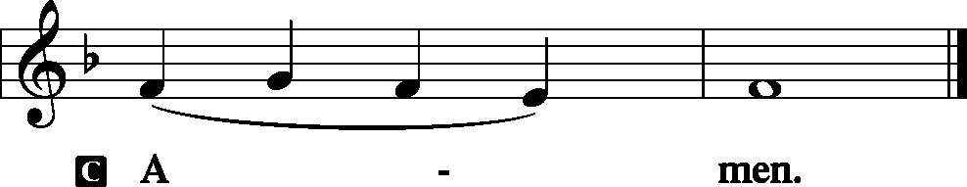
The Agnus Dei LSB 198
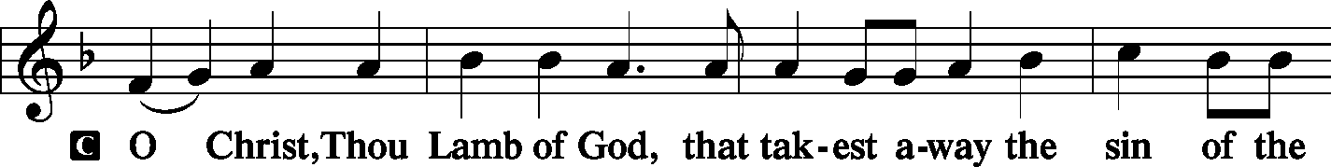
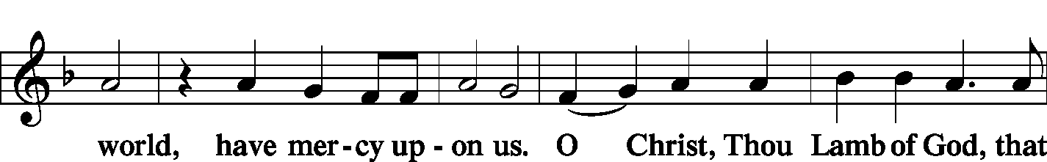
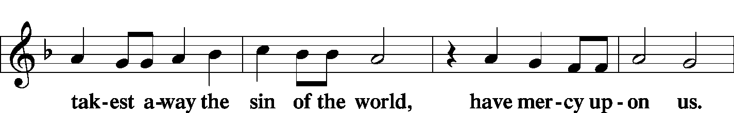
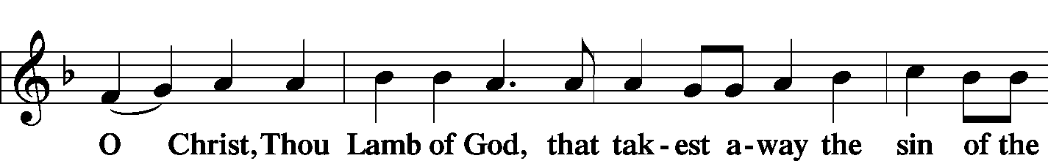
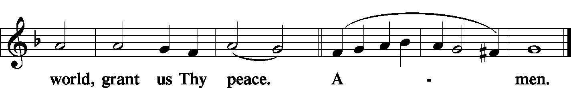
Sit
The HYMN LSB 663 Rise, My Soul, to Watch and Pray
LSB 644 The Church's One Foundation
(See Pages 18-19)
Stand

The Nunc Dimittis LSB 199
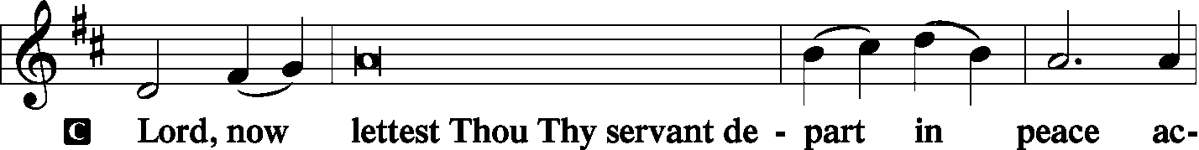
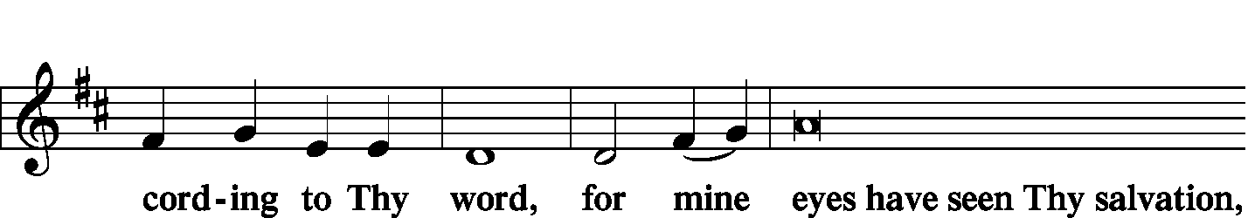
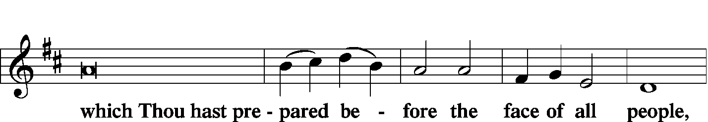
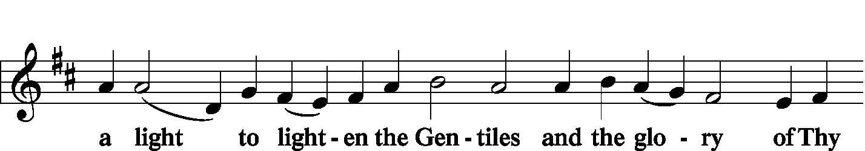
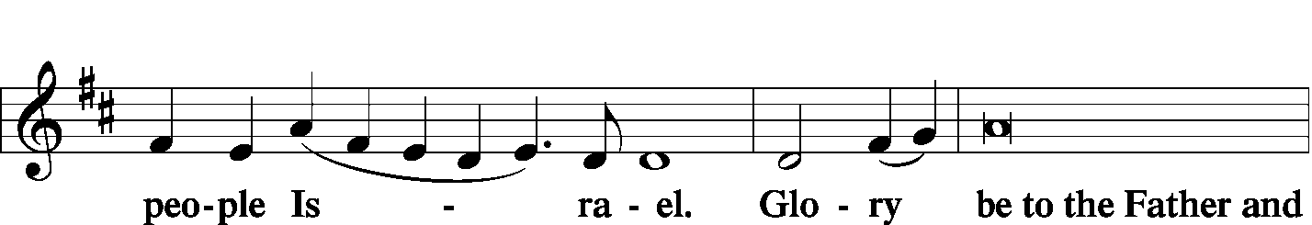
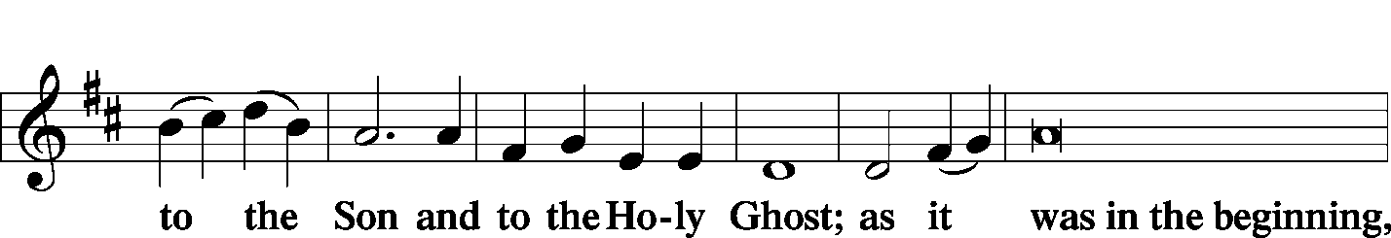
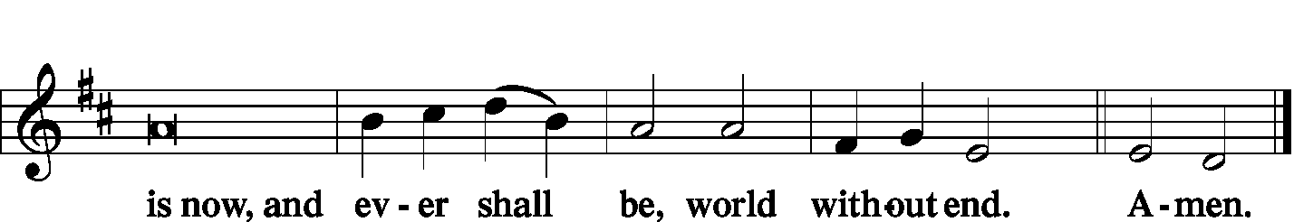

The Thanksgiving LSB 200
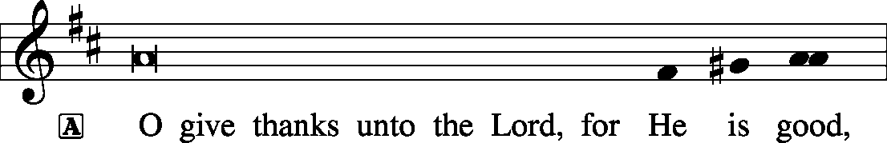
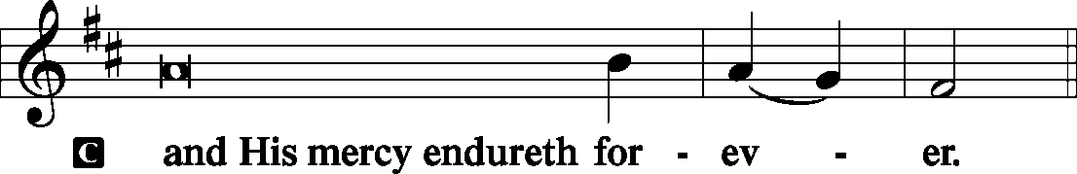
P We give thanks to You, almighty God, that You have refreshed us through this salutary gift, and we implore You that of Your mercy You would strengthen us through the same in faith toward You and fervent love toward one another; through Jesus Christ, Your Son, our Lord, who lives and reigns with You and the Holy Spirit, one God, now and forever.
The SALUTATION, BENEDICAMUS and BENEDICTION LSB 201–202
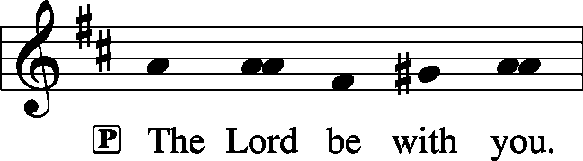
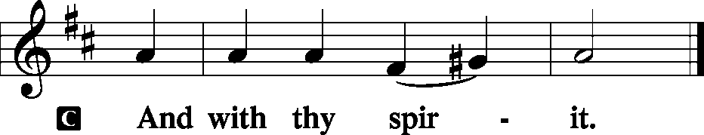

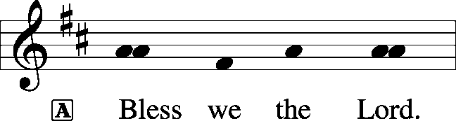
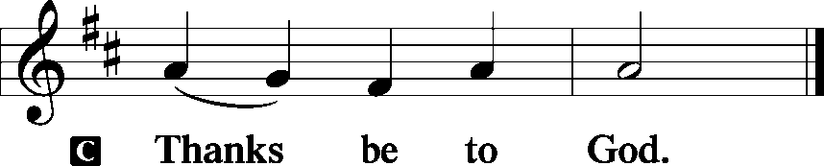
The Benediction LSB 202
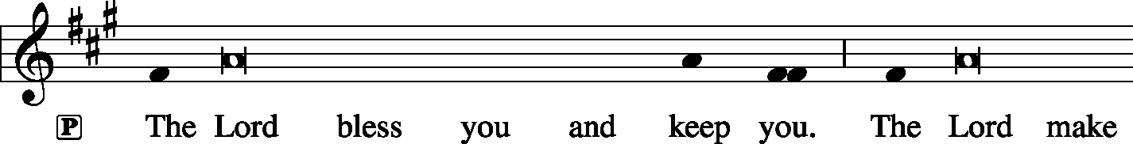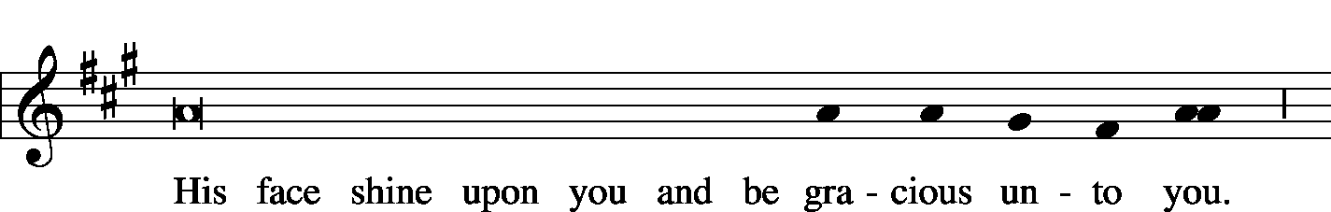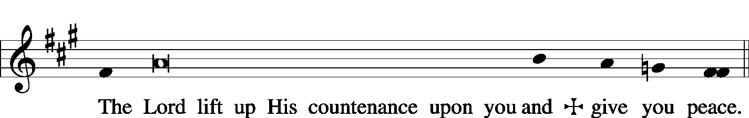
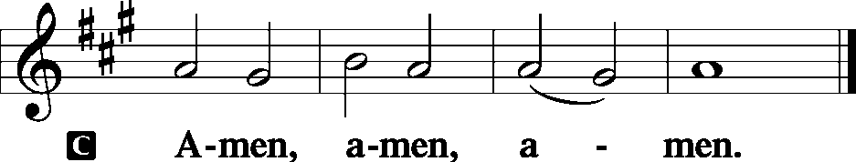

The RECESSIONAL HYMN LSB 805 Praise God, from Whom All Blessings Flow
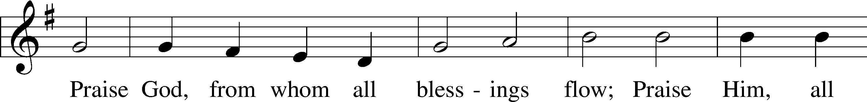
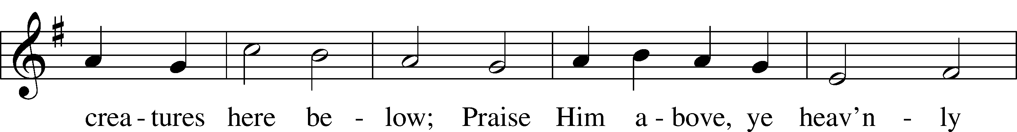
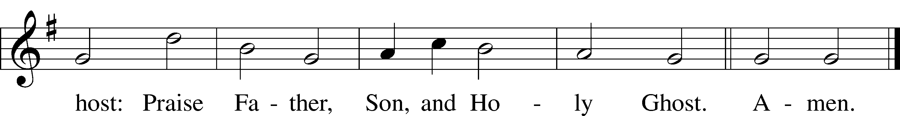

SERVING TODAY
CELEBRANT Rev. Jason Braaten
ORGANIST Mrs. Leigh Ann Whitson

ACKNOWLEDGEMENTS: Divine Service, Setting Three from Lutheran Service Book Unless otherwise indicated, all scripture quotations are from The Holy Bible, English Standard Version, copyright © 2001 by Crossway Bibles, a division of Good News Publishers. Used by permission. All rights reserved. Created by Lutheran Service Builder © 2006 Concordia Publishing House.

LSB 514 The Bridegroom Soon Will Call Us
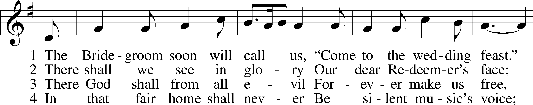
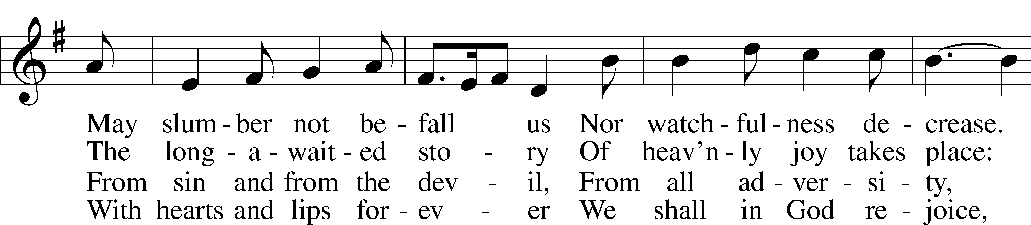
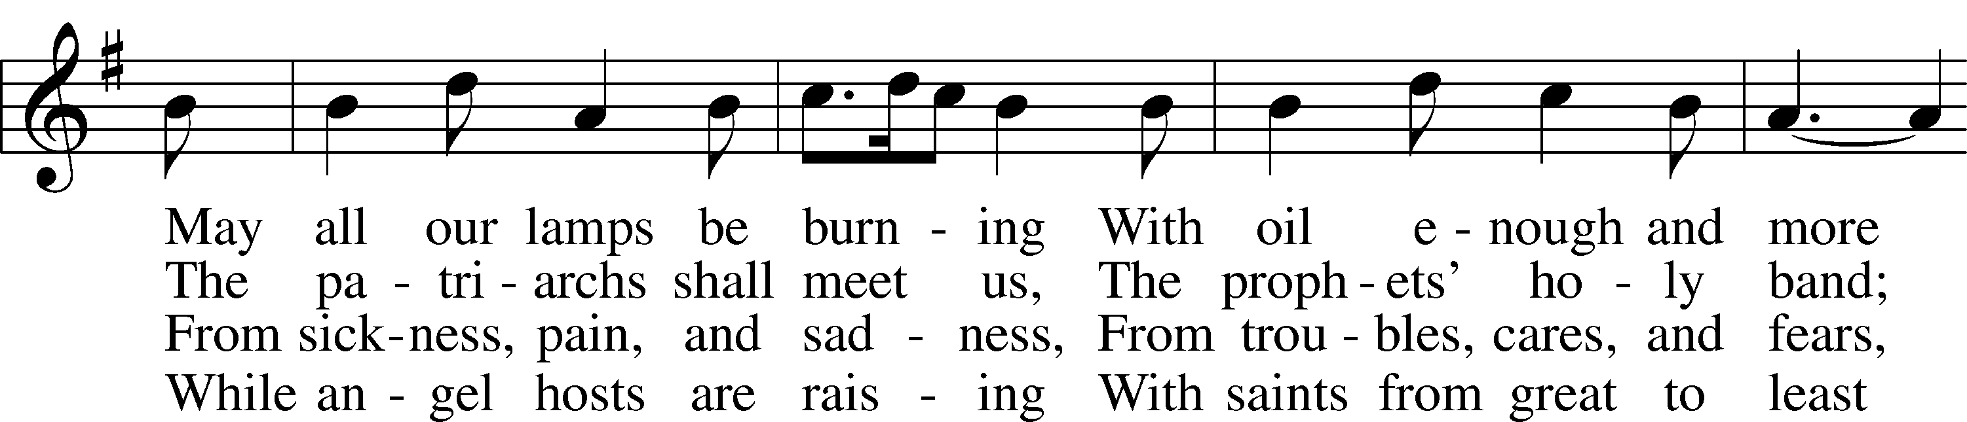
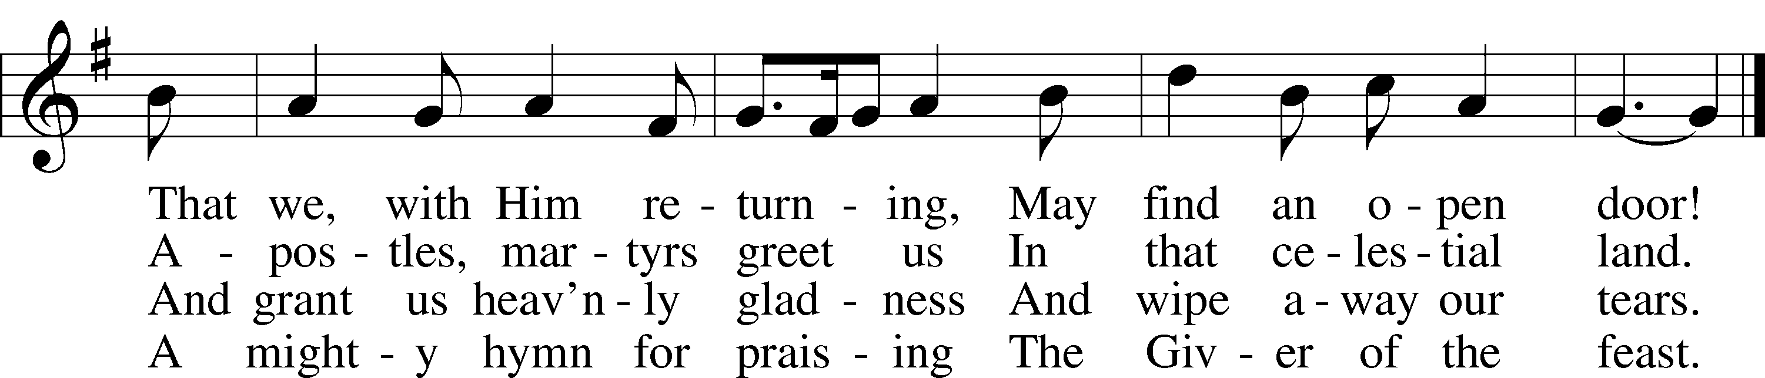
© 1982 Concordia Publishing House. Used by permission: LSB Hymn License .NET, no. 100012632.
Public domain

LSB 516 Wake, Awake, for Night Is Flying
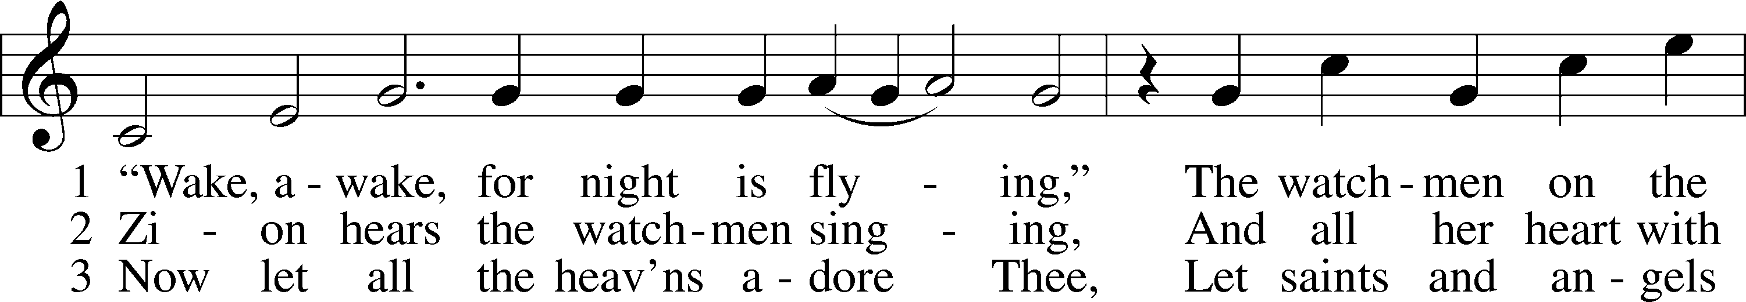
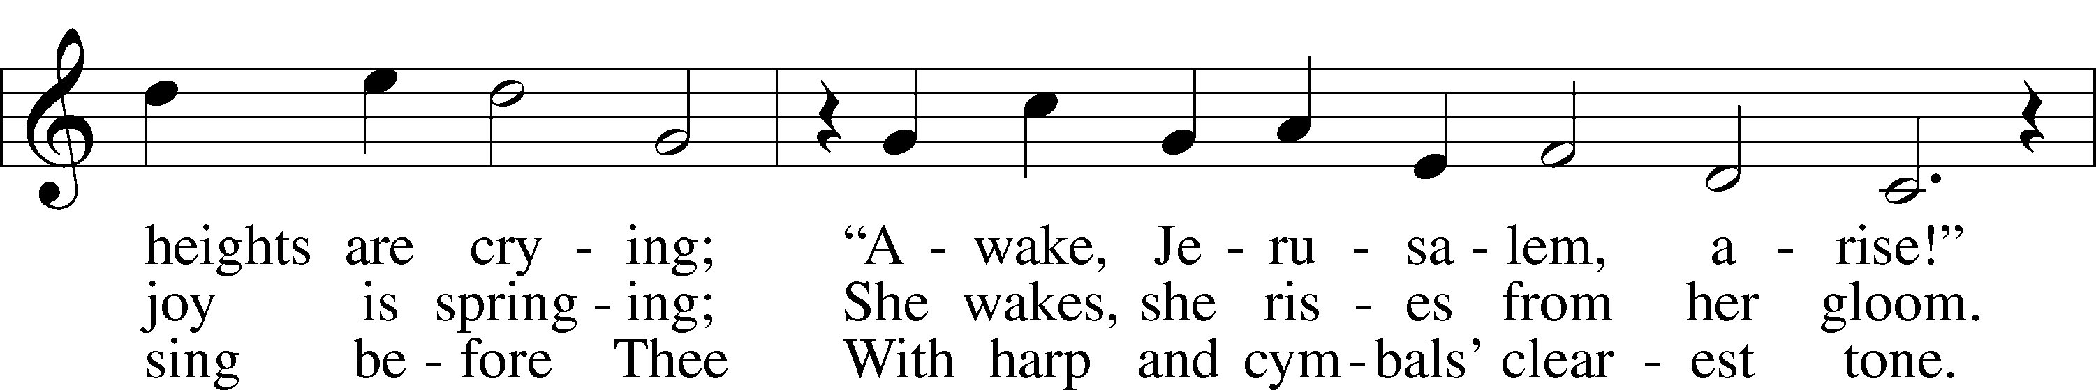
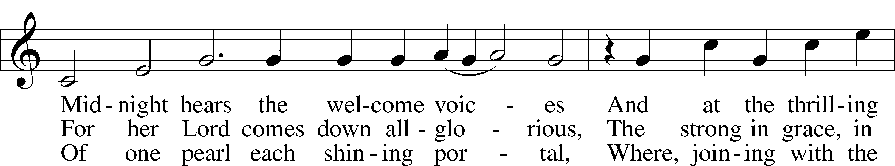
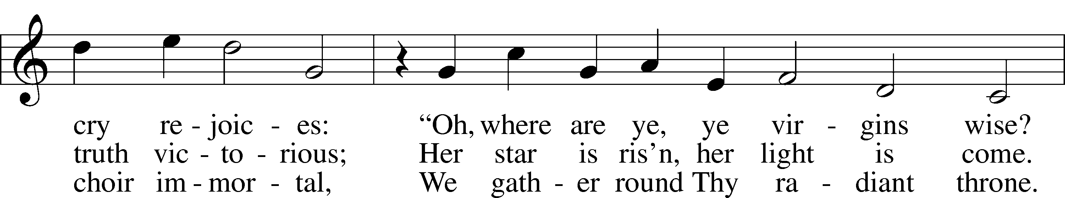
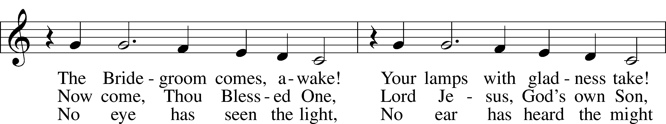
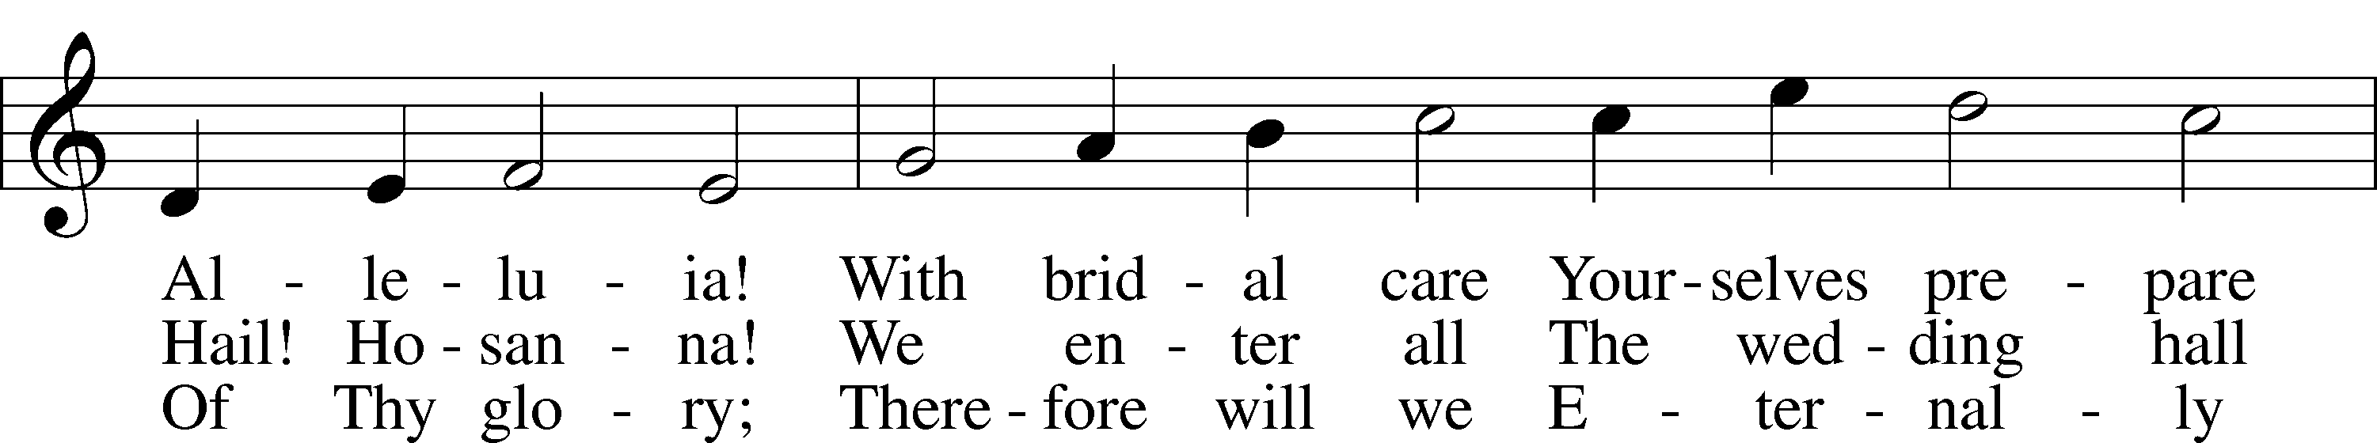
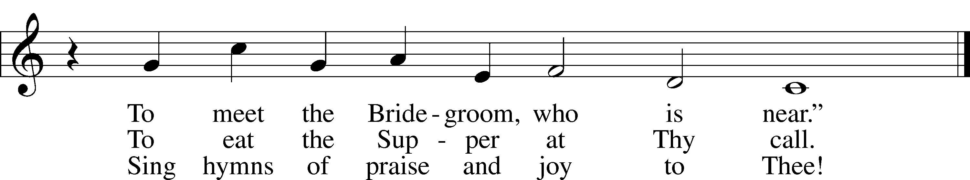
LSB 663 Rise, My Soul, to Watch and Pray
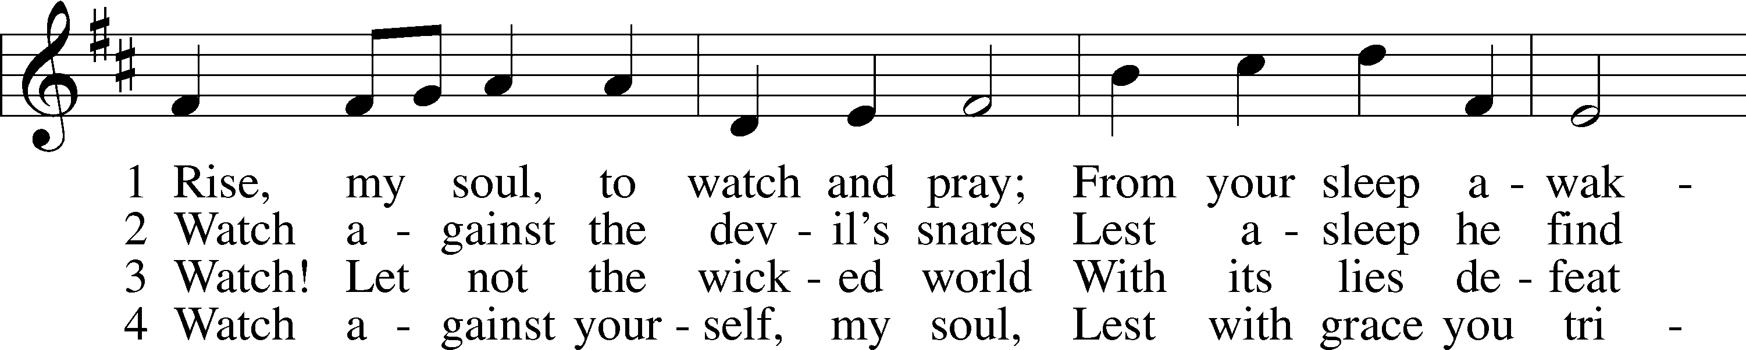
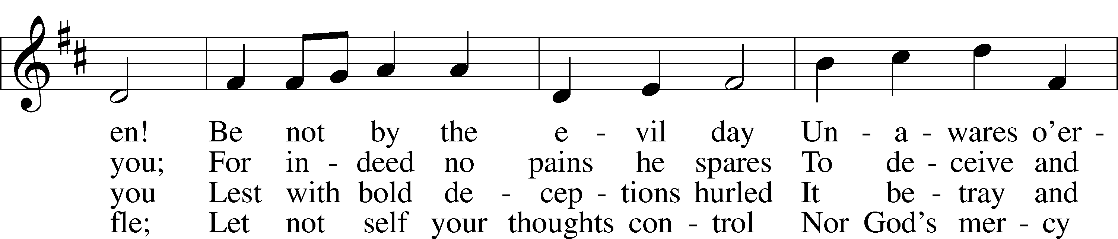
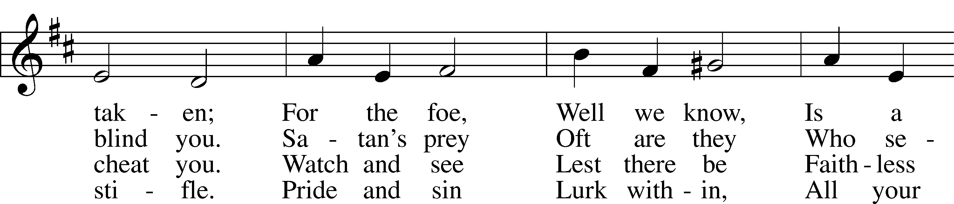
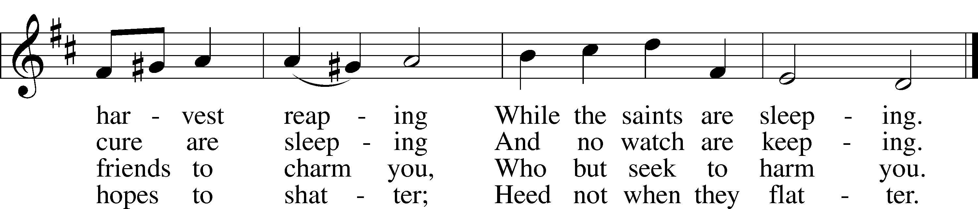

5 But while watching, also pray
To the Lord unceasing.
God protects you day by day,
Strength and faith increasing,
So that still
Mind and will
Shall unite to serve Him
And forever love Him.

LSB 644 The Church's One Foundation
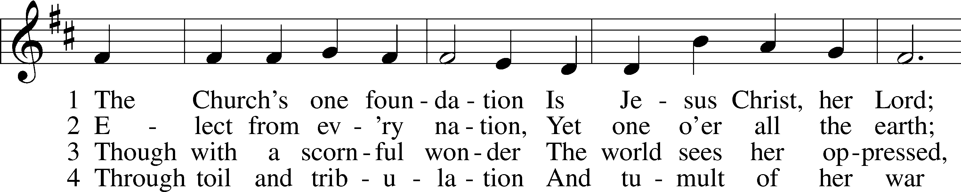
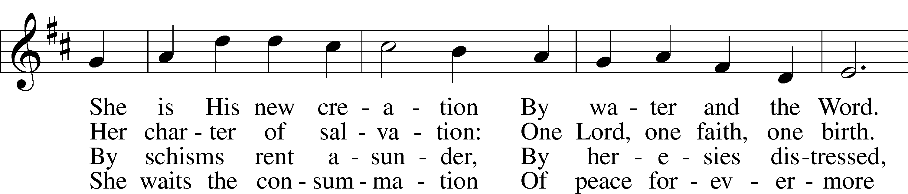
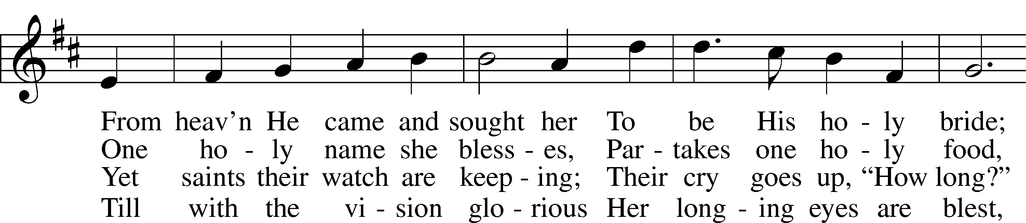
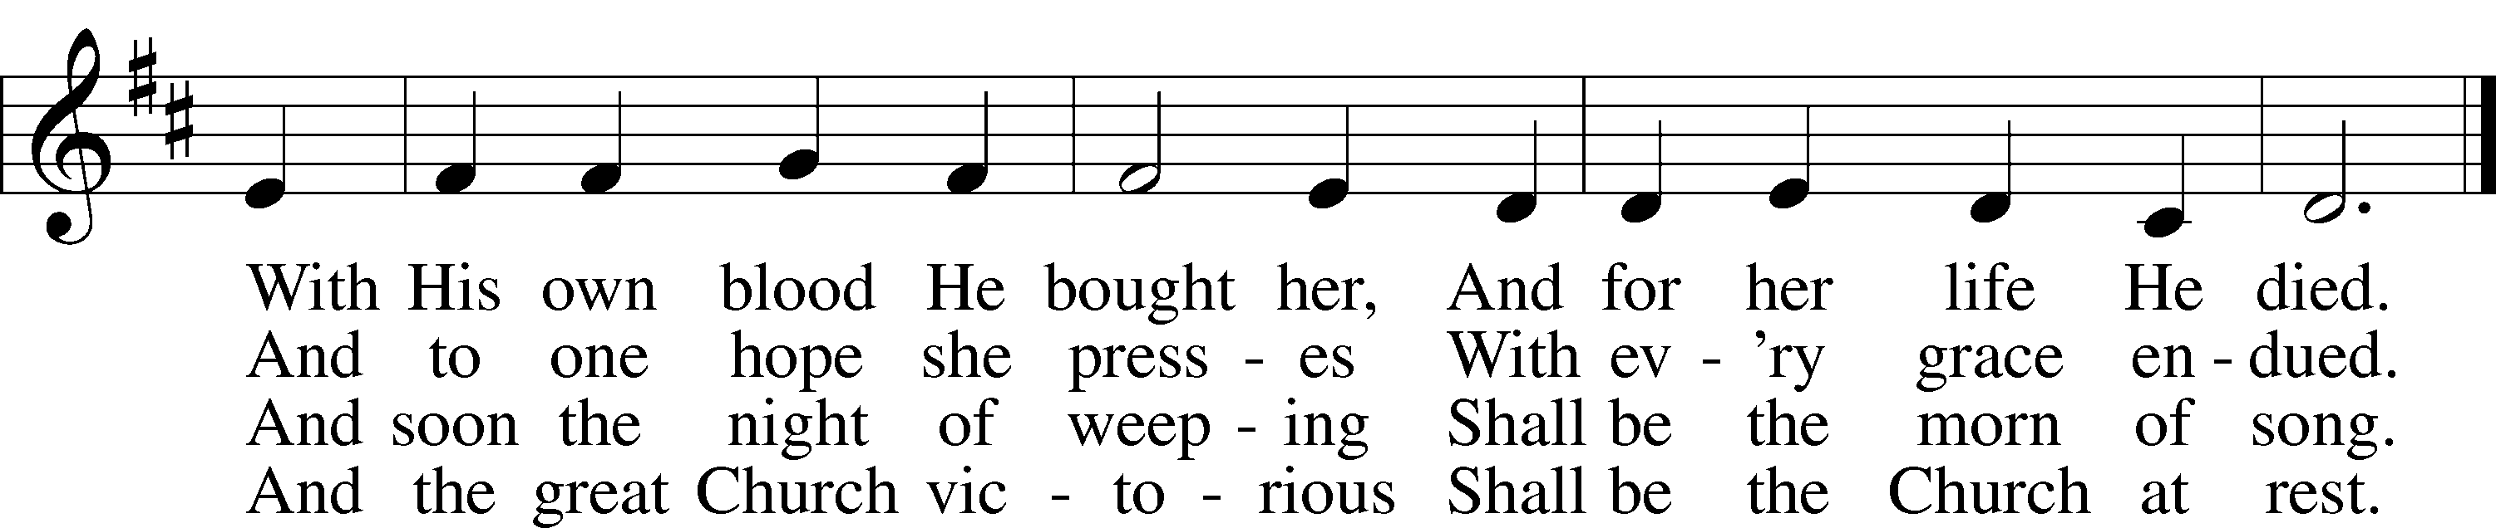

5 Yet she on earth has union
With God, the Three in One,
And mystic sweet communion
With those whose rest is won.
O blessèd heav’nly chorus!
Lord, save us by Your grace
That we, like saints before us,
May see You face to face.

THIS WEEK AT IMMANUEL
Sunday (11/22) 9:00 am Divine Service with Holy Communion
10:30 am Bible Class & Sunday School
Wednesday 12:30 PM Catechism Class
7:00 pm Thanksgiving Eve Evening Prayer
Saturday 5:30 pm Divine Service without Holy Communion
Sunday (11/29) 9:00 am Divine Service without Holy Communion
10:30 am Bible Class & SS Christmas Practice

IN OUR PRAYERS
HEALTH CONCERNS: Bernita Ashwill; Connie Bruns (cousin of Mary Appleby); Lynn Corrie (friend of Arleigh Jones); Ellie Crawford (daughter of Laran Crawford); Whitney Czerwonka; Lynn Davis (cousin of Mark Whitson); Cindy Ekstrom; Theresa Fields; Darrell Ford; Lisa Hall (sister of Holly Wikoff); Rick Hardesty (family of the Hoels); Kim Hausman (friend of Ann Carroll); Deanna Henningsen (sister-in-law of Jerry & Joyce Alexander); Glenn Linstead; Mary Miller (friend of David Holzrichter); Kimberly Mulvany (daughter of Pastor Doug Meyer); Mary Negangard (grandmother of Bryce Reifsteck); Dennis Pickett (friend of Ann Carroll); Misti Post (niece of Sue Rothe); Cary & Beth Rahn; Joan Rahn; Aurelia Tuegal (grandmother of Bethany Campbell); Emma Silver; Dave Slaughter; Ocil Slone (grandfather of Josh & Jake Dyer); Joy Stenger; Carolyn Stremming (sister-in-law of Arleigh Jones); Janet Stumeier; Brian Walker (uncle of Bryce Reifsteck); Lynn & Jane Whitson (parents of Mark Whitson).
SEMINARY STUDENT: Gunnar Campbell; Logan Smith.
DEACONESS STUDENT: Emily McLean.
MISSIONARIES: The Naumann Family; The McDermott Family, Julie Lutz
HOMEBOUND: Bernita Ashwill; Leonard Boerngen; Jim Harbaugh; Janet Pollock; Ruth Rentschler; Ruth Sims; Irene Wattjes.
MILITARY: Carl Crawford; Josh Dyer; Jeremy Gordon; Jack Leonard; Jake Lindgren; Raymond Longtin; Joey Pollock; Blake Stokes; Ruben Wilson.

THE ANNOUNCEMENTS
NEXT WEEK’S READINGS . . . Jeremiah 23:5–8; Romans 13:11–14; Matthew 21:1–9.
ABOUT THIS WEEK’S READINGS . . . “The day of the Lord will come like a thief in the night” (1 Thess. 5:1–11). The arrival of the bridegroom will be sudden and unexpected. Therefore you are to be watchful and ready like the five wise virgins. “For you know neither the day nor the hour” when the Son of Man is to return. (Matt. 25:1–13). The lamps are the Word of Christ. The oil in the lamps is the Holy Spirit, who works through the Word to create and sustain the flame of faith in Christ. The foolish are those who do not give proper attention to the working of the Holy Spirit in baptism, preaching, and the supper, and so their faith does not endure. The wise, however, are those who diligently attend to these gifts of the Spirit, and who therefore have an abundance of oil. The flame of faith endures to the end. By God’s grace they are received into the eternal wedding feast of the Lamb in His kingdom, the new heavens and the new earth created by the Lord for the joy of His people (Is. 65:17–25).
THOUGHTS ABOUT STEWARDSHIP . . . Matthew 25:4 “ . . . but the wise took flasks of oil with their lamps.” Why did they take flasks of oil with them? Because they listened to the Bridegroom’s words and believed them. Our actions always start with and flow from our beliefs. What do your actions in the realm of stewardship say about what you believe?
ALTAR FLOWERS . . . are given by Roger and Wanda Long to the glory of God on the occasion of their wedding anniversary.
THE 2021 FLOWER CHART IS NOW AVAILABLE . . . Please sign up on the bulletin board across from member mailboxes. Flowers will be $35.00 again in 2021 and can be special ordered. Flowers can be taken home after the Sunday’s service.
PASTOR WILL BE AWAY . . . the weekend following Thanksgiving (Saturday, Nov 28–Sunday, November 29). Gunnar Campbell will be serving in pastor’s absence. There will be no Holy Communion that weekend since Gunnar is not yet ordained. He will also be leading Bible Class.
BI-MONTHLY MISSION . . . is Sunday, December 3, and will be going toward the Angel Tree. There will be an Angel Tree envelope in your member mailbox. You can place cash or check payable to Immanuel in this envelope and place it in the offering on December 3 or return it to the church office on or before December 3. Thank you for your generosity in helping area children receive a few gifts under the Christmas Tree.
CHURCH-WIDE LIVE NATIVITY IN TUSCOLA . . . Immanuel will participate in a church-wide live nativity to be held in Ervin Park on Sunday, December 6, 2020, from 5:00 pm to 7:00 pm. More details are coming soon.
CHRISTMAS DECORATING . . . Saturday, December 5, 9:00 am. Advent is almost upon us, and that means the Christmas season is near! With it come the sights, the sounds, and the fellowship that unite Christians as we anticipate the birth of our Savior. Come on December 5 to help put up the Christmas trees and decorations. Mark your calendars.
UPCOMING SPECIAL SERVICES AND EVENTS
Sunday, November 29 10:20 am Sunday School Christmas Service practice
Wednesday, December 2 7:00 pm Advent Midweek Service
Saturday, December 5 9:00 am Immanuel Christmas Decorating
Sunday, December 6 5:00 pm Church-wide Live Nativity (Ervin Park)
Wednesday, December 9 7:00 pm Advent Midweek Service
Sunday, December 13 10:20 am Sunday School Christmas Service practice
Wednesday, December 16 7:00 pm Advent Midweek Service
Sunday, December 20 10:20 am Sunday School Christmas Service practice
6:00 pm Sunday School Christmas Service
Monday, December 21 7:30 pm Voter’s Budget Meeting
Thursday, December 24 7:00 pm Christmas Eve Service with Communion
Friday, December 25 9:00 am Christmas Day Service with Communion
Thursday, December 31 7:00 pm New Year’s Eve Evening Prayer

A PRAYER FOR IMMANUEL
My dear Lord Jesus, I want to know You as Savior and Friend, Help me to grow into a mature disciple so that I can demonstrate God’s love and forgiveness in all I do. Teach me to share my faith in You and to serve others in my vocation. Make Immanuel Lutheran Church a place where lost and hurting people find friendship, forgiveness, and faith, and where Christians gather to serve You in love for one another, for the community, and for the world. Amen.
Debra Parsley, Office Manager
Office: (217) 253-4341
Email: immanuel.tuscola@gmail.com

Office Hours:

Rev. Jason Braaten, Pastor
Home: (217) 253-4539
Mobile: (217) 460-2077
Email: pastor.braaten@gmail.com
Office Hours:
Monday–Thursday 8:00 am–12:00 pm
or by appointment

