THE TWENTY-THIRD SUNDAY
AFTER TRINITY

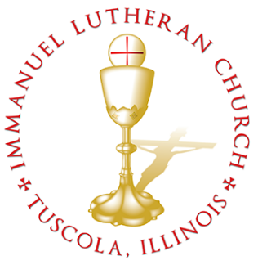
THE TWENTY-THIRD SUNDAY AFTER TRINITY

Today we celebrate the Sacrament of our Lord Jesus Christ’s true body and blood. Since receiving the Lord’s Supper expresses fellowship with the Lord and agreement with the teaching of the pastor and congregation, we follow the Biblical practice of closed communion. All guests are kindly asked to speak with Pastor Braaten before communing at our altar. Normally, members from congregations of The Lutheran Church—Missouri Synod are welcome to partake, as are people from churches in fellowship with the LCMS.
WELCOME VISITORS

Divine Service, Setting Three with Holy Communion
Stand
The PROCESSIONAL HYMN LSB 791 All People That on Earth Do Dwell
(see page 16)
The INVOCATION, CONFESSION, and ABSOLUTION LSB 184–185
P In the name of the Father and of the T Son and of the Holy Spirit.
C Amen.
P Beloved in the Lord! Let us draw near with a true heart and confess our sins unto God our Father, beseeching Him in the name of our Lord Jesus Christ to grant us forgiveness.
P Our help is in the name of the Lord,
C who made heaven and earth.
P I said, I will confess my transgressions unto the Lord,
C and You forgave the iniquity of my sin.
P O almighty God, merciful Father,
C I, a poor, miserable sinner, confess unto You all my sins and iniquities with which I have ever offended You and justly deserved Your temporal and eternal punishment. But I am heartily sorry for them and sincerely repent of them, and I pray You of Your boundless mercy and for the sake of the holy, innocent, bitter sufferings and death of Your beloved Son, Jesus Christ, to be gracious and merciful to me, a poor, sinful being.
P Upon this your confession, I, by virtue of my office, as a called and ordained servant of the Word, announce the grace of God unto all of you, and in the stead and by the command of my Lord Jesus Christ I forgive you all your sins in the name of the Father and of the T Son and of the Holy Spirit.
C Amen.
The INTROIT Ps. 85:1, 7, 9, 11; antiphon: Jer. 29:11a, 12
I know the plans I have for you, de- | clares the LORD,*
plans for wholeness and not for | evil.
Then you will call upon me and come and | pray to me,*
and I will | hear you.
LORD, you were favorable | to your land;*
you restored the fortunes of | Jacob.
Show us your steadfast love, | O LORD,*
and grant us your sal- | vation.
Surely his salvation is near to those who | fear him,*
that glory may dwell | in our land.
Faithfulness springs up | from the ground,*
and righteousness looks down | from the sky.
Glory be to the Father and | to the Son*
and to the Holy | Spirit;
as it was in the be- | ginning,*
is now, and will be forever. | Amen.
I know the plans I have for you, de- | clares the LORD,*
plans for wholeness and not for | evil.
Then you will call upon me and come and | pray to me,*
and I will | hear you.
The KYRIE LSB 186
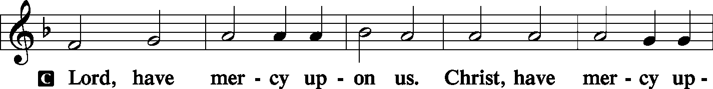
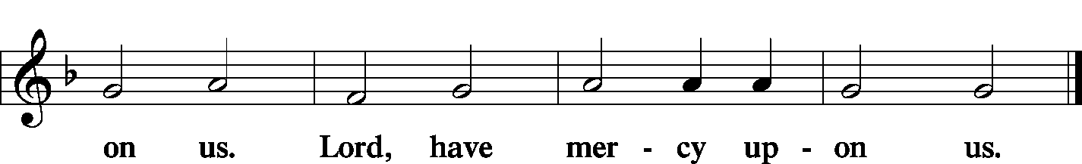
The GLORIA IN EXCELSIS LSB 187–189
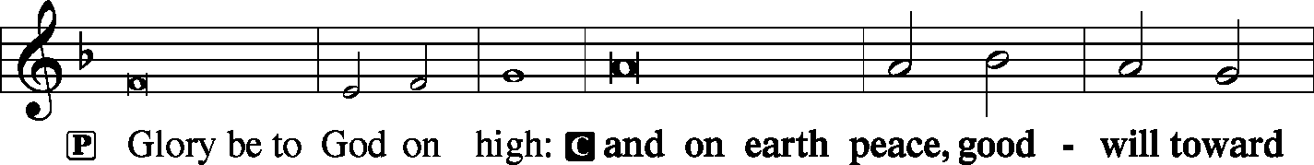
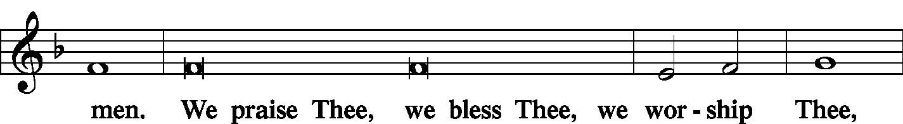
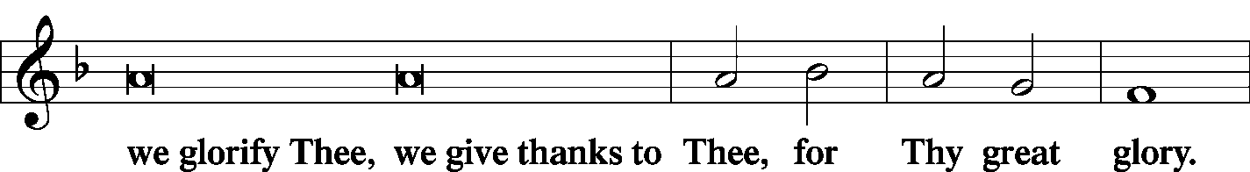
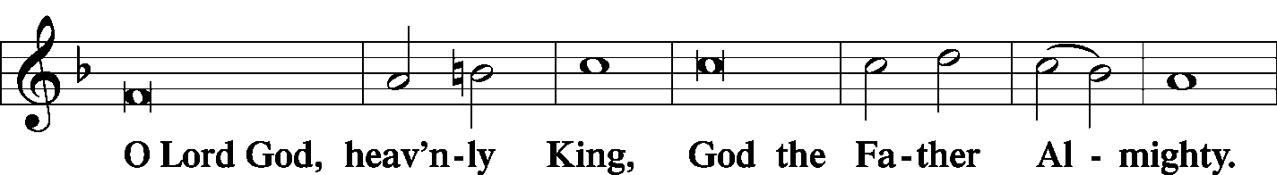
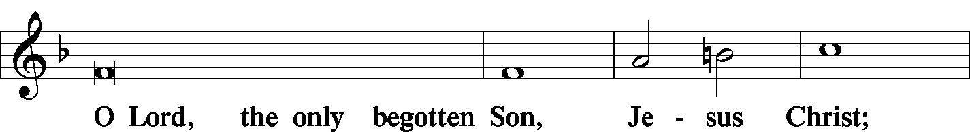
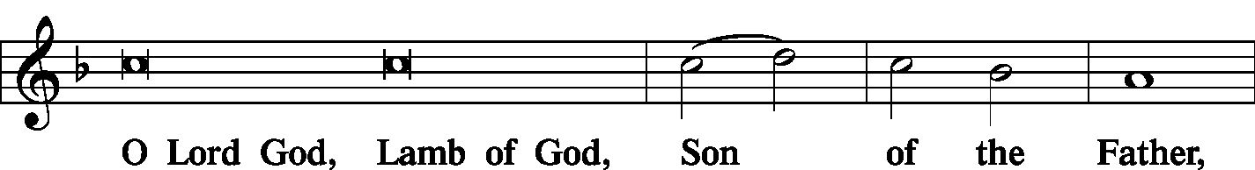
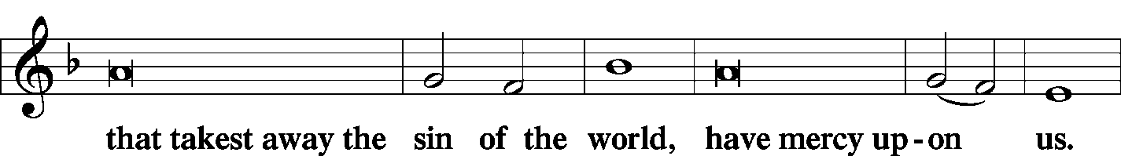
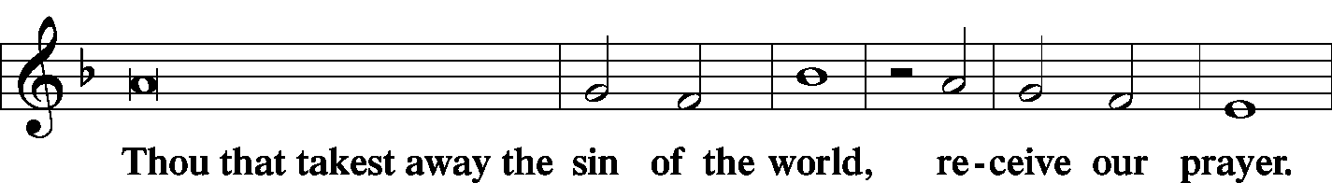
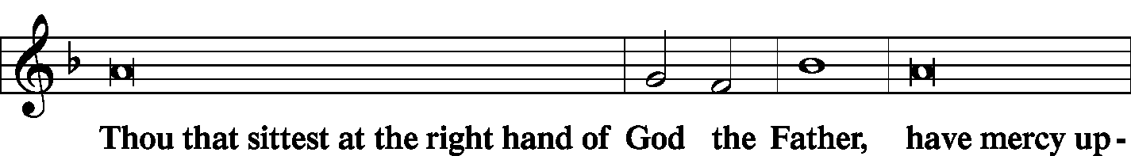
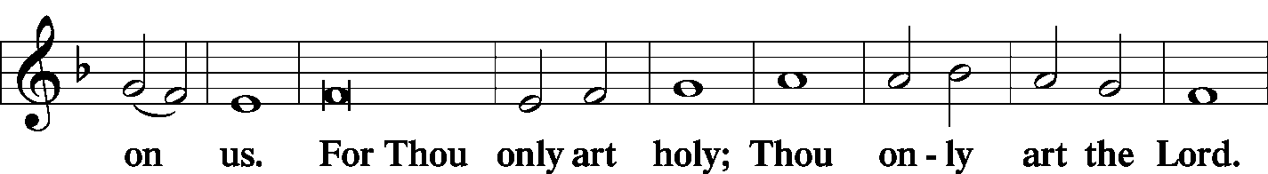
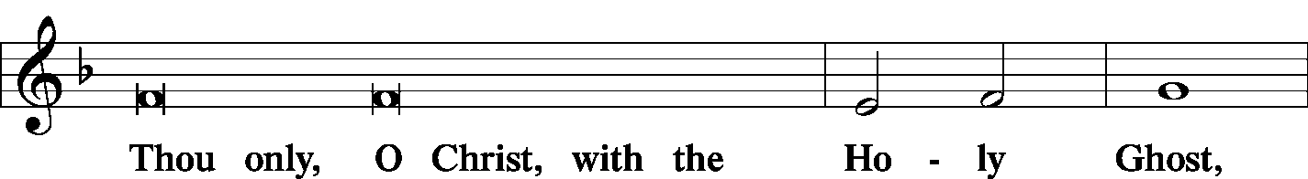
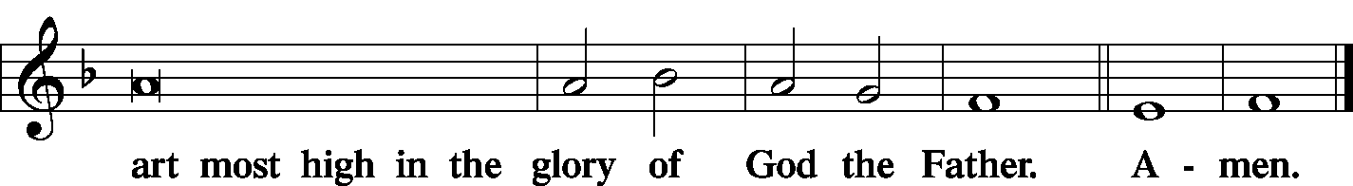

The SALUTATION and COLLECT OF THE DAY LSB 189
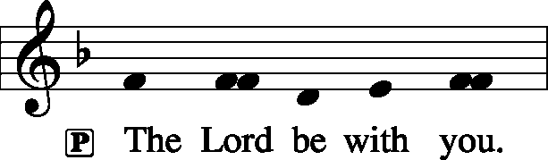
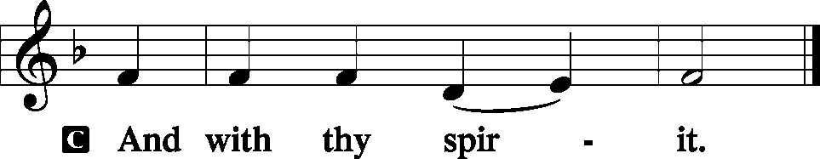
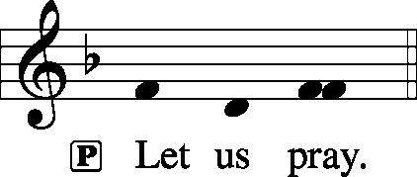
C O Lord, absolve Your people from their offenses that from the bonds of our sins, which by reason of our frailty we have brought upon ourselves, we may be delivered by Your bountiful goodness; through Jesus Christ, Your Son, our Lord, who lives and reigns with You and the Holy Spirit, one God, now and forever.
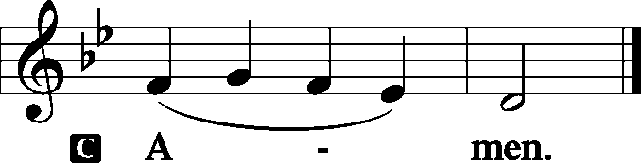
Sit

The FIRST READING Proverbs 8:11–22
For wisdom is better than jewels, and all that you may desire cannot compare with her. I, wisdom, dwell with prudence, and I find knowledge and discretion. The fear of the Lord is hatred of evil. Pride and arrogance and the way of evil and perverted speech I hate. I have counsel and sound wisdom; I have insight; I have strength. By me kings reign, and rulers decree what is just; by me princes rule, and nobles, all who govern justly. I love those who love me, and those who seek me diligently find me. Riches and honor are with me, enduring wealth and righteousness. My fruit is better than gold, even fine gold, and my yield than choice silver. I walk in the way of righteousness, in the paths of justice, granting an inheritance to those who love me, and filling their treasuries. The Lord possessed me at the beginning of his work, the first of his acts of old.
P This is the Word of the Lord.

C Thanks be to God.
The GRADUAL Ps 44:7–8
You have saved us | from our foes*
and have put to shame those who | hate us.
In God we have boasted con- | tinually,*
and we will give thanks to your name for- | ever.
The SECOND READING Philippians 3:17–21
Brothers, join in imitating me, and keep your eyes on those who walk according to the example you have in us. For many, of whom I have often told you and now tell you even with tears, walk as enemies of the cross of Christ. Their end is destruction, their god is their belly, and they glory in their shame, with minds set on earthly things. But our citizenship is in heaven, and from it we await a Savior, the Lord Jesus Christ, who will transform our lowly body to be like his glorious body, by the power that enables him even to subject all things to himself.
P This is the Word of the Lord.

C Thanks be to God.

Stand

The ALLELUIA LSB 190
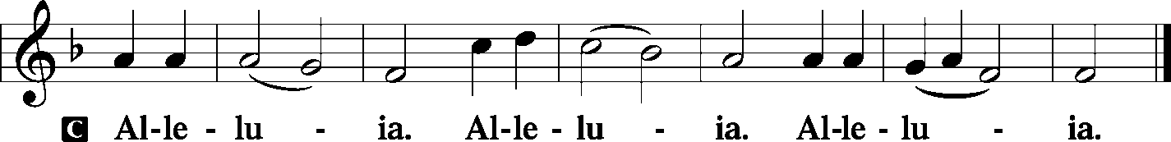
The HOLY GOSPEL St. Matthew 22:15–22
P The Holy Gospel according to St. Matthew, the twenty-second chapter.
C Glory be to Thee, O Lord. (Sung)
Then the Pharisees went and plotted how to entangle [Jesus] in his talk.
And they sent their disciples to him, along with the Herodians, saying, “Teacher, we know that you are true and teach the way of God truthfully, and you do not care about anyone’s opinion, for you are not swayed by appearances. Tell us, then, what you think. Is it lawful to pay taxes to Caesar, or not?” But Jesus, aware of their malice, said, “Why put me to the test, you hypocrites? Show me the coin for the tax.” And they brought him a denarius. And Jesus said to them, “Whose likeness and inscription is this?” They said, “Caesar’s.” Then he said to them, “Therefore render to Caesar the things that are Caesar’s, and to God the things that are God’s.” When they heard it, they marveled. And they left him and went away.
P This is the Gospel of the Lord.

C Praise be to Thee, O Christ. (Sung)

The NICENE CREED LSB 191
C I believe in one God,
the Father Almighty,
maker of heaven and earth
and of all things visible and invisible.

And in one Lord Jesus Christ,
the only-begotten Son of God,
begotten of His Father before all worlds,
God of God, Light of Light,
very God of very God,
begotten, not made,
being of one substance with the Father,
by whom all things were made;
who for us men and for our salvation came down from heaven
and was incarnate by the Holy Spirit of the virgin Mary
and was made man;
and was crucified also for us under Pontius Pilate.
He suffered and was buried.
And the third day He rose again according to the Scriptures
and ascended into heaven
and sits at the right hand of the Father.
And He will come again with glory to judge both the living and the dead,
whose kingdom will have no end.

And I believe in the Holy Spirit,
the Lord and giver of life,
who proceeds from the Father and the Son,
who with the Father and the Son together is worshiped and glorified,
who spoke by the prophets.
And I believe in one holy Christian and apostolic Church,
I acknowledge one Baptism for the remission of sins,
and I look for the resurrection of the dead
and the life T of the world to come. Amen.

Sit

The HYMN OF THE DAY LSB 714 Who Trusts in God a Strong Abode
(see page 17)
The SERMON
Stand
The OFFERTORY LSB 192
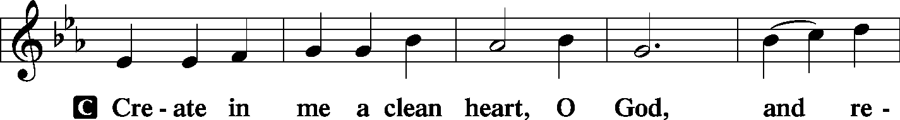
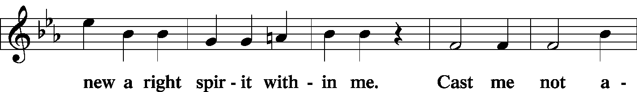
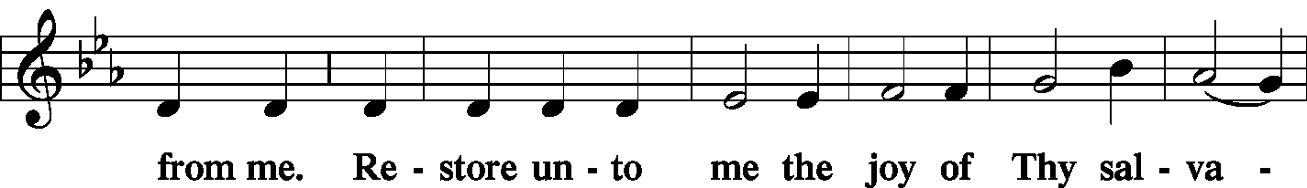
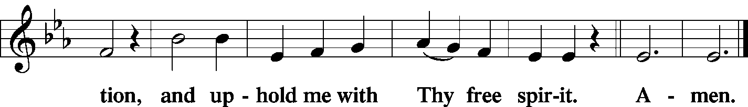
Stand

The PRAYER OF THE CHURCH
P Lord, in Your mercy.

C Hear our prayer.

The Preface and PROPER PREFACE LSB 194
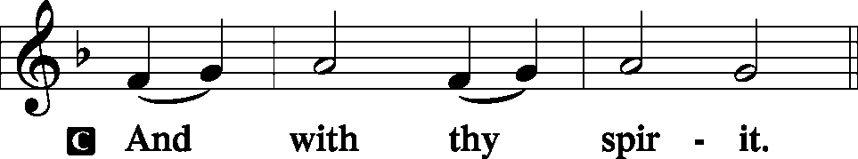
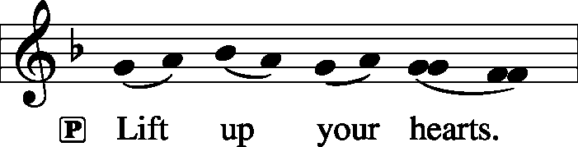
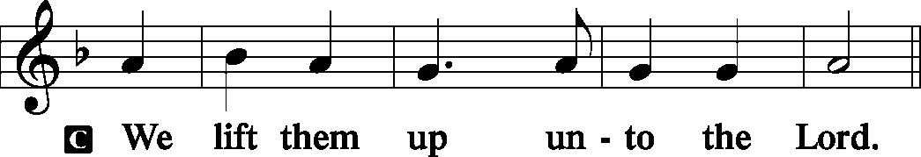
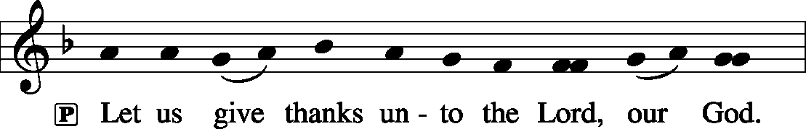
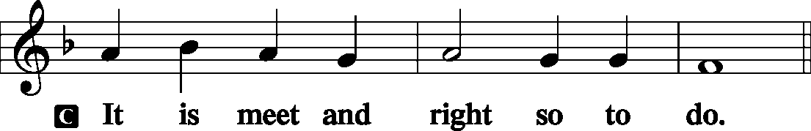
P It is truly meet, right, and salutary . . . evermore praising You and saying:
The SANCTUS LSB 195
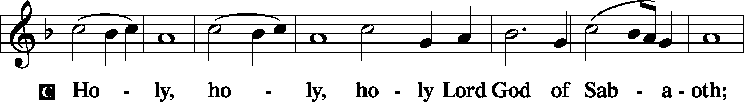
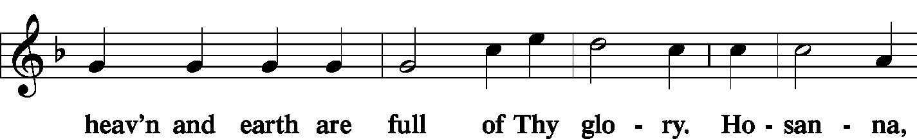
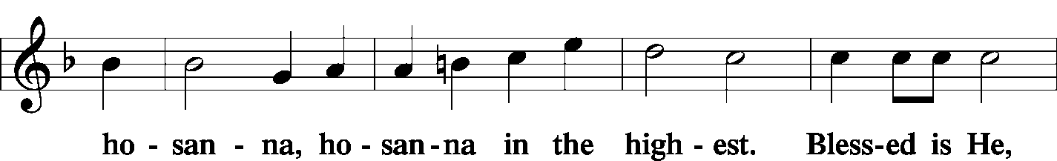
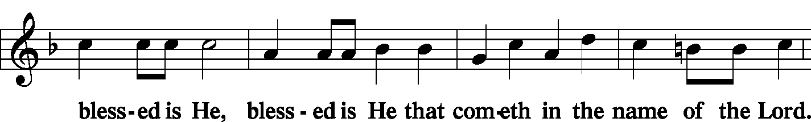
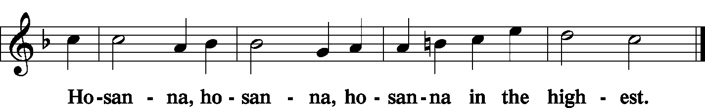
The Lord's Prayer LSB 196
C Our Father who art in heaven,
hallowed be Thy name,
Thy kingdom come,
Thy will be done on earth as it is in heaven;
give us this day our daily bread;
and forgive us our trespasses as we forgive those who trespass against us;
and lead us not into temptation,
but deliver us from evil.
For Thine is the kingdom and the power and the glory forever and ever. Amen.
The Words of Institution LSB 197
The Pax Domini LSB 197
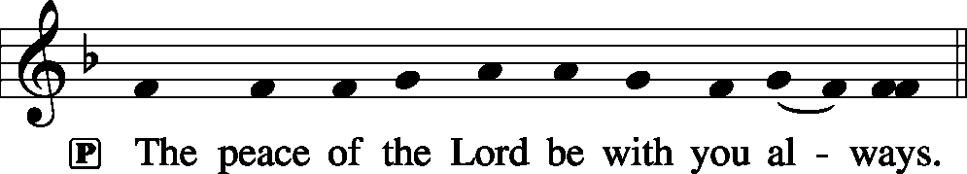
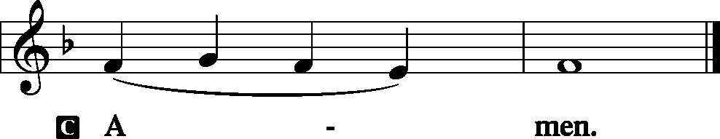
The Agnus Dei LSB 198
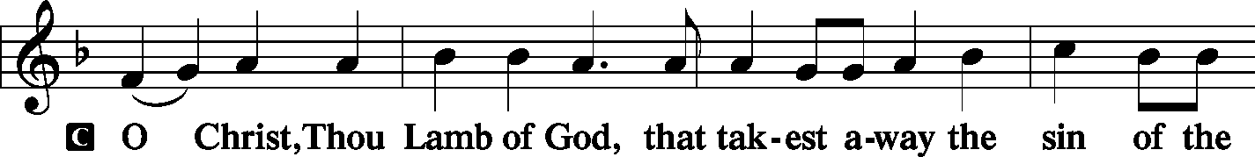
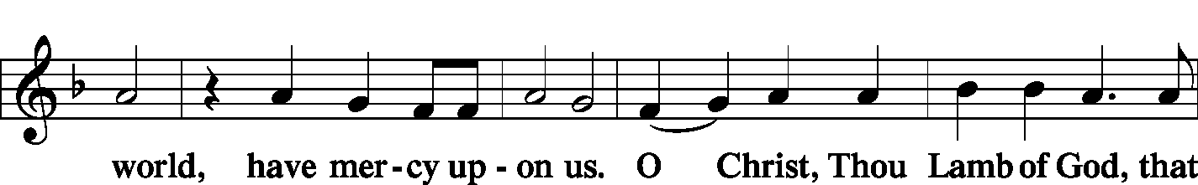
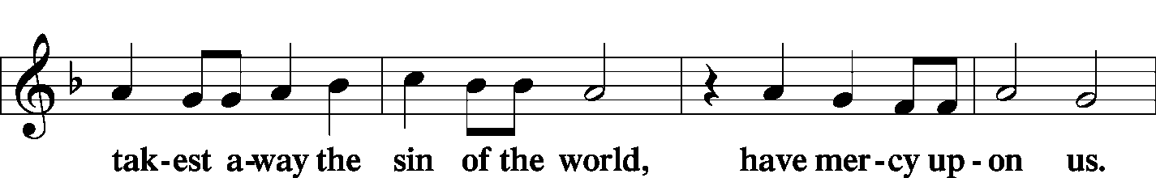
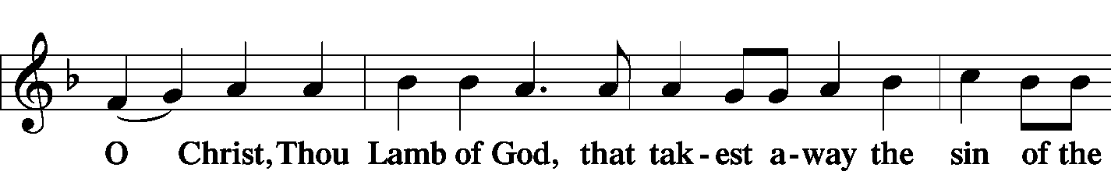
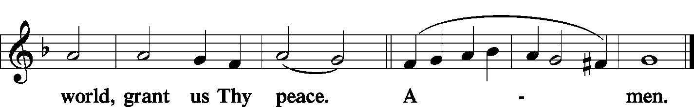
Sit
The HYMN LSB 940 Holy God, We Praise Thy Name
LSB 578 Thy Strong Word
(see pages 18–20)
Stand

The Nunc Dimittis LSB 199
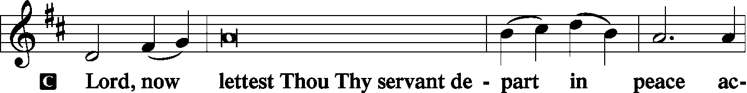
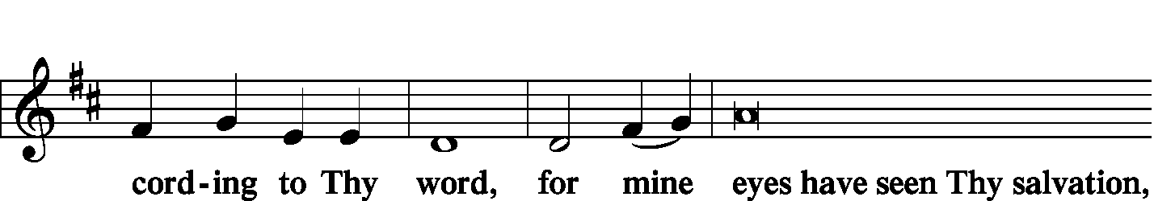
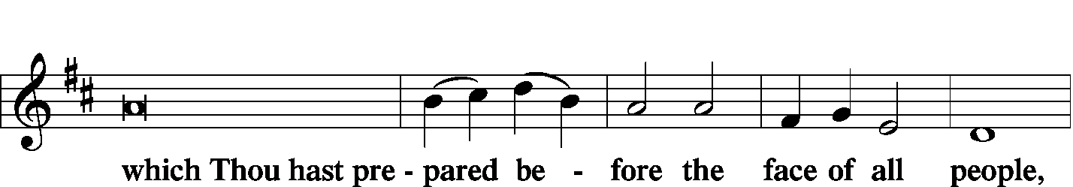
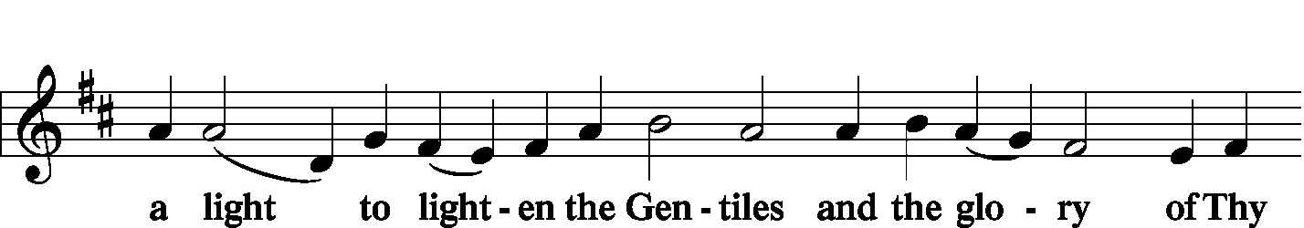
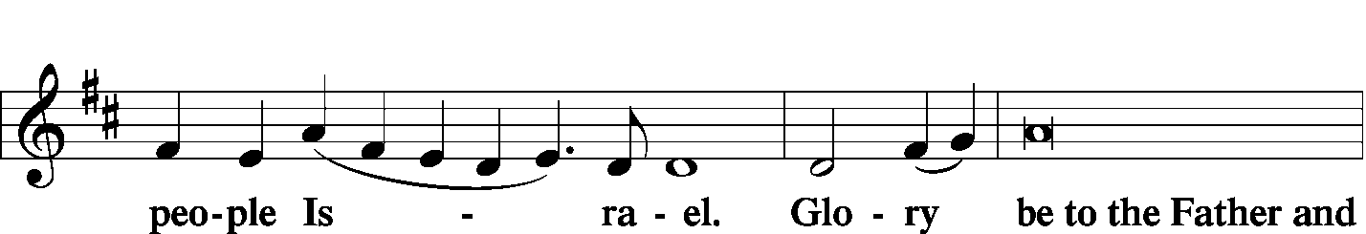
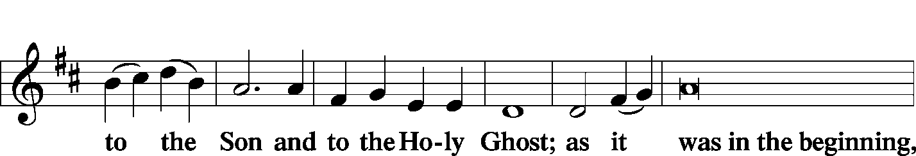
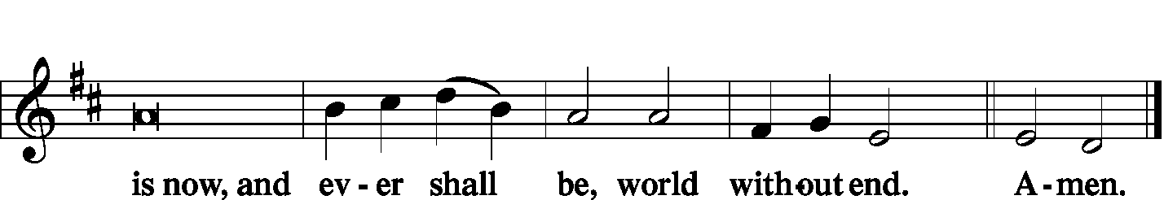

The Thanksgiving LSB 200
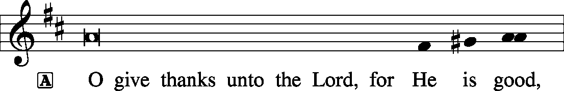
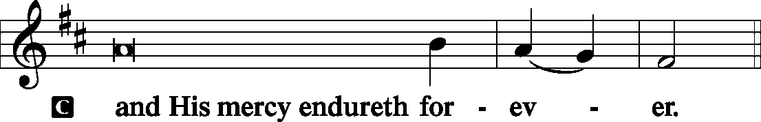
P We give thanks to You, almighty God, that You have refreshed us through this salutary gift, and we implore You that of Your mercy You would strengthen us through the same in faith toward You and fervent love toward one another; through Jesus Christ, Your Son, our Lord, who lives and reigns with You and the Holy Spirit, one God, now and forever.
The Salutation and Benedicamus LSB 201–202
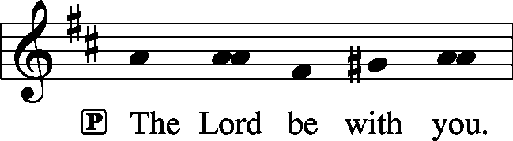
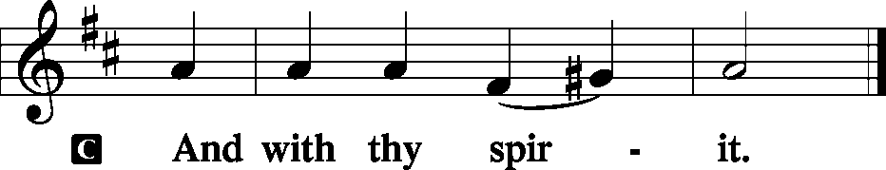
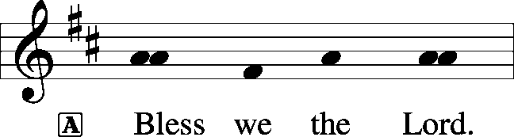
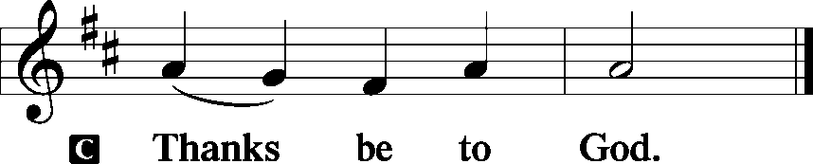
The Benediction LSB 202
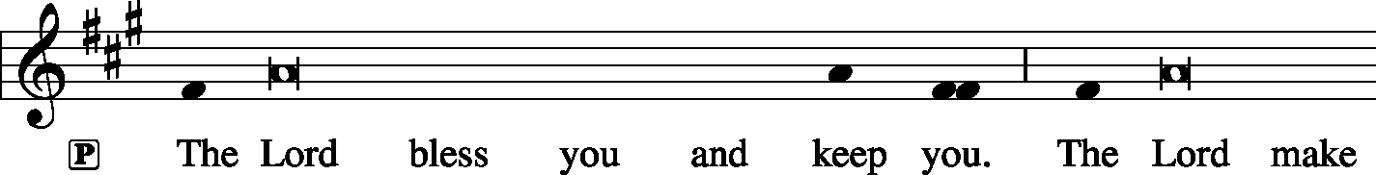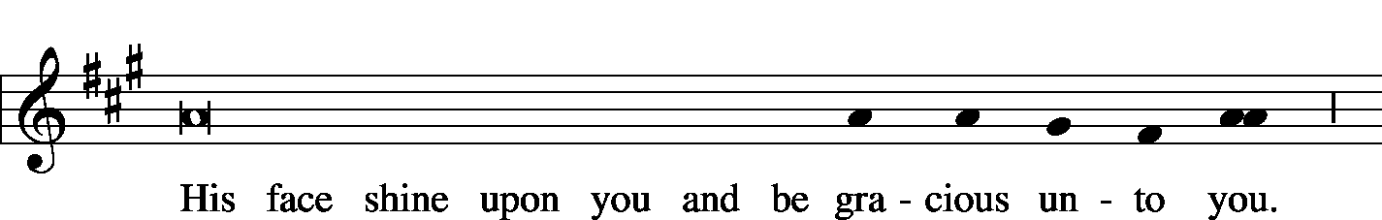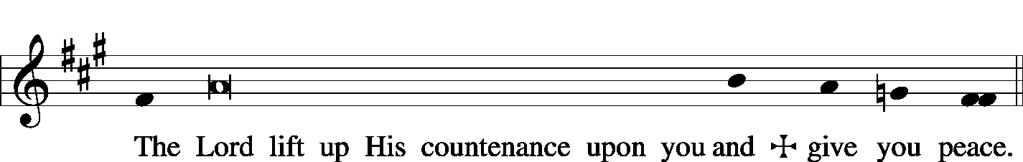
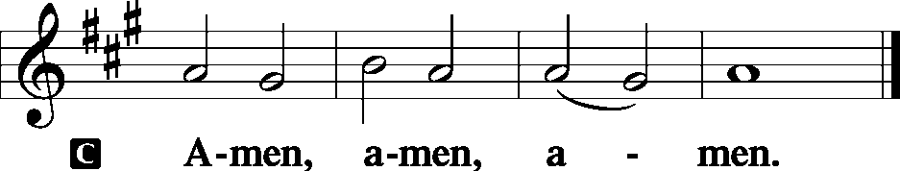

The RECESSIONAL HYMN LSB 805 Praise God, from Whom All Blessings Flow
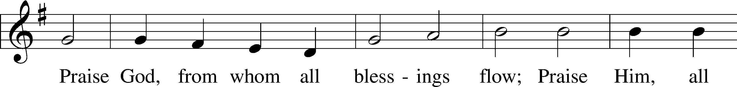
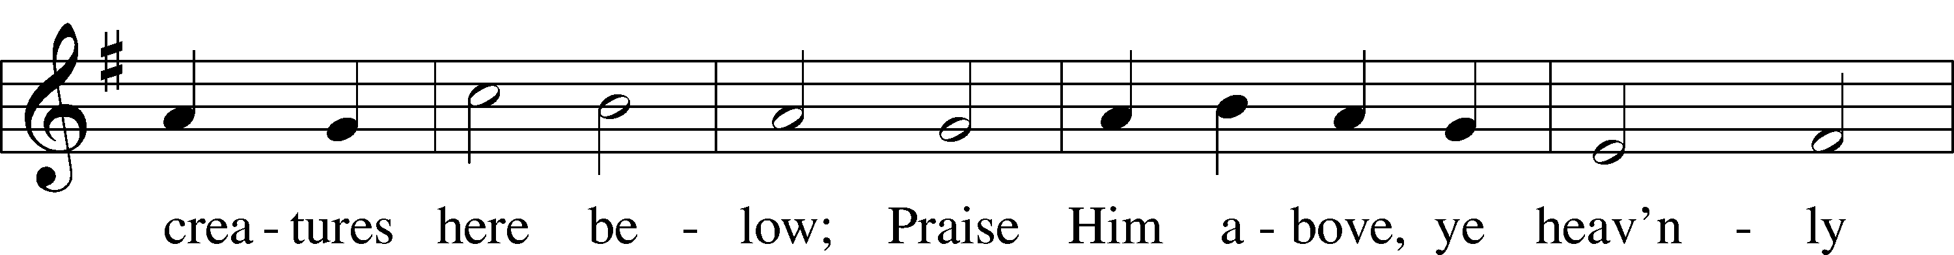
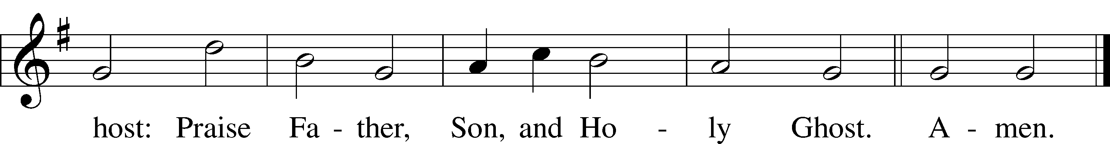

SERVING TODAY
CELEBRANT Rev. Jason Braaten
ORGANIST Mr. Glenn Linstead
Mrs. Leigh Ann Whitson

ACKNOWLEDGEMENTS: Divine Service, Setting Three from Lutheran Service Book Unless otherwise indicated, all scripture quotations are from The Holy Bible, English Standard Version, copyright © 2001 by Crossway Bibles, a division of Good News Publishers. Used by permission. All rights reserved. Created by Lutheran Service Builder © 2006 Concordia Publishing House.
LSB 791 All People That on Earth Do Dwell
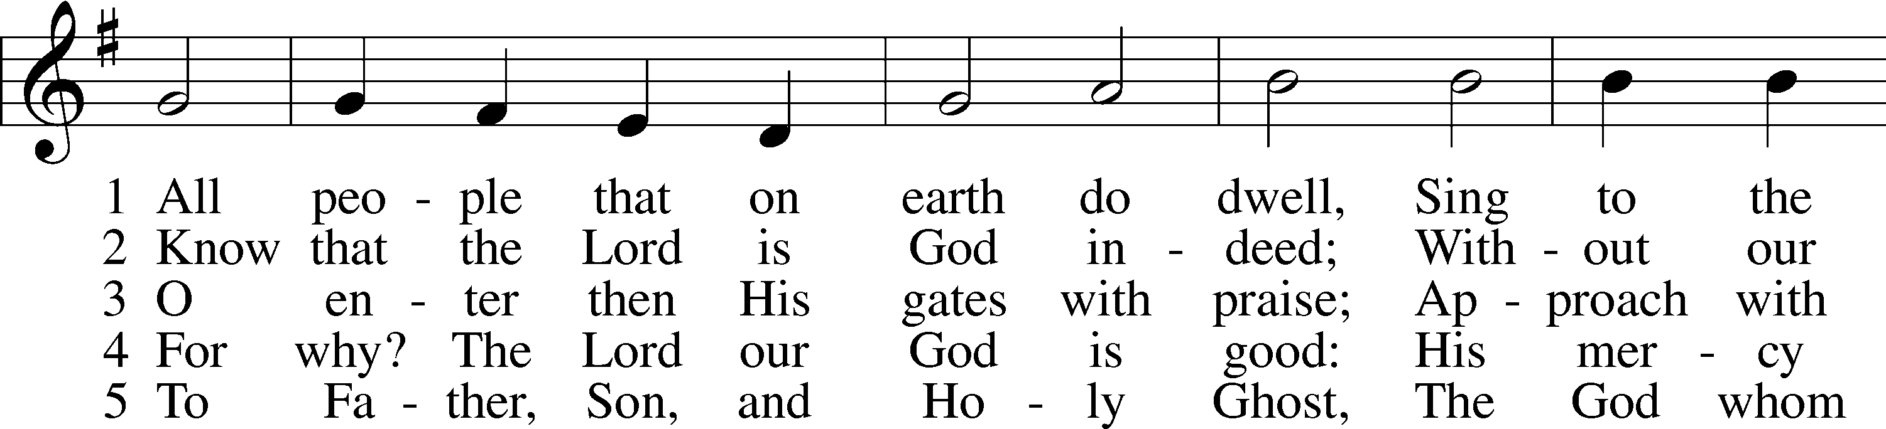
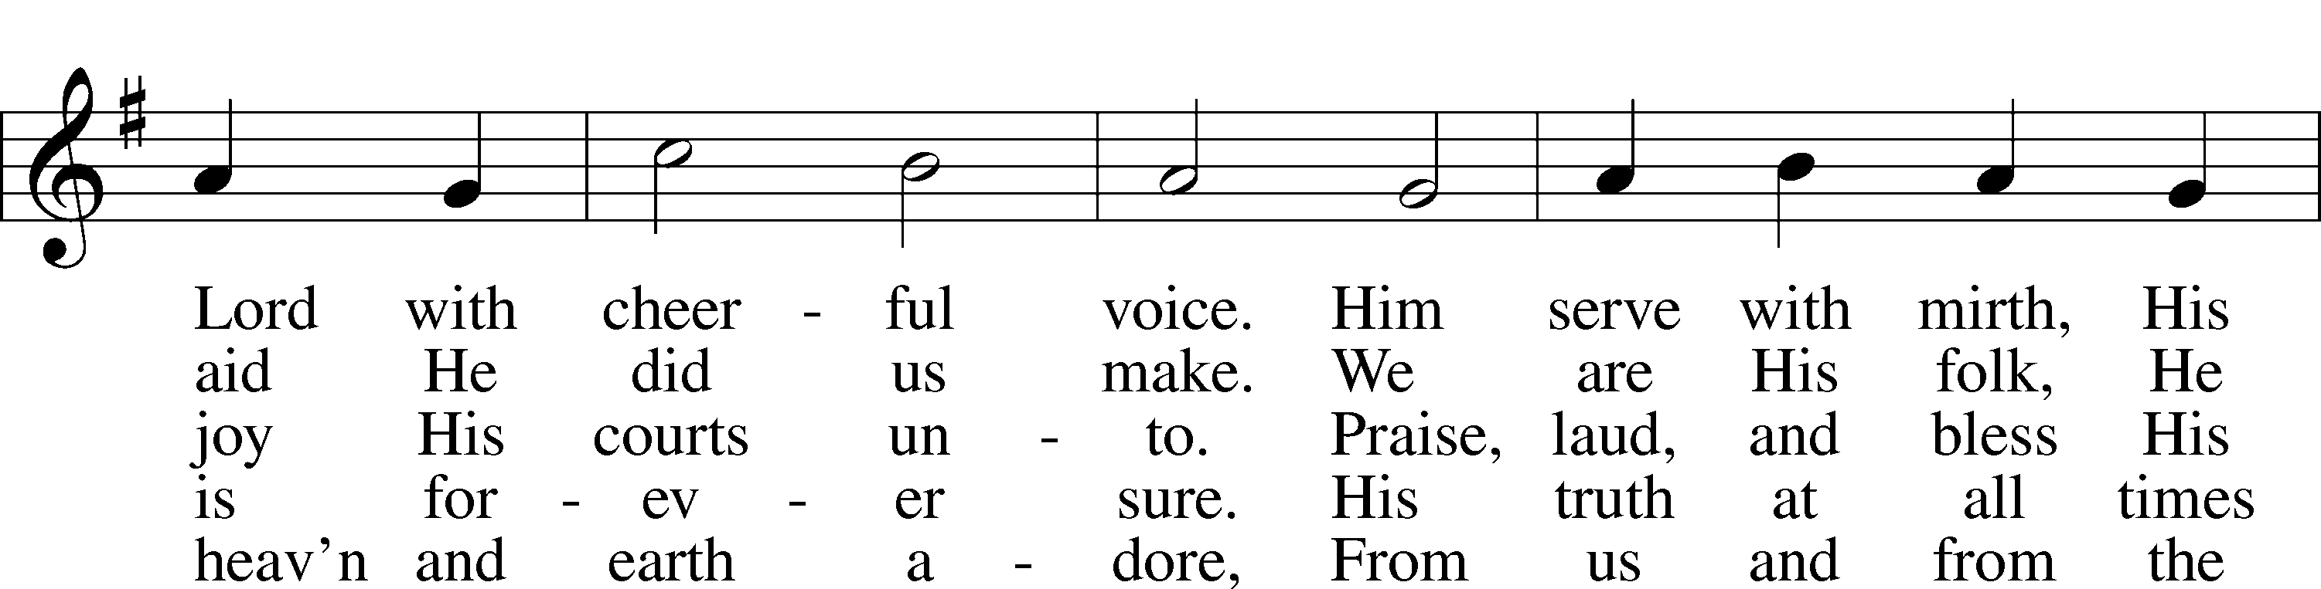
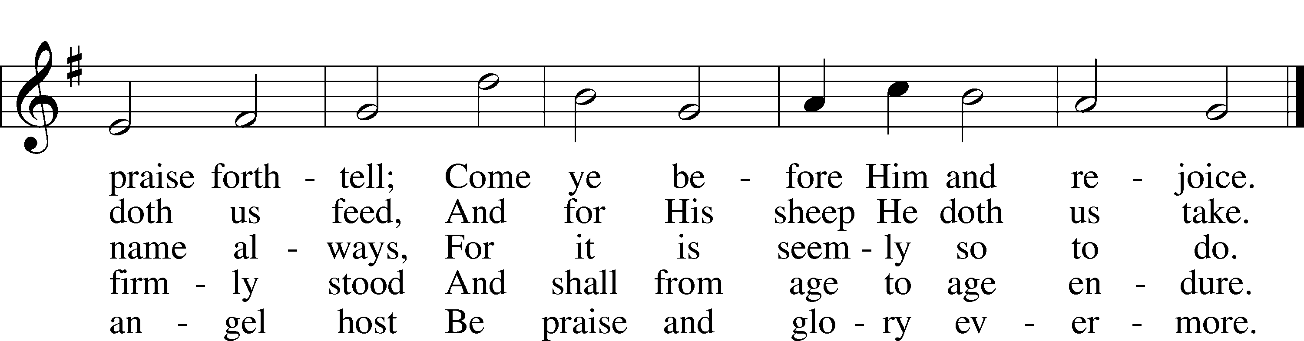
Public domain

714 Who Trusts in God a Strong Abode
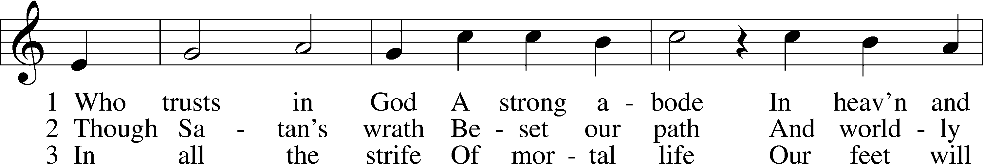
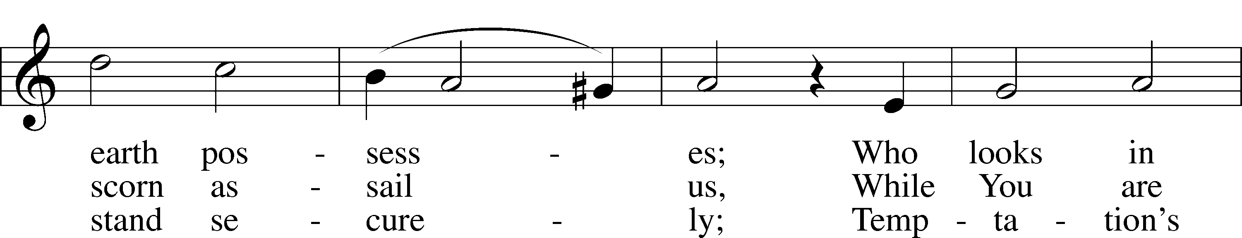
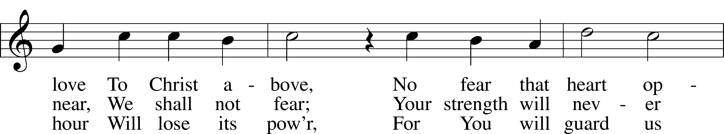
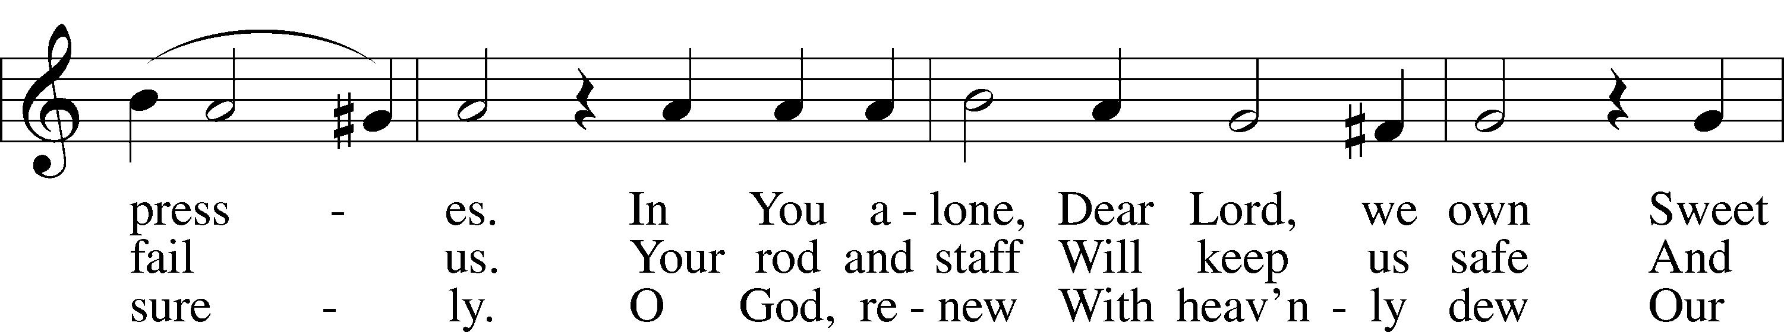
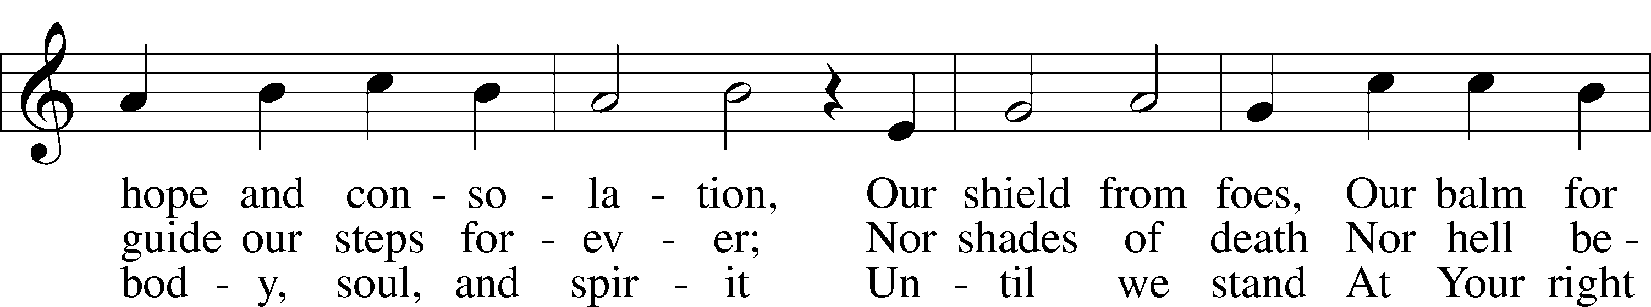
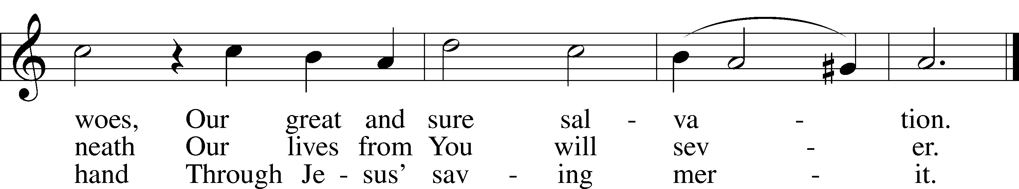
Public domain

940 Holy God, We Praise Thy Name
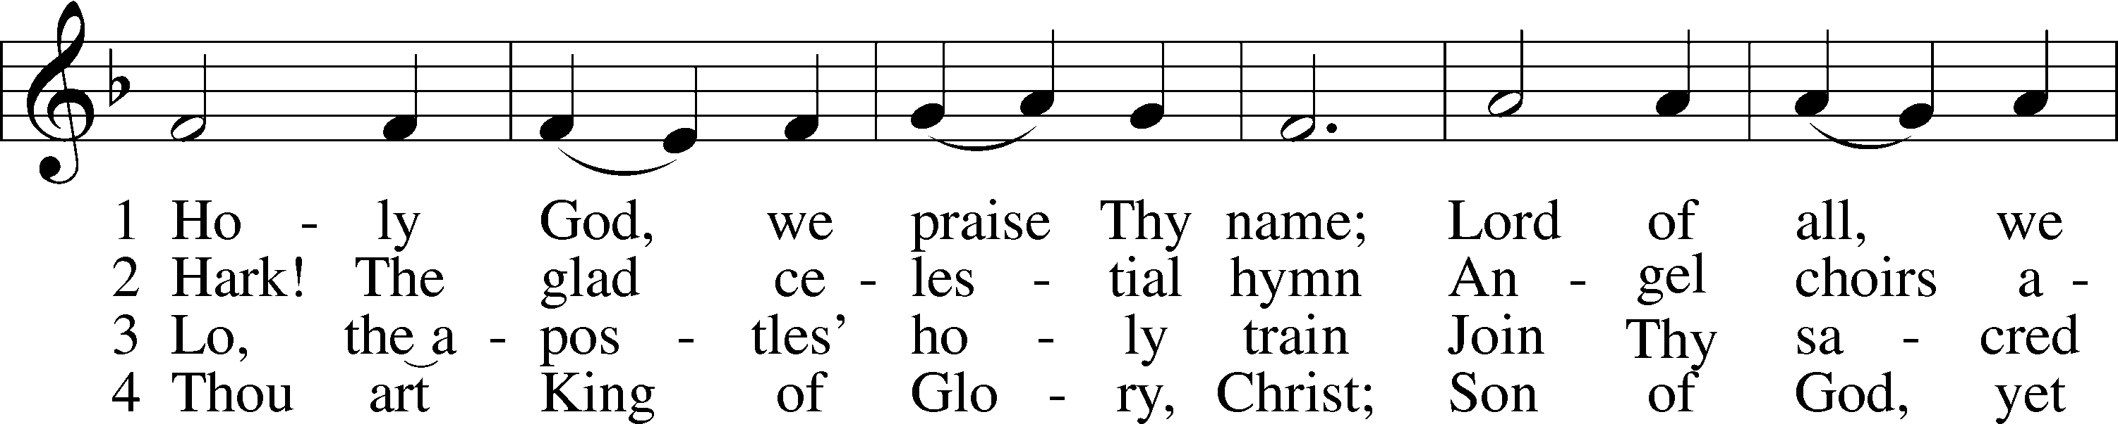
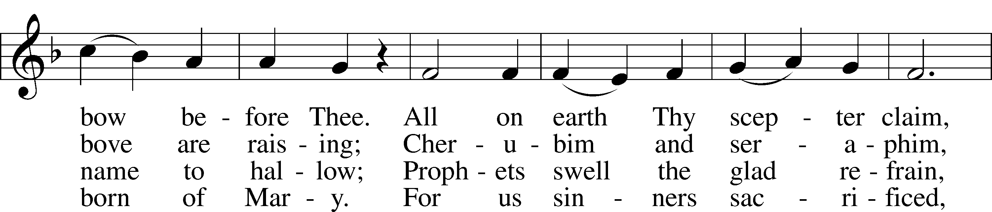
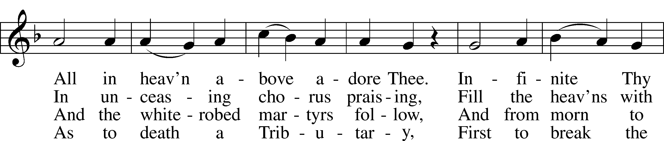
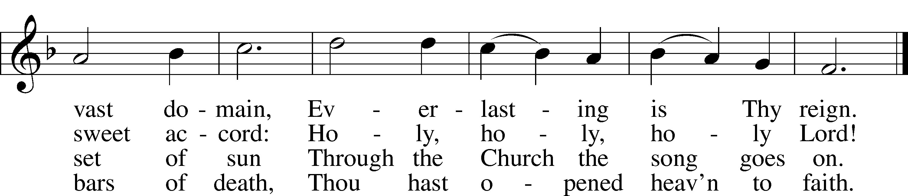

5 Holy Father, holy Son,
Holy Spirit, three we name Thee;
Though in essence only one,
Undivided God we claim Thee
And, adoring, bend the knee
While we own the mystery.

6 From Thy high celestial home,
Judge of all, again returning,
We believe that Thou shalt come
On that final judgment morning,
When Thy voice shall shake the earth
And the startled dead come forth.

7 Spare Thy people, Lord, we pray,
By a thousand snares surrounded;
Keep us without sin today,
Never let us be confounded.
Lo, I put my trust in Thee;
Never, Lord, abandon me.

578 Thy Strong Word
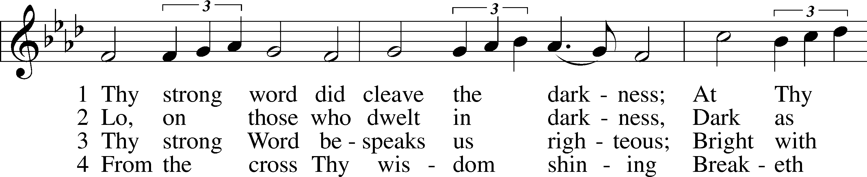
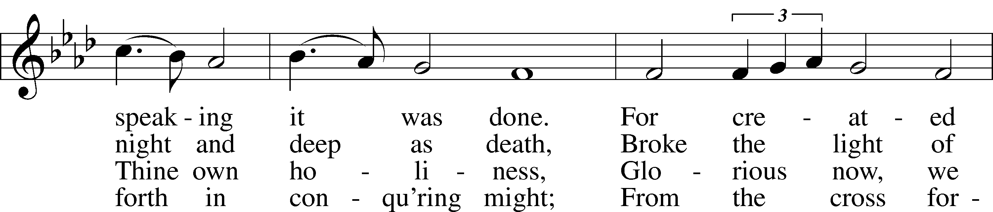
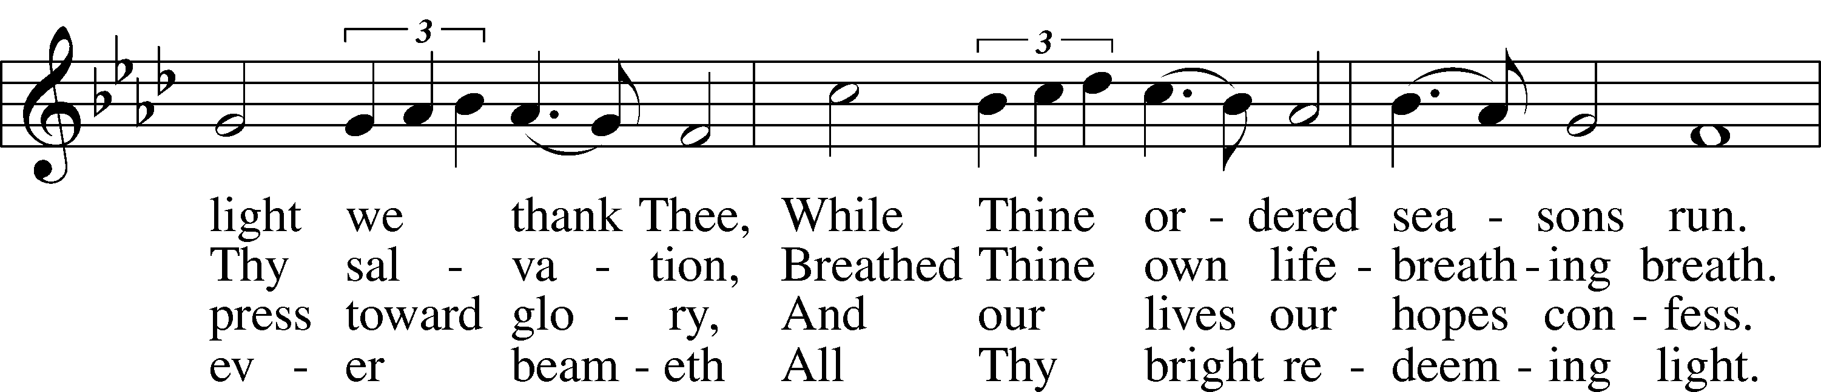
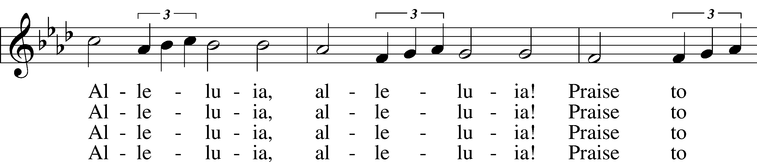
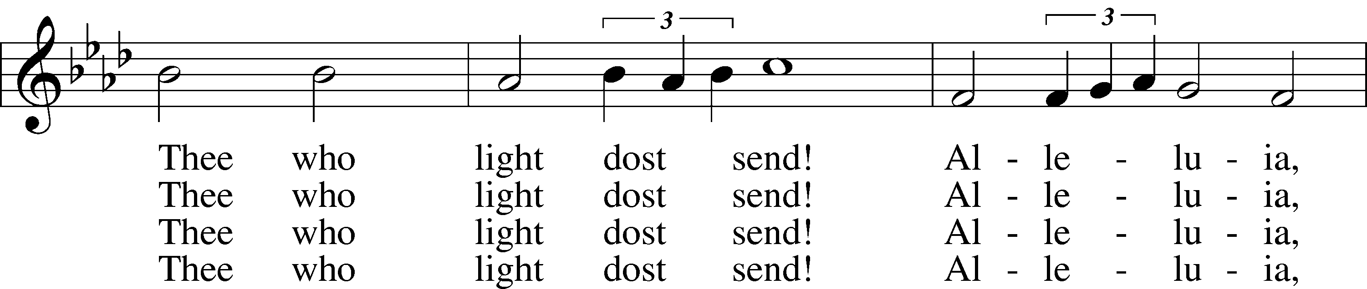
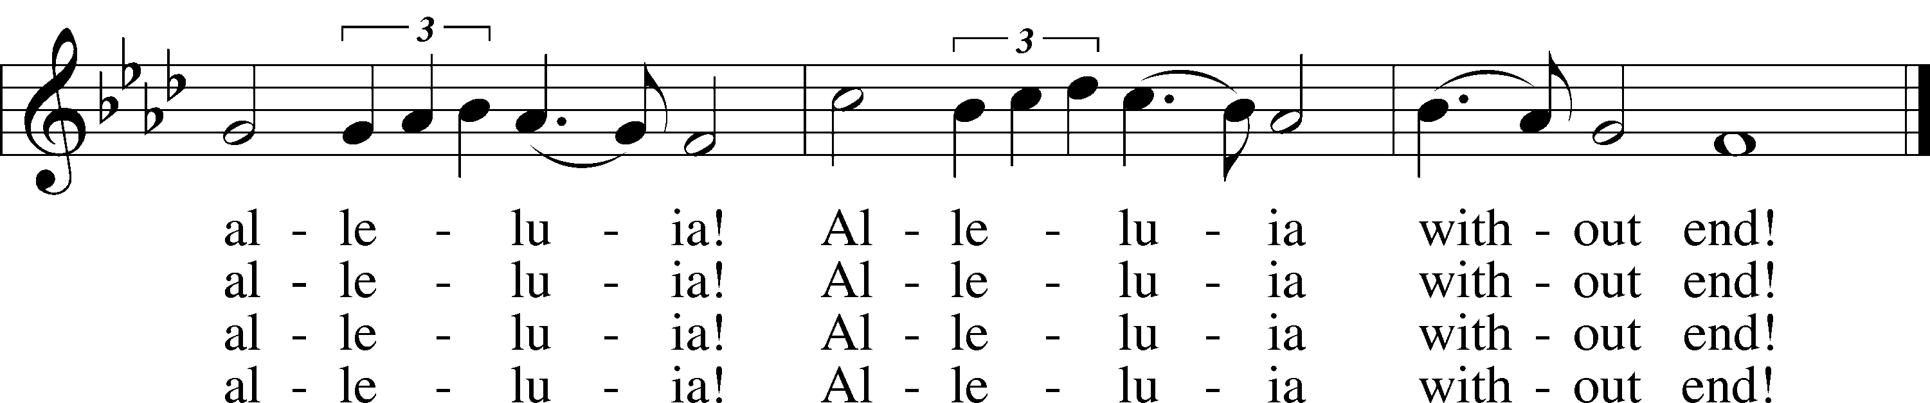

5 Give us lips to sing Thy glory,
Tongues Thy mercy to proclaim,
Throats that shout the hope that fills us,
Mouths to speak Thy holy name.
Alleluia, alleluia!
May the light which Thou dost send
Fill our songs with alleluias,
Alleluias without end!

6 God the Father, light-creator,
To Thee laud and honor be.
To Thee, Light of Light begotten,
Praise be sung eternally.
Holy Spirit, light-revealer,
Glory, glory be to Thee.
Mortals, angels, now and ever
Praise the holy Trinity!
© 1969 Concordia Publishing House. Used by permission: LSB Hymn License .NET, no. 100012632.
Public domain

THIS WEEK AT IMMANUEL
Sunday (11/15) 9:00 am Divine Service with Holy Communion
10:30 am Bible Class & Sunday School
Wednesday 12:30 pm Catechism Class
7:00 pm Bible History Bible Study
Saturday 9:00 am Sunday School Teachers Meeting
3:30 pm Individual Confession & Absolution
5:30 pm Divine Service with Holy Communion
Sunday (11/22) 9:00 am Divine Service with Holy Communion
10:30 am Bible Class & Sunday School

IN OUR PRAYERS
HEALTH CONCERNS: Bernita Ashwill; Connie Bruns (cousin of Mary Appleby); Lynn Corrie (friend of Arleigh Jones); Ellie Crawford (daughter of Laran Crawford); Whitney Czerwonka; Lynn Davis (cousin of Mark Whitson); Cindy Ekstrom; Theresa Fields; Darrell Ford; Lisa Hall (sister of Holly Wikoff); Rick Hardesty (family of the Hoels); Kim Hausman (friend of Ann Carroll); Deanna Henningsen (sister-in-law of Jerry & Joyce Alexander); Mary Miller (friend of David Holzrichter); Kimberly Mulvany (daughter of Pastor Doug Meyer); Mary Negangard (grandmother of Bryce Reifsteck); Dennis Pickett (friend of Ann Carroll); Misti Post (niece of Sue Rothe); Cary & Beth Rahn; Joan Rahn; Aurelia Tuegal (grandmother of Bethany Campbell); Emma Silver; Dave Slaughter; Ocil Slone (grandfather of Josh & Jake Dyer); Joy Stenger; Carolyn Stremming (sister-in-law of Arleigh Jones); Janet Stumeier; Brian Walker (uncle of Bryce Reifsteck); Lynn & Jane Whitson (parents of Mark Whitson).
SEMINARY STUDENT: Gunnar Campbell; Logan Smith.
DEACONESS STUDENT: Emily McLean.
MISSIONARIES: The Naumann Family; The McDermott Family, Julie Lutz
HOMEBOUND: Bernita Ashwill; Leonard Boerngen; Jim Harbaugh; Janet Pollock; Ruth Rentschler; Ruth Sims; Irene Wattjes.
MILITARY: Carl Crawford; Josh Dyer; Jeremy Gordon; Jack Leonard; Jake Lindgren; Raymond Longtin; Joey Pollock; Blake Stokes; Ruben Wilson.
THE ANNOUNCEMENTS
NEXT WEEK’S READINGS . . . Isaiah 65:17–25; 1 Thess. 5:1–11; Matthew 25:1–13.
ABOUT THIS WEEK’S READINGS . . . When confronted with the civic duty of paying taxes, our Lord Jesus, Wisdom incarnate, walked “in the way of righteousness, in the paths of justice” (Prov. 8:20) and discerned that wisdom “is better than jewels” and “better than gold, even fine gold” (Prov. 8:11, 19). When we set our minds on earthly things, such as wealth and passing glory, our “end is destruction” (Phil. 3:19). However, our humble and prudent Lord has rendered “to God the things that are God’s” (Matt. 22:21), namely, perfect fear, love, and trust, as well as the complete sacrifice for our sin. In so doing, He also rendered to Caesar the things of honor and justice, submitting to the law of the land that put Him on the cross. The true “riches and honor are with [Him],” because “enduring wealth and righteousness” (Prov. 8:18) are found in our heavenly citizenship from which “we await a Savior, the Lord Jesus Christ.” He “will transform our lowly body to be like his glorious body, by the power that enables him even to subject all things to himself” (Phil. 3:20–21).
THOUGHTS ABOUT STEWARDSHIP . . . “Their end is destruction, their god is their belly, and they glory in their shame, with minds set on earthly things” (Philip. 3:19). There is the danger in setting our minds on earthly things, serving mammon, and caring more for our bodily comfort than our spiritual well being. God does not tell us to be faithful and generous in our stewardship of the things of this earth to ruin our fun. Rather, He tells us to give generously to teach us how to make sure the things of this world do not lay a hold of our hearts.
ALTAR FLOWERS . . . are given by Jack Appleby and the Reifstecks to the glory of God on the occasion of Mary Appleby’s birthday.
CHURCH-WIDE LIVE NATIVITY IN TUSCOLA . . . Immanuel will participate in a church-wide live nativity to be held in Ervin Park on Sunday, December 6, 2020, from 5:00 pm to 7:00 pm. More details are coming soon.
CHRISTMAS DECORATING . . . Saturday, December 5, 9:00 am. Advent is almost upon us, and that means the Christmas season is near! With it come the sights, the sounds, and the fellowship that unite Christians as we anticipate the birth of our Savior. Come on December 5 to help put up the Christmas trees and decorations. Mark your calendars.

A PRAYER FOR IMMANUEL
Rev. Jason Braaten, Pastor
Home: (217) 253-4539
Mobile: (217) 460-2077
Email: pastor.braaten@gmail.com
Office Hours:
Monday–Thursday 8:00 am–12:00 pm
or by appointment

My dear Lord Jesus, I want to know You as Savior and Friend, Help me to grow into a mature disciple so that I can demonstrate God’s love and forgiveness in all I do. Teach me to share my faith in You and to serve others in my vocation. Make Immanuel Lutheran Church a place where lost and hurting people find friendship, forgiveness, and faith, and where Christians gather to serve You in love for one another, for the community, and for the world. Amen.
Debra Parsley, Office Manager
Office: (217) 253-4341
Email: immanuel.tuscola@gmail.com

Office Hours:

